

INVITATION

Dear Member Associates,
On behalf of the Organizing Committee of the BULGARIAN ARCHERY FEDERATION I would like to kindly invite you to take part to the WAE-GRAND PRIX, which is to be held on 31 July – 04 August, 2018, in Sofia – Bulgaria. This is a WA Ranking Event.
The tournament will be organized following the WORLD ARCHERY rules and the WAE GRAND PRIX rules in both divisions: Recurve and Compound.
Please find enclosed the necessary documents concerning the registration, organization and participation to this event. We kindly ask you to reply within the stated deadlines:

Preliminary Entries | 03 May 2018
Final Entries | 11 July 2018
Hotel Reservation Form | 03 May 2018
Transportation Form | 31 May 2018
Budget Form | 31 May 2018
Visa Invitation Letter Form | 31 May 2018

WAE will give a total amount of 8000 Euro for each competition
(Recurve and Compound, Men and Women)
Prize money for European winners:
1st place: Euro 1000
2nd place: Euro 600
3rd place: Euro 400

You will certainly be able to sense the Bulgarian hospitality. We also hope that you and your team will enjoy your stay in Sofia.

We are looking forward to welcoming you in Sofia.
Sincerely yours,
Daniel Pavlov
President
Bulgarian Archery Federation

PRELIMINARY PROGRAM

 | Sunday  29 July 2018 | Arrival of participants.  Practice field and local transport available.
 | Monday  30 July 2018 | Arrival of participants.  Practice field and local transport available.
Day 1 | Tuesday  31 July 2018 | Official practice, Equipment inspection,  Team Managers’ Meeting
Day 2 | Wednesday  01 August 2018 | Qualifications 70m Round Recurve and 50m Compound.
Day 3 | Thursday  02 August 2018 | Elimination Individual Round till semi finals, Mixed Team Eliminations.  ALL divisions.
Day 4 | Friday  03 August 2018 | Teams Elimination Round and finals.  ALL divisions.
Day 5 | Saturday  04 August 2018 | Individual Finals - Medal matches  Award Ceremony for Individual, Teams and Mixed Teams  Closing Party.
 | Sunday  05 August 2018 | Departure of teams.

Maximum six (6) archers are allowed to enter the competition per category and per division.

NOTE:
This preliminary program could change slightly according to the number of participants and TV requirements. All changes to the program will be published and informed to all participants in good time.

PRELIMINARY & FINAL REGISTRATION

No entry forms are available for registering to WAE events. The registration process should be done using the World Archery Online Registration System (WAREOS).
In order to use WAREOS, please login on http://register.worldarchery.org with your Username and Password assigned by World Archery. After entering WAREOS, please find the event, from the list, you wish to register your athletes. Select/press the “Entries” button to see the list of categories in the event. Select/press the “Category” to enter the athlete and official numbers/details participating for that event. A "WAREOS User Manual" can be downloaded in PDF format (English) using the same website link.
For any questions regarding the WAREOS, please contact the World Archery office, Mr. JK LEE (jklee@archery.org).
Starting date of online-registration with WAREOS is: | 12 March 2018
End of Preliminary registration: | 03 May 2018
End of Final registration: | 11 July 2018

Please respect the stated deadlines.
Member Associations should only use WAREOS to make any changes/amendments to their entries and will be able to do so at any time. Any changes made in WAREOS an email will instantly be automatically sent to the Organizing Committee and Member Association with the updated information.
However, any changes that are made after the deadlines specified or if entries differ by more than 4 athletes from the preliminary entries, the following penalty fees will automatically be applied.
Final registrations that differ from the preliminary entries by more than 4 athletes/officials will result in a penalty fee of 140,00 € per entry to be paid in cash to the LOC upon arrival at the venue.
Failure to have made preliminary entries before the deadline date but then submitting final entries will result in a penalty fee of 140,00 € per entry to be paid in cash to the LOC upon arrival at the venue.
Any entries received less than 3 days before the team managers meeting will be refused if no preliminary entry and/or final entry are made prior.
As a final note, only member Associations in good standing will be eligible to compete. This means that World Archery fee 2018 must have been paid prior the participation.

ACCOMMODATION & GENERAL INFORMATION

The Official Hotel is “Tsarsko selo” Spa Centre. The hotel is offered on a “Full board” base.
Reservation should be made before 03 May 2018.

Hotel | Category | Single room | Double room
Hotel “Tsarsko selo”  Spa Centre | 4**** | 85.00 € | 65.00€

Hotel’s prices include: bed, breakfast, lunch, dinner on the spot. The rates are in Euro (€) per person and per day.

The tournament will be organized and held in the stadiums of the “Tsarsko selo”. A free parking place is provided to each hotel guest. Free Wi-Fi in all hotel areas.

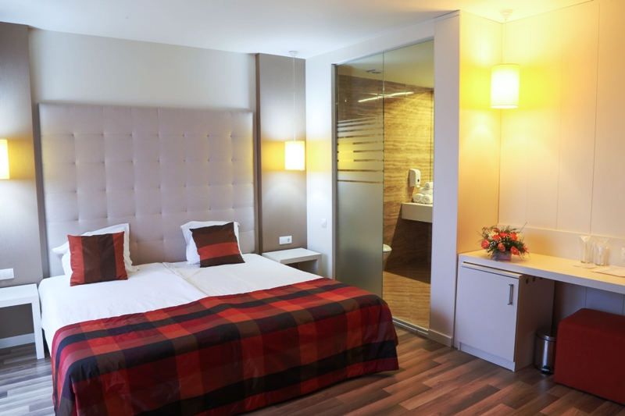 | 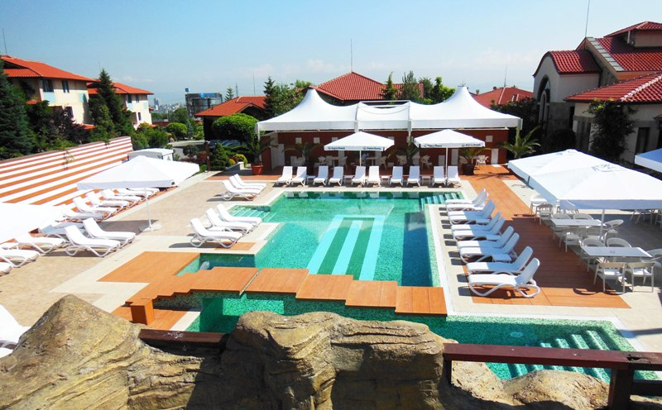
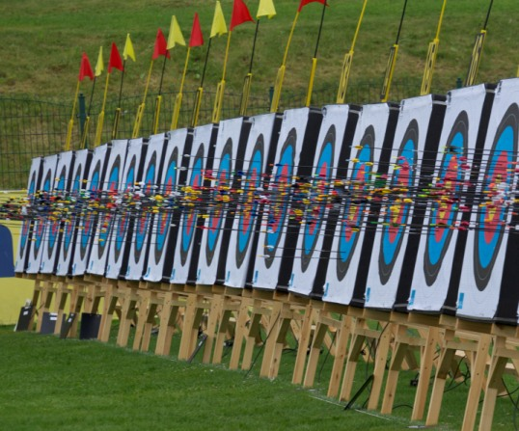 | 

Entry fees:
Individuals: 130 € / Archer
Officials: 50 € / Official
*The Entry fee includes the Closing Party meal.
*Participation in the Mixed Team and Teams event is free of charge.
Transportation:
Sofia Airport
Sofia Central Railway Station
Sofia Central Bus Station
From Sofia airport, bus or railway station to the hotels – (arrival and departure): 20€/person
* Field, hotel and buses will be available for disable persons.
Water:
Water will be available on the fields free of charge.
Weather in Sofia:
In this period is sunny and 30 – 35 degrees
Visa:
For all nations that will need visa permits, please make sure to apply for such as early as possible in your country of origin before leaving. If our help is needed you may contact us immediately: for we could send an official invitation over to the Bulgarian Embassy for further cooperation.
Closing Party: Saturday 04 August 2018
Opening: 20:00 p.m. till the end...
Everyone is awaited to join the Party!
Awards Ceremony:
It is required that each team should bring its National Anthem
(on a CD or on a pen-drive) and a country’s Flag (90cm x 120cm approx).
Pre-payments:
Hotel booking will only be regarded valid as soon as a 50 % down payment has been received by the Organizing Committee, before 31 May 2018.
The balance of full payments is to be made, before 30 June 2018.

Booking NON-OFFICIAL Hotel
Teams who book their own accommodation will be charged an entry fee of €. 300,00 per athlete, and will not receive tournament information/results or local transportation.
OC will not be responsible for providing transportation from that Hotel to the venue, but could arrange the transport from the airport to the hotel at the prices quoted below.
Furthermore, the OC won’t provide any information about the non-official hotels.
ADDITIONAL INFORMATION
Training field will be available a week before and after competition for teams who want to practice. Teams are welcome at this time.

CLUB ARCHERS PARTICIPATION
Not only National Team archers can participate in the Grand Prix, but also Club archers. National teams will have priority during the preliminary entry phase. After the preliminary entry deadline (03 May 2018) all Club members could register. The Club archers can participate only in the individual competition, not in team competition and in mixed team. Registrations must be done through their National Federations and the entries can be accepted by the Organizing Committee until the total capacity of the field has been reached.
You can find Club Archers Registration Form at the last pages of the Invitation.

TRANSPORTATION FORM
Return at the latest: 31 May 2018

Country/Team:________________________ Email: ______________________________

Team Manager: _______________________ Phone:_______________________________

Total number of Persons: |  | X 20 € = | Total (B): €

ARRIVAL
Plane:
Sofia Airport Flight No _________ From: _________
Date: ______________ Time: _____________________
Train: Train No: _________ Arriving from: _____________
Date: ______________ Time: _____________________
Car/Bus: Date: ______________ Time: _____________________

DEPARTURE
Plane:
Sofia Airport Flight No _________
Date: ______________ Time: _____________________
Train: Train No: _________
Date: ______________ Time: _____________________
Car/Bus: Date: ______________ Time: _____________________

If you are not arriving or departing in one group, please specify in the tables below.
Arrivals:
No. of persons | Flight No. /From | Date | Time
Departures:
No. of persons | Flight No. | Date | Time

Please check this box if you need facilities for persons with disabilities.

Date: _______________ President/SecretaryGeneral:___________________________

HOTEL RESERVATION FORM
Return at the latest: 03 May 2018

Country/Team:________________________ Email: ______________________________

Contact person: _______________________ Phone/Fax:__________________________________

ACCOMMODATION

4**** hotel  Tsarsko selo  Spa Centre | Number of Rooms | Number of Persons | Number of Nights | Cost price | Total Cost
Single Room |  |  |  | 85 € | €
Double Room |  |  |  | 65 € | €
 |  |  |  | Total (C) | €

The rates are in Euro (€) per person, per day, full board.
Please check this box if you need facilities for persons with disabilities.

We require that 50 % of the payment should be done before 31 May 2018.

Payment must be sent to the following bank account:

Bank Name: FIRST INVESTMENT BANK
International Banking Account Number (IBAN): BG13FINV91501203792590
Bank Identification Code (BIC): FINVBGSF
Bank address: 3, Narodno sabranie Sq. 1000 Sofia, Bulgaria
Bank account nominee: Bulgarian Archery Federation
NOTE:
All payments are required to be done in EURO:
- By BANK TRANSFER: 50% of total payment, before 31 May 2018
- By BANK TRANSFER: The rest of total payment (50%), before 30 June 2018
Bank transfer fees are the responsibility of the sender.
NO CREDIT CARDS, NO TRAVELLERS CHEQUES, NO FOREIGN CURRENCIES

Date: _______________ President/SecretaryGeneral:___________________________

BUDGET FORM
Return at the latest: 30 June 2018

Country/Team:________________________ Email: ______________________________

Contact person: _______________________ Phone/Fax:__________________________________

 | Number | Cost | Total
Individuals Entry fee |  | 130 € | €
Officials Entry fee |  | 50 € | €
Total entry fees ( A ) |  |  | €
Transportation Total ( B ) |  | 20 € | €
Total Accommodation ( C ) |  |  | €
Grand Total ( A+B+C ) |  |  | €
Deposit 50% before 31 May 2018 |  |  | €
Balance of full payments due on 30 June 2018 |  |  | €

Payment must be sent to the following bank account:
Bank Name: FIRST INVESTMENT BANK
International Banking Account Number (IBAN): BG13FINV91501203792590
Bank Identification Code (BIC): FINVBGSF
Bank address: 3, Narodno sabranie Sq. 1000 Sofia, Bulgaria
Bank account nominee: Bulgarian Archery Federation
NOTE:
All payments are required to be done in EURO:
- By BANK TRANSFER: 50% of total payment before before 31 May 2018
- By BANK TRANSFER: The rest of total payment (50%), before 30 June 2018
Bank transfer fees are the responsibility of the sender.
NO CREDIT CARDS, NO TRAVELLERS CHEQUES, NO FOREIGN CURRENCIES

Date: _______________ President/SecretaryGeneral:___________________________

VISA INVITATION LETTER FORM
Return at the latest: 03 May 2018

Country/Team:________________________ Email: ______________________________

Contact person: __________________________ Phone/Fax:__________________________________

№ | Family Name | Given Name | Date of Birth  DD/MM/YY | Passport Number | Date of issue  DD/MM/YY | Validity  DD/MM/YY | Indicate Athlete, Coach or Official
1
2
3
4
5
6
7
8
9
10
11
12
13
14

Date: _______________ President/SecretaryGeneral:___________________________

CLUB ARCHER REGISTRATION FORM

Event: European Grand Prix

PLACE: Sofia (Bulgaria)
DATE: 31.07-04.08.2018

Country:
Family Name:
Name: |  |  |  |  |  |  |  |  | WA ID #  (if any)
Date of birth: |  |  |  |  |  | DIVISION |  |  |  | Rec. men
Club name: |  |  |  |  |  |  |  |  |  | Rec. women
 |  |  |  |  |  |  |  |  |  | Comp. men
 |  |  |  |  |  |  |  |  |  | Comp. women
Email address:
Postal address | Street:
 | City:
 | Postal code:
 | Phone #:
 | ALL cells must be completed
To complete ONLY by THE LOC  Date the Form was received: |  |  |  | Day |  |  | Month |  |  |  | Year

Please send this form completed to the Local Organizing Committee and to your National Archery Federation / Association:

- The Local Organizing Committee(LOC) will contact you to coordinate final registration, payment and any other information needed to complete your registration to the event.
- Your Federation will need to register your data in WAREOS (WA Registration & Entry Online System) in order to include you into the results system and WA WAREOS data base.

REGULATION for CLUB ARCHERS participating in European GRAND PRIX
- The Club Archer is responsible to send the completed form to the LOC and his/her Federation. Sending the form does not guarantee his/her participation. The process of registration and inclusion must respect the Club Archers’ regulations and procedures in order to be able to participate to this event.

- As soon as the Club Archer will be registered in WAREOS (by his/her Federation) and the LOC has accepted his/her registration, the Club Archer will be informed by the LOC that he/she can officially take part in the event.

- Club Archers participating in WAE events must be members of a WA Member Association (therefore official members of the Archery Federation of his/her country).

- The LOC will work on a “first come, first serve” basis, to take into consideration the forms they will be receiving. However, in order to participate, the Club Archer must also fulfill all the requirements requested in terms of booking, payments and other information requested by the LOC.

- Club archers cannot have coaches or guest accredited to access the FoP (blue area). If guest or coaches will accompany a Club Archer he will be treated as a spectator.

- DRESS REGULATIONS: Club Archers must respect WA rules (Book 1, point 3.22) in terms of uniform for the WA events. Club Archers cannot use any National Team uniform (neither of his country nor any other).

- Club Archer must be present in the Official Practice day when he will pick up his/her accreditation, confirm name and data given and pass the equipment inspection. The Club Archer is not allowed to miss the official practice and arrive directly to the qualification day. Travel plan should be arranged according to the schedule.
- Club archers could be Junior or Senior Categories. Cadet’s archers are not allowed to participate in the event as Club Archer.

CLUB ARCHER REGISTRATION PROCEDURE

- The Club Archer interested in participating in a Grand Prix competition, has to read Invitation Package and study cost and conditions to participate.

- After the end of the Preliminary Registration, the LOC (Local Organizing Committee) will calculate the available spaces for Club Arches per Division and inform WAE , which will advertise and publish the spots available for Club Archer on WAE Website.

- Max 30% of spots of the spots available (for Division) are for Club Archers from the host country, 70% are for International Club Archers.

- The Club Archer will visit the WAE Website and as soon as she/he knows the places available, completes the “Club Archer Registration Form” and sends it to the LOC and to her/his National Archery Federation.

- The belonging Federation, receiving the Club Archer Registration Form, has to check:
- if she/he is a member of the Federation

- If all is OK, the Federation will register the data of the archer in WAREOS (WA Registration & Online System) in order to include her/him into the result system and WA WAREOS data base. If Club Archer is included in WAREOS, the Federation has to inform LOC that the archer is eligible for the event.

- The LOC will prepare a list of Club Archers forms ordered by date of arrival and inform the Club Archer that her/his form has been received and she/he is included in the Club Archers list. The LOC requests to start room booking and fees-cost payment as indicated in the Invitation Package.

- The Club Archer contacts LOC to arrange room booking, arranges payments and informs about travel plan.

To contact us:
Email: egpsofia2018@abv.bg
Tel / Fax: + 359 2 9300 625;
Mobile phone: + 359 888330105 – Daniel Pavlov
Mobile phone: + 359 884640216 – Donka Shopova
Web address: www.archery.bg

