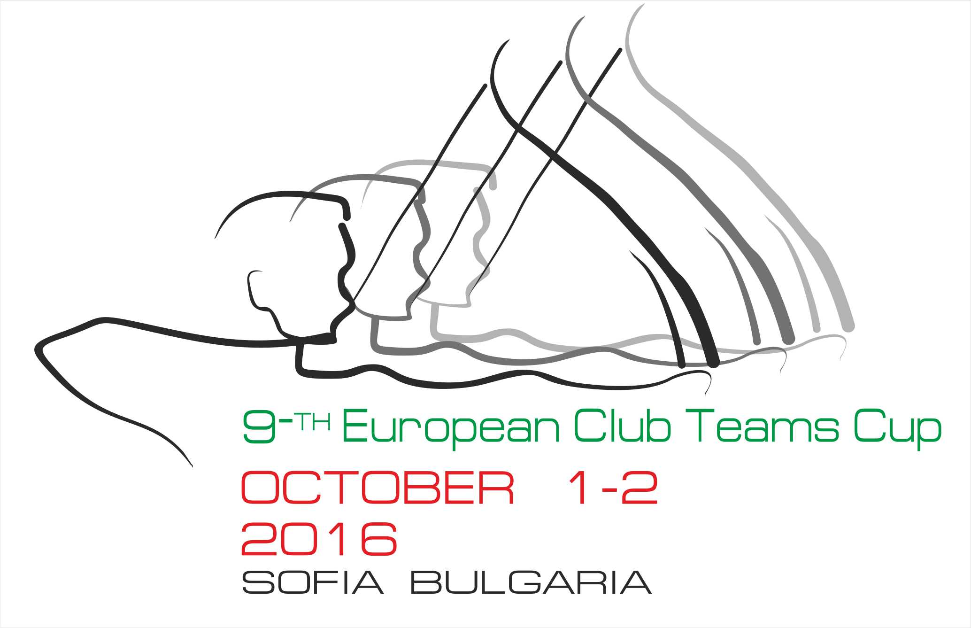

INVITATION

Dear Member Associates,
Dear Friend Archers,
On behalf of the Organizing Committee of the BULGARIAN ARCHERY FEDERATION I would like to kindly invite you to take part in the 9th European Club Teams Cup 2016 which is to be held on October 01 – 02. 2016, in Sofia – Bulgaria.
The competition is reserved only to the recurve division. Participation is open to female and male club teams. Rules of the WAE European Club Teams Cup apply.
Please find enclosed registration forms and further information on the European Club Teams Cup 2016.
Please find enclosed the necessary documents concerning the registration, organization and participation to this event. We kindly ask you to reply within the stated deadlines:

Preliminary Entries | 19 /08/2016
Final Entries | 14/09/2016
Hotel Reservation Form | 19/08/2016
Transportation Form | 19/08/2016
Budget Form | 01/09/2016
Visa Invitation Letter Form | 19/08/2016

You will certainly be able to sense the Bulgarian hospitality. We also hope that you and your team will enjoy their stay in Sofia.
We are looking forward to seeing you in Sofia.

Sincerely yours,
Daniel Pavlov
President
Bulgarian Archery Federation

PRELIMINARY PROGRAM

Friday, 30 September, 2016
14h00 Arrival of teams
16h-19h Official practice
18h-19h Team Captains Meeting
20h-22h Teams presentation, banquet, a few hours together, music,
chatter and friendship

Saturday, 01 October, 2016
09h45 Opening ceremony
10h00 Warm up-Men & Women
10h30 2×36 arrows (A-B-C)
12h00 Lunch break
14h15 1st matches Club teams W&M
14h40 2nd matches Club teams W&M
15h05 3rd matches Club teams W&M
Free evening

Sunday, 02 October, 2016
08h30 Warm - up
09h00 1st ranking group matches Club teams W&M
09h35 2nd ranking group matches Club teams W&M
10h05 Break (25 minutes)
10h30 Bronze medal Women
11h00 Bronze medal Men
11h30 Gold medal match Women
12h00 Gold medal match Men
12h30 Awards Ceremony

NOTE:
This preliminary program could change slightly according to the number of participants and TV requirements. All changes to the program will be published and informed to all participants in good time.

GENERAL INFORMATION& ACCOMMODATION

In any case, before being allowed to participate to the European Club Teams Cup, the Member Association must confirm that the club teams-athletes are members of the participating Clubs since the 1st of January 2016.

Maximum number of club teams per country: 5 men club teams and 5 women club teams. Countries with the winning teams in the previous year are allowed to participate with 6 club teams.

Each Club Team is composed of 3 archers. Mixed teams are not accepted. Maximum number of teams by Club: 1 per gender.

For Participants who will decide to book their accommodation in other hotels (non-official hotels) the Bulgarian Archery federation is not responsible for providing transportation from these hotels to the venue (transportation for these persons will only be provided from the official hotels). In addition, no information will be distributed to the non-official hotels.

The Official Hotel is “Tsarsko selo” Spa Centre. The hotel is offered on a “Full board” base.
Reservation should be made before 19 August’2016.

Hotel | Category | Single room | Double room
Hotel “Tsarsko selo”  Spa Centre | 4**** | 85.00 € | 65.00€

Hotel’s prices include: bed, breakfast, lunch, dinner on the spot. The rates are in Euro (€) per person and per day.

The tournament will be organized and held in the stadiums of the “Tsarsko selo” - Spa Centre 4**** hotel itself. A free parking place is provided to each hotel guest. Free Wi-Fi.

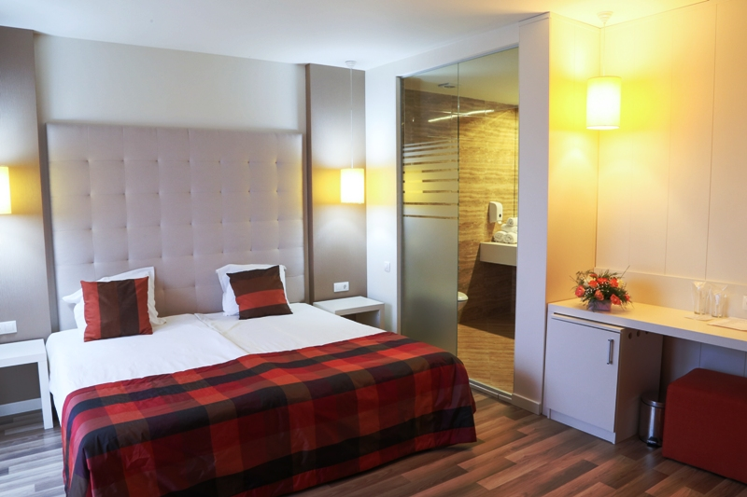 | 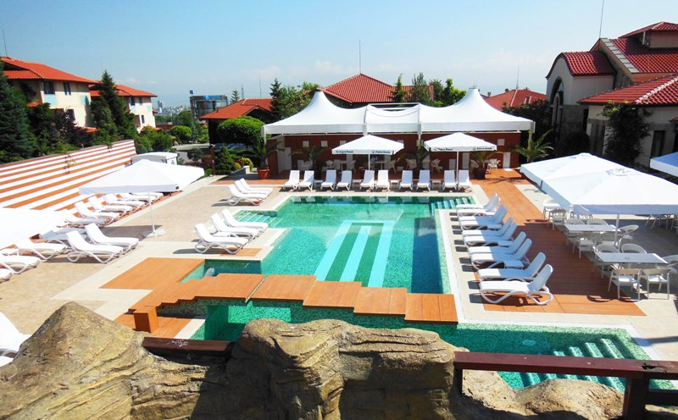
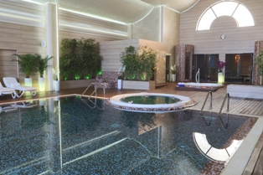 | 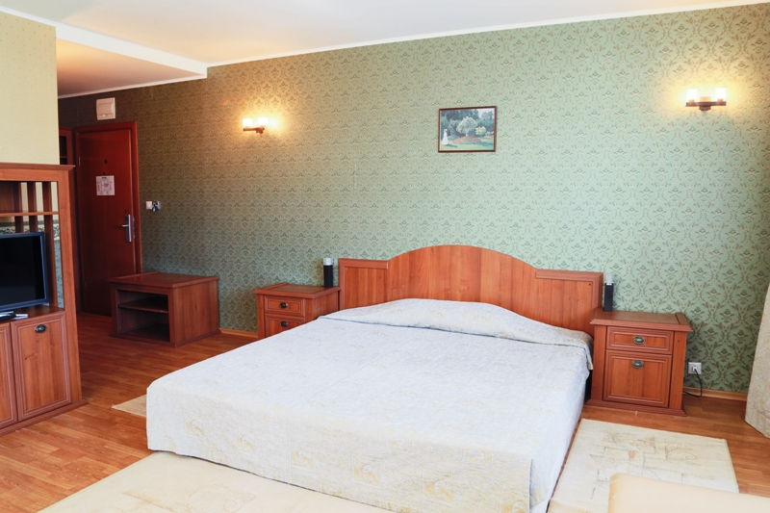

Team Entry fees: 200€ / Team
*The Entry fee includes the Party.

Transportation:
Sofia Airport
Sofia Central Railway Station
Sofia Central Bus Station
From Sofia airport, bus or railway station to the hotels – (arrival and departure): 20€/person
* Field, hotel and buses will be available for disable persons.

Water:
Water will be available on the fields free of charge.

Visa:
For all nations that will need visa permits, please make sure to apply for such as early as possible in your country of origin before leaving. If our help is needed you may contact us immediately: egpsofia_2016@abv.bg, for we could send an official invitation over to the Bulgarian Embassy for further cooperation.

Pre-payments:
Hotel booking will only be regarded valid as soon as a 50 % down payment has been received by the Organizing Committee, before 01 September’2016.
The balance of full payments is to be made, before 15 September’2016.

To contact us:
Email: egpsofia_2016@abv.bg
pavlovarchery@gmail.com
Tel / Fax: + 359 2 9300 625;
Mobile phone: + 359 886 697 615; +359 888 330105
Web address: www.archery.bg

Preliminary Entry Form

Deadline : 01 of September 2016

Member association: …………………………………………...

Club name: ………………………………………………………….

Contact name: ……………………………………………………..

Tel: ………………………….Mobile: ……………………………...

Email: ………………………………………………………………….

Men team
Club name: ………………………………………………………….

Tel: ………………………….Mobile: ……………………………...

Email: ………………………………………………………………….

Number of athletes + official(s): ……………………………

Women team
Club name: ………………………………………………………….

Tel: ………………………….Mobile:………………………………

Email: …………………………………………………………………

Number of athletes + official(s): ……………………………

I hereby declare that our Member Association is in good standing and that for all competitors and officials are covered in case of illness or accident and have signed the WA Anti-Doping Agreement.

Date : / /2016 Signature President or Secretary General:
TRANSPORTATION FORM
Return at the latest: 19 August’2016

Team: ________________________ Email: ____ _________________________
Team Manager: _______________________ Phone:_______________________________
Total number of Persons: |  | X 20 € = | Total (B): €

ARRIVAL
Plane:
Sofia Airport Flight No _________ From: _ ________
Date: ______________ Time: _____________________
Train: Train No: _________ Arriving from: ____________
Date: ______________ Time: _____________________
Car/Bus: Date: ______________ Time: _____________________

DEPARTURE
Plane:
Sofia Airport Flight No _________
Date: ______________ Time: _____________________
Train: Train No: _________
Date: ______________ Time: _____________________
Car/Bus: Date: ______________ Time: _____________________

If you are not arriving or departing in one group, please specify in the tables below.
Arrivals:
No. of persons | Flight No. /From | Date | Time
Departures:
No. of persons | Flight No. | Date | Time

Please check this box if you need facilities for persons with disabilities.

Date: _______________ President/SecretaryGeneral:___________________________
HOTEL RESERVATION FORM
Return at the latest: 19 August’2016

Team: ________________________ Email: ______________________________

Contact person: _______________________ Phone/Fax:__________________________________

ACCOMMODATION

4**** hotel  Tsarsko selo  Spa Centre | Number of Rooms | Number of Persons | Number of Nights | Cost price | Total Cost
Single Room |  |  |  | 85 € | €
Double Room |  |  |  | 65 € | €
 |  |  |  | Total (C) | €

The rates are in Euro (€) per person, per day, full board.
Please check this box if you need facilities for persons with disabilities.

We require that 50 % of the payment should be done before 01 September’2016.

Payment must be sent to the following bank account:

Bank Name: FIRST INVESTMENT BANK
International Banking Account Number (IBAN): BG13FINV91501203792590
Bank Identification Code (BIC): FINVBGSF
Bank address: 3, Narodno sabranie Sq. 1000 Sofia, Bulgaria
Bank account nominee: Bulgarian Archery Federation
NOTE:
All payments are required to be done in EURO:
- By BANK TRANSFER: 50% of total payment, before 01 September’2016
- By BANK TRANSFER: The rest of total payment (50%), before 15 September’2016
Bank transfer fees are the responsibility of the sender.
NO CREDIT CARDS, NO TRAVELLERS CHEQUES, NO FOREIGN CURRENCIES

Date: _______________ President/SecretaryGeneral:___________________________

BUDGET FORM
Return at the latest: 01September’2016

Country/Team:________________________ Email: ______________________________

Contact person: _______________________ Phone/Fax:__________________________________

 | Number | Cost | Total
Team Entry fee |  | 200 € | €
Total entry fees ( A ) |  |  | €
Transportation Total ( B ) |  | 20 € | €
Total Accommodation ( C ) |  |  | €
Grand Total ( A+B+C ) |  |  | €
Deposit 50% before 01September’2016 |  |  | €
Balance of full payments due on 15 September’2016 |  |  | €

Payment must be sent to the following bank account:
Bank Name: FIRST INVESTMENT BANK
International Banking Account Number (IBAN): BG13FINV91501203792590
Bank Identification Code (BIC): FINVBGSF
Bank address: 3, Narodno sabranie Sq. 1000 Sofia, Bulgaria
Bank account nominee: Bulgarian Archery Federation
NOTE:
All payments are required to be done in EURO:
- By BANK TRANSFER: 50% of total payment before 01 September’2016
- By BANK TRANSFER: The rest of total payment (50%), before 15 September’2016
Bank transfer fees are the responsibility of the sender.
NO CREDIT CARDS, NO TRAVELLERS CHEQUES, NO FOREIGN CURRENCIES

Date: _______________ President/SecretaryGeneral:___________________________

VISA INVITATION LETTER FORM
Return at the latest: 19 August’2016

Country/Team:________________________ Email: ______________________________

Contact person: __________________________ Phone/Fax:__________________________________

№ | Family Name | Given Name | Date of Birth  DD/MM/YY | Passport Number | Date of issue  DD/MM/YY | Validity  DD/MM/YY | Indicate Athlete, Coach or Official
1
2
3
4
5
6
7
8
9
10

Date: _______________ President/SecretaryGeneral:___________________________

FINAL ENTRY FORM

DEAD LINE: 15 September’ 2016

Email: ………………………………………………………………..

NAME OF MEMBER ASSOCIATION:…………………………………………...

Name of the Club: ……………………………………………….

Men team (surmname/given name)

1:…………………………………………………………………………

2:………………………………………………………………………….

3:………………………………………………………….………………

Officials:……………………………………………………………….

Women team (surmname/given name)

1:…………………………………………………………………………

2:………………………………………………………………………….

3:………………………………………………………….………………

Officials:……………………………………………………………….

I hereby declare that our Member Association is in good standing and that for all competitors and officials are covered in case of illness or accident and have signed the WA Anti-Doping Agreement.

Date : / /2016 Signature President or Secretary General:……………………………..

Official Hotel is “Tsarsko selo” Spa Centre

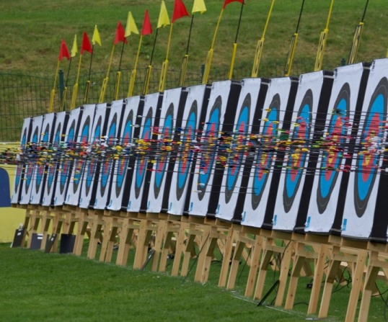 | 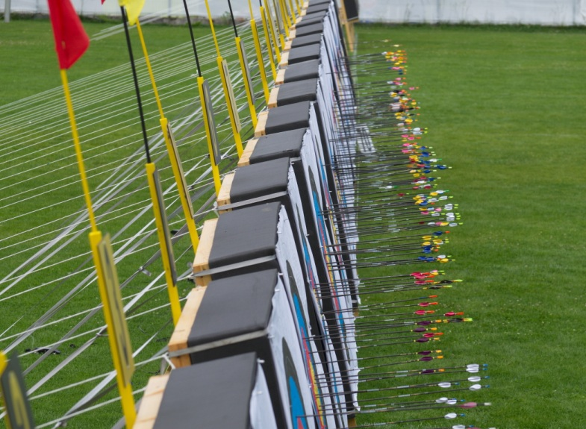
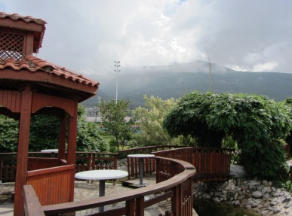 | 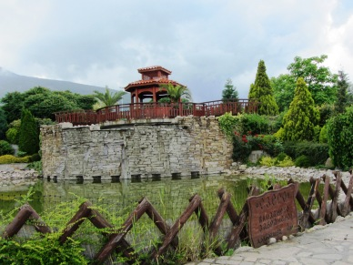
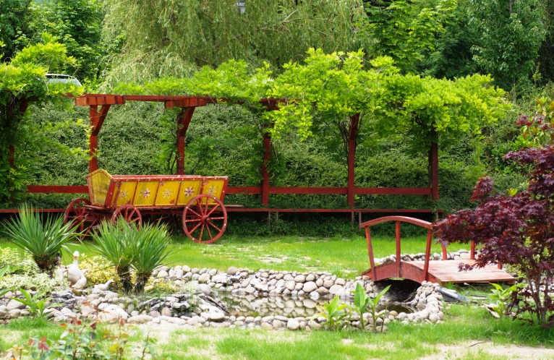 | 
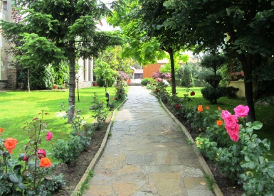 | 