……………………………………………………………………………………………………………………………………..……………………………….
INVITATION

TO ALL WORLD ARCHERY MEMBER ASSOCIATIONS

Dear President,
On behalf of the Organizing Committee and Romanian Archery Federation we are pleased to invite you to the 2020 European Youth Cup that will be held in Bucharest, Romania, 6 -11 July 2020.
This event will be organized following the WA and WAE YOUTH CUP RULES for Junior Women, Junior Men, Cadet Women and Cadet Men classes, Recurve and Compound divisions in the Outdoor Target Archery discipline.

THE PARTICIPATION IS OPEN TO ALL WORLD ARCHERY MEMBER ASSOCIATIONS.

Please, find enclosed the necessary documents concerning the registration, organization and participation in this event. To register participation, please complete all the necessary sections in WAREOS within the deadlines listed below:

Registration Opening Date - online WAREOS 01 March 2020
Preliminary Entries Deadline 07 April 2020
Preliminary Hotel reservation and payment 05 May 2020
Final Entries Deadline 16 June 2020
Final Hotel reservation 05 June 2020
Transportation 15 June 2020
Final Payment 15 June 2020
Visa Application 01 June 2020

We are looking forward to welcoming you and we are sure you will enjoy your stay in Bucharest.

Yours sincerely,
Zoltan Miklos  Competition Manager | President of Romanian Archery Federation  Mugurel Virgil Ciusca

LOC E-mail: eyc2020@frta.ro | Secretary General  Ion Pandele

...........................................................................................................................................................................
PRELIMINARY PROGRAMME

Saturday 04 July 2020 Arrival of Delegations
Unofficial Practice

Sunday 05 July 2020 Arrival of Delegations
Unofficial Practice
Team Registration

Monday 06 July 2020 Official practice and Equipment inspection
Team Managers' Meeting at the RIN Hotel
Opening Ceremony

Tuesday 07 July 2020 Qualification round CADETS
Qualification round JUNIORS

Wednesday 08 July 2020 Mixed Teams

Thursday 09 July 2020 Individual Eliminations – up to Semi-finals

Friday 10 July 2020 Team Eliminations and Finals
Team & Mixed Team Awarding

Saturday 11 July 2020 Individual Finals
Award Ceremony/Closing Ceremony
Disco party

Sunday 12 July 2020 Departure of Delegations

Note: This preliminary program is subject to change according to the number of participants and special requirements. All changes will be published and distributed in good time.

Website: http://eyc2020.frta.ro

...........................................................................................................................................................................
PRELIMINARY & FINAL REGISTRATION

No entry forms will be available for registering for this event. The registration process should be done using the World Archery Online Registration System (WAREOS).

The number of athletes that July be entered by a Member Association is limited to six (6) in each category.

All World Archery MA’s are eligible to compete in European Youth Cup competitions, but only the results of the athletes from WORLD ARCHERY EUROPE MA’s will be taken in consideration for the Youth Cup Circuit.

In order to use WAREOS, please login on http://register.worldarchery.org with your Username and Password assigned by World Archery. For any questions regarding the WAREOS, please contact the World Archery office, Ms. Cecile Tosetti (ctosetti@archery.sport).
Starting date of online-registration with WAREOS is: | 01 March 2020
End of Preliminary registration: | 07 April 2020
End of Final registration: | 16 June 2020

Please respect the stated deadlines.

Member Associations should only use WAREOS to make any changes/amendments to their entries and will be able to do so at any time. Any changes made in WAREOS an email will instantly be automatically sent to the Organizing Committee and Member Association with the updated information.

However, any changes that are made after the deadlines specified or if entries differ by more than 4 athletes from the preliminary entries, the following penalty fees will automatically be applied:
Penalty fees to be paid to Organizing Committee: | Cost (EURO):
Entries made after the preliminary and/or final entry deadline date. | 45 per entry
If final entries differ from the preliminary entries by more than 4 athletes/officials. | 140 per entry
Failure to have made preliminary entries before the deadline date but then have submitted final entries. | 140 per entry

Any entries received less than 3 days before the team managers meeting will be refused if no preliminary entry and/or final entry are made prior.

As a final note, only Member Associations in good standing will be eligible to compete. This means that World Archery fee must have been paid prior the participation.
...........................................................................................................................................................................

ACCOMMODATION & GENERAL INFORMATION

The official hotel is 4* stars category RIN GRAND HOTEL in Bucharest.
The room rate:
- is per person per night,
- include full board accommodation, taxes and VAT
- include free parking in front of the hotel for cars, with exception to Minivans and Buses*
  - Minivans: 10 euro / day -- to be paid at accreditation
  - Buses: 15 euro / day -- to be paid at accreditation
- internet in the hotel lobby and rooms

HOTEL | Category | Single room  Price per person per night - full board | Double room  Price per person per night - full board
RIN Grand Hotel | 4* Room | € 140 | € 100
RIN Grand Hotel | 3* Room | € 130 | € 90

Lunch during the competition days will be served at the Hotel.
RIN Grand Hotel @ Șoseaua Vitan - Barzești 7D, 042121 Bucharest, Romania
Coordinates: Latitude: 44.398919 | Longitude: 26.143583



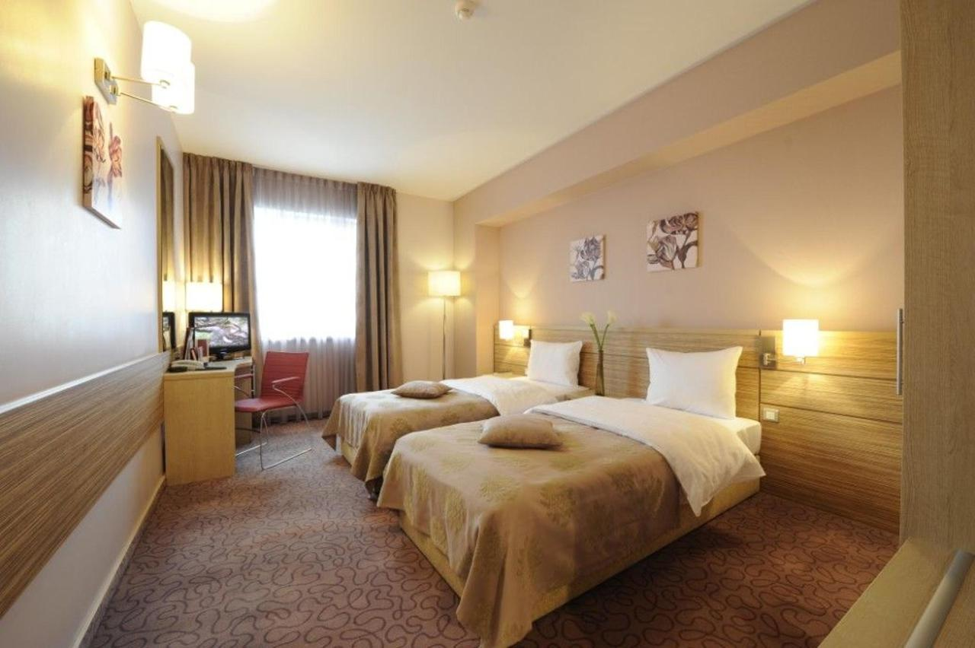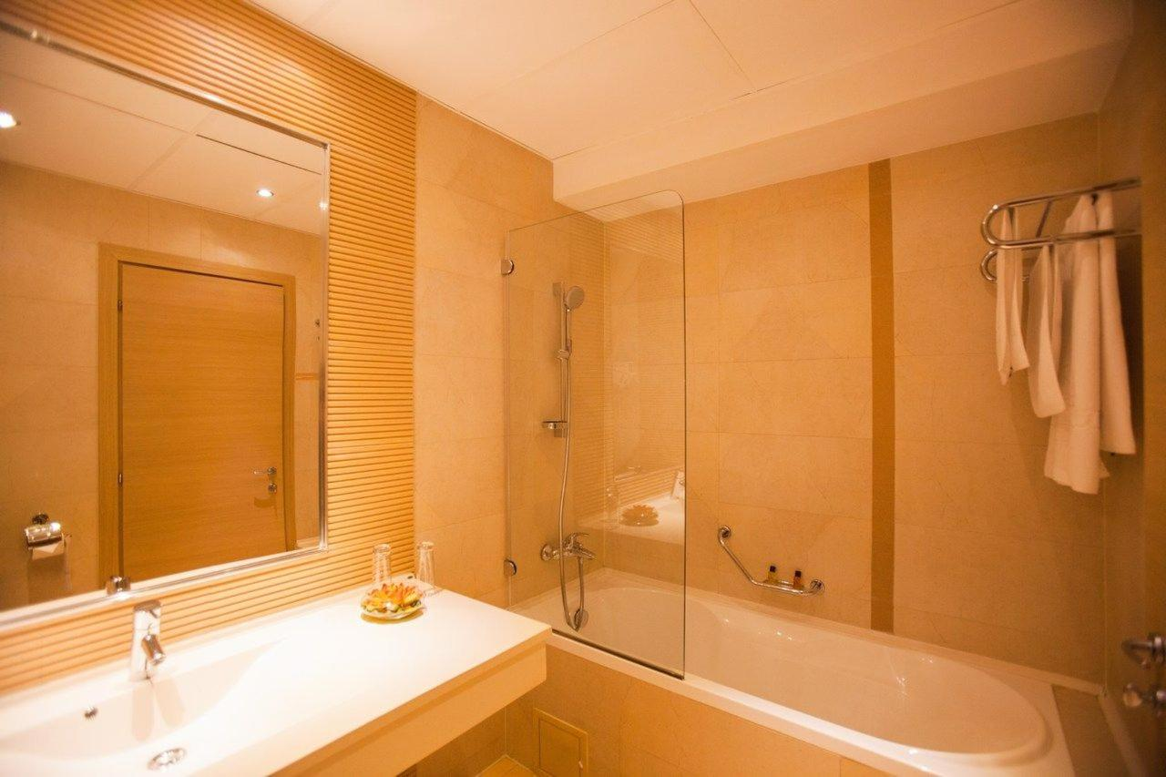

RIN GRAND HOTEL Șoseaua Vitan-Bârzești 7D, 042121 Bucharest, Romania
Coordinates: Latitude: 44.398919 | Longitude: 26.143583

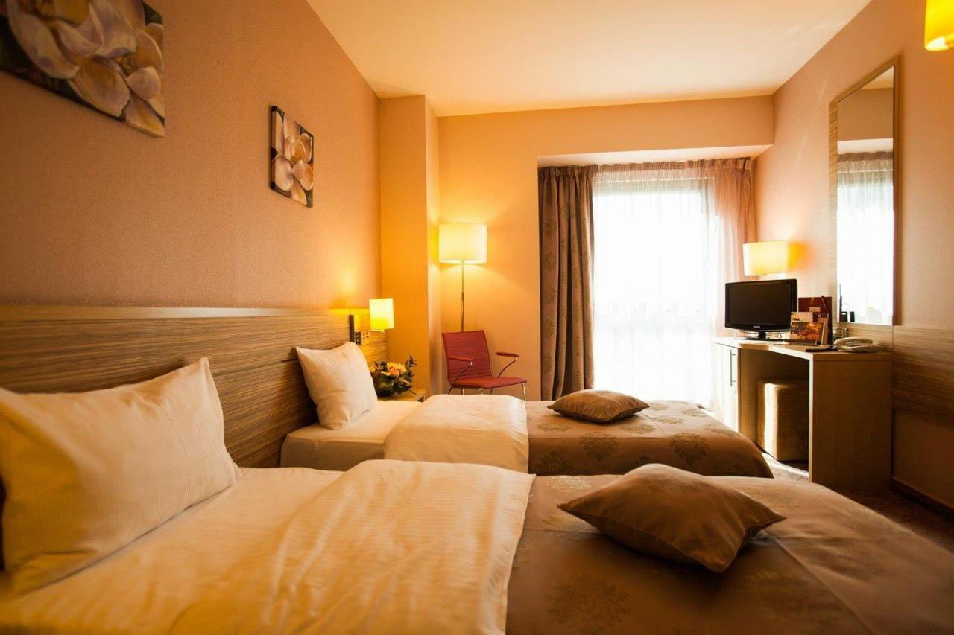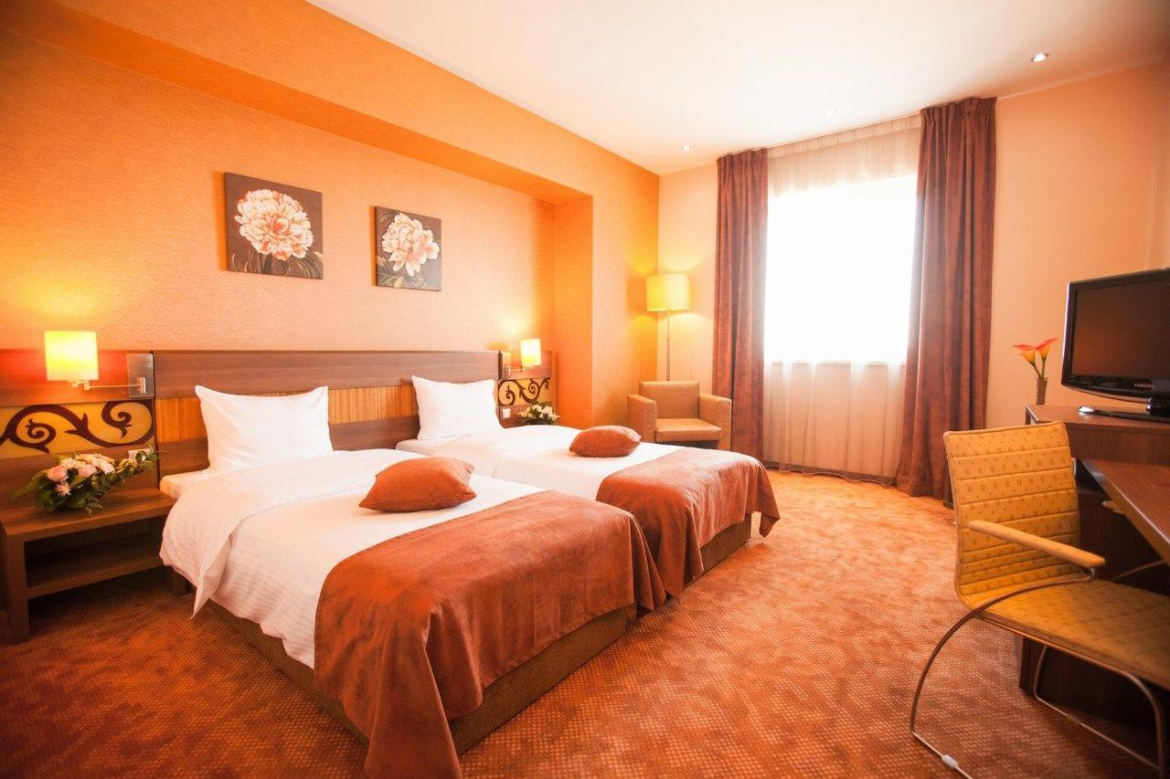
...........................................................................................................................................................................

Reservations should be made before 05 May 2020.
To confirm the reservation, a 60% deposit of the total amount is required to be bank transferred to the OC before 05 May 2020. Reservations after this date will be considered only according to availability, the room rate can change and we cannot guarantee rooms in the official hotel.

...........................................................................................................................................................................

Final Hotel Reservations and remaining payment should be made before 5th June 2020.

Note: Please ensure that you complete all the necessary forms by the specified dates and make full payment for the accommodation at the time of booking. See detailed payment instructions below.

Participants who book their accommodation in non official hotels will need to pay a entry fee of
300,00 € for each athlete to the LOC. It will not be possible to distribute any information at the non-official hotels.

ADDITIONAL INFORMATION

Entry fees:
Individual: 85 € per athlete
Officials: Free
Teams: Free

Transportation fees from/to the airports:
The OC will collect the teams from the Bucharest (OTOPENI) International Airport. You have to pay the transportation fee /including arrival and departure/ as follows:
Bucharest (OTOPENI) International Airport – RIN Grand Hotel 37 km 26 € per person

The last date for the payment of the Transportation fee is 15 June 2020.

From the airport to the hotel / return trip, the LOC will use buses, small buses, vans and cars, what will depend of number of persons scheduled for transportation.
Transportation from the airport will start two days before the official practice day and will end one day after the closing day.

Cancellations & Changes:
Following conditions will apply:
- cancellation received before the final entry: full refund of the paid deposit
- cancellation received after the final entry: no refunds

All rates for payments after deadlines are subject to additional charges without prior notice.
All refunds, if any, will be processed after the event.

...........................................................................................................................................................................
OC has to be informed about changes in the travel program 72 hour’s prior arrivals. If your arrival is later then your original schedule, the room charges are starting from the original date indicated by the Member Association.

Lunch Meals:
Lunch during the competition days of 06-11 July will be served at the Hotel.

Drinking water will be available at lunch and at dinner and on the competition field free of charge.
All other costs made in cafeteria at the archery venue or in the hotel /snacks, drinks, small meals/ are not included in the entry fee and must be paid on consumptions.

Please inform us if you have special requirements for food and specify it.

Accreditation and Team Managers Meeting
Accreditation will take place upon arrival of teams in the lobby of the RIN Grand Hotel 5th of July 2020. Accreditation office will be open on Sunday 5th of July from 08:00 - 21:00.

For all Ceremonies WA dress code is obligatory.
More details will be provided at the Team Manager’s Meeting.
Team Managers Meeting will be held in the conference room of the RIN Grand Hotel / the conference room on Monday, 06 July 2020.

Competition Field: Latitude: 44.409707 | Longitude: 26.135288
For European Youth Cup 2nd Edition the Olympia Rugby field will be used.
The Competition Venue is 2 km distance from RIN Grand Hotel.

Training Field (unofficial practice): Latitude: 44.409358 | Longitude: 26.136248
The unofficial practice will be available during period 4th & 5th July 2020 right beside to main Venue (Rugby Stadium Olympia).
The Training Field – RIN Grand Hotel distance is 2km.

Visas
All participants who need an entry visa to Romania, will be required to complete the Visa Support Form in WAREOS by no later than 1 June 2020.

It is the applicants’ responsibility for supplying the necessary information, ensuring all details are up to date, correct and submitted by the deadlines specified.

In addition, all participants that require a visa are kindly requested to supply a copy of their latest/valid passport. Copies of each applicant can be uploaded on WAREOS. All passport copies and personal details entered/uploaded to WAREOS will be held securely and in the strictest of confidence and not shared with other parties.

Please note that the Organizing Committee can provide invitation for the period of the European Youth Cup in Bucharest only.
...........................................................................................................................................................................

As long as the Organizing Committee gets no different information, the Invitation Letter will be sent by email. If an express service should be desired, this service will be charged to the MA and must be paid to the Organizing Committee upon arrival.

Please note: the deadline for Visa Invitation Letter Form is 1st June 2020.

Disco Party
On the final day - Saturday, 11 July 2020, after the dinner the Disco party will be organized with the cost of 10 euro / person.
The soft-drinks and cakes are included in the cost for Disco party.
The Disco party payment has to be paid during accreditation.

Internet
Free of charge in all locations of RIN Grand Hotel.
Website
The official website of the competition is http://eyc2020.frta.ro

...........................................................................................................................................................................

PAYMENT INSTRUCTIONS

BANK: Banca Comerciala Romana
Address: Str. Lipscani Nr. 18-20, Sector 2, Bucharest, Romania

A/C NAME Romanian Archery Federation
Fiscal code: 4204135
Address: Str. Vasile Conta, Nr. 16, Sector 2, Bucharest, Romania

SWIFT CODE: RNCBROBU
IBAN: RO46 RNCB 0090 0005 0853 0017

NOTE:
ALL PAYMENTS ARE REQUIRED TO BE DONE IN EUROS BY BANK TRANSFER LATEST 15 JUNE 2020 !
ALL BANK TRANSFER FEES HAVE TO BE PAID BY PARTICIPATING MA’s, you need to state OUR option when paying.
IN CASE OF NOT PAYING THE BANK TRANSFER FEES, YOU WILL BE CHARGED FOR THE DIFFERENCE UPON ARRIVAL, AT THE ACCREDITATION.

- NO CREDIT CARDS
- NO TRAVEL CHECKS

IN CASE YOU WILL BRING CASH, YOU WILL BE CHARGED FOR EXTRA BANK COSTS FOR DEPOSIT,
1% OF THE DEPOSIT.

PLEASE SEND THE COPY OF THE BANK TRANSFER TO THE ORGANIZER by email to:
eyc2020.frta.ro

LOC contacts

For all matters:
Ms Stefania Ficleanu - 24 hours English
Mobile +40 741 211 177
E-mail: eyc2020@frta.ro


For questions about visa support
Ghenadi Iepuri - 24 hours English
Mobile +40 757 077 608
E-mail: eyc2020@frta.ro

INFORMATION ABOUT BUCHAREST

Bucharest is the primary entry point into Romania. Bucharest is a booming city with many large infrastructure projects changing the old face of the city. Known in the past as "The Little Paris," Bucharest has changed a lot lately, and today it has become a very interesting mix of old and new that has little to do with its initial reputation.

Finding a 300 year old church near a steel-and-glass building that both sit next to a communist style building is commonplace in Bucharest. Bucharest offers some excellent attractions, and has, in recent years, cultivated a sophisticated, trendy, and modern sensibility that many have come to expect from a European capital.

Those who knew Bucharest in the past but have not visited it after 2010 will be surprised by the scale of the changes that are taking place. Ambitious projects are quite common in Bucharest.
The largest project finished at this time is the impressive Basarab Bridge, which is Europe's widest cable-stayed bridge.

