INVITATION

TO ALL WORLD ARCHERY MEMBER ASSOCIATIONS

Dear President,
On behalf of the Organizing Committee and Romanian Archery Federation we are pleased to invite you to the 2021 European Youth Cup 2nd Leg that will be held in Bucharest, Romania, 2 – 7 August 2021.
This event will be organised following the WA rules and WAE YOUTH CUP RULES for Junior Women, Junior Men, Cadet Women and Cadet Men classes, Recurve and Compound divisions in the Outdoor Target Archery discipline.

This European Youth Cup in Bucharest is a very good opportunity for the final preparation for World Youth Outdoor Championships in Wroclaw, Poland, just 2 days prior to World Archery Youth Championships 2021.

THE PARTICIPATION IS OPEN TO ALL WORLD ARCHERY MEMBER ASSOCIATIONS.

Please, find enclosed the necessary documents concerning the registration, organization and participation in this event. To register participation, please complete all the necessary sections in WAREOS within the deadlines listed below:

Registration Opening Date - online WAREOS 30 April 2021
Preliminary Entries Deadline 17 June 2021
Preliminary Hotel reservation and payment 17 June 2021
Final Entries Deadline 13 July 2021
Final Hotel reservation 13 July 2021
Transportation 13 July 2021
Final Payment 13 July 2021
Visa Application 17 June 2021

We are looking forward to welcoming you and we are sure you will enjoy your stay in Bucharest.

Yours sincerely,
Zoltan Miklos  Competition Manager | Vice-President of Romanian Archery Federation  Adrian Poeana

Cornel Milan Project Manager | LOC E-mail: oc-bucharest@frta.ro  Info: +40 733 735 444 Cornel Milan

PRELIMINARY PROGRAMME

Saturday 31 July 2021 Arrival of Delegations
Unofficial Practice

Sunday 1 August 2021 Arrival of Delegations
Unofficial Practice
Team Registration

Monday 2 August 2021 Official practice and Equipment inspection
Team Managers' Meeting at the RIN Grand Hotel,
Bucharest Opening Ceremony

Tuesday 3 August 2021 Qualification round CADETS
Qualification round JUNIORS

Wednesday 4 August 2021 Mixed Teams

Thursday 5 August 2021 Individual Eliminations – up to Semifinals

Friday 6 August 2019 Team Eliminations and Finals
Team & Mixed Team Awarding

Saturday 7 August 2021 Individual Finals
Award Ceremony/Closing Ceremony
Disco party * (subject to restrictions)

Sunday 8 August 2021 Departure of Delegations

Note: This preliminary program is subject to changes according to the number of participants and the special requirements due to Covid-19. Although the future conditions regarding the pandemic are unknown, we hope to run the event without big restrictions. However, all requirements of the Ministry of Health and National institute of Public Health will be followed.
All changes and necessary information will be published and distributed in good time.

Website: http://www.archeryeurope.org

PRELIMINARY & FINAL REGISTRATION

No entry forms will be available for registering for this event. The registration process should be done using the World Archery Online Registration System (WAREOS).

The number of athletes that may be entered by a Member Association is limited to six (6) in each category.

All World Archery MA’s are eligible to compete in European Youth Cup competitions, but only the results of the athletes from WORLD ARCHERY EUROPE MA’s will be taken in consideration for the Youth Cup Circuit.

In order to use WAREOS, please login on https://extranet.worldarchery.sport/with your Username and Password assigned by World Archery. For any questions regarding the WAREOS, please contact the World Archery office, Ms Cecile Tosetti (ctosetti@archey.sport).

Starting date of online-registration with WAREOS is: | 30 April 2021
End of Preliminary registration: | 17 June 2021
End of Final registration: | 13 July 2021

Please respect the stated deadlines.

Member Associations should only use WAREOS to make any changes/amendments to their entries and will be able to do so at any time. Any changes made in WAREOS an email will instantly be automatically sent to the Organizing Committee and Member Association with the updated information.

However, any changes that are made after the deadlines specified or if entries differ by more than 4 participants from the preliminary entries, the following penalty fees will automatically be applied:

Penalty fees to be paid to Organizing Committee: | Cost (EURO):
Entries made after the final entry deadline date. | 45 per entry

Any entries received less than 3 days before the team managers meeting will be refused if no preliminary entry and/or final entry are made prior.

As a final note, only Member Associations in good standing will be eligible to compete. This means that World Archery fee must have been paid prior the participation.

ACCOMMODATION & GENERAL INFORMATION

The official hotel with rooms of 4* and 3* stars category in RIN GRAND HOTEL in Bucharest.
The room rate:
- is per room per night,
- include full board accommodation, taxes and VAT
- include free parking in front of the hotel for cars, with exception to Minivans and Buses*
  - Minivans: 10 euro / day -- to be paid at accreditation
  - Buses: 15 euro / day -- to be paid at accreditation
- internet in the hotel lobby and rooms

HOTEL | Category | Single room  Matrimonial Bed  Price per room per night - full board | Double room  Twin Beds  Price per room per night - full board | Triple room  Price per room per night - full board
RIN Grand Hotel | 4 **** | € 140 | € 200 | € 270
RIN Grand Hotel | 3 *** | X | € 180 | X

Lunch during the competition days will be served at the Hotel.
RIN Grand Hotel @ Șoseaua Vitan - Bârzești 7D, 042121 Bucharest, Romania
Coordinates: Latitude: 44.398894 | Longitude: 26.143517

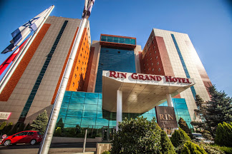 | 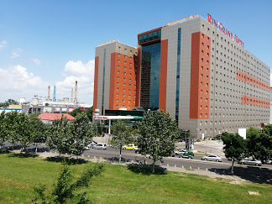

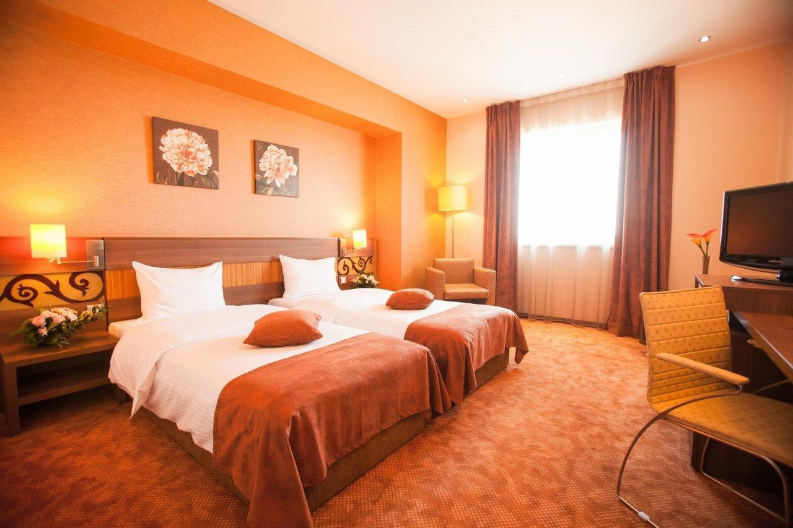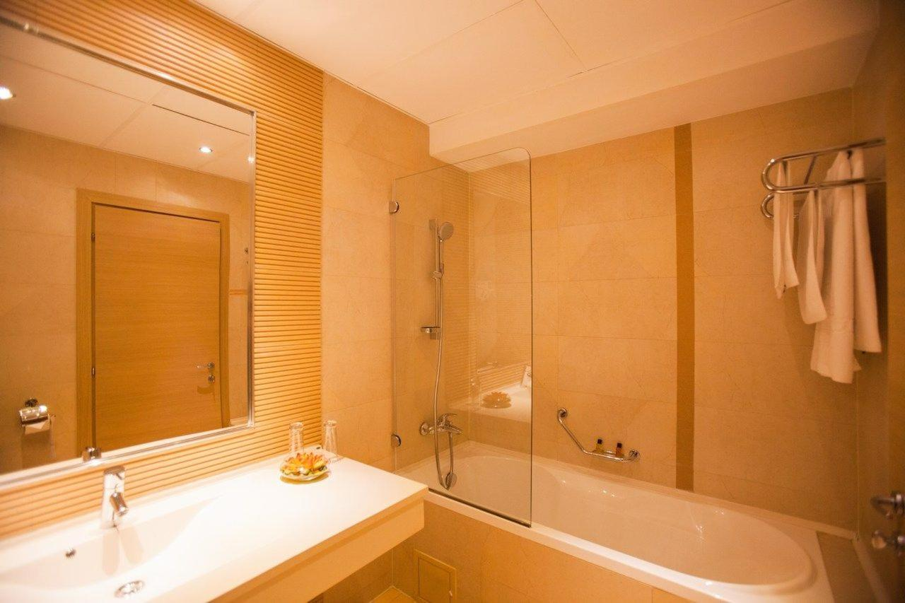

RIN GRAND HOTEL Șoseaua Vitan-Bârzești 7D, 042121 Bucharest, Romania
Coordinates: Latitude: 44.398894 | Longitude: 26.143517

Reservations should be made before 17 June 2021.
To confirm the reservation, a 60% deposit of the total amount is required to be bank transferred to the OC before 17 June 2021. Reservations after this date will be considered only according to availability, the room rate can change and we cannot guarantee rooms in the official hotel.

Final Hotel Reservations and remaining payment should be made before 13 July 2021.

Note: Please ensure that you complete all the necessary forms by the specified dates and make full payment for the accommodation at the time of booking. See detailed payment instructions below.

Participants who book their accommodation in non-official hotels will need to pay an entry fee of 300,00 € for each athlete and officials to the LOC. It will not be possible to distribute any information at the non-official hotels.

ADDITIONAL INFORMATION

Entry fees:
Individual: 85 € per athlete
Officials: Free
Teams: Free

Transportation fees from/to the airports:
The OC will collect the teams from the Bucharest (OTOPENI) International Airport.
You have to pay the transportation fee /including arrival and departure/ as follows:
Bucharest (OTOPENI) International Airport – RIN Grand Hotel distance is 37 km that costs of
26 € per person / round trip.

The last date for the payment of the Transportation fee is 13 July 2021.

From the airport to the hotel / return trip, the organiser will use buses, small buses, vans and cars, what will depend of number of persons scheduled for transportation /.
Transportation from the airport will start two days before the official practice day and will end one day after the closing day.

Cancellations & Changes:

Following conditions will apply:
- cancellation received before the final entry: full refund of the paid deposit
- cancellation received after the final entry: no refunds

All rates for payments after deadlines are subject to additional charges without prior notice.
All refunds, if any, will be processed after the event.

OC has to be informed about changes in the travel programme 72 hours prior arrival. If your arrival is later then your original schedule, the room charges are starting from the original date indicated by the Member Association.

Meals at the venue:
Lunch will be served in the restaurant of the hotel.

Drinking water will be available at lunch and at dinner and on the competition field free of charge. All other costs made in cafeteria at the archery venue or in the hotel /snacks, drinks, small meals/ are not included in the entry fee and must be paid on consumptions.
Please inform us if you have special requirements for food and specify it.

Accreditation and Team Managers Meeting:
Accreditation will take place upon arrival of teams in the lobby of the RIN Grand Hotel at 1st of August 2021.
Accreditation office will be open on Sunday 01 August from 08:00 - 21:00.
Accreditation cards will be possible to issue from Monday 2nd of August on the competition area only with the additional payment of 50 € per person.

For all Ceremonies WA dress code is obligatory.
More details will be provided at the Team Manager’s Meeting.
Team Managers Meeting will be held in the conference room of the RIN Grand Hotel / the conference room on Monday, 2nd of August 2021.

Competition Field: Latitude: 44.41090672596869, | Longitude: 26.041428417505728
For European Youth Cup 2nd Edition the Ghencea Stadium facility field will be used.
The Competition Venue is 10,9 km distance from RIN Grand Hotel.

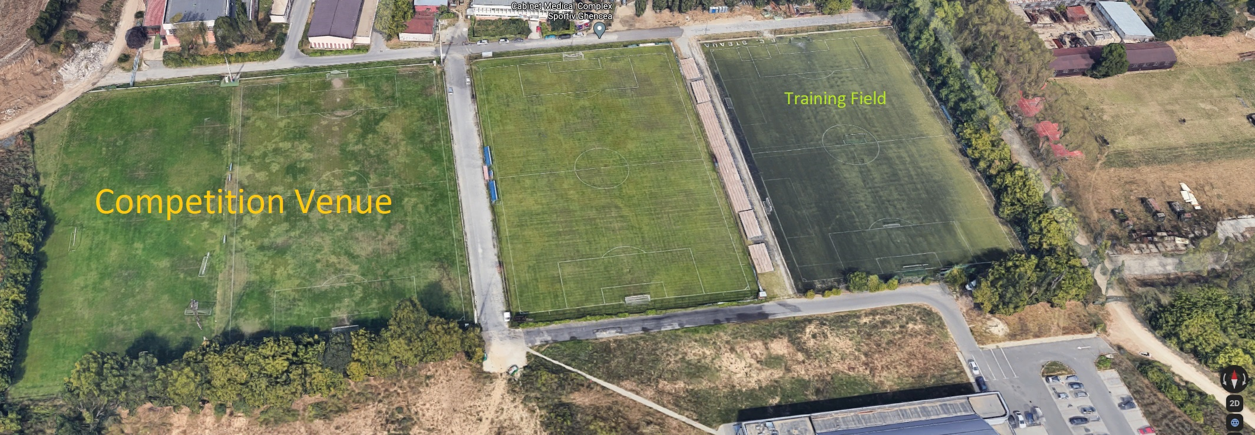

Training Field (unofficial practice): Latitude: 44.4118762178558 | Longitude: 26.0447168057139
The Training Field will be available during period of 31 July - 6 August 2021 that is 70 meters away of the main Competition Venue.
The Training Field – RIN Grand Hotel distance is 10,9 km.

The Pre-WROCLAW 2021 WORLD ARCHERY YOUTH CHAMPIONSHIPS information:
All Members Associates that willing to book extra days of accommodations as well transportation service and practice conditions for teams should send the official letters respectively via email:
office@frta.ro
The extra days of fullboard accommodation costs remain the same as stated in Invitation Package initially, please refer to the ACCOMMODATION & GENERAL INFORMATION.

The Pre-WROCLAW transportation service / hotel – practice field – hotel / cost is 10 € per person.

The Pre-WROCLAW Practice field: Latitude: 44.40955447 | Longitude: 26.13673478
This training field will be available during period of 7-8 August 2021 nearest Rugby Stadium Olympia. The Training Field -- RIN Grand Hotel distance is 2 km.

The deadline for Pre-WROCLAW inquiries is: 13 July, 2021

Visas
All participants who need an entry visa to Romania, will be required to complete the Visa Support Form in WAREOS by no later than 17 June 2021.

It is the applicants’ responsibility for supplying the necessary information, ensuring all details are up to date, correct and submitted by the deadlines specified.

In addition, all participants that require a visa are kindly requested to supply a copy of their latest/valid passport. Copies of each applicant can be uploaded on WAREOS. All passport copies and personal details entered/uploaded to WAREOS will be held securely and in the strictest of confidence and not shared with other parties.

Please note that the Organizing Committee can provide invitation for the period of the European Youth Cup in Bucharest only.

As long as the Organizing Committee gets no different information, the Invitation Letter will be sent by email. If an express service should be desired, this service will be charged to the MA and must be paid to the Organizing Committee upon arrival.

Please note: the deadline for Visa Invitation Letter Form is 17 June 2021.

Disco Party*
On the final day - Saturday, 7th August 2021, after the dinner the Disco party will be organized with the cost of 10 euro / person, if possible due to the special requirements due to Covid-19.
The drinks and cakes are included in the cost for Disco party.
The Disco party payment has to be paid during accreditation.

Internet
Free of charge in all locations of RIN Grand Hotel.

Website
The official website of the competition is http://www.archeryeurope.org

PAYMENT INSTRUCTIONS

BANK: Banca Comerciala Romana
Address: Str. Lipscani Nr. 18-20, Sector 2, Bucharest, Romania

A/C NAME Romanian Archery Federation
Fiscal code: 4204135
Address: Str. Vasile Conta, Nr. 16, Sector 2, Bucharest, Romania
Zip Code: 020951

SWIFT CODE: RNCBROBU
IBAN: RO46 RNCB 0090 0005 0853 0017

NOTE:
ALL PAYMENTS ARE REQUIRED TO BE DONE IN EUROS BY BANK TRANSFER LATEST 13 July 2021 !
ALL BANK TRANSFER FEES HAVE TO BE PAID BY PARTICIPATING MA’s, you need to state OUR option when paying.
IN CASE OF NOT PAYING THE BANK TRANSFER FEES, YOU WILL BE CHARGED FOR THE DIFFERENCE UPON ARRIVAL, AT THE ACCREDITATION.

- NO CREDIT CARDS
- NO TRAVEL CHECKS

IN CASE YOU WILL BRING CASH, YOU WILL BE CHARGED FOR EXTRA BANK COSTS FOR DEPOSIT, 1% OF THE DEPOSIT.

PLEASE SEND THE COPY OF THE BANK TRANSFER TO THE ORGANIZER by email to:
oc-bucharest@frta.ro

LOC contacts
For all matters:  Ms Stefania Ficleanu,  Registration Manager, 24 hours English  Mobile + 40 741 211 177  E-mail: oc-bucharest@frta.ro  For questions about visa support:  Mr Ghenadi Iepuri, 24 hours English  Mobile +40 757 077 608  E-mail: oc-bucharest@frta.ro  INFORMATION ABOUT BUCHAREST  Bucharest is the primary entry point into Romania. Bucharest is a booming city with many large infrastructure projects changing the old face of the city. Known in the past as "The Little Paris," Bucharest has changed a lot lately, and today it has become a very interesting mix of old and new that has little to do with its initial reputation.  Finding a 300 year old church near a steel-and-glass building that both sit next to a communist style building is commonplace in Bucharest. Bucharest offers some excellent attractions, and has, in recent years, cultivated a sophisticated, trendy, and modern sensibility that many have come to expect from a European capital.  Those who knew Bucharest in the past but have not visited it after 2010 will be surprised by the scale of the changes that are taking place. Ambitious projects are quite common in Bucharest.  The largest project finished at this time is the impressive Basarab Bridge, which is Europe's widest cable-stayed bridge. | 

