To All World Archery Europe Member Associations

Dear President,

on behalf of the Organizing Committee (OC), we would like to invite your country to the 2022 European Outdoor Championships + European Games CQT, which will be held from June 6 -June 12, 2022 in Munich, Germany.

The World Archery Europe Congress will be held in Munich June 5th, there will be a separate invitation for this.

We are looking forward to welcoming you in Munich.

Sincerely yours,

Hans-Heinrich von Schönfels
President of the
Organizing Committee

Important Dates:

Please find enclosed detailed information regarding this event. To register participation, please complete all the necessary sections in WAREOS (https://extranet.worldarchery.sport) within the deadlines listed below.

Summary of deadlines:
- Preliminary Entries 07/03/2022
- Preliminary Hotel Reservation 06/04/2022
- Final Hotel Reservation 20/04/2022
- 80% Deposit Hotel Payment 06/05/2022
- Final Rooming 06/05/2022
- Final Transportation 06/05/2022
- Final Entries 17/05/2022
- Visa Support 17/05/2022
- Remaining Payments (Entries/Transportation/Hotel) 17/05/2022

PRELIMINARY PROGRAMME:

05/06/2022  Sunday | Arrival of participants  Practice Field and Local Transportation available  WAE Congress
06/06/2022  Monday | Official Practice and Equipment Inspection  Team Manager’s Meeting and Opening Ceremony
07/06/2022  Tuesday | Qualification Rounds  Recurve and Compound
08/06/2022  Wednesday | Individual Eliminations  Mixed Team Eliminations  Recurve and Compound
09/06/2022  Thursday | Individual Eliminations  Mixed Team Eliminations  Recurve and Compound
10/06/2022  Friday | Qualifier European Games 2023
11/0672022  Saturday | Compound Finals
12/06/2022  Sunday | Recurve Finals
13/06/2022  Monday | Departures

NOTE:
This preliminary program is subject to change according to the number of participants and special requirements. All changes will be published and distributed in good time.

PRELIMINARY & FINAL REGISTRATION
All entries, accommodation reservations, transport needs, flight arrival/departure information and visa invitation letter requests are to be completed using the World Archery Online Registration System WAREOS https://extranet.worldarchery.sport. This system handles the entire registration process for this event. No entry forms, hotel reservations or transportation forms will be accepted; all information must be entered into WAREOS.

Member Associations can login to WAREOS at https://extranet.worldarchery.sport with the username and password assigned by World Archery. After entering WAREOS, selecting the event from the list will allow a member association to register their athletes. Select/press the “Entries” button to see the list of categories in the event. Select/press the “category” to enter the athlete and official numbers/details participating for that event. A WAREOS User Manual can be downloaded in PDF format (English) upon login.

Contact wareos@archery.sport with any questions regarding technical problems on WAREOS. For any question regarding the organization of the event (transport, accommodation, meals, invoices, visa etc.) please contact directly the LOC.

A maximum number of three (3) athletes per country can be registered into each category and divisions of the event.

Any changes that are made after the deadlines specified or if entries differ by more than 4 athletes from the preliminary entries, the following penalty fees will automatically be applied:
Penalty fees to be paid to Organizing Committee: | Cost (EURO):
Entries made after the preliminary and/or final entry deadline date. | 45 per entry
If final entries differ from the preliminary entries by more than 4 athletes/officials. | 140 per entry
Failure to have made preliminary entries before the deadline date but then have submitted final entries. | 140 per entry

Any entries received less than 3 days before the team managers’ meeting will be refused if no preliminary entry and/or final entry are made prior.

As a final note, only Member Associations in good standing will be eligible to compete. This means that World Archery fee must have been paid prior the participation.
ACCOMMODATION & GENERAL INFORMATION
All room rates are calculated per night including full board (Breakfast, lunch and dinner). Please note that lunch will be served at the competition venue.
All room rates include the current German VAT. Please note that in case of an increase, we must increase the room rates as well.

It is mandatory to choose the official hotel listed by the Local Organizing Committee. A delegation choosing a non-official hotel will not be allowed to participate in the Championships.

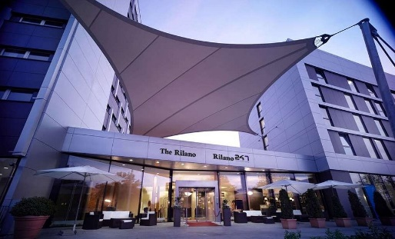
The Rilano Hotel Munich ****

https://www.rilano-hotel-muenchen.de/

EUR 167 / single incl. breakfast
EUR 252 / double incl. breakfast

This preferred hotel in Munich Schwabing is a 4-star hotel that is combined with many facilities for shopping, dining and relaxing. The hotel offers 150 modern rooms, all well equipped with direct dial telephone, mini bar, TV and internet access. Most are air conditioned. A subway station is about 5 minutes away from the hotel. From there you can reach the city center in about 15 minutes. The hotel restaurant offers international and regional dishes. Distances: 15 minutes' drive from the qualification venue and 20 minutes' drive from the final venue.

Rilano 24/7 Hotel Munich ***
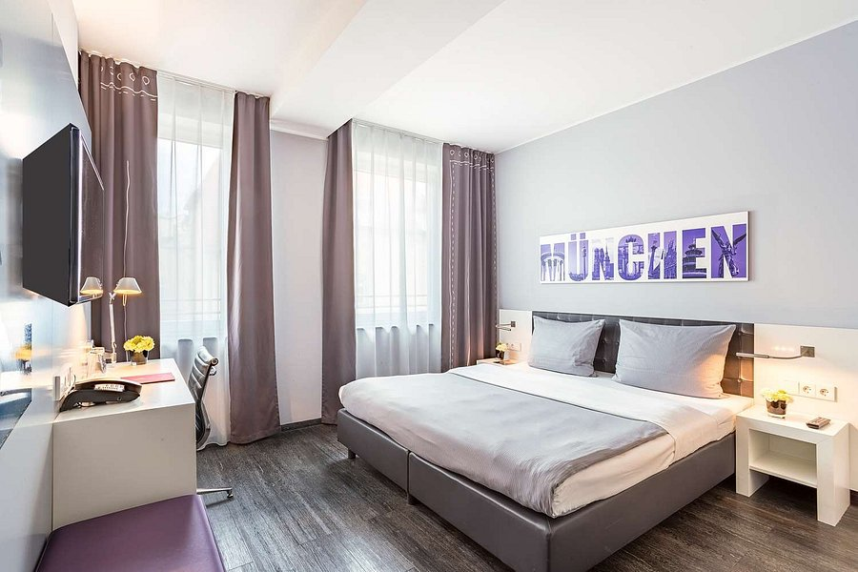
https://www.rilano-247-hotel-muenchen-schwabing.de/

EUR 147 / single incl. breakfast
EUR 238 / double incl. breakfast

Tourist class hotel in Munich-Schwabing in a central location, with a total of 230 rooms, all of them with bath/shower, toilet, SAT- TV, telephone and analog or DSL high-speed internet-access. The hotel offers a bar and a restaurant with international and regional dishes. A subway station is about 5 minutes away from the hotel. From here you can reach the city center in about 15 minutes. Buffet breakfast is included. Distances: 15 minutes' drive from the qualification venue and 20 minutes' drive from the final venue.

Holiday Inn City Centre ****
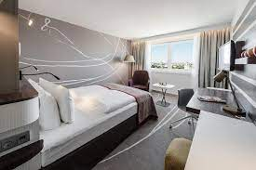
https://holiday-inn-city-centre-munich.hotel-ds.com/de/

EUR 179 / single incl. breakfast
EUR 266 / double incl. breakfast

The hotel has 580 rooms that are equipped with bath tub, hair dryer, minibar, radio, TV, self-dial telephone including voicemail and fax modem for internet access. For dinner the hotel offers three different restaurants. There is direct access within the same building complex to Munich's underground system at the "Rosenheimer Platz" station that guarantees rapid and direct transit to the Central Station, the Munich International Airport and the new Trade Fair Grounds. Buffet breakfast is included.
Distances: 20 minutes' drive from the qualification venue and 12 minutes' drive from the final venue.

Leonardo Munich City Olympiapark ****
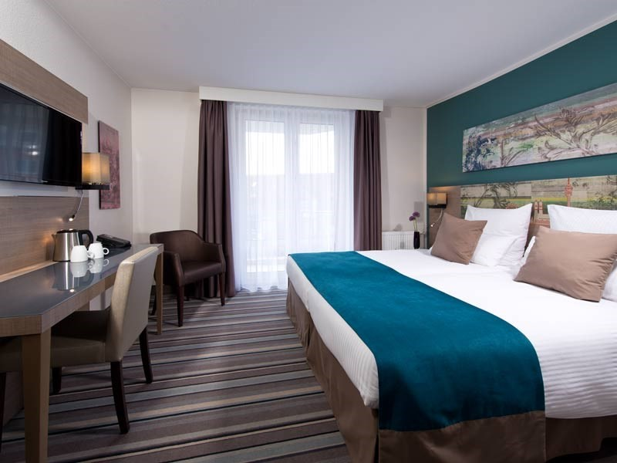
https://www.leonardo-hotels.de/leonardo-hotel-munich-city-olympiapark

EUR 174 / single incl. breakfast
EUR 252 / double incl. breakfast

Its unique location at the Olympic Park makes this hotel an ideal starting point for the city center, the BMW World, the Olympic Park and the other sightseeing highlights of Munich. It is perfectly connected by public transport to the city center. The hotel offers a restaurant and a bar. Feel at home in its new 196 spacious and modern designed rooms that feature facilities like air-conditioning, free Wi-Fi and flat screen TV. Buffet breakfast is included.
Distances: 20 minutes' drive from the qualification venue and 12 minutes' drive from the final venue.

PAYMENT CONDITIONS HOTELS:

To confirm hotel reservations, an 80% deposit of the total amount is required to be transferred to the HK Travel Plus GmbH before 06 May 2022 via a bank transfer using the details below. The remaining payment for accommodation should be paid by 17 May 2022.

Accommodation cannot be guaranteed after this deadline. In case of cancellation after 6 May 2022 and/or a no-show, the travel agency will charge a cancellation fee of 100% of the costs for all nights and rooms you have booked.

BANK INFORMATION FOR ACCOMMODATION ONLY

Account holder:
HK Travel Plus GmbH
Frauenlobstraße 97,
D-55118 Mainz

Account:
Volksbank Alzey-Worms eG
Marktplatz 19
D-67547 Worms, Germany

IBAN DE 15 5509 1200 0080 518307
BIC GENODE61AZY

PLEASE DO NOT MAKE HOTEL PAYMENTS TO THE ORGANIZING COMMITTEE

Contact to Travel Agency
hk travel plus GmbH Phone: +49-6131-217098-0
Mrs. Birgit Huhn Fax: +49-6131-217098-20
Frauenlobstraße 97 E-mail: birgit.huhn@hktravelplus.de 55118 Mainz, Germany Web: www.hktravelplus.de

ENTRY FEE
Entry fee:
Individual: 200,00€ EUR per athlete
Officials: 125,00€ EUR per person
Teams: 100,00€ EUR per team

Entry fees include daily local transport to/from the practice field to/from the official hotels during the qualification, elimination and finals venues (timetable to be confirmed on site).

Airport Transportation Fee:
Roundtrip 30 Euro per person

PAYMENT CONDITIONS:
The entry fees and Transportation fees should be paid fully via bank transfer or upon arrival.

NOTE:
- Please indicate in the reference/notes section the team or reservation name that corresponds to the payment
- All payment shall be made in EURO by BANK TRANSFER.
- All bank wire charges will be paid by the participant
- CREDIT CARDS will not be accepted as payment.

Payment of Entry and Transportation Fees
All Entry Fee and transportation fees must be made to the Organizing Committee by the set deadline.
The payment for the entry fee and transportation fee must be transferred to the following bank account:

German Shooting Sport and Archery Federation/Deutscher Schützenbund e.V.
Lahnstr. 120
65195 Wiesbaden, Germany

Account:
Wiesbadener Volksbank
Schillerplatz 4
65185 Wiesbaden, Germany
IBAN DE16 5109 0000 0008 8088 80
BIC WIBADE5W

HEALTH REGULATIONS (COVID-19)
INFORMATION
- Everybody should follow the Government/public health authorities measures (national and sport-specific regulations) and be aware of the travel restrictions
- The Organizing Committee will do everything to minimize the risks of COVID-19 infections. We will follow the instructions of WHO, the German government and World Archery. A considerable hygiene concept will be provided in due time.

PERSONAL HYGIENE AND HEALTH ADVICES
- Anyone due to participate in the event who is feeling ill should not attend
- Participants (athlete, volunteer, official etc.) should proactively and regularly check their health status (including taking their temperature and monitoring for any symptoms)
- Stay home and self-isolate even with minor symptoms for 10 days or more depending on national protocols, when showing any symptoms (fever, tiredness, dry cough, headache, nasal congestion, runny nose, sore throat, difficulty breathing).
- Contact a healthcare provider immediately if any respiratory illness is noted
- Masks to be worn at all times everywhere (transport, common area in the hotel, venue, training etc.) except on shooting line
- Regularly and thoroughly clean your hands with an alcohol-based hand rub or wash them with soap and water
- Avoid touching eyes, nose and mouth
- Cover your mouth and nose with your bent elbow or tissue when you cough or sneeze. Then dispose of the used tissue immediately and wash your hands
- Avoid touching high-contact surfaces such as door handles, walls or windows, etc.
- Avoid going to crowded places
- Avoid steam rooms or saunas
- No spitting, as the main mode of transmission of the virus is in respiratory secretions
- No handshakes, high fives and any other personal contact
- Athletes should not share clothing, bar soap, sports equipment, water bottles or other personal items
VENUE
- Access to the venue might be denied at any time in case of disease suspicion
- Limit contact/interactions
- Handwashing/alcohol- based hand gel will be available at multiple locations in the event facility and accommodation
- Tissues and containers will be at disposal to dispose of used tissues on transport to the venue, at the venue and any other facility
- No shows allowed. Winners will receive their medals in a simple ceremony only with the winners and their team, all wearing masks
- Medical post and designated personnel on site able to help assess cases and potential other illness will be present
PARTICIPANTS
- Maintain the staff/team to a minimum to minimize transmission
- Maintain social distancing, at least 1,5-meter distance between yourself and others at all time
ADDITIONAL INFORMATION
World Archery Europe Congress:
World Archery Europe Congress will be held on 5 June 2022. All information will be provided in advance to the Member Associations.

Transportation
Transport from/to Munich Airport is 30 Euros per person. A daily shuttle service is free of charge (only for those persons accommodated in the official hotels). Shuttle services will be available from the official hotels to competition venue/practice venue/final venue.

Continental Quota Tournament for European Games 2023
The CQT will take place on 10 June 2022 at the special place in the competition field and all matches will be one by one and running by alternate shooting.

Cancellations & Changes
- Cancellations received before 6 May 2022 a full refund of the deposit payment will be made.
- Cancellations received after 6 May 2022 no refund will be given.
- Refunds will be processed after the event.
- Name changes to team officials or athletes (same category and division) will be accepted up to 72 hours before the event without any additional charge.
- Should flight arrival details change last minute, please contact the Organizing Committee using the details indicated in the Team Managers’ Booklet.
- If a participant’s arrival is later than the original scheduled arrival date, the room will be charged from the date of the original booking.

Training
A training field will be available starting on 5 June 2022. Transport to training field will be made available at no additional cost.

Weather
Temperatures in May are expected to range between 18 and 25 degrees Celsius. The average in the last few years has been 25 degrees Celsius.

Media Registration:
Media representatives can apply for registration by emailing info@archery.sport

Internet
Will be available in the official hotel for free (in hotel rooms and in the lobby). There will also be Wi-Fi available at the venue.

Water
Bottled water will be available at the venue.
LOC Contact:
Name: Ms. Julia Matheis, Event Manager
Email: matheis@dsb.de
Phone: +49 611 46807 415
Language: English, German

Visa:
It is your responsibility to establish with your respective foreign office if your team requires a visa for Germany. You can find additional information on https://www.auswaertiges-amt.de/en/visa-service. All participants who need an entry visa to Germany, will be required to complete the Visa Support Form in WAREOS by no later than 6 May 2022.

It is the applicants’ responsibility for supplying the necessary information, ensuring all details are up to date, correct and submitted by the deadlines specified.

In addition, all participants that require a visa are kindly requested to supply a copy of their latest/valid passport. Copies of each application can be uploaded on WAREOS. All passport copies and personal details entered/uploaded to WAREOS will be held securely and in the strictest of confidence and not shared with other parties.

Please ensure your passport is valid for at least six months from the date you enter Germany, or you may not be admitted.

