INVITATION PACK (Final Update 7/3/2022)

TO ALL WORLD ARCHERY EUROPE MEMBER ASSOCIATIONS

Dear President,

On behalf of the Local Organising Committee and Archery GB, I am pleased to invite you to the European Youth Championships 2022 which will be held at Lilleshall National Sports and Conferencing Centre, Shropshire, Great Britain, 15 – 20 August 2022.

This event will be organised following the World Archery Rules for U21 Women, U21 Men, U18 Women and U18 Men classes, Recurve and Compound divisions in the Outdoor Target Archery discipline.

PARTICIPATION IS OPEN TO ALL WORLD ARCHERY EUROPE MEMBER ASSOCIATIONS.

Please find enclosed the necessary documents concerning the registration, organisation and participation in this event.

We are looking forward to welcoming you and we are sure you will enjoy your stay at Lilleshall.

Yours sincerely
Neil Armitage
Neil Armitage
CEO
Archery GB
www.archerygb.org
Email:EYC2022@archerygb.org

IMPORTANT DATES

Please find enclosed detailed information regarding this event. To register participation, please complete all the necessary sections in WAREOS (https://extranet.worldarchery.sport) within the deadlines listed below.

Summary of deadlines:

Registration Opening date on WAREOS | 10 March 2022
Preliminary Entries | 17 May 2022
Final Entries | 26 July 2022
Late entries fee | 50 Euro
Hotel reservation down-payment (60%) | 17 May 2022
Hotel reservation and payment | 24 June 2022
Transportation | 24 June 2022
Visa support | 1 June 2022
Full refund cancellation deadline  *After this deadline, the LOC is allowed to retain all amounts due by the Member Association. | 24 June 2022

Please respect the stated deadlines.

PRELIMINARY PROGRAMME

Saturday 13 August 2022 Arrival of Delegations
Unofficial Practice 14:00 - 17:00

Sunday 14 August 2022 Arrival of Delegations
Unofficial Practice 10:00 - 17:00
Team Registration

Monday 15 August 2022 Official Practice and Equipment Inspection
Team Managers' Meeting
Opening Ceremony

Tuesday 16 August 2022 Qualification Round U18
Qualification Round U21

Wednesday 17 August 2022 Mixed Team and Team Eliminations

Thursday 18 August 2022 Individual and Team Eliminations
Mixed Team Finals

Friday 19 August 2022 Individual Eliminations
Team Finals

Saturday 20 August 2022 Individual Finals
Awards Ceremony
Closing Ceremony
Disco Party (tbc)

Sunday 21 August 2022 Departure of Delegations

Note: The preliminary programme is subject to change according to the number of participants and special requirements. All changes will be published and distributed in good time.

PRELIMINARY & FINAL REGISTRATION
All entries, accommodation reservations, transport needs, flight arrival/departure information and visa invitation letter requests are to be completed using the World Archery Online Registration System WAREOS https://extranet.worldarchery.sport. This system handles the entire registration process for this event. No entry forms, hotel reservations or transportation forms will be accepted; all information must be entered into WAREOS.

Member associations can login to WAREOS at http://extranet.worldarchery.sport with the username and password assigned by World Archery. After entering WAREOS, selecting the event from the list will allow a member association to register their athletes. Select/press the “Entries” button to see the list of categories in the event. Select/press the “category” to enter the athlete and official numbers/details participating for that event. A WAREOS User Manual can be downloaded in PDF format (English) upon login.

Contact wareos@archery.sport with any questions regarding technical problems on WAREOS. For any question regarding the organisation of the event (transport, accommodation, meals, invoices, visa etc.) please contact directly the LOC.

Athletes from a minimum of 4 different Member Associations shall be registered and participate in the event.

A maximum number of three (3) athletes per country can be registered into each category and divisions of the event.

Member Associations can only use WAREOS to make any changes or amendments to entries and will be able to do so at any time. An email will automatically notify the Organising Committee and Member Association of any changes made in WAREOS.

PENALTY FEES TO BE PAID TO ORGANISING COMMITTEE
Penalty fees for Late Entries (after final deadline): | 50 per entry
Penalty fees for not filling Preliminary entries | 150 per entry
Penalty fee for differences between preliminary and final entries:  *If the difference between final and preliminary entries number is more than 4 athletes/officials | 150 per entry

ACCOMMODATION & GENERAL INFORMATION

Important Note: Non-official accommodation is not allowed. Any team or individual accommodated in a non-official hotel will not be accredited and participation in the event will be refused.

The official hotels are 4* and 3* stars category hotels.

The room rate:
- Is listed in Euros, per room, per night,
- includes full board accommodation, taxes and VAT
- includes free parking in front of the hotel for cars & minivans
- includes internet provided in the hotel lobby and bedrooms

HOTEL | Category | Single room - full board | Twin room - full board
Holiday Inn Telford | **** | € 185 | € 280
The Mercure Hotel | **** | € 185 | € 280
The International Hotel | *** | € 140 | € 230
Lilleshall National Sports Centre | *** | € 135 | € 190

All lunches will be served at Lilleshall every day and costs are included in the above fees.

Holiday Inn Telford
At this hotel you can enjoy:
Free Wi-Fi
24-hour room service
Transfer to Venue: 20 – 25 mins

Thoughtfully designed rooms come with pillow menus and flat-screen TVs. Revive leisure club includes a heated indoor pool, a gym, a spa pool, saunas and a steam room. The hotel's Olive Tree restaurant serves breakfast and dinner daily, plus Sunday lunch, and the Olive Branch bar is open all day and into the evening. Sip a drink by the restaurant fire in winter, or take in some fresh air on the patio in summer.
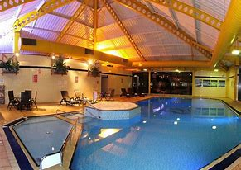
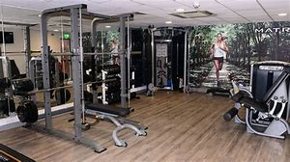

The Mercure Hotel
At this hotel you can enjoy:
Free Wi-Fi
24-hour room service
Transfer to Venue: 20 – 25 mins

The hotel is completely non-smoking. All rooms have flat-screen TVs, tea and coffee making facilities and free Wi-Fi access. Guests can make full use of the Innaction leisure club, complete with gym and weights room, indoor heated swimming pool, sauna, and steam room.
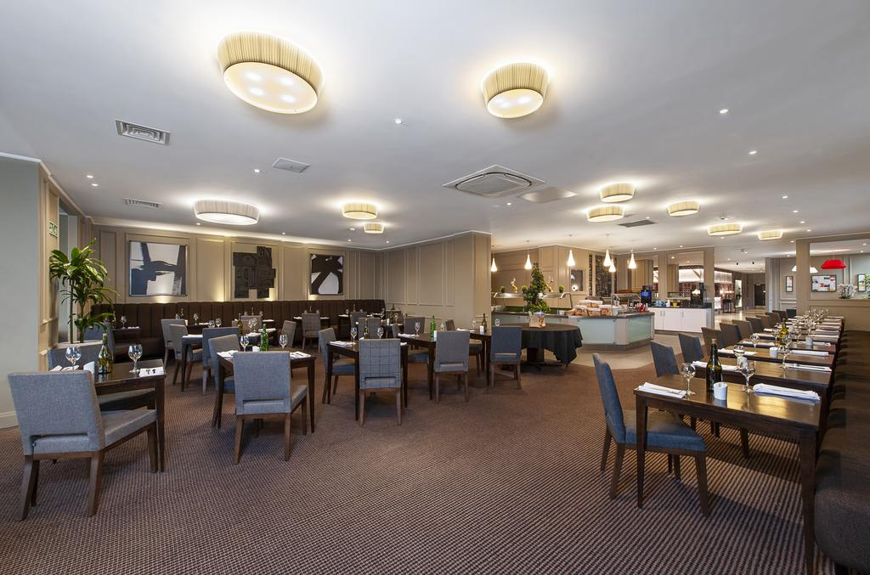
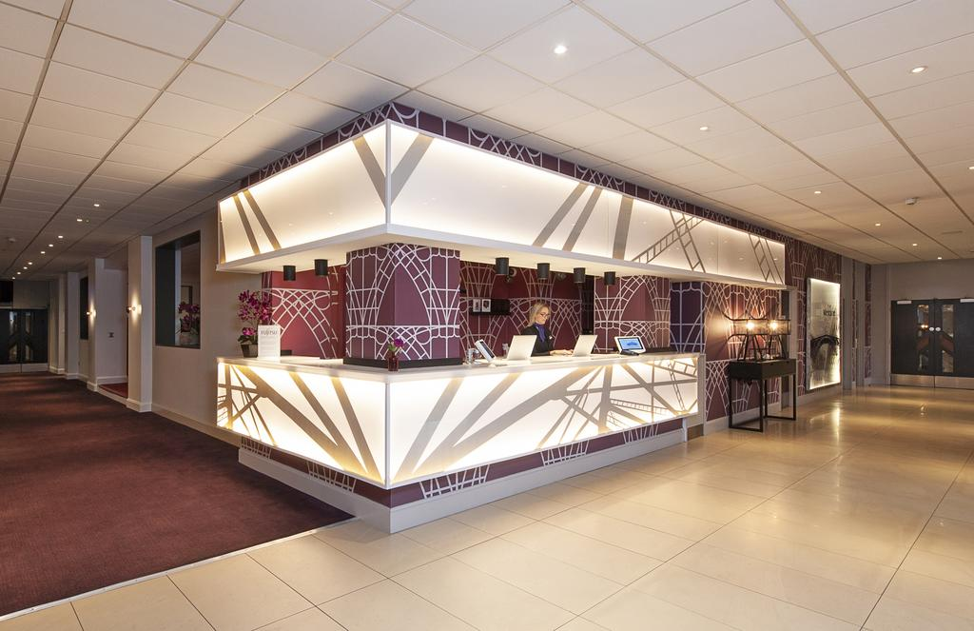

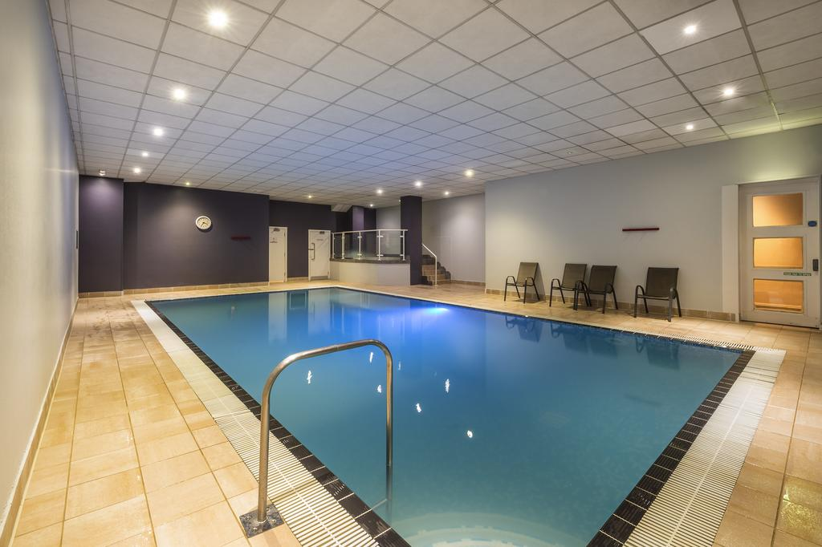
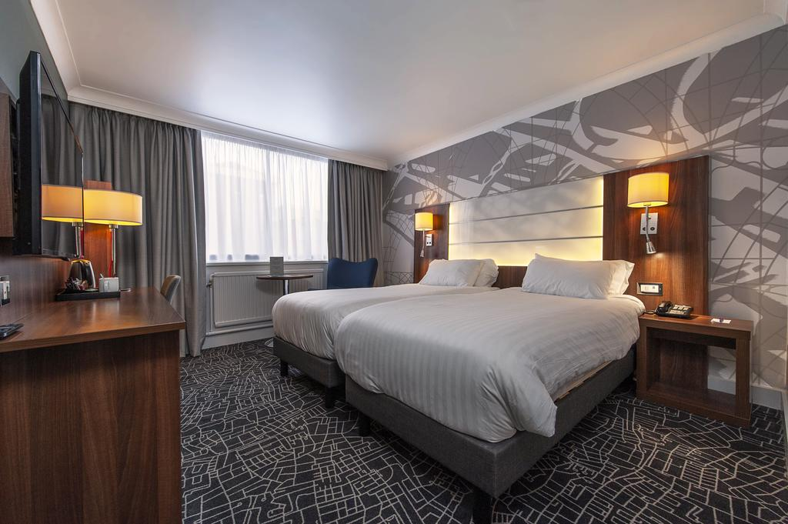
The International Hotel
At this hotel you can enjoy:
Free Wi-Fi
Transfer to Venue: 20 – 25 mins

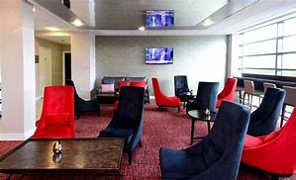
The bedrooms at the International Hotel each have a private bathroom and a TV with Freeview channels. Rooms also have a work desk and tea and coffee making facilities.
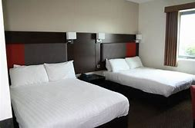
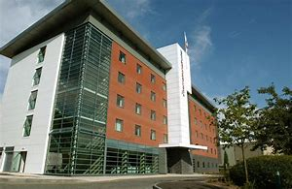

Lilleshall National Sports Centre (can only be booked from 14th to 20th August, extra nights available)
At this hotel you can enjoy:
Free Wi-Fi
Transfer to Venue: 5 minutes’ walk to competition field
Bus service to Telford town centre available each day.

The bedrooms at Lilleshall each have a private bathroom and a TV with Freeview channels. Rooms also have a work desk and tea and coffee making facilities.
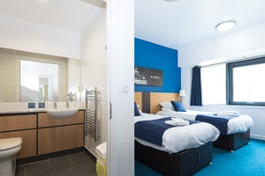

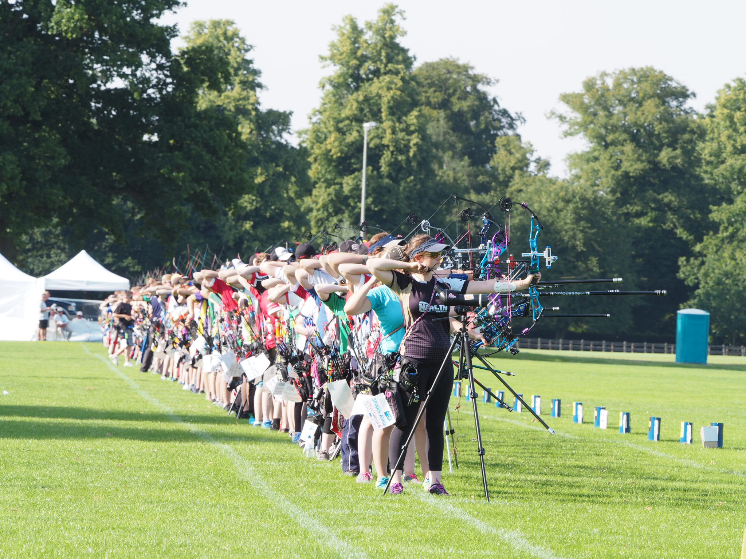
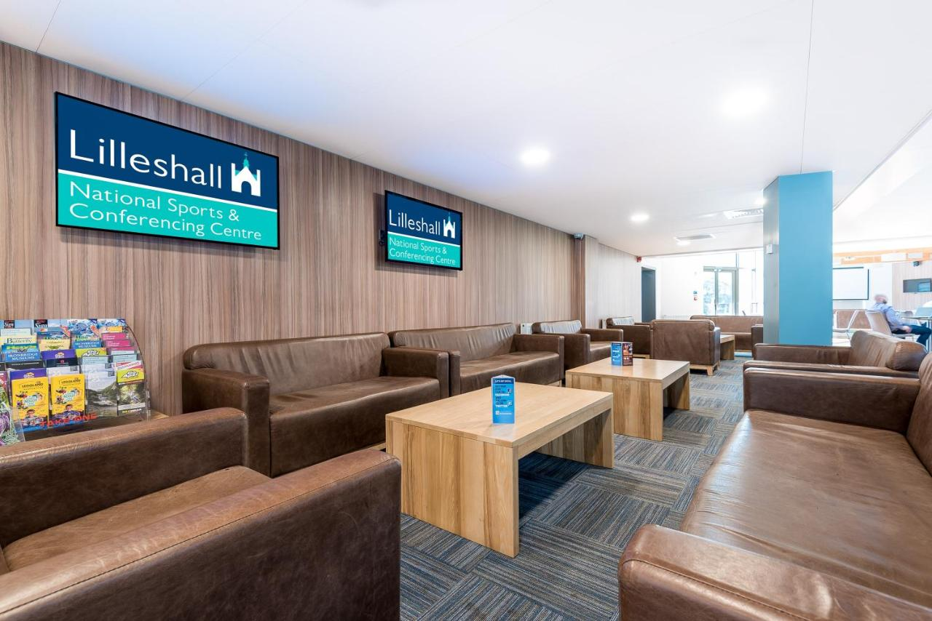

All hotels, except for the one at LNSCC itself, are set in close proximity to each other in Telford Town Centre and Southwater, where a cinema, bowling alley, ice rink, shopping centre, supermarket, many restaurants, and the town park are all a short walk away.

Your reservation of room choice will only be given on receipt of deposit, selection on WAREOS is not a guarantee without deposit.

To confirm the reservation, a 60% deposit of the total amount is required to be bank transferred to the LOC before 17 May 2022. Reservations after this date will be considered only according to availability, we

cannot guarantee availability and the room rate may change.

Final Hotel Reservations should be made before 24 June 2022, after this date we cannot guarantee the advertised prices.

Note: Please ensure that you complete all the necessary forms by the specified dates and make full payment for the accommodation at the time of booking. See detailed payment instructions below.

Entry fees:
Individual: €200 - Per Athlete
Officials: €100 - Per Official
Teams: €125 - (no fee for mixed teams)

Transportation fees from/to the airports:
The LOC will collect the teams from Birmingham International airport. You have to pay the transportation fee that includes arrival and departure as follows:
Birmingham International Airport – BHX – 55 KM €60 Euro per person each way
(Transfers should take 50 minutes to 1 hour)

London or Manchester airports can be arranged by special arrangement. (Contact LOC for info)

The last date for the payment of the transportation details must be with the LOC no later than 29 June. All fees must be paid no later than 26 July 2022.

From the airports to the hotel / return trip, the organiser will use buses, small buses, vans, and cars, which will depend on number of persons scheduled for transportation.

Transportation from the airports will start Saturday 13 August and will end Monday 22 August. Arrivals and transport requests outside of these dates can be arranged by special arrangement with the LOC only.

PAYMENT CONDITIONS
- The Entry Fee should be paid in full before 26 July 2022.
- The 60% deposit of the total amount for hotel accommodation should be paid before 17 May 2022
- The full balance of payment for accommodation and total transportation should be paid before 26 July 2022
- An Invoices will be provided via WAREOS.
- All prices for payments after the stated deadlines are subject to additional charges.

Payments must be sent to the following bank account:
Account Name: The Grand National Archery Society T/A Archery GB
Account Address: Lilleshall National Sports Centre, Nr Newport, Shropshire, TF10 9AT

IBAN Number: GB47NWBK60720117529050
Account Number: 17529050
SWIFT / BIC code: NWBKGB2L

Bank Name: Natwest,
Bank Address: 217 Dean Street, Telford TF3 4BB
NOTE:
- Please state country code as reference when making payment on transfer.
- ALL PAYMENTS MUST HAVE BEEN MADE IN FULL BEFORE ARRIVAL
- ALL PAYMENTS SHOULD BE IN EURO (€) by Bank Transfer
- NO CREDIT CARDS, NO TRAVELLERS CHEQUES, NO FOREIGN CURRENCIES
- BANK TRANSFER FEES ARE THE RESPONSIBILITY OF THE SENDER

Cancellations & Changes:
All cancellations and changes must be made through WAREOS:
- Received before 17 May 2022, for full refund of the deposit payment
- Received before 24 June 2022, for 50% refund of the deposit payment
- Received after 24 June 2022, no refunds
- Refunds, if any, will be processed after the end of the event
- Late arrivals or early departures than the originally scheduled, the room will be charged from the date of the original booking in WAREOS
- Name changes to team officials or athletes (same category and division) will be accepted up to three days before the event without any additional charge
- Should flight details change last minute, please contact the Organising Committee
- An email will automatically notify the Organising Committee and Member Association of any changes made in WAREOS.

Lunches at the venue:

Lunch will be served for all Athletes and Officials at Lilleshall National Sports centre in Ford Hall. This will start on Sunday 14 August and end on Saturday 20 August. There will be two sittings each day and Athletes / Officials must attend their designated time slot.
Drinking water from water fountains will be available on the competition field free of charge.
Any charges made in the cafeteria at the archery venue or in the hotel are not included in the entry fee and must be paid when ordering.
Please inform us if you have special dietary requirements for food, you must inform the LOC no later than 26 July 2022.

Insurance

World Archery Licence will provide Event & medical insurance will be in accordance with World Archery rules and regulations.

Accreditation and Team Managers’ Meeting

Accreditation will take place at the LOC Accreditation office at Lilleshall, as well as the Holiday Inn Hotel. From Saturday AM:
Any lost accreditations will be charged at £30 at venue.

For all ceremonies, Word Archery dress code is obligatory.

More details will be provided at the Team Managers’ Meeting.

Team Managers’ Meeting will be held in the Queens Hall Lecture Theatre on Monday 15 August

Practise and Competition Field

The practice field will be open from 14:00 on Saturday 13 August, and from 10:00 on Sunday 14 August, until the end of each competition each day until 17:00 on Friday 19 August. Some shelter will be provided.

Map of Lilleshall National Sports and Conferencing Centre

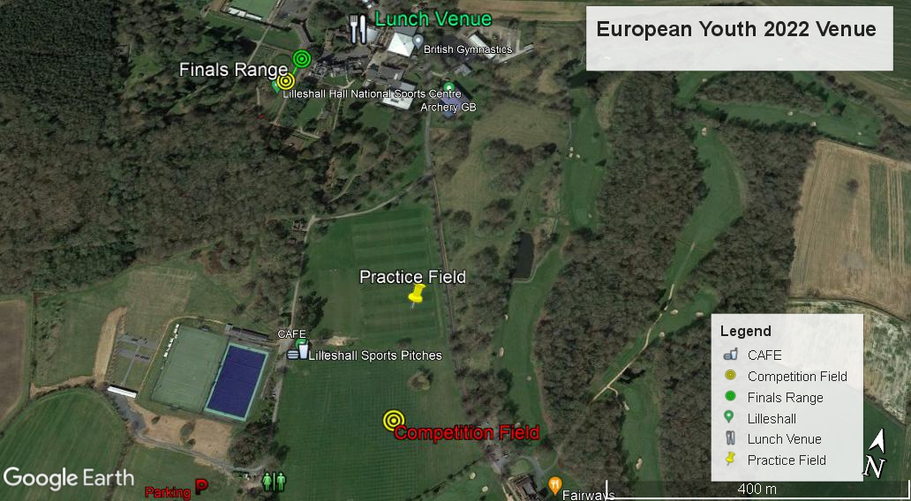
Equipment Repair and Supply
Wales Archery Specialists will be onsite all week with their mobile shop and repair booth for any equipment needs or problems. https://walesarchery.com/

Event merchandise will be available to purchase at the venue during the week.

Weather
Average temperature - 19°C / 12° C
Average rainfall for the month of August - 5.89 cm

Closing Party Night
We will inform teams closer to the time if we are running a closing party.

Contact the LOC
General Email: EYC2022@archerygb.org
Event Director: Jon Nott
Accommodation Manager: Katy Cumming
Media Registrations: Sophie.Meering@archerygb.org
Website: https://www.archerygb.org/shoot-compete/compete/european-youth-championships/
About Lilleshall: https://www.lilleshallnsc.co.uk/

About Shropshire
Explore award-winning attractions in beautiful Shropshire, the beautiful Ironbridge Gorge World Heritage Site not far from Telford and it’s the cradle of the Industrial Revolution.
http://www.shropshiretourism.co.uk/
https://www.ironbridge.org.uk/explore/blists-hill-victorian-town/

VISAs

VISA
All participants who need an entry visa to UK, will be required to complete the Visa Support sections in WAREOS by no later than 1 June 2022.

It is the applicants’ responsibility for supplying the necessary information, ensuring all details are up to date, correct and submitted by the deadlines specified.

In addition, all participants that require a visa are kindly requested to supply a copy of their latest/valid passport. Copies of each application can be uploaded on WAREOS. All passport copies and personal details entered/uploaded to WAREOS will be held securely and in the strictest of confidence and not shared with other parties.

To check if you require a Visa to enter the UK Check if you need a UK visa - GOV.UK (www.gov.uk)
Please Note: Visas are the responsibility of the individual nations and not the organising committee.
For visa support or letters please contact EYC2022@archerygb.org

Looking forward to welcoming you in Great Britain .

