……………………………………………………………………………………………………………………………………..…………………………...………...

INVITATION 15 November 2021

TO ALL WORLD ARCHERY EUROPE MEMBER ASSOCIATIONS

Dear President,

On behalf of the Organizing Committee and Archers Association of Slovenia we are pleased to invite you to the 18th European Indoor Archery Championships 2022 that will be held in Laško, Slovenia, from 14 - 19 February 2022 for women and men, junior women (under 21 women) and junior men (under 21 men) categories in Recurve, Compound and Barebow division.
For the first time European Indoor Archery Championships will be organized also for Barebow division.
Please, find enclosed the necessary documents concerning the registration, organization and participation in this event. To register participation, please complete all the necessary sections in WAREOS within the deadlines listed below:

Registration Opening Date - online WAREOS 19 November 2021
Preliminary Entries Deadline 15 December 2021
Preliminary Hotel reservation and payment 15 December 2021
Final Entries Deadline 25 January 2022
Final Hotel reservation 25 January 2022
Transportation 25 January 2022
Final Payment 25 January 2022
Visa Application 1 January 2022

We are looking forward to welcoming you and we are sure you will enjoy your stay in Laško. We truly hope that by the end of January, the corona virus will be under control and that we will be able to run the competition without big restrictions. In any case, during the competition all necessary precautions regarding Covid-19 will be taken both by the Organizing Committee and the hotel management, in order to offer to all the delegations a safe competition.

Yours sincerely

Irena Rosa Marjan Ilar
Event & Competition Manager President of Archers Association of Slovenia and President of the LOC

Website: http://www.archeryeurope.org
E-mail: oc-lasko@archery-si.org
Info: +386 31 633 851 Ms Irena Rosa

…………………………………………………………………………………………………………………………………….…………………………………

PRELIMINARY PROGRAMME

Saturday 12 February 2022 Arrival of Delegations
Practice available

Sunday 13 February 2022 Arrival of Delegations
Practice available
Team Registration

Monday 14 February 2022 Official practice and equipment inspection
Opening
Team Managers' Meeting

Tuesday 15 February 2022 Qualification Round

Wednesday 16 February 2022 Individual Eliminations

Thursday 17 February 2022 Individual & Team Eliminations

Friday 18 February 2022 Team eliminations & Finals
Award Ceremony

Saturday 19 February 2022 Individual Medal Matches
Award Ceremony
Closing

Sunday 20 February 2022 Departure of Delegations

Note: This is a preliminary program and could be changed slightly according to the number of participants. Although the future conditions regarding the pandemic are unknown, we hope to run the event without big restrictions. However, all requirements of the Ministry of Health and National institute of Public Health will be followed.
All changes and necessary information will be published and distributed in good time.

Website: http://www.archeryeurope.org/

...................................................................................................................................................................................
PRELIMINARY & FINAL REGISTRATION

No entry forms will be available for registering to this event. The registration process has to be done using the World Archery Results and Entry Online System (WAREOS).

The number of athletes that may be entered by a Member Association is limited to three (3) in each category.

In order to use WAREOS, please login on https://extranet.worldarchery.sport/with your Username and Password assigned by World Archery. For any questions regarding the WAREOS, please contact the World Archery office, Ms Cecile Tosetti (ctosetti@archey.sport).

Starting date of online-registration with WAREOS is: | 19 November 2022
End of Preliminary registration: | 15 December 2022
End of Final registration: | 25 January 2022

Please respect the stated deadlines.

Member Associations should only use WAREOS to make any changes or amendments to their entries and will be able to do so at any time. After any change made in WAREOS an email will be automatically sent to the Organizing Committee and Member Association with the updated information.

However, any changes that are made after the deadlines specified or if entries differ by more than 2 participants from the preliminary entries, the following penalty fees will automatically be applied:

Penalty fees to be paid to Organizing Committee: | Cost (EURO):
Entries made after the preliminary and/or final entry deadline date. | 45 per entry
If final entries differ from the preliminary entries by more than 2 athletes/officials. | 140 per entry
Failure to have made preliminary entries before the deadline date but then have submitted final entries. | 140 per entry

Any entries received less than 3 days before the team managers meeting will be refused if no preliminary entry and/or final entry are made prior.

As a final note, only Member Associations in good standing will be eligible to compete. This means that World Archery fee must have been paid prior to participation.

.....................................................................................................................................................................................
ACCOMMODATION & GENERAL INFORMATION

The official hotel is 4* stars category HOTEL THERMANA PARK ****superior in Laško.
Laško is a spa town in eastern Slovenia. It is the seat of the Municipality of Laško. The area is part of the traditional region of Styria.

The room rate:
- is per room per night,
- include full board accommodation, taxes and VAT
- include use of the swimming pool (subject to restrictions)
- include use of fitness and/or gym
- include free parking next to the hotels for cars, minivans and busses
- internet in the hotel lobby and rooms

HOTEL | Category | Single room | Double room | Triple room | Apartment
 |  |  |  |  | 2 x double room
Hotel Thermana Park | **** | € 160,00 | € 250,00 | € 330,00 | € 480,00

Lunch during the competition days will be served in the hotel. Upon request lunch boxes will be available.

It is mandatory to choose the official hotel listed by the Local Organizing Committee. A delegation choosing a non-official hotel will not be allowed to participate in the Championships.

Hotel Thermana Park Laško Zdraviliška cesta 6
3270 Laško, Slovenija

GPS coordinates: 46.161655, 15.232087
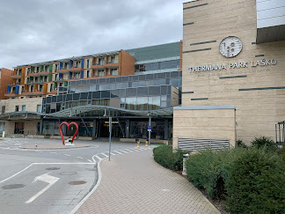

Rooms include a safe, minibar, and a bathroom with shower or bathtub, hairdryer and a robe. Rooms are decorated in vivid colours.
The hotel's Thermal Centre includes swimming pools, sauna, fitness and a wellness centre. Guests of the Thermana Park Laško Hotel can use the swimming pools free of charge.
Restaurants and coffee shops are available on site. The local bus station is in front of the hotel and the train station is just 300 m away.
The centre of Laško is a 15-minute walk away from the property. The town of Celje is 11 km away.

Reservations should be made before 15 December 2021.
....................................................................................................................................................................................
To confirm the reservation, a 60% deposit of the total amount is required to be bank transferred to the OC before 15 December 2021. Reservations after this date will be considered only according to availability and the room rate can change.

Final Hotel Reservations and remaining payment should be made before 25 January 2022.

Note: Please ensure that you complete all the necessary forms by the specified dates and make full payment for the accommodation at the time of booking. See detailed payment instructions below.

ADDITIONAL INFORMATION

Entry fees Individual: 200 € per athlete
Officials: 100 € per official
Teams: 125 € per team
Transportation fees from/to the airports
The OC will collect the teams from the two airports. You have to pay the transportation fee as follows:

LJUBLJANA International Airport - Hotel: 30 € per person SLO (90 km)
Hotel - LJUBLJANA International Airport: 30 € per person SLO (90 km)
ZAGREB International Airport – Hotel: 35 € per person CRO (115 km)
Hotel - ZAGREB International Airport: 35 € per person CRO (115 km)
Be aware that Zagreb is in Croatia and some countries might need visa for Croatia.

The last date for the payment of the transportation fee is 25 January 2022.

Between airports and hotel, the organiser will use buses, small buses, vans and cars, what will depend of number of persons scheduled for transportation.
Transportation from the airports will start two days before the official practice day and will end two days after the closing day.

Cancellations & Changes
Following conditions will apply:
- cancellation received before the final entry deadline: full refund of the paid deposit
- cancellation received after the final entry deadline: no refunds

All rates for payments after deadlines are subject to additional charges without prior notice.
All refunds, if any, will be processed after the event.

OC has to be informed about changes in the travel programme 72 hours prior arrival. If your arrival is later then your original schedule, the room charges are starting from the original date indicated by the MA.

....................................................................................................................................................................................
The competition will be organized in sport hall Tri Lilije

Tri Lilije Sports Hall is a multi-purpose hall spreading across 4500 square meters. It offers 2100 square meters of playing surface and can simultaneously hold 3 internationally standardized basketball courts. The stands have 1800 seats and the whole hall has a capacity of 2500.

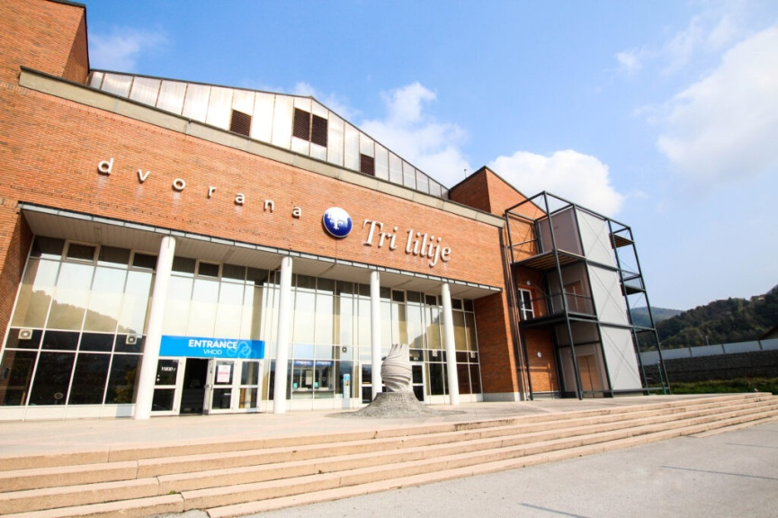
The hall is the home of Zlatorog basketball club.
Tri Lilije Sports Hall hosts handball, basketball, volleyball, tennis, futsal matches as well as concerts and dance shows, and now also archery. It is also available for congress and private event hire.
It’s also disabled-friendly and has been hosting the International Slovenian Open Para Table Tennis Championship since 2004.

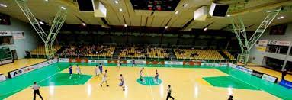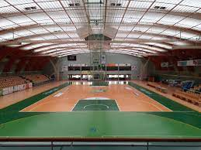

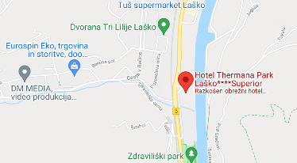

Tri Lilije Sport Hall is 7 min. walking distance from the hotel.

Two additional small halls will be available inside the hotel for training, one for shooting at 18m and one at 5m, as well as also fitness and gym.

Swimming pool is possible to use every day up to max. 3 hours free of charge.

Location: Poženelova ulica 22, 3270 Laško, Slovenia Coordinates: 46.164708°N 15.230361°E
…..................................................................................................................................................................................
Meals at the venue
Lunch during the competition days will be served in the hotel. Upon request lunch boxes will be available.

Drinking water will be available at lunch and at dinner and on the competition field free of charge.
All other costs made in cafeteria at the archery venue or in the hotel /snacks, drinks, small meals/ are not included in the entry fee and must be paid on consumptions.

Please inform us if you have special requirements for food and specify it.

Accreditation and Team Managers Meeting
Accreditation will take place upon arrival of teams in the lobby of the Hotel Thermana Park Laško. Accreditation office will be open on Sunday 13 February from 09:00 - 21:00. Accreditation cards will be possible to issue from Monday 14 February only with the additional payment of 50 € per person.

For all Ceremonies WA dress code is obligatory.
More details will be provided at the Team Manager’s Meeting.
Team Managers Meeting will be held in the conference room of the Hotel Thermana Laško on Monday, 14 February 2022.

Training and Competition Field
Warming up will always be available on the competition field.
Practice will also be available in two halls inside the hotel, in one at 18m and in one at 5m, starting from 13 February 2022.

Visas
All participants who need an entry visa to Slovenia, will be required to complete the Visa Support Form in WAREOS by no later than 1 January 2022.

It is the applicants’ responsibility to supply the necessary information, ensuring all details are up to date, correct and submitted by the deadlines specified.
In addition, all participants that require a visa are kindly requested to supply a copy of their latest/valid passport. Copies of each applicant can be uploaded on WAREOS. All passport copies and personal details entered/uploaded to WAREOS will be held securely and in the strictest of confidence and not shared with other parties.

Please note that the Organizing Committee can provide invitation for the period of the European Indoor Archery Championships in Laško only.

As long as the Organizing Committee gets no different information, the Invitation Letter will be sent by email. If an express service should be desired, this service will be charged to the MA and must be paid to the Organizing Committee upon arrival.

Those teams that want to land in Zagreb airport must be aware that they might need visa for Croatia.
In this case we might not be able to help you.

...................................................................................................................................................................................
Please note: the deadline for Visa Invitation Letter Form is 1 January 2022.

Barebow and target faces
For the first time European Indoor Archery Championships will be organized also for Barebow division.
WAE EB confirmed for Barebow the use of 40cm single face throughout the European Indoor Archery Championships. Therefore Barebow archers will shoot on the 40cm single face from Qualification Round to Finals.

Banquet *
On the final day - Saturday, 19 February 2022, the dinner will be served in the hotel.
If permitted, due to the special requirements to Covid-19, after the dinner, music and dancing will take place from 20:30 till 24:00. Some drinks, snacks and a sweet surprise will be offered free of charge.

Internet - Free of charge in all locations of the Hotel.
Website - The official website of the competition is http://www.archeryeurope.org/

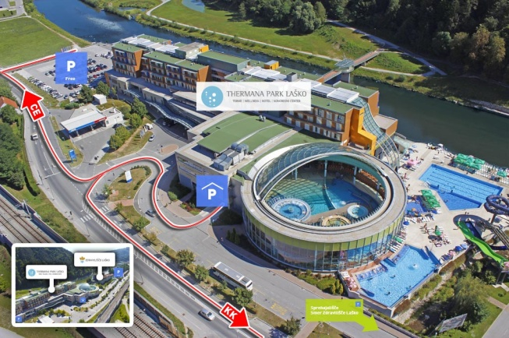

...................................................................................................................................................................................
PAYMENT INSTRUCTIONS

BANK: NOVA LJUBLJANSKA BANKA d.d.
Address: Trg republike 2
1000 Ljubljana
Slovenia

A/C NAME LOKOSTRELSKA ZVEZA SLOVENIJE
Address: Stozice 28
1000 Ljubljana
Slovenia

SWIFT CODE /BIC/: LJBASI2X
IBAN: SI56 0201 3001 7204 321

NOTE:
ALL PAYMENTS ARE REQUIRED TO BE DONE IN EUROS BY BANK TRANSFER LATEST 25 JANUARY 2022!

ALL BANK TRANSFER FEES HAVE TO BE PAID BY PARTICIPATING MAs, you need to state OUR option when paying.

IN CASE OF NOT PAYING THE BANK TRANSFER FEES, YOU WILL BE CHARGED FOR THE DIFFERENCE UPON ARRIVAL, AT THE ACCREDITATION.
- NO CREDIT CARDS
- NO TRAVEL CHECKS

IN CASE YOU WILL BRING CASH, YOU WILL BE CHARGED FOR EXTRA BANK COSTS FOR DEPOSIT,
1% OF THE DEPOSIT.

PLEASE SEND THE COPY OF THE BANK TRANSFER TO THE ORGANIZER by email to
oc-lasko@archery-si.org

OC contacts
For all matters
Ms Irena Rosa - 24 hours English
Mobile +386 31 633 851
E-mail: oc-lasko@archery-si.org

For questions about visa support
Mr Marjan Ilar - 24 hours English
Mobile +386 41 788 907
E-mail: oc-lasko@archery-si.org

