to ALL World Archery MEMBER ASSOCIATIONS

INVITATION

Dear Member Associates,

On behalf of the Organizing Committee of the Bulgarian Archery Federation, I’m pleased to invite you and welcome your Federation to participate to the 2022 European Club Team Cup, which is to be held on 17 – 18 September 2022, in Ruse (Bulgaria).
The competition is open to female and male club teams and it is reserved only to the Recurve Division.

The competition will be organized according European Club Team Cup rules published on WAE web site.

We are happy to welcome national teams from all continents.
You will certainly be able to sense the Bulgarian hospitality. We also hope that you and your team will enjoy your stay in Ruse and will enjoy great tournament and a wonderful weekend in the Danube city.

WAE will
give a total amount of 6 000 Euro to the winners as follows:
(for each competition: Recurve Men Club and Recurve Women Club)
Prize money for European winners:
1st place: Euro 1 500
2nd place: Euro 1 000
3rd place: Euro 500

Please, find enclosed the necessary documents concerning the registration, organization and participation in this event. To register participation, please complete all the necessary forms within the deadlines listed below:

Preliminary Entries | 25 July 2022
Final Entries | 25 August 2022
Preliminary Hotel Reservation | 25 July 2022
50% Hotel Reservation  Visa Support | 25 July 2022  25 July 2022
Transportation | 25 August 2022
Final Hotel Reservation & Payment | 25 August 2022
Final Payment | 25 August 2022
Full refund cancellation deadline* | 25 August 2022
*After this deadline, the LOC is allowed to retain all amounts due by the Member Association

Looking forward to welcoming you in Ruse!

Sincerely yours,
Mr. Atanas Temelkov
President of Bulgarian Archery Federation

PRELIMINARY PROGRAM
DAY 0 | Thursday  15 September 2022 | Arrival of the Club teams  Practice field and local transportation available  Team Registration
DAY 1 | Friday  16 September 2022 | Arrival of the Club teams  Practice field and local transportation available  Team Registration  Team Managers Meeting
DAY 2 | Saturday  17 September 2022 | Qualification round 2 x 36 arrows  Pool matches Main Event  Pool matches Secondary Tournament
DAY 3 | Sunday  18 September 2022 | Ranking rounds  Medal matches  Award Ceremony & Closing
NOTE:
This preliminary program is subject to change according to the number of participants and TV requirements. All changes to the program will be published and informed to all participants in good time.
ACCOMMODATION & GENERAL INFORMATION

The Official Hotel is DUNAV PLAZA HOTEL. Hotel is especially selected by the organization for the event. Hotel allocations will be made on a 'first come-first serve' basis. Accommodation rates will offer full board meal menu.
Reservation should be made before 25 July 2022.

To confirm your hotel reservations, 50% deposit of the total amount is to be paid by a bank transfer to the Organizing Committee before 25 July 2022. Reservations received
after this date will be considered only according to availability and the room rate can change.

The room rates:
- are in Euro (€) per room, per night
- including bed, breakfast, lunch, dinner with non-alcoholic drinks on the spot
- including free internet in hotel lobby
- Additional purchases in the hotel bar, café and mini bar is at own expense.*
*All prices are including city tax.

Booking NON-OFFICIAL hotel:
Participants who may decide to book their accommodation at or with other hotels, i.e. non-official hotels, and not through the Local Organizing Committee (LOC), shall have to pay a TRIPLE entry fee, and the LOC will not be responsible for providing transportation from those hotels to the venue (transport for these teams will be provided only to and from airport& train station). It is not possible to distribute any information at the non-official hotels, also.

DUNAV PLAZA HOTEL

HOTEL | CATEGORY | Single room | Double room | Triple room
DUNAV PLAZA HOTEL | 4 **** | 120 € | 220 € | 300 €

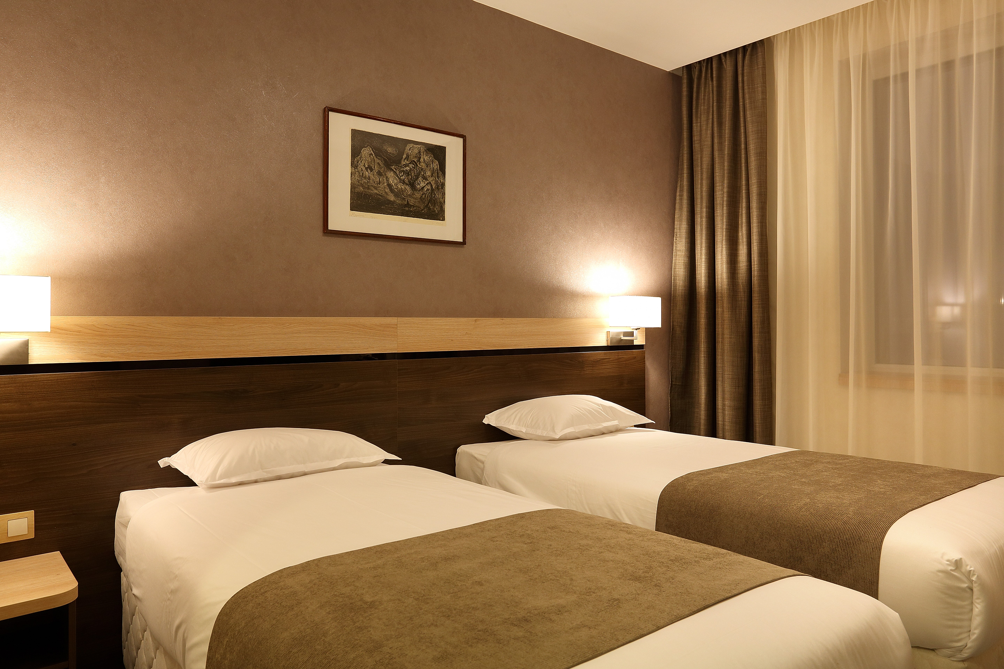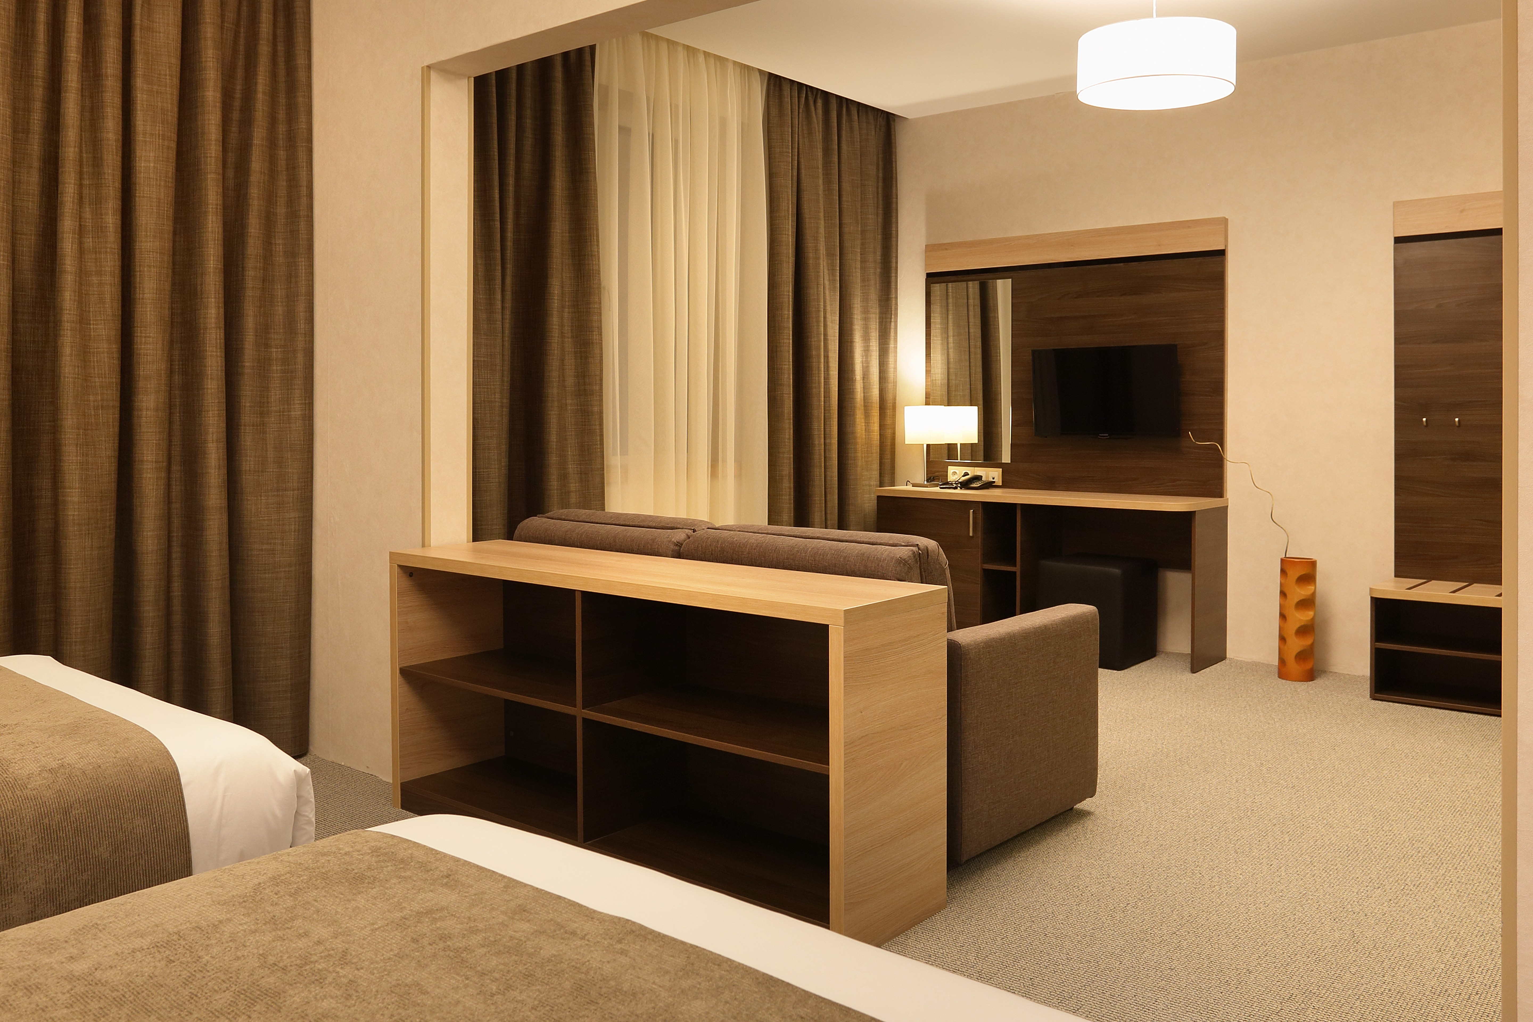
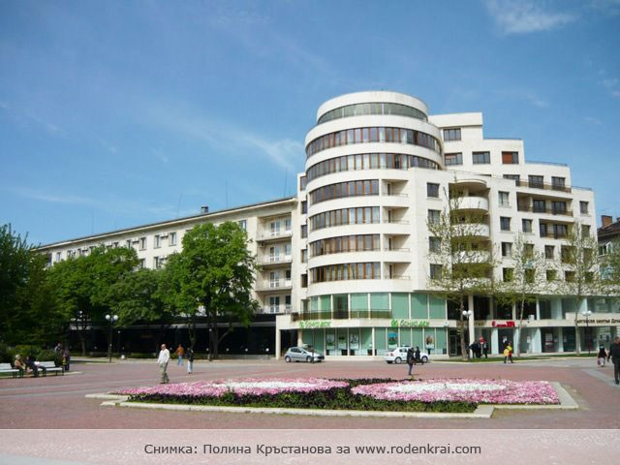

ADDITIONAL INFORMATION

ENTRY FEES
Club team: 200 € per club team

Entry fees include daily local transport to and from the practice field to/from official
hotel during the qualification, elimination and finals venues (timetable to be confirmed
on site).
*The Entry fee includes the Local transport during competition days.

TRANSPORTATION
The OC will collect the teams from the two airports. You have to pay the transportation fee as follows:

From BUCHAREST (ROM) airport to Official Hotel – (one way): 60 €/person
From VARNA (BUL) airport to Official Hotel – (one way): 60 €/person

The last date for the payment of the transportation fee is 25 August 2022.
Between airports and hotel, the organizer will use buses, small buses, vans and cars, what will depend of number of persons scheduled for transportation. Transportation from the airports will start one day before the official practice day and will end the day after the closing day

A daily shuttle service will be available for the tournament days from the Official Hotel to the competition venue and back - free of charge.

VISA
Bulgaria is a member of European Union.
It is your responsibility to establish with your respective foreign office if your team requires a visa for Bulgaria.
For participants who need a formal visa and invitation letter for entry to Bulgaria, will be required to complete the Visa Form by no later than 25 July 2022.
It is the applicants’ responsibility for supplying the necessary information, ensuring all details are up to date, correct and submitted by the deadlines specified.
In addition, all participants that require a visa are kindly requested to supply a copy of their latest/valid passport.
Please ensure your passport is valid for at least six months from the date you enter Bulgaria, or you may not be admitted.

If our help is needed you may contact us immediately.

PAYMENT CONDITIONS
All fees should be paid in full before arrival!
Payment of accommodation and local transportation: a minimum deposit of 50% of the total amount owed should be made when booking by 25 July 2022.
The final outstanding balance shall be transferred before 25 August 2022.
Accommodation cannot be guaranteed after this deadline.

NOTE:
- Please indicate in the reference/notes section the team or reservation name that corresponds to the payment.
- All payment shall be made in EURO only by BANK TRANSFER.
- Bank transfer fees are responsible on the sender.
- Credit cards and Travel checks will not be accepted.

BANK INFORMATION for ACCOMMODATION, TRANSPORTATION and ENTRY FEES:
BANK: FIRST INVESTMENT BANK
SWIFT CODE: FINVBGSF
IBAN: BG13FINV91501203792590
ADDRESS: 37, Dragan Tsankov Blvd., 1797 Sofia, Bulgaria

NOTE: ALL PAYMENTS SHALL BE MADE IN EURO

Cancellations & Changes
Following conditions will apply:
- cancellation received before the final entry: full refund of the paid deposit
- cancellation received after the final entry: no refunds
All refunds, if any, will be processed after the event.

OC has to be informed about changes in the travel programme 72 hours prior arrival. If your arrival is later then your original schedule, the room charges are starting from the original date indicated by the Club.

Training
Training venues will be available starting from 14 September 2022.
For those teams wishing to arrive earlier and practice at a practice field we would be happy to organize a training camp for everyone who intends to come earlier.
Please announce your arrival at the Training Camp by 25 August 2022.

Weather in RUSE
In this period in Ruse is sunny. The temperatures in September are expected to range between 23 and 28 degrees Celsius. The average in the last few years has been 25 degrees Celsius.

Internet
Will be available at the official hotel for free.
There will also be Wi-Fi available for access to results at the venue.

Water
Water will be available at the venue free of charge.

Meals
The lunch is foreseen to be served at hotel.

Dress regulations
WA & WAE dress regulations do apply.

By signing in the Club team declares that:
- Club team’s Member Association is in good standing
- All competitors and officials are covered in case of illness or accident
- Club team members have signed the WA Anti-Doping Agreement
- All archers of the Club team belong to the same club and are its members at least from 1st January 2022
- All competitors and officials allow his/her person, name, pictures or sport performance to be used for advertising purposes

HEALTH REGULATIONS (COVID-19)
INFORMATION
- Everybody should follow the Government/public health authorities measures
(national and sport-specific regulations) and be aware of the travel restrictions
- For your information, Medical infrastructure/Hospital with proper care will be
reachable within 15 minutes from the venue, where COVID-19 test can be
done

LOC CONTACT
Email: bfsl@abv.bg

Mobile phone: + 359 88 796 3009 – Atanas Temelkov – president (English)
Mobile phone: + 359 88 464 0216 – Donka Shopova – secretary general (English)

Web address: https://ectc2022.archery.bg/

Looking forward to welcoming You in RUSE, Bulgaria!

...................................................................................................................................................................
PRELIMINARY HOTEL RESERVATION FORM

Club team and Member Association: ____________________________________________
Contact person: ________________________________________________
Mobile: _______________________________________________________
E-mail: _______________________________________________________
Number of Rooms:
Hotel DUNAV PLAZA/****
Single € 120

Double: € 220

Triple: € 300
Do you require a room for a disabled team member? Yes No

If yes, please specify: ______________________________________________

Do any of your team members have dietary requirements or allergies such as, vegetarian,
nut allergies or gluten free etc. Yes No

If yes, please specify: ______________________________________________

Accommodation Payment:
ROOM TYPE AMOUNT OF ROOMS NIGHT RATE P/N TOTAL RATE

___________ _____________________ _________________ _____________

Single ______________________x ___________ x = _______________

Double/Twin _____________________ x ___________ x = _______________

TOTAL ACCOMMODATION AMOUNT _____________________________

DEPOSIT 60% OF TOTAL AMOUNT ______________________________
PLEASE RETURN THIS PRELIMINARY HOTEL RESERVATION FORM TO THE ORGANIZERS by e-mail to bfsl@abv.bg AND PAY THE DEPOSIT BEFORE 25 July 2022

Date: ___________________ Signature of President / Secretary General: ____________________

...................................................................................................................................................................
TRANSPORTATION FORM

Club team and Member Association: __________________________

Number of passengers: ________ person/s

Arrival information

We will arrive by plane:

Airport: __________________ Flight Nr: _____________

Date: ______________ Arrival Time: ___________

We will arrive to RUSE by: _____________________________________

____________________________________________________________

Departure information

We will depart by plane:

Airport: __________________ Flight Nr: _____________

Date: ______________ Departure Time: ___________

We will depart from RUSE by: _______________________________________

____________________________________________________________

Date: _________

Signature of President / Secretary General: ______________________________

PLEASE RETURN THIS TRANSPORTATION FORM TO THE ORGANIZER BEFORE
25 July 2022 by e-mail to bfsl@abv.bg
...................................................................................................................................................................
VISA INVITATION LETTER FORM

Club team and Member Association: ___________________________________

Contact person: _______________________________________

No | First name | Family name | Date and place of birth | Citizenship /Country/
 | Address of residence |  |  | Passport
 |  |  |  | Number | Expiration
1
2
3
4
5
6
7

Date: ______________________ Signature of President / Secretary General: ______________________

PLEASE RETURN THIS VISA INVITATION LETTER FORM TO THE ORGANIZER AS SOON AS POSSIBLE.
Latest 25 July 2022 by e-mail to bfsl@abv.bg

...................................................................................................................................................................
FINAL BUDGET FORM
Club team and Member Association: ____________________________________________
Contact person: ________________________________________________
Mobile: _______________________________________________________
E-mail: _______________________________________________________

1) Entry Fees
Posit Cost Number of athletes Total
Club team in official hotel € 200 x ___ € ____
Club team in unofficial hotel € 600 x ___ € ____

Total 1 ................................................................................. € ____
2) Accommodation
HOTEL - Full Board
Room Cost Nr of Rooms Nr of nights Total
Hotel DUNAV/**** - Single room € 120 x ___ x __ € ____
Hotel DUNAV/**** - Double room € 220 x ___ x __ € ____
Hotel DUNAV/**** - Triple room € 300 x ___ x __ € ____

Total 2 .................................................................................. € ____
3) Transportation
Airport Cost Number of Persons Total
BUCHAREST € 60 x ______ € ____
VARNA € 60 x ______ € ____
Total 3 .................................................................................. € ____

Date, ___________ TOTAL /1+2+3/ € ____

Signature of President / Secretary General: _____________________________
PLEASE RETURN THIS BUDGET FORM TO THE ORGANIZER BEFORE
25 August 2022 by e-mail to bfsl@abv.bg

PARTICIPATION FORM
Return at the latest: August 25th

MEMBER ASSOCIATION:
CLUBNAME:
CONTACT PERSON:
MOBILE PHONE NUMBER:
EMAIL ADDRESS:

MEN’S TEAM
PARTICIPANT | PASSPORT NUMBER | EXPIRY DATE | NAME | SURNAME | DATE OF BIRTH dd/mm/yy | Note
OFFICIAL
ARCHER
ARCHER
ARCHER
ARCHER

WOMEN’S TEAM
PARTICIPANT | PASSPORT NUMBER | EXPIRY DATE | NAME | SURNAME | DATE OF BIRTH dd/mm/yy | Note
OFFICIAL
ARCHER
ARCHER
ARCHER
ARCHER

