INVITATION PACKAGE – V 1.0 08th June 2022

Dear Archery Firends

Local Organising Committee of the 2022 Czech OPEN Run-Archery and the European Cup warmly welcomes all participants and fans of the Run Archery to the Sports Club in Nove Město nad Metuji.
LOC feels honoured to be entrusted with hosting of the European Cup hoping we will be able to provide the participants with good condition for their elite sports performance and while helping internationally with promoting of this relatively new event.
LOC has much experience with elite track & field and archery major events. We have also hosted the RunArchery European Cups in October 2019 and 2021.
It is evident that the RunArchery as a new archery discipline enjoyes huge growth worldwide and LOC is convinced that we all will have a great time with the 2022 edition of the Czech Open and WAE Run – Archery European Cup!

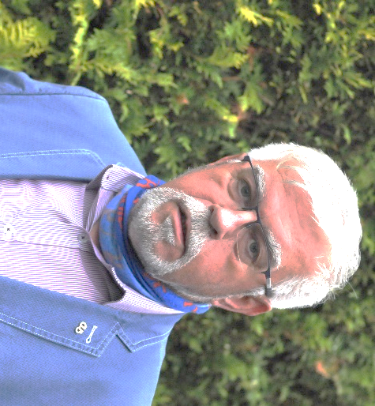

Libor ŠNAJDR
Chair of the Organizing Committee

Venue

Sportovni klub, 28.rijna 943, Nové Město nad Metují, Czech Republic
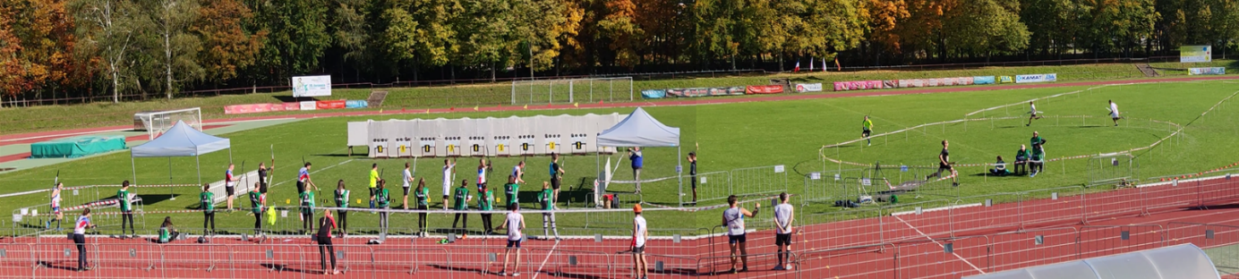
The 1km circle is situated within the Sports Club complex (cross-country flat terrain including 100m asphalt surface, spikes possible but not recommended), 400m lap on the athletic track, penalty laps on soccer field with a natural grass);
Shooting range located on a soccer field (natural grass).
Car parking available on designated parking places No. 1 and No. 2, close to the venue (100m).

Local Organising Committee and WA Officials
ŠNAJDR Libor LOC Chairman (CZE)
ŠNAJDR David Secretary (CZE), +420724080831, snajdrcpv@volny.cz
Martinkova Jana Treasurer (CZE)
Ohlmann Dominique WAE Technical Delegate (FRA)
Tbd WAE Chair of Judges
Pavlíková Radka Track Referee (CZE)
Hasek Oldrich Shooting range manager (CZE)

Preliminary schedule

Friday 7th October  Day 1 | During the day  15 :00-19 :00  19 :00-20 :00  20 :30-21 :00 | Arrivals, accreditation  Official practice & Equipment Inspection  Team captains meeting  Opening Ceremony
Saturday 8th October  Day 2 | 08 :30-09 :45  09 :45-10 :00  10 :05-10 :40  10 :45-11 :00  11 :00-11 :45  11 :45-12 :30  12 :30-12 :45  12 :45-13 :15  13 :15-13 :30  13 :30-14 :00  14 :00-14 :30  14 :30-14 :50  14 :50-15 :10  15 :10-15 :30  15 :30-15 :50  16 :45-17 :15  17 :45 | SPRINT  Practice (all categories)  Practice & inspection Women categories  Qualification Women (every 30sec)  Practice & inspection Men categories  Qualification Men (every 30sec)  Practice (all categories)  Practice Women categories  Semi finals Women (2)  Practice Men categories  Semi finals Men (2)  Practice (only for the finals)  Final B Women (1)  Final B Men (1)  Final Women (1)  Final Men (1)  Mixed RELAY RACE  Final Relay Mixed (1 or 2 rounds)  Award Ceremony
Sunday 9th October  Day 3 | 08 :00-09 :00  09 :10-12 :00  12 :30  13 : 00-13 :30  13 : 30-14 :00  14 : 00-14 :30  14 : 45 | INDIVIDUAL RACE  Practice & Equipment inspection  Individual Race (by groups)  Award Ceremony  RELAY RACE  Practice  Final Relay Women  Final Relay Men  Award Ceremony  Departures of the teams
Monday 10th October |  | Official departure date
This preliminary programme is a subject to change according to the number of participants in each division. All changes will be distributed to all participants in advance.

Call-room
All competitors should be present at Call-room for collecting electronic chips and checking of start bibs and equipment latest 10 min. before the start of their race. Omitting to be present in the call room latest 10 min. prior the start of the proper event will result in disqualification of such a racer.

Participation / Registration
Participation is reserved for people licensed for the current season in a national federation which is member of WORLD ARCHERY .
Entering the license number on the entry form is a mandatory to enable any checks.

Entry fees :
Category Women (incl. 50+), Men(incl. 50+) 60,00EUR
Category U21 (incl. U18) 50,00 EUR
Team Relay or Team Mixed Relay 60,00 EUR
Team official : 30,00 EUR

Fee should be paid via bank account by Sept. 23, 2022.

Entry form to use
It is required that all participants are registered officially through the given Excel form that can be uploaded on the WA Europe Website event page :
https://www.archeryeurope.org/event/run-archery-european-cup-2022/

Registration should be completed not later than in 23rd September 2022.
All fees per each team should be transferred to LOC bank account by 23rd Sept. 2022.

Accommodation
Not provided by LOC automatically. LOC can advise regarding suitable accommodation upon request. Participants are expected to arrange for their own accommodation.

Recommended hotels:
- Hotel Rajska Zahrada, Nove Město nad Metuji (1km from the venue)
www.hotelrajskazahrada.cz, recepce@hotelrajskazahrada.cz
- Hotel Rambousek, Nove Město nad Metuji (1km)
www.rambousekhotel.cz, info@rambousekhotel.cz
- Hotel Hron, Nachod (12 km) hotelhron@hotelhron.cz
- Hotel Vyhlidka, Nachod (12km) www.vyhlidka.cz, vyhlidka@vyhlidka.cz

Meals
LOC can offer snacks and/ or lunch in its cafeteria at the venue.

Local transport
LOC offers local transport from
- Prague Intl. Airport (150km)
- Pardubice Intl. Airport (70km).
Return way including transport among hotels and venue will be charged 120,- EUR per person. Should be ordered in advance (by Sept. 23, 2022 latest).

Payment details
The Entry form and Sheet of Payment altogether with fees should be sent to LOC (snajdrcpv@volny.cz) and to LOC bank account by Sept. 23, 2022.

Bank Address: CSOB, a.s.,
Komenskeho 72,
549 01, Nove Mesto nad Metuji
Czech Republic

Bank Account Owner: Sports Club Nove Mesto nad Metuji
Bank Account Number: 275371783/ 0300
IBAN: CZ73 0300 0000 0002 7537 1783
SWIFT Code: CEKOCZPP
Variable Symbol: 20221007
Specific Symbol: WRT/ country code (specify your international country code)

