Dear President,

On behalf of the Organizing Committee, I am pleased to invite you to the 19th European Archery Indoor Championships that will be held in Samsun - TURKEY, on 13 - 18 February 2023. This Competition will be organized following the WA and WAE competition rules in divisions Recurve, Compound and Barebow with both age categories of Senior Men and Women and Under 21 Men and Women.

Hereby please find enclosed all the necessary documents concerning the registration, organization and participation in this event.

Please complete all the necessary sections in WAREOS within the deadlines listed below, to register participation;

- Preliminary Entries 15 November 2022
- Final Entries 23 January 2023
- Hotel Reservation 15 November 2022
- Entry & Transportation 15 November 2022
- Final Hotel Reservation 25 January 2023
- Final Entry & Transportation 23 January 2023

We hope you and your team will enjoy your stay in Samsun, where you will experience Turkish hospitality at its best.

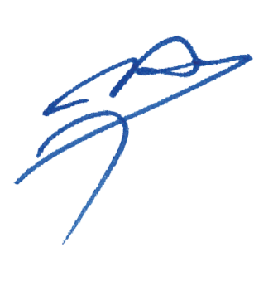
Yours sincerely,

Husnu KOCAOGLU
Chairman of the Organizing Committee

PRELIMINARY PROGRAM

Saturday 11 February 2023 Arrival of Delegations & Accreditation
Unofficial Practice

Sunday 12 February 2023 Arrival of Delegations & Accreditation
Unofficial Practice

Monday 13 February 2023 Official Practice & Equipment Inspection
Team Manager’s Meeting

Tuesday 14 February 2023 Qualification Rounds

Wednesday 15 February 2023 Senior Individual Eliminations, 1/4 and 1/2 Finals
Junior Individual Eliminations, 1/4 and 1/2 Finals
Barebow Eliminations

Thursday 16 February 2023 Senior Teams Eliminations
Junior Teams Eliminations
Barebow Teams Eliminations

Friday 17 February 2023 Junior Teams Bronze & Gold Finals
Junior Teams Award Ceremony
Junior Individuals Bronze & Gold Finals
Junior Individuals Award Ceremony

Saturday 18 February 2023 Senior Teams Bronze & Gold Finals
Senior Teams Award Ceremony
Senior Individuals Bronze & Gold Finals
Senior Individuals Award Ceremony

Sunday 19 February 2023 Departure of Teams

Note
This preliminary programme could change according to the number of participants and TV requirements. All changes to the programme will be published and informed to all participants in good time.

PRELIMINARY & FINAL REGISTRATION

No entry forms will be available to register for this event; the registration process must be completed using by WAREOS.

Member Associations can login WAREOS at http://register.worldarchery.org with the username and password assigned by World Archery. After entering WAREOS, selecting the event from list will allow a member association to register their athletes. Select/press “Entries” button to see list of categories in the event. Select/press the “Category” to enter the athlete and official numbers/details participating for that event.
Please contact wareos@archery.sport with any questions regarding technical problems on WAREOS.

A maximum number of three (3) athletes per country can be registered into each category and divisions of the event.

- Starting date of on-line registration with WAREOS : 5 October 2022
- End of Preliminary Registration using WAREOS : 15 November 2022
- End of Final Registration using WAREOS : 23 January 2023
Please respect the stated deadlines.

Member Associations should only use WAREOS to make any changes/amendments to their entries and will be able to do so at any time. Any changes made in WAREOS an email will be automatically sent to the Organizing Committee and Member Association with the updated information.

However, any changes that are made after the deadlines specified or if entries differ by more than 4 athletes from the preliminary entries, the following penalty fees will automatically be applied:
Penalty fees to be paid to Organising Committee: | Cost (EURO):
Entries made after the preliminary and/or final entry deadline date. | 45 per entry
If final entries differ from the preliminary entries by more than 6 athletes/officials. | 140 per entry
Failure to have made preliminary entries before the deadline date but then have submitted final entries. | 140 per entry

Any entries received less than 3 days before the team managers meeting will be refused if no preliminary entry and/or final entry are made prior.
As a final note, only Member Associations in good standing will be eligible to compete. This means that World Archery fee must have been paid prior the participation.

ACCOMMODATION AND TRANSPORTATION

Official Hotels are SHERATON GRAND SAMSUN HOTEL (Sheraton) and RAMADA PLAZA by WYNDHAM SAMSUN HOTEL (Ramada). Hotel rates include “full board” (breakfast, lunch and dinner including beverages). In addition, tea, coffee and 0,5-liter water are available from 10:00 to 22:00 hrs. at the hotels.

Room rates specified per person per night, which includes service charge and VAT.

Transportation Samsun Carsamba Airport is 70 € (Round Trip) per person for all participants. A daily shuttle service is free of charge. Shuttle services will be available from/to hotels – competition venue.

Hotel and Transportation reservation should be made before 15 November 2022. Booking will only be valid once a 50% deposit has been received by the LOC before 15 November 2022. Full payments are to be made before 23 January 2023.

Reservation after this date shall be subject to availability.

HOTEL | CATEGORY | SINGLE ROOM | DOUBLE ROOM (PER PERSON)
SHERATON HOTEL | 5* | 200,00 € | 150,00 €
RAMADA HOTEL | 5* | 160,00 € | 120,00 €

All the delegations must mandatory choose a hotel among the official ones listed by the Local Organizing Committee. A delegation choosing a non-official hotel will be forbidden to participate.

ENTRY FEES

- Individual Entry Fee : 200,00 € per Archer
- Team Entry Fee : 125,00 € per Team
- Officials Entry Fee : 100,00 € per Official

HOTELS

Room rates for all hotels are per person per night and include, Breakfast, Lunch and Dinner. There will be free internet access at the official hotel’s in at the lobby and rooms.
SHERATON HOTEL*****

Sheraton Hotel located 800m, 2 minutes (driving), 10 minutes walking distance to competition venue.
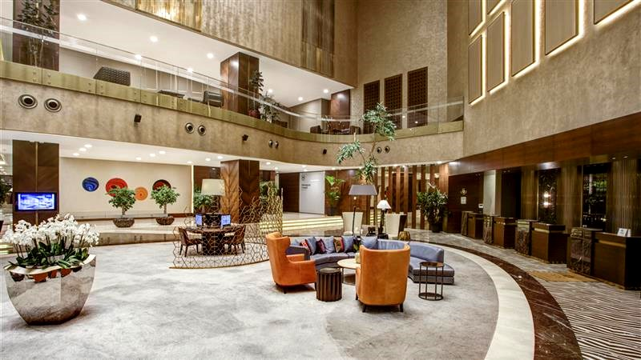

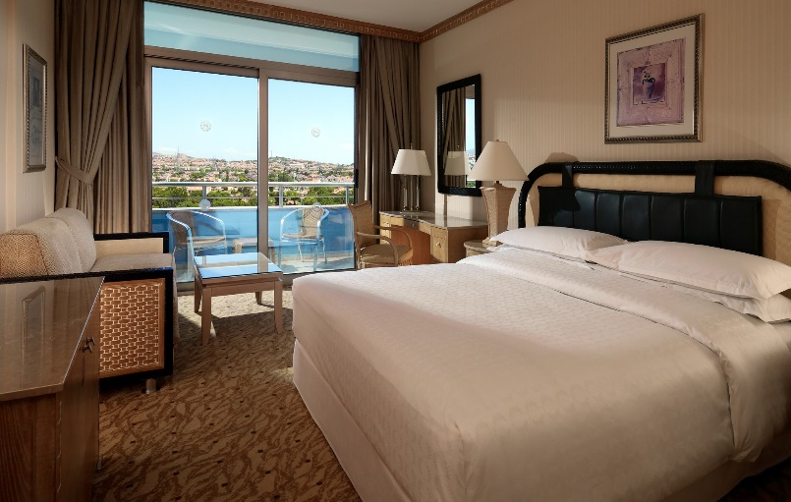
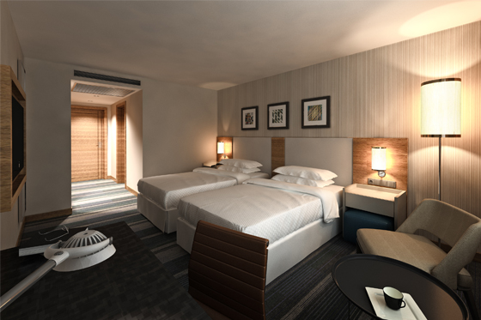

RATES PER PERSON PER NIGHT
Single Room | 200,00 €
Twin/Double Room | 150,00 €

RAMADA HOTEL *****

Ramada Hotel located 2,1 km, 5 minutes (driving) and 20 minutes walking distance to competition venue.

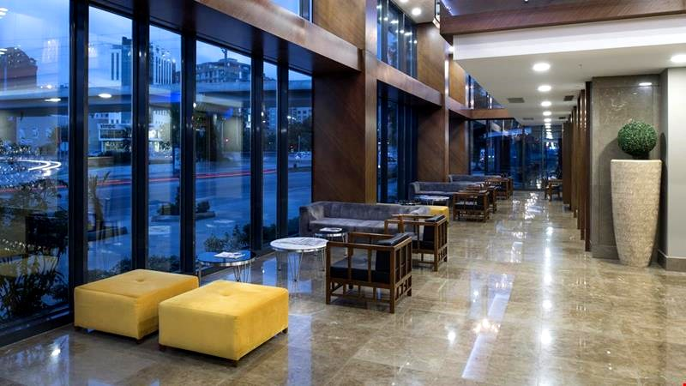

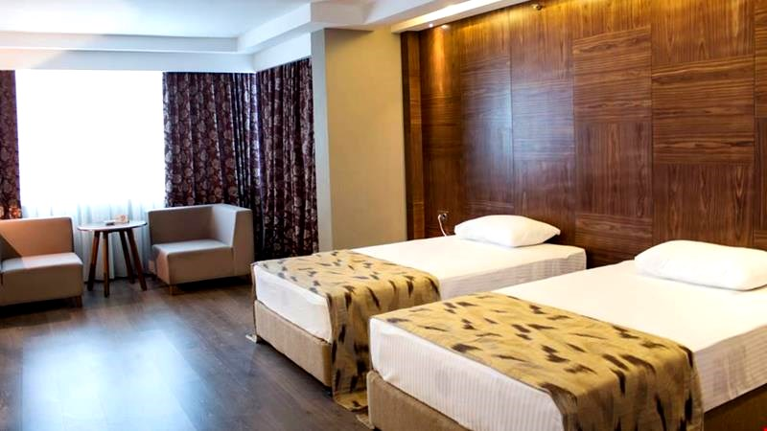
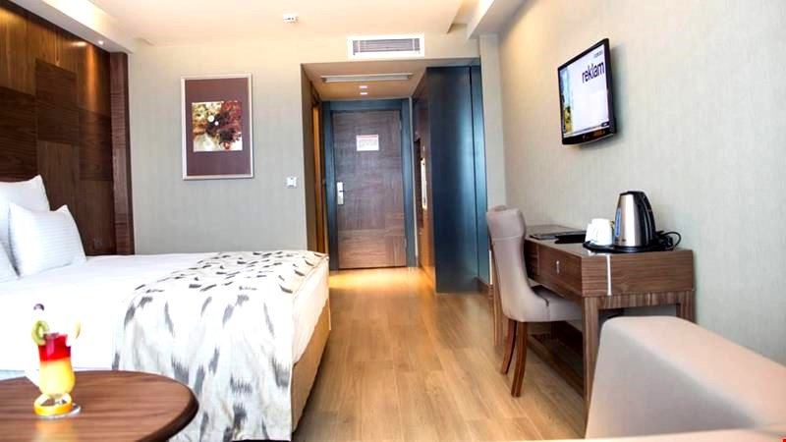

RATES PER PERSON PER NIGHT
Single Room | 160,00 €
Twin/Double Room | 120,00 €

CANCELLATIONS & CHANGES

Cancellation must be made by email to samsun2023@antalyaokculuk.org and be received before 23 January 2023 for a complete refund of deposit paid. Refunds will be processed after the event.

Any entries received after this date will not be eligible for refund. All rates for payment after deadlines are subject to additional changes without prior notice.

PAYMENT INSTRUCTION

All payments are to be made in Euros by bank transfer to:

Payment for Bank Transfer

Account Name : ANTALYA OKCULUK IHTISAS SPOR KULUBU
Bank : YAPI KREDI BANKASI
Account Number : 25086669
Swift Code : YAPITRIS

IBAN : TR 03 0006 7010 0000 0025 0866 69

We regret that credit cards and travelers’ cheques will not be accepted.

Bank transfer fee is the responsibility of the sender.

Entry and accommodation fees must be paid in full before 23 January 2023.

VISA SUPPORT

All participants who need an entry visa to Turkey, will be required to complete the Visa Support Form in WAREOS by no later than 15 November 2022.

It is the applicants’ responsibility for supplying necessary information, ensuring all details are up to date, correct and submitted by the deadlines specified.

In addition, all participants that require a visa are kindly requested to supply a copy of their latest/valid passport. Copies of each applicate can be uploaded on WAREOS. All passport copies and personal details entered/uploaded to WAREOS will be held securely and in the strictest of confidence and shared with other parties.

Please note that the Organizing Committee can provide invitation only for the period of the 2023 European Archery Indoor Championship.

LOC Contact:

Name : Sirer AYDIN

Email : samsun2023@antalyaokculuk.org

ARCHERY VENUE

The Qualification, Eliminations and Finals will be held at the Samsun Ilkadım Okculuk Tesisleri, Atatürk Bulvarı, Baruthane Mahallesi, 55100 Ilkadim, Samsun - TURKEY

TRAINING

A training field will be available starting from 11 February 2023. The training field will be located at the competition venue.

WATER ON THE VENUE

Bottled water will be provided on venue during the competition for accredited persons.

WHETHER IN SAMSUN

February (Average):
Average Temperature : 07^{O} C
Low Temperature : 04^{O} C
High Temperature : 10,6^{O} C
Sunshine Hours : 3,2 Hrs.
Rainfall Days : 13,5 days

