EUROPEAN 3D CHAMPIONSHIPS 2023 -
INVITATION PACKAGE

v.2.0

To all World Archery Europe Member Associations

Dear President, Secretary General,

On behalf of the Local Organizing Committee, I would like to invite your Country to the European 3D Championships 2023, which will be held from 25-30 September in Cesana/Sansicario Alto, Italy.

Please find enclosed all the necessary information for registration, organization, and participation for this event. To register participation, please complete the necessary details in WAREOS within the deadlines listed below.

Summary of deadlines:

Registration Opening date - WAREOS 15 May 2023
Preliminary Entries Deadline 25 June 2023
Preliminary Hotel Reservation 25 June 2023
Hotel Reservation & 50% Payment 25 June 2023
Visa Support Deadline 25 June 2023
Final Entries Deadline 8 September 2023
Entry Fee Payment Deadline 8 September 2023
Final Hotel Reservation & Full Payment 8 September 2023
Transportation & Full Payment 8 September 2023

Sincerely yours,
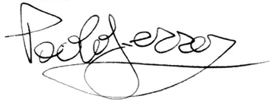
Mr. Paolo Ferrero Mr. Gabriele Giovine
LOC President Competition Manager

Website: www.field3dchamps.eu

PRELIMINARY PROGRAMME

Day | Date | Description
Day -1 | Sunday  24 September | Arrival of Delegations  Unofficial Practice field and local transportation available  Team Registration
Day 0 | Monday  25 September | Official Practice and equipment inspection  Team Managers' Meeting  Opening Ceremony
Day 1 | Tuesday  26 September | 1st Qualification Round – 24 targets unmarked
Day 2 | Wednesday  27 September | 2nd Qualification Round – 24 targets unmarked  MixedTeam Semifinals and Bronze
Day 3 | Thursday  28 September | Individual Eliminations
Day 4 | Friday  29 September | Team Eliminations and Bronze  Team & MixedTeam Gold Finals
Day 5 | Saturday  30 September | Semifinals  Individual Finals  Award & Closing Ceremony
Day 6 | Sunday  01 October | Departure of Delegations

NOTE
This preliminary programme is subject to change according to participation and TV requirements. All changes will be published and distributed in time.

PRELIMINARY & FINAL REGISTRATION

All entries, accommodation reservations, transport needs, flight arrival/departure information and visa invitation letter requests are to be completed using the World Archery Online Registration System WAREOS. These systems now handle the entire registration process for this event. No entry forms, hotel reservations or transportation forms will be accepted.
Member associations can login to WAREOS at
http://extranet.worldarchery.sport with the username and password assigned by World Archery. After entering WAREOS, selecting the event from the list will allow a member association to register their athletes. Select/press the “Entries” button to see the list of categories in the event. Select/press the “category” to enter the athlete and official numbers/details participating for that event. A WAREOS User Manual can be downloaded in PDF format (English) upon login.

Contact wareos@archery.sport with any questions regarding technical problems on
WAREOS. For any question regarding the organization of the event (transport, accommodation, meals, invoices, visa etc.) please directly contact the LOC.

A maximum number of 3 (three) athletes per country (host country included) are allowed to be registered into each category of the event.

Start date for online registration using WAREOS: 15 May 2023
Preliminary Entries Deadline using WAREOS 25 June 2023
End of Final registration using WAREOS: 8 September 2023

Please respect the stated deadlines.

Member Associations should only use WAREOS to make any changes/amendments to their entries and will be able to do so at any time. Any changes made in WAREOS an email will instantly be automatically sent to the Local Organizing Committee and Member Association with the updated information.

However, any changes that are made after the deadlines specified or if entries differ by more than 4 athletes from the preliminary entries, the following penalty fees will automatically be applied:

Penalty fees to be paid to Organizing Committee: | Cost (EURO):
Entries made after the preliminary and/or final entry deadline date. | € 50 per entry
If final entries differ from the preliminary entries by more than 4 athletes/officials. | € 150 per entry
Failure to have made preliminary entries before the deadline date but then have submitted final entries athletes/officials/teams | € 150 per entry

Any change to the final country entry list, such as (but not limited to): € 30 each
• Athlete or official name change
• Date of birth change
• Official position change

NOTE
Member Associations that have penalty fees outstanding from earlier events will need to pay these penalty fees and get good standing before being eligible to enter and compete.
Also, World Archery fee must have been paid prior the participation.

ACCOMMODATION & GENERAL INFORMATION

Important Note
Non-official accommodation is not allowed. Any team or individual accommodated in non-official hotel will not be accredited and participation in the event will be refused.

The official hotels are divided in three categories: **, ***, ****. Hotels are especially selected by the organization for the event. Hotel allocations will be made on a 'first come-first serve' basis.

Reservations should be made before 25 June 2023
Final Hotel Reservation & Transportation Forms 8 September 2023

To confirm your hotel reservations, 50% deposit of the total amount is to be paid by a bank transfer to the Organizing Committee before 25 June 2023. Reservations received after this date will be considered only according to availability.

HOTEL | Cat. | Single Room | Double Room | Triple Room | 4-People ⁽³⁾ Room | Apartment ⁽²⁾  2 people | Apartement ⁽²⁾  3 people
Chaberton ⁽¹⁾ | *** | / | € 260,00 | € 369,00 | € 492,00 | / | /
Hotel Du Col | **** | € 130,00 | € 238,00 | € 323,00 | € 398,00 | / | /
Solaris | *** | / | € 238,00 | € 323,00 | € 398,00 | / | /
La Ginestra | ** | € 121,00 | € 220,00 | € 310,00 | / | € 231,00 | € 310,00

The hotel rates are per room/per night half-board *, including free internet and free parking near the hotel. Additional purchases in the hotel bar, café and mini bar are at own expense.
*All prices are including city tax and VAT.

- Dinner at Hotel Chaberton will be in an external restaurant.
- Apartements with half-board solution in an external restaurant: please note cleaning, changing bath and bed linen will be once a week.
- Bunk beds or sofa beds may be present in four-bed rooms. Four-bed rooms can be used as triple rooms.

HOTELS

Hotel Chaberton ***  www.hotelchaberton.com | Hotel Du Col ****  www.hotelducol.com
Hotel Solaris ***  www.hotelsolaris.eu/ | Hotel La Ginestra **  www.laginestra-cesana.it

NOTE
Refer to the accommodation pages for detailed hotel information.
Please complete all the necessary sections in WAREOS and make full payment for entries, transport, and accommodation by the specified deadlines.
Bank transfers only, no credit cards or travel checks will be accepted.
ENTRY FREE
Individual: | 200 € | per athlete
Officials: | 100 € | per person
Teams: | 125 € | per team
MixedTeam: | no entry fee

Entry fees include daily local transport to and from the practice field to/from official hotels during the qualification, elimination, and finals venues (timetable to be confirmed on site).

PAYMENT CONDITIONS

All fees should be paid in full before arrival.

Payment of accommodation and local transportation: a minimum deposit of 50% of the total amount owed should be made when booking by 25 June 2023.
The final outstanding balance shall be transferred 15 days before arrival. Accommodation cannot be guaranteed after this deadline. A balance invoice will be provided via WAREOS.
Entry fee should be paid by 8 September 2023.

Bank information:

Beneficiary: P.AR.C.O. – Piemonte Arco Comitato Organizzatore
BANCA: UNICREDIT Filiale 23101 CODICE SWIFT /BIC/: UNCRITM1C01
Address: P.zza Galiberti, 26/F 10134 Torino - Italy

IBAN: IT85X0200801141000106549254

NOTE
All payments shall be made in EUR only by BANK TRANSFER.
Bank transfer fees are responsible on the sender.
Credit cards and Travel checks will not be accepted.

CANCELLATIONS & CHANGES

All cancellations and changes must be made through WAREOS:
- Cancellations received before 8 September 2023 a full refund of the deposit payment will be made.
- Cancellations received after 8 September 2023 no refund will be given.
- Refunds will be processed after the event.
- Name changes to team officials or athletes (same category and division) will be accepted up to 72 hours before the event without any additional charge.
- Should flight arrival details change last minute, please contact the Organizing Committee using the details indicated in the Team Managers’ Booklet.
- If a participant’s arrival is later than the original scheduled arrival date, the room charges will start from the dates of the original booking made by the Member Association.

ADDITIONAL INFORMATION

LUNCH
Lunch during all the event will be served at the Olympic Centre, at the venue, near to the competition fields.
All other costs incurred in the bar at the archery venue or in the hotel, like snacks, drinks, light meals, are not included in the registration fee and must be paid according to consumption by your own.
Please inform us in advance if there are any food needs and/or intolerances.

Types of lunch:
- Lunch Box (2 sandwiches + fruit + water) € 12,00 per person/a day
- Complete meal (2 courses + fruit + water) € 15,00 per person/a day

Lunches should be all paid by 8 September 2023, by bank transfer.

ACCREDITATION
Accreditation will take place at the competition venue, at Olympic Centre.
The accreditation office will be open on Saturday 23 September and Sunday 24 September from 09:00 to 18:00.
It is not possible access the practice field without the Accreditation Pass.

TEAM MANAGER MEETING
More details will be provided during the Team Manager Meeting.
The Team Manager Meeting will be held in the Olympic Centre conference room, at the venue, on Monday September 25th at 12.00 pm.

VENUE
For the European 3D Championships will be used the ski area at Olympic Centre in SanSicario Alto. Entry to the competition areas outside the official program is not allowed. The area will be available from 23 September 2023 on the practice field.

TRANSPORT
L.O.C. will provide transportation services with dedicated vehicles for Delegations and International-National Technical Officials for all days of training and competition. This service will start at the official opening of the training field until the closure and will operate for opening/closing ceremonies and arrivals/departures too. The L.O.C. will provide transportation service from September 14 until October 01, including arrival and departure transfer services from/to International airport Torino Caselle (TRN) and Milano Malpensa (MXP).

The Organizing Committee will welcome the teams from the two airports, according to the transport costs as follows:

Turin Caselle Airport - Cesana T.se: 110 Km 40,00 € per person
Cesana T.se - Turin Caselle Airport: 110 Km 40,00 € per person

Milan Malpensa Airport - Cesana T.se: 230 Km 70,00 € per person
Cesana T.se - Milan Malpensa Airport: 230 Km 70,00 € per person

Price is per person one way, including VAT.

The final deadline for transport payments is 8 September 2023.
Between airports and hotels, the organizer will use buses, small buses, vans and cars, which will depend on the number of people planned for transportation.
Transportation from airports will begin two days before the day of official practice and will end two days after the closing day.

Shuttle buses will transport athletes and officials to venues and back on fixed routes all day long. Everyday athletes will have a bus, the first in the morning, dedicated to bring them to the competition venue and/or to the training venue, departing from each official Hotel with no stops over the official routing.

INTERNET
Free WiFi will be available in the official hotels.

WATER
Water will be available at the venue free of charge.

MEDIA/PRESS
Media representatives can apply for registration by emailing: info@field3dchamps.eu

WEATHER
Cesana is located at 1,354 mt. above see and venue is located at 1,700 mt.
September is the beginning of autumn in Cesana/Sansicario, so rain and wind could be possible.
The average temperature is 13-15°C (high 20-21°C and a low 5-7°C).

DRESS REGULATION
WA & WAE dress regulations do apply.

CLOSING PARTY
On the last day, Saturday September 30, dinner will be served in the Olympic Centre. After dinner, music and dancing will take place from 20:30 to 24:00 ca.
Banquet cost is € 15,00 per person.
Party Tickets should be all paid by 8 September 2023, by bank transfer.

HOTEL ROOM COMPOSITION
L.O.C. is kindly asking to compose hotel rooms in the best way possible thinking on athletes that will compete on both events (European Field and 3D Championships).

VISA SUPPORT
All participants who need an entry Visa to Italy, will be required to complete the Visa Support Form in WAREOS no later than 25 June 2023.

It is the applicants’ responsibility for supplying the necessary information, ensuring all details are up to date, correct and submitted by the deadlines specified.

In addition, all participants that require a visa are kindly requested to supply a copy of their latest/valid passport. Copies of each application can be uploaded on

WAREOS. All passport copies and personal details entered/uploaded to WAREOS will be held securely and in the strictest of confidence and will not be shared with other parties.

Please note that the Organizing Committee can provide invitation for the period of the European 3D Championships.

L.O.C. CONTACTS

L.O.C. President Mr. Paolo Ferrero
Email: presidente@parco2023.com
Mobile: +39 347 393 0681
Language: English

Competition Manager Mr. Gabriele Giovine
Email: competitionmanager@parco2023.com
Mobile: +39 334 976 3331
Language: English

Transport Manager Mr. Alessio Corbucci
Email: trasport@field3dchamps.eu
Mobile: +39 328 321 2697
Language: English

Accommodation Manager Mrs. Barbara Camandona
Email: accommodation@field3dchamps.eu
Mobile: +39 392 4977667
Language: English

Secretary and Finance Mrs. Rosella Bertolotti/Mrs. MariaPia Martino
Email: info@field3dchamps.eu
Language: English

Website: www.field3dchamps.eu

LOCATIONS

CESANA
The town of Cesana Torinese, located at the foot of Mount Chaberton (1,354 meters above sea level) is not only an ideal place to stay in summer, but also the right place to practice many winter sports and search within its territory a complex of traditions and natural beauty.
Cesana is an important point of healthy residence, as well as transit to other locations, but also a place of convergence of the major sports facilities in the area. Cesana is in fact connected to the large ski area of the Vialattea with a chairlift that reaches the fields and slopes of the Monti della Luna and connects with the lifts of Claviere/Montgenevre (FRA), and with a cable car on the opposite side that connects with those of SanSicario and, therefore, of Sestriere.
So Cesana, with its baggage of historical traditions related to skiing, has experienced sports thrill as a protagonist, being also a place participating, in its picturesque mountain architectural theater, of the Winter Olympic Games - Turin2006. The area is located about 1,560 m above sea level, in case of bad weather it could get a little bit cold.

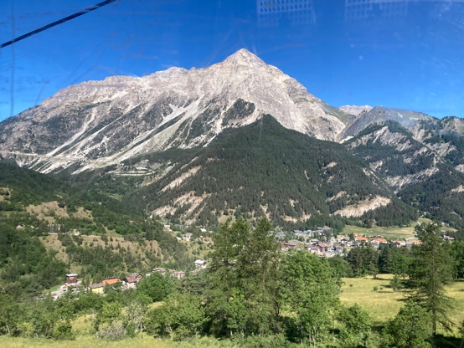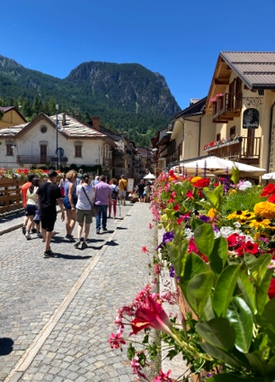

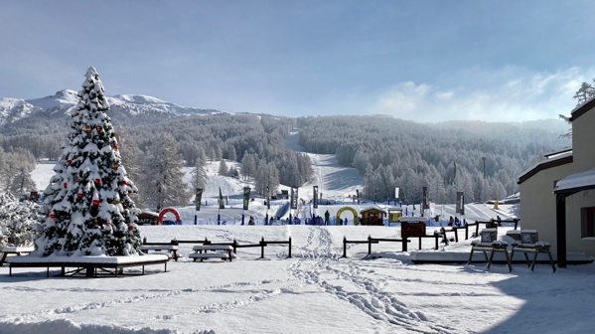

OLYMPIC CENTRE
The Olympic Centre was built in SanSicario, in the ViaLattea ski area, during the Olympic Games - Turin2006. The ski resort offers 212 slopes (7 green, 67 blue, 97 red and 41 black) and 69 ski lifts and it is characterized by large spaces, sunny and panoramic slopes that combine characteristic villages of Occitan huts with modern places equipped with all comforts. The vastness and variety of the area are able to satisfy both the most demanding skiers, thanks to the long and demanding slopes, and those who approaches the world of skiing for the first time.
The hotel has 64 rooms for a total of 200 beds, the structure is equipped with rooms for people with disabilities.
As one of Cesana Torinese's quality hotels, guests staying there will appreciate its advantageous, location and quiet atmosphere surrounded by nature with pleasant walks both summer and winter.
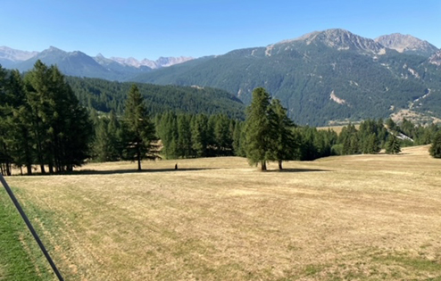
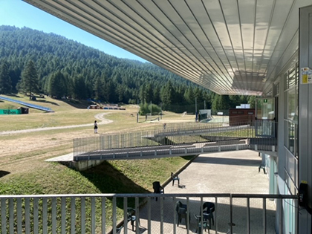
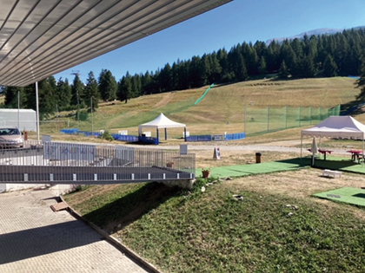
The Olympic Center restaurant offers a nice panoramic view.

