INVITATION

TO ALL WORLD ARCHERY AND WORLD ARCHERY EUROPE MEMBER ASSOCIATIONS

Dear President and Secretary General,

On behalf of the Local Organizing Committee, we would like to invite Club Teams from your country to the European Club Team Cup 2023, held from 7th to 8th October in Belgrade, Serbia.

The competition is open to female and male club teams and is reserved only for the Recurve Division.

The competition is organised according to European Club Team Cup Rules published on the WAE website.

Club teams from all continents are welcome to apply.

Belgrade is the largest city in Serbia and the country's capital. Perhaps most notable is that it is one of Europe's oldest, perpetually inhabited cities and where various cultures have met throughout history. All this significantly contributes to the city's rich culture and historic feel. The city is also located at the confluence of the Sava and Danube rivers. The view of the confluence and the city can be enjoyed from the walls of the Belgrade fortress, one of the country’s most notable historical monuments.

We invite you to visit us in Belgrade and experience our hospitality, gastronomy, and warm friendship while enjoying the sport we so dearly love.

Looking forward to welcoming you to our beautiful city and ensuring you have a great stay.

On behalf of LOC:

Aleksandra Stanković - AC Košutnjak
Dragan Svilanović - Serbian Archery Association

IMPORTANT DATES

Summary of deadlines:

Preliminary Entries Deadline 31st July 2023
Preliminary Hotel Reservation 31st July 2023
Final Entries Deadline 4th September 2023
Final Hotel Reservation & Payment (60%) 4th September 2023
Transportation 18th September 2023
Final Payment 18th September 2023
Visa Support 7th August 2023
Full refund cancellation deadline 7th August 2023

PRELIMINARY PROGRAMME

Day | Date | Description
Friday | 6th October | Arrival of the Club teams  Practice field and local transportation available Team Registration
Saturday | 7th October | Team Manager Morning Meeting Opening Ceremony  Qualification round 2 x 36 arrows Pool matches Main Event  Pool matches Secondary Tournament
Sunday | 8th October | Ranking rounds Medal matches  Award Ceremony & Closing  Departure of teams
Monday | 9th October | Departure of teams

NOTE
This preliminary programme is subject to change. All changes will be published and distributed in good time at the WAE website.

PRIZE MONEY

WAE will provide a total amount of 6.000 € to the winners as follows:

1st place 1.500 €
2nd place 1.000 €
3rd place 500 €

PRELIMINARY & FINAL REGISTRATION

All entries, accommodation reservations, transport needs, flight arrival/departure information and visa invitation letter requests are to be completed using the entry forms, hotel reservations or transportation forms attached to this document.

Please respect the stated deadlines.

ACCOMMODATION & GENERAL INFORMATION

The official hotels are ‘Trim’ and ‘Šumadija’.
The organisation specially selects hotels for the event. Hotel allocations will be made on a 'first come-first serve' basis.

Accommodation rates will offer full board, half board at ‘Trim’, and half board at ‘Šumadija’. Hotel Trim is located 2 minutes away from the competition field.
During the competition days, lunch for all competitors and officials may be provided at the restaurant ‘Trim’ near the field, either as a regular sit-down meal at the restaurant Trim or lunch box (take away). This has to be pre ordered and paid due to 18th September 2023.
To confirm your hotel reservation, a 60% deposit of the total amount will be paid by a bank transfer to the Organizing Committee before 4th September 2023.

Reservations received after this date will be considered only according to availability, and the room rate can change.

THE ROOM RATES

- Are in EUR (€) per room, per night including bed, breakfast, and dinner (HB) in both ‘Trim’ and ‘Šumadija’ and including lunch (FB) in ‘Trim’
- Including free internet in both hotels
- Including free parking
- Additional purchases in the hotel bar and mini bar are at your own expense.

BOOKING UNOFFICIAL HOTEL

Participants who may decide to book their accommodation in unofficial hotels and not through the Local Organizing Committee shall have to pay a TRIPLE entry fee. The LOC will not be responsible for providing transportation to the venue. Transport for these teams will be offered only to and from the airport/train station if submitted by the form.
Information about the competition will not be provided in unofficial hotels and other forms of accommodation.

HOTEL ‘ŠUMADIJA’ ***

Hotel ‘Šumadija’ is a three-star business hotel. It is located about 3 km from the competition court and 5 km from the city centre.
The hotel is within walking distance of Ada Ciganlija Lake, Ada Shopping Centre, and the local recreation centre. Within the hotel is a cosy restaurant serving international and national cuisine. During the summer a garden restaurant is also available. Hotel ‘Šumadija’ also has a café bar offering various kinds of coffee, beer, wine, desserts, and sandwiches. The hotel has a spa and wellness centre that performs individual massages by highly trained massage therapists. Free Wi-Fi and Parking are available.

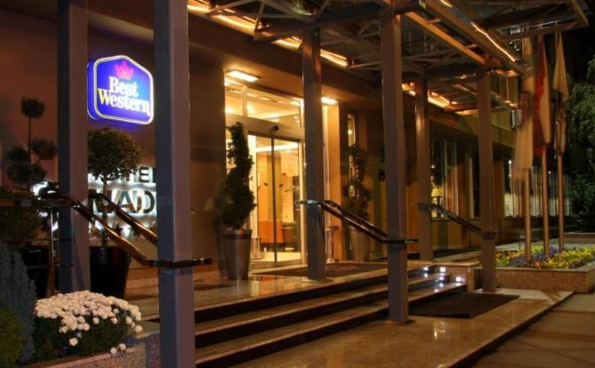
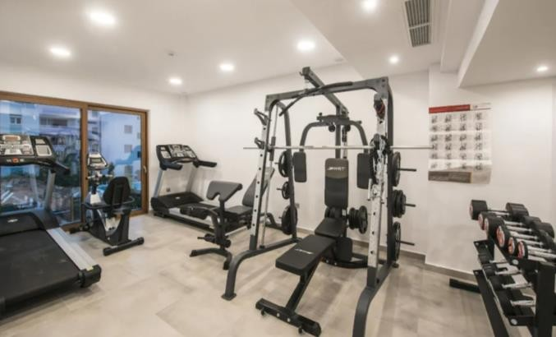
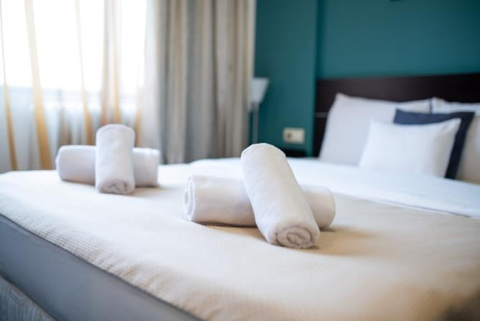
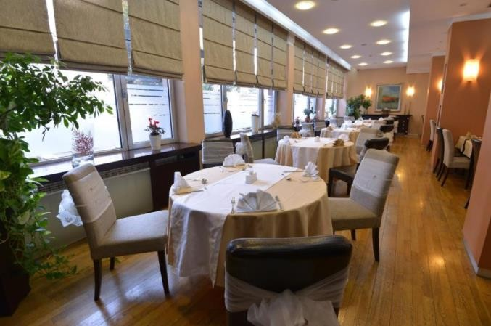

HOTEL ‘TRIM’ **

Hotel ‘Trim’ is a two-star sports-oriented hotel located within the green oasis aimed at sports and recreation enthusiasts. Located at one of the most beautiful parts of Belgrade, Košutnjak, a landscaped park forest with numerous sports and recreational facilities, Hotel ‘Trim’ is a great choice for anyone looking to enjoy nature and physical activity.
This hotel, for years, has been the number one choice of national and Olympic teams during the competition preparations since it’s part of the Serbian Institute and Sports Medicine complex.
It is a 2-minute walk from the competition court, and 9 km from the city centre. The hotel is close to numerous restaurants that offer various national and international cuisine and the Ada Lake and Ada Shopping Centre. The hotel also has its own restaurant that offers various dishes.
Hotel ‘Trim’ offers free Wi-Fi and free parking.

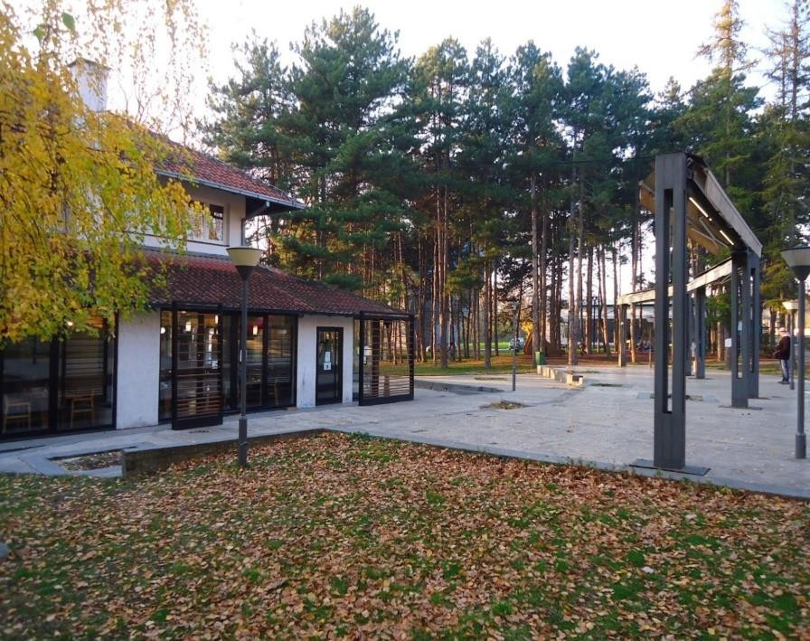
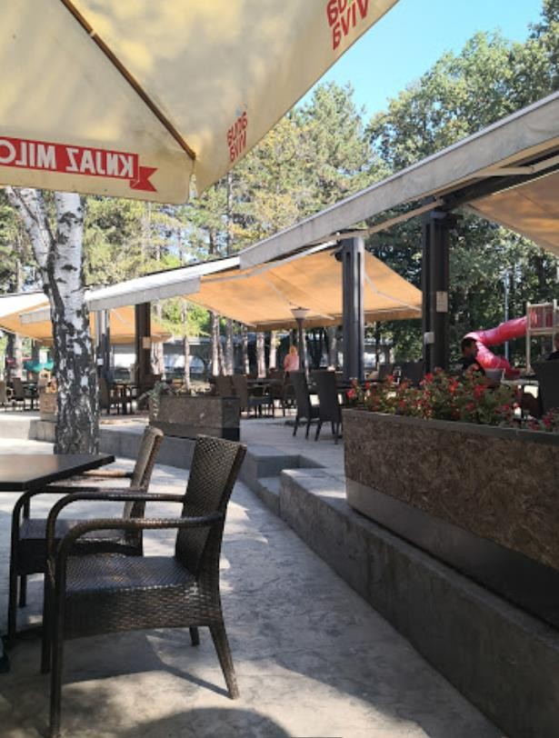

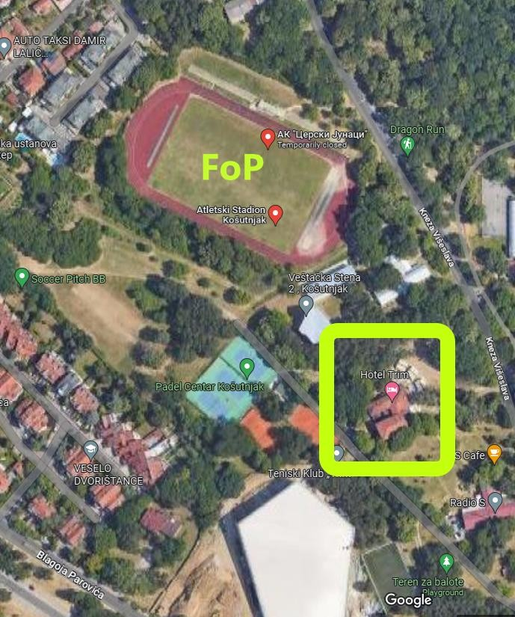

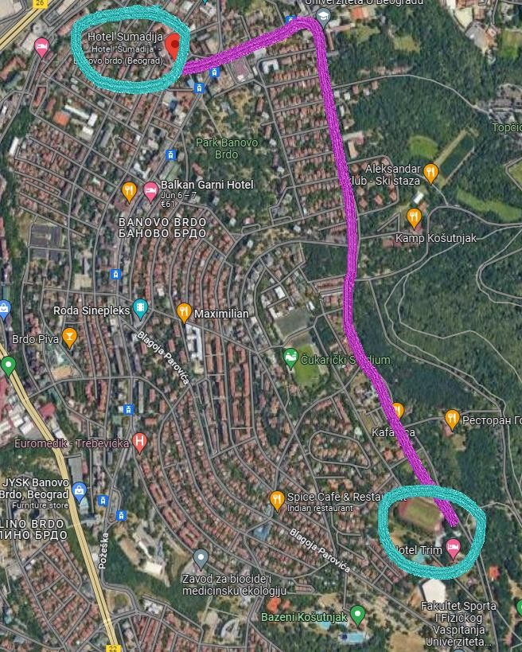
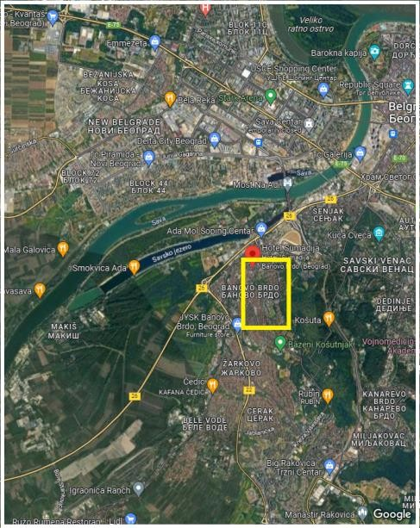

ADDITIONAL INFORMATION

Entry Fees

Club team: € 200 per club team.

Entry fees include daily local transport to and from the FoP to/from official hotels during the qualification, elimination, and finals - competition days.
Timetable is to be confirmed.

Transportation

The OC will collect the teams from the Belgrade airport.

Transportation fees from Belgrade Nikola Tesla Airport (BEG) to Official Hotels are as follows:
  - by car (1 - 3 persons) € 35 /person (one way)
  - by van (4 - 7 persons) € 25 /person (one way)
  - by minibus (8 - 16 persons) € 20 /person (one way)

The deadline for payment of the transportation fee is 18th September 2023.
The organiser will use buses, small buses, vans and cars between airports and hotels, depending on the number of persons scheduled for transportation. Transportation from the airports will start before the official practice day (5th October) and end the day after the closing day (9th October).
A daily shuttle service will be available for the tournament days from the Official Hotel to the competition venue and back - free of charge.

Meals

  - lunch € 20 /person
  - lunch box € 10 /person

Visa

Serbia is not a member of the European Union.
Please contact your foreign office if your team requires a visa for Serbia.

Participants who need a formal visa and Invitation letter to enter Serbia must complete the Visa Form no later than 7th August 2023.

The applicant is responsible for supplying the necessary information, ensuring all details are up to date, correct and submitted by the specified deadlines. In addition, all participants that require a visa are kindly requested to supply a copy of their latest/valid passport.

Please ensure your passport is valid for at least six months from entering Serbia, or you may not be admitted. If help is needed, you may contact us immediately.

PAYMENT CONDITIONS

All fees should be paid in full before arrival.

Payment of accommodation and local transportation: a minimum deposit of 60% of the total amount owed should be made when booking by 4th September 2023.
The final outstanding balance shall be transferred before 18th September 2023.
Accommodation cannot be guaranteed after this deadline. LOC will provide a balance invoice.

Due to Serbian Tax policy, the entry fee should be paid separately.

Bank information for Accommodation & Transportation

BANK: OTP BANKA SRBIJA A.D.
ACCOUNT HOLDER NAME: STRELICARSKI KLUB KOSUTNJAK

ADDRESS: PERE VELIMIROVICA 72, RAKOVICA, SERBIA
ACCOUNT NO: RS35325960170007256648
BIC/SWIFT CODE: OTPVRS22

Bank information for Entry Fees

BANK: OTP BANKA SRBIJA A.D.
ACCOUNT HOLDER NAME: STRELICARSKI KLUB KOSUTNJAK

ADDRESS: PERE VELIMIROVICA 72, RAKOVICA, SERBIA
ACCOUNT NO: RS35325960170007256648
BIC/SWIFT CODE: OTPVRS22

NOTE: All payments shall be made in EUR only by BANK TRANSFER. Bank transfer fees are the responsibility of the sender. Credit cards and Travel checks will not be accepted.

CANCELLATIONS & CHANGES

The following conditions will apply:

- Cancellation received before 7th August 2023 full refund of the paid deposit
- Cancellation received after 7th August 2023 no refunds
- All refunds, if any, will be processed after the event

LOC must be informed about travel programme changes 48 hours before arrival. If your arrival is later than your original schedule, the room charges start from the original date indicated by the Club.

TRAINING

Training venues will be available starting from 5th October 2023.
For teams wishing to arrive early and practice at a practice field, we would be happy to organise training sessions at Archery Club ‘Košutnjak’, located a 10-minute drive from both hotels.

Please let us know by 4th September 2023 if you plan on coming early and attending training sessions. Transfer between the court and either of the hotels is not included in the competition's price but can be arranged if necessary.

Internet
Free WiFi will be available in the official hotels (in hotel rooms and the lobby).

Meals
The lunch is foreseen to be served at hotel ‘Trim’. Team managers can also request a lunch box to dine at FoP during the official days.

Water
Will be available at the venues free of charge.

Media Registration
Media representatives can apply for registration by emailing ectc2023@archery.co.rs

Weather
Monthly Averages in October - Belgrade
Min Temperature: 10°C Max Temperature: 18°C Daylight Hours: 11 Humidity: 67% Rainfall: 31 mm Rainy Days: 9

Dress regulations
WA & WAE dress regulations apply, please comply with ECTC Rules.

Opening & Closing Party
Banquet or closing party will not be organised.

Other notes
By signing in, the Club team declares that:

- Club team’s Member Association is in good standing
- All competitors and officials are covered in case of illness or accident
- Club team members have signed the WA Anti-Doping Agreement
- All archers of the Club team belong to the same club and are its members at least from 1st January 2023
- All competitors and officials allow his/her person, name, pictures, or sports performance to be used for advertising purposes.

HEALTH REGULATIONS (COVID-19)

Information

- Everybody should follow the Government/public health authorities measures (national and sport-specific regulations) and be aware of the travel restrictions.
- For your information, the medical infrastructure/Hospital with proper care will be reachable within 20 minutes from the venue.

Personal Hygiene and Health Advice

- Anyone due to participate in the event who is feeling ill should not attend.
- Participants (athletes, volunteers, officials etc.) should proactively and regularly check their health status (including taking their temperature and monitoring for symptoms).
- Contact a healthcare provider immediately if any respiratory illness is noted.
- Regularly and thoroughly clean your hands with an alcohol-based hand rub or wash them with soap and water.
- Avoid touching the eyes, nose, and mouth.
- No spitting, as respiratory secretions are the main mode of virus transmission.
- Athletes should not share clothing, bar soap, sports equipment, water bottles or other personal items.

LOC CONTACT

President of Organizing Committee
Entry Fees: Aleksandra Stanković
Email: ectc2023@archery.co.rs
Mobile: +381 60 3340460
Language: English and Serbian
Official website: www.ectc2023.archery.co.rs

General Secretary of Serbian Archery Association
Info: Zaviša Lučić
Email: strelicarskisavezsrbije@gmail.com
Mobile: +381 64 3090779
Language: English and Serbian
Official website: www.serbianarchery.com

Transport, Accommodation & Finances
Info: Zaviša Lučić
Email: ectc2023@archery.co.rs
Mobile: +381 64 1436856
Language: English and Serbian

PRELIMINARY HOTEL RESERVATION FORM

Club team and Member Association: Contact person: Mobile: E-mail:

Hotel ‘ŠUMADIJA’ ***
Number of Rooms: 10 Economy Twin, 15 Economy Double, 22 Standard Twin, 31 Standard Double Single-use HB € 80
Economy Double/Twin HB € 120
Standard Double/Twin HB € 140
Do you require a room for a disabled team member?

Yes No

If yes, please specify:

Do any of your team members have dietary requirements or allergies such as vegetarian, nut allergies or gluten-free etc.?

Yes No

If yes, please specify:

Hotel ‘TRIM’ **
Number of Rooms: 12 Single, 12 Double, 1 Triple
Single FB € 70 HB € 50
Double FB € 140 HB € 100
Triple FB € 180 HB € 120
Do you require a room for a disabled team member?

Yes No

If yes, please specify:

Do any of your team members have dietary requirements or allergies such as vegetarian, nut allergies or gluten-free etc.?

Yes No

If yes, please specify:

Hotel ‘TRIM’ annex **
Number of Rooms: 4 Single, 3 Double, 3 Triple Single FB € 60 HB € 40
Double FB € 120 HB € 80
Triple FB € 150 HB € 90
Do you require a room for a disabled team member?

Yes No

If yes, please specify:

Do any of your team members have dietary requirements or allergies such as vegetarian, nut allergies or gluten-free etc.?

Yes No

If yes, please specify:

Accommodation Payment:

Room type | Amount of rooms | Night rate | Total rate
Single | x | x € | = €
Double | x | x € | = €
Triple | x | x € | = €

TOTAL ACCOMMODATION AMOUNT: €

DEPOSIT 60% OF THE TOTAL AMOUNT: €

PLEASE RETURN THIS PRELIMINARY HOTEL RESERVATION FORM TO THE ORGANISERS by email
to ectc2023@archery.co.rs AND PAY THE DEPOSIT BEFORE 4th September 2023.

Date: Signature of President / Secretary General

TRANSPORTATION FORM

Club team and Member Association:

Number of passengers:

Arrival information

We will arrive by plane:

Airport: Flight Nr:

Date: Arrival Time:

We will arrive to Belgrade by:

Departure information

We will depart by plane:

Airport: Flight Nr:

Date: Departure Time:

We will depart from Belgrade by:

PLEASE RETURN THIS TRANSPORTATION FORM TO THE ORGANISERS BEFORE
18th September 2023. by email to ectc2023@archery.co.rs

Date: Signature of President / Secretary General

VISA INVITATION LETTER FORM

Club team and Member Association:

Contact person:

First name |  | Family name | Date and place of birth | Citizenship /Country/
No | Address of residence |  |  | Passport
 |  |  |  | Number | Expiration
1
2
3
4
5
6
7

PLEASE RETURN THIS VISA INVITATION LETTER FORM TO THE ORGANISERS BEFORE
7th August 2023 by email to ectc2023@archery.co.rs

Date: Signature of President / Secretary General

FINAL BUDGET FORM

Club team and Member Association:

Contact person:

Mobile: E-mail:

1) ENTRY FEES
Posit | Cost | Number of athletes |  |  |  | Total
Club team in official hotel | € 200 | x |  |  |  | = €
Club team in unofficial hotel | € 600 | x |  |  |  | = €
Total 1 |  |  |  |  |  | €
2) ACCOMMODATION
2/1 HOTEL - HALF BOARD
Room |  | Cost Nr. of rooms |  |  |  | Nr. of nights Total
Hotel ‘ŠUMADIJA’ *** - Single room |  |  | € 80 | x |  | x | = €
Hotel ‘ŠUMADIJA’ *** - Economy Double/Twin |  |  | €120 | x |  | x | = €
Hotel ‘ŠUMADIJA’ *** - Standard Double/Twin |  |  | €140 | x |  | x | = €
Hotel ‘TRIM’ ** - Single room |  |  | € 50 | x |  | x | = €
Hotel ‘TRIM’ **- Double room |  |  | €100 | x |  | x | = €
Hotel ‘TRIM’ ** - Triple room |  |  | €120 | x |  | x | = €
Hotel ‘TRIM’ annex ** - Single room |  |  | € 40 | x |  | x | = €
Hotel ‘TRIM’ annex **- Double room |  |  | € 80 | x |  | x | = €
Hotel ‘TRIM’ annex ** - Triple room |  |  | € 90 | x |  | x | = €
Total 2/1 |  |  |  |  |  |  | €

2/2 HOTEL - FULL BOARD
Room  Hotel ‘TRIM’ ** - Single room | Cost  € 70 | x | Nr. of Rooms | x | Nr. of nights | Total  = €
Hotel ‘TRIM’ ** - Double room | €140 | x |  | x |  | = €
Hotel ‘TRIM’ ** - Triple room | €180 | x |  | x |  | = €
Hotel ‘TRIM’ annex** - Single room | € 60 | x |  | x |  | = €
Hotel ‘TRIM’ annex**- Double room | €120 | x |  | x |  | = €
Hotel ‘TRIM’ annex** - Triple room | €150 | x |  | x |  | = €
Total 2/2 |  |  |  |  |  | €

3) TRANSPORTATION
Airport | Cost | Number of Persons | Total
BELGRADE | € 35 by car | x | = €
 | € 25 by van | x | = €
 | € 20 by minibus | x | = €
Total 3 |  |  | €

4) EXTRA MEALS (optional)
Lunch | Cost  € 20 | Number of Persons  x | Total  = €
Lunch box | € 10 | x | = €
Total 4 |  |  | €
TOTAL 1+2+3+4 |  |  | €

PLEASE RETURN THIS BUDGET FORM TO THE ORGANISERS BEFORE 4th September 2023 by email
to ectc2023@archery.co.rs

Date: Signature of President / Secretary General

PARTICIPATION FORM

Return until 4th September 2023

Member Association: Club Name: Contact Person: Mobile Phone Number: Email Address:

MEN’S TEAM

Participant | Passport number | Expiry date | Name | Surname | Date of birth dd/mm/yy | Note
Official
Archer
Archer
Archer
Archer

WOMEN’S TEAM

Participant | Passport number | Expiry date | Name | Surname | Date of birth dd/mm/yy | Note
Official
Archer
Archer
Archer
Archer

Tournament Sponsors:

