…..........................................................................................................................................................................

INVITATION

TO ALL WORLD ARCHERY MEMBER ASSOCIATIONS 29 November 2022

Dear President,
On behalf of the Organizing Committee and Archers Association of Slovenia we are pleased to invite you to the 2023 European Youth Cup 1st Leg that will be held in Čatež, Slovenia, 01-06 May 2023.
This event will be organized following the WA and WAE YOUTH CUP RULES for Under 21 Women, Under 21 Men, Under 18 Women and Under 18 Men classes, Recurve and Compound divisions in the Outdoor Target Archery discipline.

THE PARTICIPATION IS OPEN TO ALL WORLD ARCHERY MEMBER ASSOCIATIONS.

Please, find enclosed the necessary documents concerning the registration, organization and participation in this event. To register participation, please complete all the necessary sections in WAREOS within the deadlines listed below:
Registration Opening Date - online WAREOS 22 December 2022
Preliminary Entries Deadline 1 March 2023
Preliminary Hotel reservation and payment 1 March 2023
Final Entries Deadline 10 April 2023
Final Hotel reservation 10 April 2023
Transportation 10 April 2023
Final Payment 10 April 2023
Visa Application 20 March 2023

We are looking forward to welcoming you and we are sure you will enjoy your stay in Čatež.

Yours sincerely

Irena Rosa Marjan Ilar
Event Manager & President of the Organizing Committee &
Competition Manager President of Archers Association of Slovenia

Website: http://www.archeryeurope.org
E-mail: oc-catez@archery-si.org
Info: +386 (0)31 633 851 Ms Irena Rosa
…..........................................................................................................................................................................

PRELIMINARY PROGRAMME

Saturday 29 April 2023 Arrival of Delegations
Unofficial Practice
Team Registration

Sunday 30 April 2023 Arrival of Delegations
Unofficial Practice
Team Registration

Monday 1 May 2023 Opening
Official practice and Equipment inspection
Team Managers' Meeting at the Terme Hotel in Čatež

Tuesday 2 May 2023 Qualification round Under 18
Qualification round Under 21

Wednesday 3 May 2023 Mixed Teams

Thursday 4 May 2023 Individual Eliminations – up to Semifinals

Friday 5 May 2023 Team Eliminations and Finals
Team & Mixed Team Awarding

Saturday 6 May 2023 Individual Finals
Award Ceremony/Closing Ceremony
Disco party

Sunday 7 May 2023 Departure of Delegations

Note: This preliminary program is subject to changes according to the number of participants.
All changes and necessary information will be published and distributed in good time.

Website: http://www.archeryeurope.org
….................................................................................................................................................................

PRELIMINARY & FINAL REGISTRATION

No entry forms will be available for registering for this event. The registration process should be done using the World Archery Online Registration System (WAREOS).

The number of athletes that may be entered by a Member Association is limited to four (4) in each category.

All World Archery MA’s are eligible to compete in European Youth Cup competitions, but only the results of the athletes from WORLD ARCHERY EUROPE MA’s will be taken in consideration for the Youth Cup Circuit.

In order to use WAREOS, please login on https://extranet.worldarchery.sport/with your Username and Password assigned by World Archery. For any questions regarding the WAREOS, please contact the World Archery office wareos@archery.sport

Starting date of online-registration with WAREOS is: | 22 December 2022
End of Preliminary registration: | 1 March 2023
End of Final registration: | 10 April 2023

Please respect the stated deadlines.

Member Associations should only use WAREOS to make any changes/amendments to their entries and will be able to do so at any time. Any changes made in WAREOS an email will instantly be automatically sent to the Organizing Committee and Member Association with the updated information.

However, any changes that are made after the deadlines specified or if entries differ by more than
4 participants from the preliminary entries, the following penalty fees will automatically be applied:

Penalty fees to be paid to Organizing Committee: | Cost (EURO):
Penalty fee for late entries (after the final deadline) | 45 per entry
Penalty fee for not filling Preliminary entries | 140 per entry
Penalty fee for differences between preliminary and final entries *: | 140 per entry
*If the difference between final and preliminary entries number is more than 4 athletes/officials

Any entries received less than 3 days before the team managers meeting will be refused if no preliminary entry and/or final entry are made prior.

As a final note, only Member Associations in good standing will be eligible to compete. This means that World Archery fee must have been paid prior the participation.
…..........................................................................................................................................................................

ACCOMMODATION & GENERAL INFORMATION

The official hotels are 4* and 3* stars category hotels TOPLICE HOTEL and ČATEŽ HOTEL in Čatež,
standing next to each other in Čatež Spa.

The room rate:
- is per room per night,
- include full board accommodation, taxes and VAT
- include use of the swimming pool in hotel Terme and Čatež
- include use of the summer or winter thermal riviera – free entrance twice per day
- include free parking in front of the hotel for cars, minivans and busses
- internet in the hotel lobby and rooms

HOTEL | Category | Single room  Price per room per night - full board | Double room  Price per room per night - full board
TOPLICE | **** | € 150 | € 220
ČATEŽ | *** | € 130 | € 200
Lunch during the competition days will be served in the restaurant of the Hotel.
TOPLICE HOTEL Terme Čatež d.d., Topliška 35, SI - 8251 Čatež ob Savi
Coordinates: 45.89192 15.621547

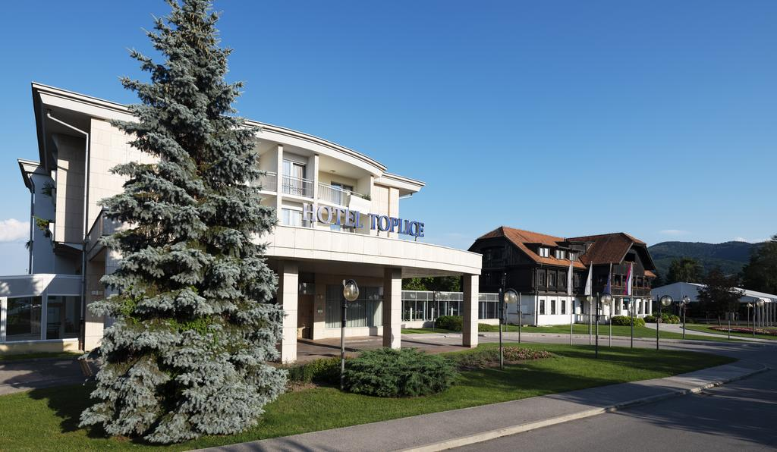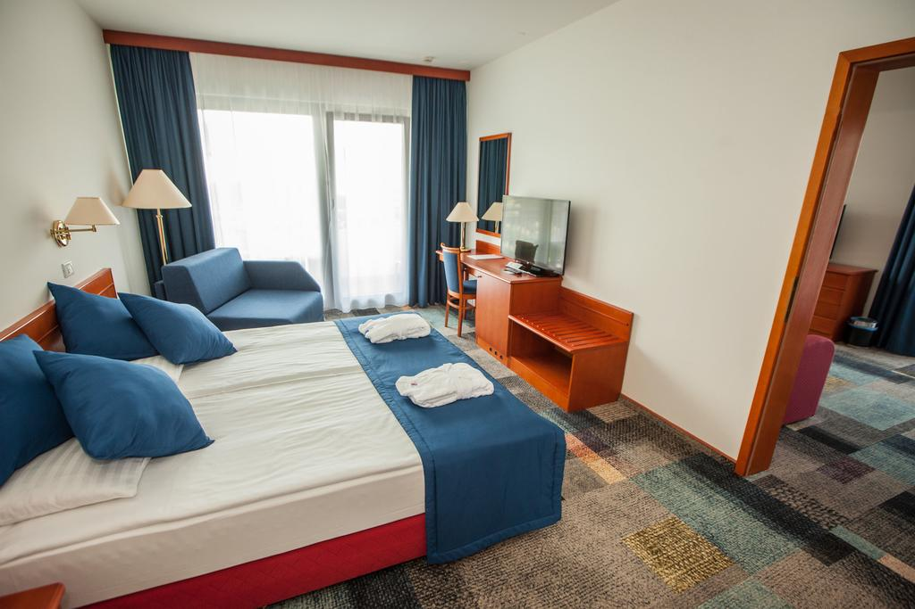

ČATEŽ HOTEL Terme Čatež d.d., Topliška 35, SI - 8251 Čatež ob Savi
Coordinates: 45.89192 15.621547


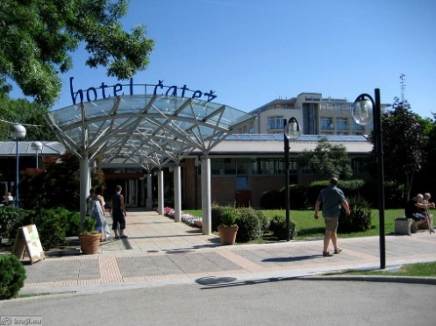
…..........................................................................................................................................................................
Welcome to the largest water park in Central Europe and unlimited water fun, 365 days a year!

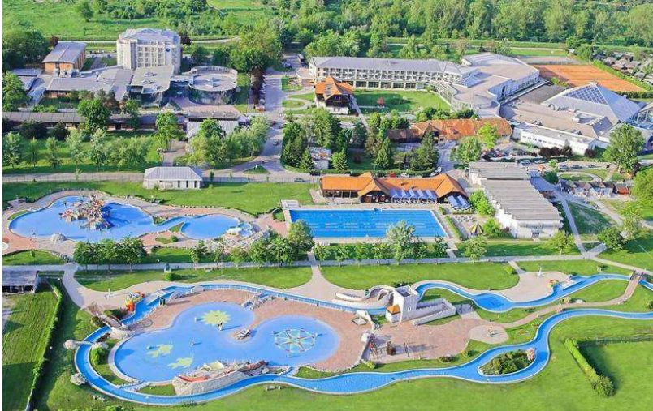
Winter Thermal Riviera
As temperatures start to decline, dive into a water adventure at the Winter Thermal Riviera. Ride your wave on a surfing route, slide down a jumping toboggan or a kamikaze toboggan, and the youngest can enjoy the magical world of a pirate ship.

Summer Thermal Riviera
From the end April until October, under the caressing warm sun, the Thermal Riviera will impress you with numerous water slides, lazy river, pools with waves, children's water park...

Reservations should be made before 1 March 2023.

To confirm the reservation, a 60% deposit of the total amount is required to be bank transferred to the OC before 1 March 2023. Reservations after this date will be considered only according to availability, the room rate can change and we cannot guarantee rooms in the official hotel.

Final Hotel Reservations and remaining payment should be made before 10 April 2023.
Note: Please ensure that you complete all the necessary forms by the specified dates and make full payment for the accommodation at the time of booking. See detailed payment instructions below.

It is mandatory to choose the official hotel listed by the Local Organizing Committee. A delegation choosing a non-official hotel will not be allowed to participate in the event.
.............................................................................................................................................................................
ADDITIONAL INFORMATION
Entry fees
Individual: 85 € per athlete
Officials: Free
Teams: Free

Transportation fees from/to the airports
The OC will collect the teams from the two airports. You have to pay the transportation fee /including arrival and departure/ as follows:
ZAGREB International Airport – Hotel: 30 € per person CRO (50km)
Hotel - ZAGREB International Airport: 30 € per person CRO (50km)
LJUBLJANA International Airport - Hotel: 45 € per person SLO (130km)
Hotel - LJUBLJANA International Airport: 45 € per person SLO (130km)
Be aware that Zagreb is in Croatia and some countries might need visa for Croatia.

The last date for the payment of the transportation fee is 10 April 2023.

From the airports to the hotel /return trip), the organiser will use buses, small buses, vans and cars, what will depend of number of persons scheduled for transportation.
Transportation from the airports will start two days before the official practice day and will end two days after the closing day.

Cancellations & Changes
Following conditions will apply:
- cancellation received before the final entry: full refund of the paid deposit
- cancellation received after the final entry: no refunds

All rates for payments after deadlines are subject to additional charges without prior notice.
All refunds, if any, will be processed after the event.

OC has to be informed about changes in the travel programme 72 hours prior arrival. If your arrival is later then your original schedule, the room charges are starting from the original date indicated by the Member Association.

Meals at the venue
Lunch will be served in the restaurant of the hotel.

Drinking water will be available at lunch and at dinner and on the competition field free of charge.
All other costs made in cafeteria at the archery venue or in the hotel /snacks, drinks, small meals/ are not included in the entry fee and must be paid on consumptions.

Please inform us if you have special requirements for food and specify it.
.............................................................................................................................................................................
Accreditation and Team Managers Meeting
Accreditation will take place upon arrival of teams in the lobby of the Hotel Čatež 29 and 30 April 2023. Accreditation office will be open from 09:00 till 21:00. Accreditation cards will be possible to issue from Monday 1 May on the competition area only with the additional payment of 50 € per person.

For all Ceremonies WA dress code is obligatory.
More details will be provided at the Team Manager’s Meeting.
Team Managers Meeting will be held in the conference room in the hotel on Monday, 1 May 2023.

Training and Competition Field
For European Youth Cup the football sport fields will be used. Fields are in walking distance from hotels.

The practice field will be available starting from 28 April 2023 in Čatež Spa.

Central European Cup
For those teams who will plan to arrive earlier and those who might choose to arrive earlier for this purpose, we would like to inform you that on Sunday, 30 April 2023 there will be a Central European Cup tournament (70m/50m Round with Eliminations and Finals) organized on the same competition field in Terme Čatež d.d., Topliška 35, SI - 8251 Čatež ob Savi . The tournament is open to all classes Recurve and Compound. The Entry fee for this tournament will be 20,00 €. The invitation will be published on the federation web site: www.archery‐si.org.

Visas
All participants who need an entry visa to Slovenia, will be required to complete the Visa Support Form in WAREOS by no later than 20 March 2023.

It is the applicants’ responsibility to supply the necessary information, ensuring all details are up to date, correct and submitted by the deadlines specified.

In addition, all participants that require a visa are kindly requested to supply a copy of their latest/valid passport. Copies of each applicant can be uploaded on WAREOS. All passport copies and personal details entered/uploaded to WAREOS will be held securely and in the strictest of confidence and not shared with other parties.

Please note that the Organizing Committee can provide invitation for the period of the European Youth Cup in Čatež only.

As long as the Organizing Committee gets no different information, the Invitation Letter will be sent by email. If an express service should be desired, this service will be charged to the MA and must be paid to the Organizing Committee upon arrival.

Those teams that want to land in Zagreb airport must be aware that they might need visa for Croatia.
In this case we might not be able to help you.

Please note: the deadline for Visa Invitation Letter Form is 20 March 2023.
.............................................................................................................................................................................
Disco Party *
On the final day - Saturday, 6 May 2023, after the dinner the Disco party will be organized free of charge, if possible (depending on requirements due to health protection).
Drinks and snacks are not included and must be paid on consumptions.

Internet
Free of charge in all locations of Spa Čatež.
Website
The official website of the competition is http://www.archeryeurope.org

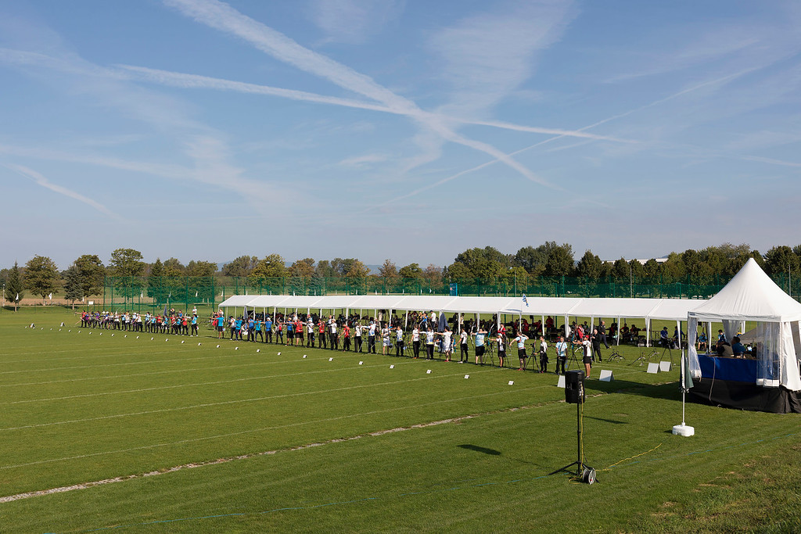

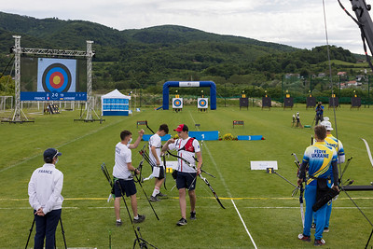
............................................................................................................................................................................

PAYMENT INSTRUCTIONS

BANK: NOVA LJUBLJANSKA BANKA d.d.
Address: Trg republike 2
1000 Ljubljana
Slovenia
A/C NAME LOKOSTRELSKA ZVEZA SLOVENIJE
Address: Stožice 28
1000 Ljubljana
Slovenia

SWIFT CODE /BIC/: LJBASI2X
IBAN: SI56 0201 3001 7204 321

…..........................................................................................................................................................................
NOTE:
ALL PAYMENTS ARE REQUIRED TO BE DONE IN EUROS BY BANK TRANSFER LATEST 10 April 2023!
ALL BANK TRANSFER FEES HAVE TO BE PAID BY PARTICIPATING MAs, you need to state OUR option when paying.

IN CASE OF NOT PAYING THE BANK TRANSFER FEES, YOU WILL BE CHARGED FOR THE DIFFERENCE UPON ARRIVAL, AT THE ACCREDITATION.

- NO CREDIT CARDS
- NO TRAVEL CHECKS

IN CASE YOU WILL BRING CASH, YOU WILL BE CHARGED FOR EXTRA BANK COSTS FOR DEPOSIT,
1% OF THE DEPOSIT.

PLEASE SEND THE COPY OF THE BANK TRANSFER TO THE ORGANIZER by email to
oc-catez@archery-si.org

OC contacts

For all matters
Ms Irena Rosa - 24 hours English
Mobile +386 (0)31 633 851
E-mail: oc-catez@archery-si.org

For questions about visa support
Mr Marjan Ilar - 24 hours English
Mobile +386 (0)41 788 907
E-mail: oc-catez@archery-si.org
............................................................................................................................................................................

Photos from Youth Cup event Čatež 2019

