Dear President

INVITATION

On behalf of the organizing committee and the Swiss Archery Federation, we are pleased to invite you to the European Youth Cup 2023. The EYC Sion 2023 will take place in Switzerland in SION VS from 5 to 10 June 2022.
This event will be organized following the WA and WAE YOUTH CUP RULES for Under 21 Women, Under 21 Men, Under 18 Women and Under 18 Men age classes, for both the Recurve and Compound divisions in the Outdoor Target Archery discipline.
The European Youth Cup - 2nd leg 2023 in Sion is a very good opportunity for an optimal preparation for the World Archery Youth Championships in Limerick, Ireland.
Please, find enclosed the necessary documents concerning the registration, organization, and participation in this event. To register participation, please complete all the necessary sections in WAREOS within the deadlines listed below:
Summary of deadlines:

Registration opening date on WAREOS | 12.01.2023
Preliminary entries deadline | 07.03.2023
Hotel reservation down-payment (50%) | 07.03.2023
Hotel reservation and payment | 15.05.2023
Final Entries | 15.05.2023
Full refund cancellation deadline | 15.05.2023
Visa Application | 01.05.2023

We are looking forward to your visit to Switzerland. We are sure you will enjoy your stay in the beautiful canton of Valais, an alpine region with a world-renowned mountain world and a strong cultural heritage.
PARTICIPATION IS OPEN TO ALL MEMBER FEDERATIONS OF WORLD ARCHERY.

Maël Loretan  LOC und Organisation-Manager | Maël Loretan  President SwissArchery Association
Angela Hunsperger  LOC / OK - Sekretariat / E- Mails | Yves Loretan  LOC und Stv. Organisation-Manager
Website: http://www.archeryeurope.org Website: https://eyc2023.org
LOC-E-Mail: infos@eyc-sion.ch / administration@eyc-sion.ch
Info: +41 78 225 67 16

Preliminary programme

Saturday | 3 June 2023 | Arrival Delegation  Unofficial Practice National Tournament
Sunday | 4 June 2023 | Arrival Delegation
Unofficial Practice
Team Registration
 |  | National Tournament
Monday | 5 June 2023 | Official Practice and Equipment Inspection
 |  | Team Managers' Meeting at the Moxy Hotel
 |  | Sion Opening Ceremony
Tuesday | 6 June 2023 | Qualification round Under 18
 |  | Qualification round Under 21
Wednesday | 7 June 2023 | Mixed Teams
Thursday | 8 June 2023 | Individual Eliminations - up to Semifinals
Friday | 9 June 2023 | Team Eliminations and Finals
 |  | Team & Mixed Team Awarding
Saturday | 10 June 2023 | Individual Finals  Award Ceremony/Closing Ceremony
 |  | Disco party
Sunday | 11 June 2023 | Departure of Delegations

Note: This preliminary program is subject to changes according to the number of participants. All changes and necessary information will be published and distributed in good time.

PRELIMINARY & FINAL REGISTRATION
No entry forms will be available for registering for this event. The registration process must be done using the World Archery Online Registration System (WAREOS).
The number of athletes that may be entered by a member association is limited to four (4) in each category.
All World Archery MA’s are eligible to compete in European Youth Cup competitions, but only the results of the athletes from WORLD ARCHERY EUROPE MA’s will be taken in consideration for the Youth Cup circuit.
In order to use WAREOS, please login on https://extranet.worldarchery.sport/with your username and password assigned by World Archery. For any questions regarding the WAREOS, please contact the World Archery office (wareos@archery.sport).

Starting date of online-registration with WAREOS is: | 12 January 2023
End of Preliminary registration: | 7 March 2023
End of Final registration: | 15 May 2023

Please respect the stated deadlines.
Member associations should solely use WAREOS to make any changes/amendments to their entries and will be able to do so at any time. Changes made in WAREOS an email sent to the organizing committee and member association with the updated information.

However, any changes that are made after the deadlines specified or if entries differ by more than four (4) participants from the preliminary entries, the following penalty fees will automatically be applied:
Penalty fees to be paid to organizing committee: | Cost (EURO):
Penalty fee for late entries (after the final deadline) | € 45 per entry
Penalty fee for not filling Preliminary entries | € 140 per entry
Penalty fee for differences between preliminary and final entries * | € 140 per entry

*If the difference between final and preliminary entries number is more than 4 athletes/officials Any entries received less than three (3) days before the team managers meeting will be refused if no
preliminary entry and/or final entry are made prior.As a final note, only member associations in good standing will be eligible to compete. This means that World Archery fee must have been paid prior to the participation.

ACCOMMODATION & GENERAL INFORMATION

Entry fees:
Individual: € 85 per athlete
Officials: Free
Teams: Free

Entry fees for accommodation in a non-official hotel:
Individual: € 300 per athlete
Official: € 300 per person

Accommodation:
The official hotels are 3* stars category hotels Hotel Moxy and Hotel IBIS on 1950 Sion.

The room rate:
→ is per room per night
→ include full board accommodation, taxes and VAT
→ include free parking in front of the hotel for cars, minivans and buses
→ internet in the hotel lobby and rooms

HOTEL | Category | Single room  Price per room per night - full board | Double room  Price per room per night - full board | Triple room  Price per room per night - full board
Moxy | *** | € 155 | € 200 | n.a.******
Ibis | *** | € 155 | € 200 | € 240

3* Hotel Moxy
Address: Hotel Moxy, Route de Chippis 64C - 1950 Sion
Website: https://www.marriott.com/en-us/hotels/gvaos-moxy-sion/
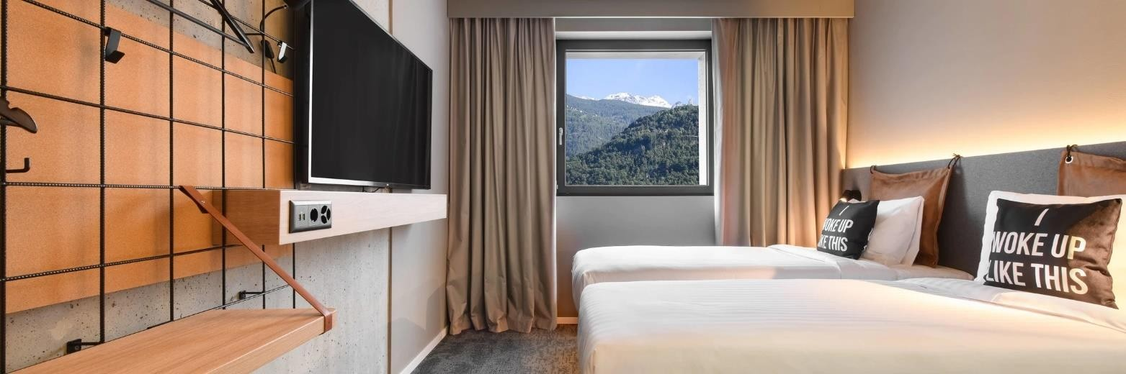

3* Hotel Ibis in Sion
→ Adresse : Hotel Ibis, Avenue Grand Champsec 21 en 1950 Sion
→ Web Site : https://all.accor.com/hotel/0960/index.de.shtml
→ GPS: 46.231108, 7.381664

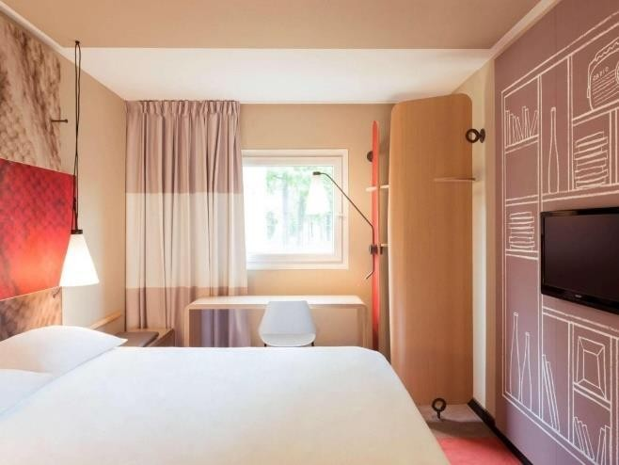 | 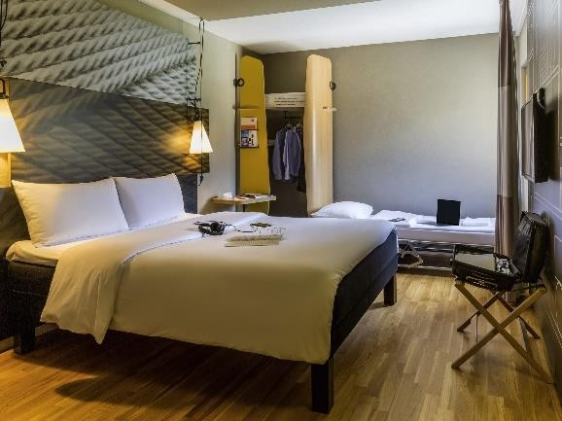

The accommodation includes breakfast, lunch and dinner. Lunch and dinner will be served at the tennis center next to the competition field in Sion and breakfast will be served direct in the hotel.
Teams that do not book their accommodation through the organizing committee will have to pay €
300 entry fee per athlete and official.
In addition, the LOC is not responsible for providing information about the event in non-official hotels and does not provide transport to the venues.

Lunch and Dinner

Lunch and dinner are included for teams who have booked accommodation with the organiser.

Lunch and dinner will be held at the tennis centre next to the competition court. Lunch and dinner will be buffet style, allowing each athlete to have a meal adapted to their diet or desires.

Address of the tennis center: Valère Tennis Club, Rue des Echutes 40, 1950 Sion.

For teams or external persons who do not have a reservation in the official hotels, the meal can be paid directly on site.
For all persons staying in NON-Official hotels, the meal will only be offered for an additional fee of €
30.00 per day. Registration must be made in advance with the LOC by 15 May 2023.

Transport

The organizing committee relies on public transport (train) for the organization of the EYC Sion 2023.

Transport from Zurich International Airport (ZRH) or Geneva International Airport (GVA) to the official hotel will be organized on request at an additional cost of € 60 (one way Zurich ZRH-Sion) or € 30 (one way Geneva GVA-Sion) per athlete and per official.

The LOC will order the tickets after booking and reserve the seats for the teams.

Train costs | Cost per person –  One way
Zurich International Airport (ZRH) – Sion VS | € 60
Genève-Aéroport (GVA) – Sion VS | € 30

Homepage: www.SBB.ch
No transport will be provided between the official hotels and the competition center.

Distance between the hotel and the tournament field "Stade de Tourbillon" is about 600-800 m on foot.

VISA
All participants who require a visa to enter Switzerland must complete the "Visa Support" section in WAREOS by 01 May 2023 at the latest.
It is the responsibility of the applicants to provide the required information and to ensure that all information is up to date, correct and submitted within the specified deadlines.
In addition, all participants requiring a visa will be asked to provide a copy of their current/valid passport. Copies of each application can be uploaded on WAREOS. All passport copies and personal data entered/uploaded on WAREOS will be kept secure and strictly confidential and will not be shared with any other party.

Terms of payment
Complete all required fields in WAREOS and make full payment within the specified deadlines. Only bank transfers are accepted. All bank charges are the responsibility of the participants.
Participation fees must be paid in full before arrival.

A deposit of at least 50% of the total amount is required to confirm the hotel reservation, to be transferred to the OC before 07.03.2023. Reservations after this date will only be considered subject to availability. The balance must be paid before arrival. Accommodation cannot be guaranteed after this date. A balanced invoice will be provided via WAREOS.

Bank information for accommodation, entry fees and train tickets

Account holder: Archery Events Switzerland Ruelle de Champlong 11 1926 Fully VS

Bank account: Banque Cantonale du Valais Place des Cèdres 8, 1951 Sion

Account Number IBAN: CH04 0076 5001 0487 8530 2
Swift/BIC: BCVSCH2LXXX
Clearing: 765

NOTE
All payments are to be made in €.

- NO CREDIT CARDS

- NO TRAVEL CHECKS

If you pay the balance in cash on arrival, a one-off charge of at least €10.00 or a maximum of 1% of
the deposit will be made as a bank handling fee.

PLEASE SEND A COPY OF THE BANK TRANSFER TO THE ORGANISER by e-mail to:
infos@eyc-sion.ch / administration@eyc-sion.ch

Cancellations and Changes

All cancellations and changes must be made through WAREOS:

If there are any last-minute changes to arrival dates, please contact the organizing committee using the dates provided in the team managers' Booklet.
If a participant's arrival is later than the originally scheduled arrival date, the room will be charged from the date of the original booking in WAREOS.
The organising committee and the member association will be automatically informed by email of any changes made in WAREOS.

In case of emergency

In serious cases or in case of doubt, call the emergency medical services immediately: Phone number: 144
Address and contact for medical emergencies: Sion Hospital Centre
Av. Grand-Champsec 80
1951 Sion
Phone number: +41 27 603 40 00

A first aid station will be operated at the competition site and will coordinate care with the regional hospital in case of emergency.

Further information

Practice:
A practice field will be available from 4 June 2023 in the immediate vicinity of the "Stade de Tourbillon" tournament field, which is about a 10-minute walk from the official hotels.
GPS coordinates of the practice field: 46° 14′ 00″ N, 7° 22′ 35″ E.

Material Depot:
A material depot will be provided at the competition field for the teams. The depot will be guarded and is secured. Access will only be granted with an ID/accreditation card.

Weather:

In Sion, the temperatures are more like 15 to 20 degrees and it doesn't usually rain.

Accreditation and team leader meeting

Accreditation will take place as teams arrive in the lobby of the Moxy Hotel from 4 June 2023 on. The accreditation office will be open from 08:00 to 21:00 on Sunday 4 June.
From Monday, 5 June on, accreditation cards can only be issued on site against an additional
payment of € 50.00 per athletes and team officials.

Media registration

Media representatives can register by emailing infos@eyc-sion.ch.

Internet
Internet will be available free of charge at the official hotels. There will also be Wi-Fi access to the results available at the venue.

Drinks and water

Water dispensers or drinks will be available at the competition field.

Disco Party

On Saturday, 10 June 2023, a disco party will be offered after dinner at a price of € 15.00 per person.
Drinks and a snack will be provided at the party.

Registration for the party can be done via WAREOS or directly on site at the accreditation. Payment must be made at the accreditation.

LOC-Kontakt
Name: Maël Loretan / Angela Hunsperger Addresse : Ruelle de Champlong 11, 1926 Fully VS
E-Mail: infos@eyc-sion.ch / administration@eyc-sion.ch Languages: Französisch, Deutsch, English und Spanisch Mobile phone: +41 78 225 67 16

We are happy to welcome you in Sion.

