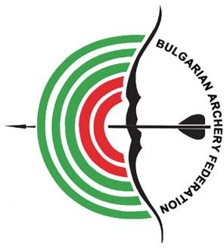

EUROPEAN YOUTH CUP

INVITATION PACKAGE

First Leg
15-21 April 2024

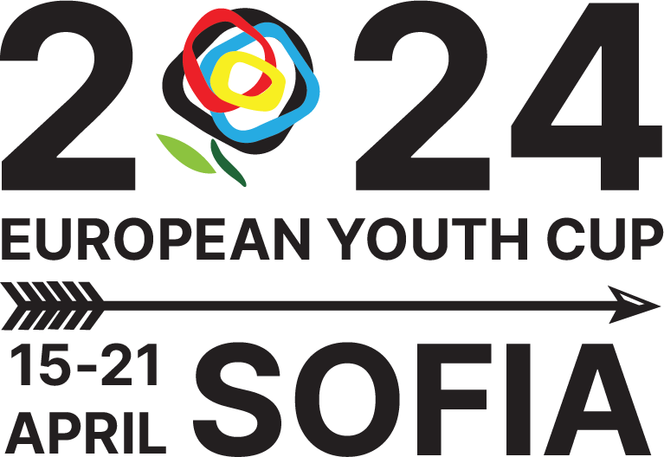

INVITATION
To all WORLD ARCHERY and WORLD ARCHERY EUROPE Member Associations

Dear President, Dear Friends,

On behalf of the Local Organizing Committee and Bulgarian Archery Federation we are pleased to invite you to the 2024 European Youth Cup 1st Leg which will be held in Sofia, Bulgaria, 15-21 April 2024.
This event will be organized following the WA and WAE YOUTH CUP RULES for Under 21 Women, Under 21 Men, Under 18 Women and Under 18 Men classes, Recurve and Compound divisions in the Outdoor Target Archery discipline.

THE PARTICIPATION IS OPEN TO ALL WORLD ARCHERY MEMBER ASSOCIATIONS.

Please find enclosed the necessary documents concerning the registration, organization and participation in this event. To register participation, please complete all the necessary sections in WAREOS within the deadlines listed below:

Registration opening deadline Preliminary Entries | 20 November 2023  12 February 2024
Final Entries | 25 March 2024
Preliminary Hotel Reservation | 12 February 2024
50% Hotel Reservation  Visa Support | 12 February 2024  10 March 2024
Transportation | 25 March 2024
Final Hotel Reservation & Payment | 25 March 2024
Final Payment | 25 March 2024
Full refund cancellation deadline* | 12 February 2024
Hotel Cancelation 100% | 12 February 2024
Hotel Cancelation 70% | 25 March 2024

*After this deadline, the LOC is allowed to retain all amounts due by the Member Association.

We are looking forward to welcoming you and we are sure you will enjoy your stay in Sofia.

Website: https://www.archeryeurope.org/ Yours sincerely Atanas Temelkov
Website: https://eyc2024.archery.bg/
E-mail: eyc@abv.bg President of the Organizing Committee &
Info: +359 887 963009 President of Bulgarian Archery Federation

PRELIMINARY PROGRAMME

Friday | 12 April 2024 | Arrival of Delegations  Open National Tournament
Saturday | 13 April 2024 | Arrival of Delegations Unofficial Practice  Open National Tournament
Sunday | 14 April 2024 | Arrival of Delegations Unofficial Practice  Open National Tournament Team Registration
Monday | 15 April 2024 | Opening  Official practice and Equipment inspection Team Managers' Meeting
Tuesday | 16 April 2024 | Qualification round Under 18 Qualification round Under 21
Wednesday | 17 April 2024 | Mixed Teams
Thursday | 18 April 2024 | Individual Eliminations – up to Semifinals
Friday | 19 April 2024 | Team Eliminations and Finals Team & Mixed Team Awarding
Saturday | 20 April 2024 | Individual Finals  Award Ceremony/Closing Ceremony Party
Sunday | 21 April 2024 | Departure of Delegations

Note: This preliminary program is subject to changes according to the number of participants. All changes and necessary information will be published and distributed in good time.

Website: https://www.archeryeurope.org/

PRELIMINARY & FINAL REGISTRATION
No entry forms will be available for registering for this event. The registration process should be done using the World Archery Online Registration System (WAREOS).

The number of athletes that may be entered by a Member Association is limited to four (4) in each category.

All World Archery MA’s are eligible to compete in European Youth Cup competitions, but only the results of the athletes from WORLD ARCHERY EUROPE MA’s will be taken in consideration for the Youth Cup Circuit.

In order to use WAREOS, please login on https://extranet.worldarchery.sport/ with your Username and Password assigned by World Archery. For any questions regarding the WAREOS, please contact the World Archery office wareos@archery.sport

Starting date of online-registration with WAREOS is: | 1 December 2023
End of Preliminary registration: | 12 February 2024
End of Final registration: | 25 March 2024

Please respect the stated deadlines!

Member Associations should only use WAREOS to make any changes/amendments to their entries and will be able to do so at any time. Any changes made in WAREOS an email will instantly be automatically sent to the Organizing Committee and Member Association with the updated information.

However, any changes that are made after the deadlines specified or if entries differ by more than 4 participants from the preliminary entries, the following penalty fees will automatically be applied:

Penalty fees to be paid to Organizing Committee: | Cost (EURO):
Penalty fee for late entries (after the final deadline) | €45 per entry
Penalty fee for not filling Preliminary entries | €140 per entry
Penalty fee for differences between preliminary and final entries *: | €140 per entry

*If the difference between final and preliminary entries number is more than 4 athletes/officials

Any entries received less than 3 days before the team managers meeting will be refused if no preliminary entry and/or final entry are made prior.

As a final note, only Member Associations in good standing will be eligible to compete. This means that World Archery fee must have been paid prior the participation.

ACCOMMODATION & GENERAL INFORMATION

Important Note:
Non-official accommodation is not allowed. Any team or individual accommodated in non-official hotel will not be accredited and participation in the event will be refused.
The official hotels are 4* stars category hotels - HOTEL ZOO and PARK HOTEL VITOSHA in Sofia. The room rate:
- are in Euro (€) per room, per night
- include full board accommodation, taxes and VAT
- including free internet in hotel lobby and rooms
- Additional purchases in the hotel bar, café and mini bar is at own expense.*
*All prices are including city tax.

HOTEL | Category | Single room  Price per room per night -  full board | Double room  Price per room per night -  full board
HOTEL ZOO SOFIA | **** | €130 | €200
PARK HOTEL VITOSHA | **** | €140 | €220

*Lunch during the competition days will be served in the restaurant of the Hotel.

To confirm the reservation, a 50% deposit of the total amount is required to be bank transferred to the OC before 12 February 2024 Reservations after this date will be considered only according to availability, the room rate can change and we cannot guarantee rooms in the official hotel.

Final Hotel Reservations and remaining payment should be made before 25 March 2024

Note: Please ensure that you complete all the necessary forms by the specified dates and make full payment for the accommodation at the time of booking. See detailed payment instructions below.

HOTEL ZOO ****
6 Simeonovsko shose blvd., 1700 Sofia, Bulgaria
2.8 km from Venue
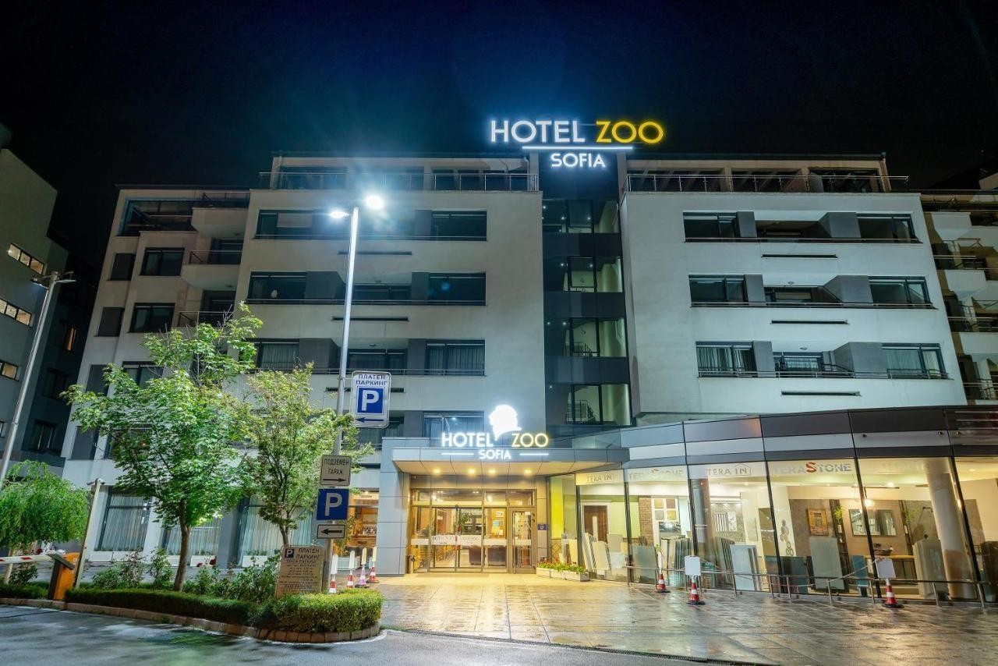

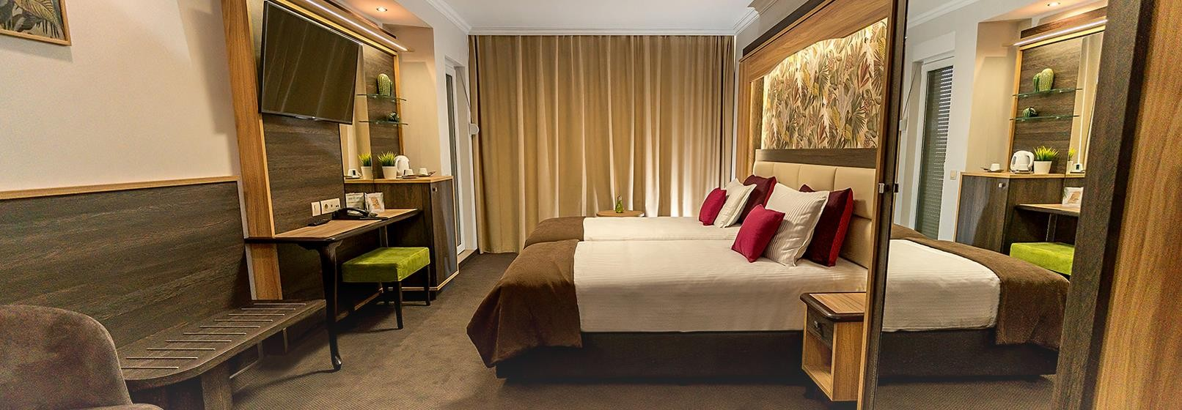

PARK HOTEL VITOSHA ****
1 Rosario Street, Sofia 1700, Bulgaria
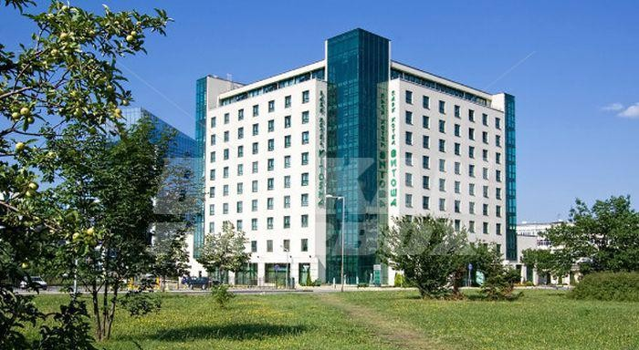1.4 km from Venue
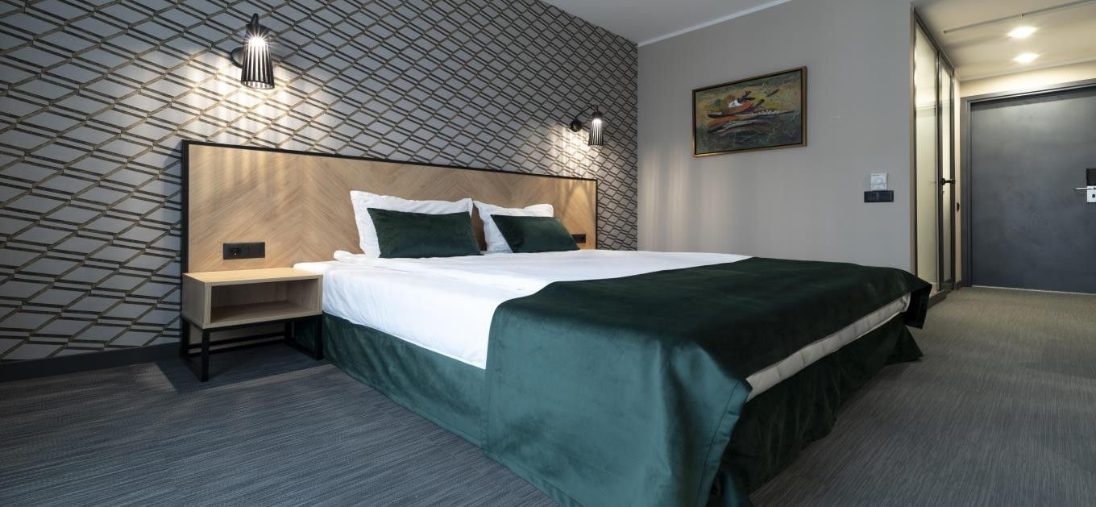

Reservations should be made before …………………….

VENUE

NATIONAL SPORTS ACADEMY (NSA) “VASSIL LEVSKI”
1 Akad. Stefan Mladenov, Sofia 1700, Bulgaria
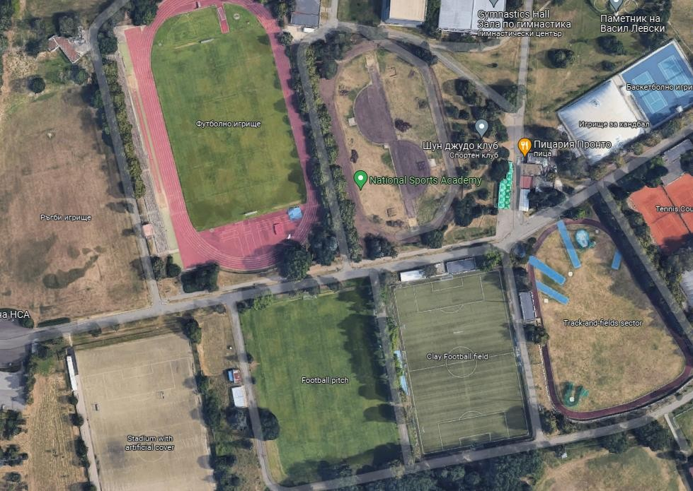

Important Note:
Refer to the accommodation pages for detailed hotel information. Please complete all the necessary sections in WAREOS and make full payment for entries, transport, and accommodation by the specified deadlines.

ADDITIONAL INFORMATION

Entry fees
Individual: €85 per athlete
Officials: Free
Teams: Free

Transportation fees from/to the airports
The OC will collect the teams from the Sofia Airport or Sofia Central Railway Station. You have to pay the transportation fee as follows:

SOFIA airport to Official Hotels – (one way): €25 /person SOFIA Central Bus/Railway Station to Official Hotels – (one way): €25 /person Official Hotels to SOFIA airport – (one way): €25 /person Official Hotels to SOFIA Central Bus/Railway Station – (one way): €25 /person

The last date for the payment of the transportation fee is 25 March 2024
Between airports and hotel, the organizer will use buses, small buses, vans and cars, what will depend of number of persons scheduled for transportation. Transportation from the airports will start two days before the official practice day and will end the day after the closing day.

A daily shuttle service will be available for the tournament days from the Official Hotels to the competition venue and back - free of charge.

Cancellations & Changes
Following conditions will apply:
- cancellation received before the preliminary entry: full refund of the paid deposit.
- cancellation received after the preliminary entry but before the final entry: 70% refund of the paid hotel deposit and full refund of the paid transportation and fees deposit.
- cancellation received after the final entry: no refunds.

All rates for payments after deadlines are subject to additional charges without prior notice. All refunds, if any, will be processed after the event.

OC has to be informed about changes in the travel programme 72 hours prior arrival. If your arrival is later then your original schedule, the room charges are starting from the original date indicated by the Member Association.

Meals at the venue
Lunch will be served in the restaurant of the hotel.

Drinking water will be available at lunch and at dinner and on the competition field free of charge.
All other costs made in cafeteria at the archery venue or in the hotel /snacks, drinks, small meals/ are not included in the entry fee and must be paid on consumptions.
Please inform us if you have special requirements for food and specify it.

Accreditation and Team Managers Meeting
Accreditation will take place upon arrival of teams on Sunday, 14 April 2024
Accreditation office will be open from 09:00 till 21:00.
Accreditation cards will be possible to issue from Monday, 15 April 2024 on the competition area only with the additional payment of €50 per person.

For all Ceremonies WA dress code is obligatory.
More details will be provided at the Team Manager’s Meeting.
Team Managers Meeting will be held on Monday, 15 April 2024

Training and Competition Field
For European Youth Cup Training venues will be available starting from 13 April 2024

VISAs
All participants who need an entry visa to Bulgaria, will be required to complete the Visa Support Form in WAREOS by no later than 10 March 2024.

It is the applicants’ responsibility to supply the necessary information, ensuring all details are up to date, correct and submitted by the deadlines specified.

In addition, all participants that require a VISA are kindly requested to supply a copy of their latest/valid passport. Copies of each applicant can be uploaded on WAREOS. All passport copies and personal details entered/uploaded to WAREOS will be held securely and in the strictest of confidence and not shared with other parties.

Please note that the Organizing Committee can provide invitation for the period of the European Youth Cup in Sofia only.

As long as the Organizing Committee gets no different information, the Invitation Letter will be sent by email. If an express service should be desired, this service will be charged to the MA and must be paid to the Organizing Committee upon arrival.

Please note: the deadline for Visa Invitation Letter Form is 10 March 2024.

Party *(depending on requirements due to health protection)
On the final day - Saturday, 20 April 2024, after dinner in hotels, Party will be organized. One non-alcoholic drink and small snacks will be provided at the Party.
Registration for the Party can be done via WAREOS or at accreditation desk.

Internet
Will be available at the official hotels for free.
There will also be Wi-Fi available for access to results at the venue.

Website
The official website of the competition is https://www.archeryeurope.org/

PAYMENT CONDITIONS
All fees should be paid in full before arrival!
Payment of accommodation and local transportation: a minimum deposit of 50% of the total amount owed should be made when booking by 12 February 2024.
The final outstanding balance shall be transferred before 25 March 2024.
Accommodation cannot be guaranteed after this deadline. A balance invoice will be provided via WAREOS.

NOTE:
Please indicate in the reference/notes section the team or reservation name that corresponds to the payment.
All payment shall be made in EURO only by BANK TRANSFER LATEST 25 March 2024! Bank transfer fees are responsible on the sender.
Credit cards and Travel checks will not be accepted.

PLEASE SEND THE COPY OF THE BANK TRANSFER TO THE ORGANIZER by email to: eyc@abv.bg

BANK INFORMATION for ACCOMMODATION, TRANSPORTATION and ENTRY FEES:

BANK: FIRST INVESTMENT BANK SWIFT CODE: FINVBGSF
IBAN: BG13FINV91501203792590
ADDRESS: 37, Dragan Tsankov Blvd., 1797 Sofia, Bulgaria NOTE: ALL PAYMENTS SHALL BE MADE IN EURO

LOC CONTACT

Website: https://www.archeryeurope.org/
Website: https://eyc2024.archery.bg

E-mail: eyc@abv.bg
Name: Atanas Temelkov Mobile phone: + 359 88 796 3009

LOOKING FORWARD TO WELCOMING YOU IN SOFIA, BULGARIA!

