INVITATION PACK (Final Update 16/02/2024)

TO ALL WORLD ARCHERY EUROPE MEMBER ASSOCIATIONS

Dear President,

On behalf of the Local Organizing Committee and Romanian Archery Federation, I am pleased to invite you to the European Youth Championships 2024 which will be held at Ploieşti Hippodrome Complex, Romania, 08 – 13 July 2024.

This event will be organized following the World Archery Rules for U21 Women, U21 Men, U18 Women and U18 Men classes, Recurve and Compound divisions in the Outdoor Target Archery discipline.

PARTICIPATION IS OPEN TO ALL WORLD ARCHERY EUROPE MEMBER ASSOCIATIONS AND IT IS COUNTING ALSO FOR THE FINAL RESULTS OF EUROPEAN YOUTH CUP 2024.

Please find enclosed the necessary documents concerning the registration, organization and participation in this event.

We are looking forward to welcoming you and we are sure you will enjoy your stay at Ploieşti, in Prahova County.

Yours sincerely,

Cristian MOCANU Cornel Răzvan MILAN
Event Manger President
European Youth Championships Romanian Archery Federation

Email: eychamp2024@frta.ro
www.frta.ro

IMPORTANT DATES

Please find enclosed detailed information regarding this event. To register participation, please complete all the necessary sections in WAREOS (https://extranet.worldarchery.sport) within the deadlines listed below.

Summary of deadlines:

Registration Opening date on WAREOS | 21 February 2024
Preliminary Entries | 09 April 2024
Final Entries | 18 June 2024
Late entries fee | 50 Euro
Hotel reservation down-payment (60%) | 09 April 2024
Hotel reservation and payment | 17 May 2024
Transportation | 17 May 2024
Visa Application | 01 May 2024
Full refund cancellation deadline*  *After this deadline, the LOC is allowed to retain all amounts due by the Member Association. | 17 May 2024

Please respect the stated deadlines.

PRELIMINARY PROGRAMME

Sunday 07 July 2024 Arrival of Delegations
Unofficial Practice 16⁰⁰ – 19⁰⁰
Team Registration

Monday 08 July 2024 Opening Ceremony
Official Practice & Equipment Inspection
Team Managers' Meeting at Hippodrome Complex in Ploieşti

Tuesday 09 July 2024 Qualification Round U18
Qualification Round U21

Wednesday 10 July 2024 Mixed Team & Awarding

Thursday 11 July 2024 Individual Eliminations – up to semifinals

Friday 12 July 2024 Team Eliminations & Finals
Team Awarding

Saturday 13 July 2024 Individual Finals
Awards Ceremony/Closing Ceremony
Disco Party (tbc)

Sunday 14 July 2024 Departure of Delegations

Note: The preliminary program is subject to change according to the number of participants. All changes and necessary information will be published and distributed in useful time.

Website: https://www.archeryeurope.org

PRELIMINARY & FINAL REGISTRATION

All entries, accommodation reservations, transport needs, flight arrival/departure information and visa invitation letter requests are to be completed using the World Archery Online Registration System WAREOS https://extranet.worldarchery.sport. This system handles the entire registration process for this event. No entry forms, hotel reservations or transportation forms will be accepted; all information must be entered into WAREOS.

Member associations can login to WAREOS at http://extranet.worldarchery.sport with the username and password assigned by World Archery. After entering WAREOS, selecting the event from the list will allow a member association to register their athletes. Select/press the “Entries” button to see the list of categories in the event. Select/press the “category” to enter the athlete and official numbers/details participating for that event. A WAREOS User Manual can be downloaded in PDF format (English) upon login.

Contact wareos@archery.sport with any questions regarding technical problems on WAREOS. For any question regarding the organization of the event (transport, accommodation, meals, invoices, visa etc.) please contact directly the LOC.

Athletes from a minimum of 4 different Member Associations shall be registered and participate in the event.

A maximum number of 3 (three) athletes per country can be registered into each category and divisions of the event.

Member Associations can only use WAREOS to make any changes or amendments to entries and will be able to do so at any time. An email will automatically notify the Organizing Committee and Member Association of any changes made in WAREOS.

PENALTY FEES TO BE PAID TO ORGANISING COMMITTEE
Penalty fees for Late Entries (after final deadline): | € 50 per entry
Penalty fees for not filling Preliminary entries | € 150 per entry
Penalty fee for differences between preliminary and final entries*:  *If the difference between final and preliminary entries number is more than 4 athletes/officials | € 150 per entry

ACCOMMODATION & GENERAL INFORMATION

Important Note: Non-official accommodation is not allowed. Any team or individual accommodated in a non-official hotel will not be accredited and participation in the event will be refused.

The official hotels are 4* and 3* stars category hotels classification.

The room rate:
- is listed in Euros, per room, per night
- includes full board accommodation, taxes and VAT
- includes free parking in front of the hotel for cars & minivans
- includes internet provided in the hotel lobby and bedrooms

HOTEL | Category  classification | Single room - full board | Rooms available | Twin room - full board | Rooms available
Central Hotel Ploieşti | **** | € 185 | 20 | € 300 | 85
Europa Hotel | *** | € 140 | 4 | € 230 | 18
Albert Hotel - Restaurant | *** | € 140 | 5 | € 230 | 10
Best Hotel | *** | € 150 | 5 | € 250 | 25
Tiara Hotel | *** | € 140 | 10 | € 230 | 15
Nord Hotel | *** | € 150 | 10 | € 250 | 14

All lunches will be served at restaurants of each hotel every day and costs are included in the above fees.

Central Hotel Ploieşti
At this hotel you can enjoy:
- Free Wi-Fi
- Free Parking
- Room service
- Wellness Center Access
- Transfer to Venue: 8-10 mins

Built in the neoclassical style, the Central Hotel is fully renovated. The rooms are equipped with: quality furniture, hypoallergenic bedding, LED TV, telephone with national and international connection, minibar refrigerator with products, robe, slippers, safe, hairdryer.

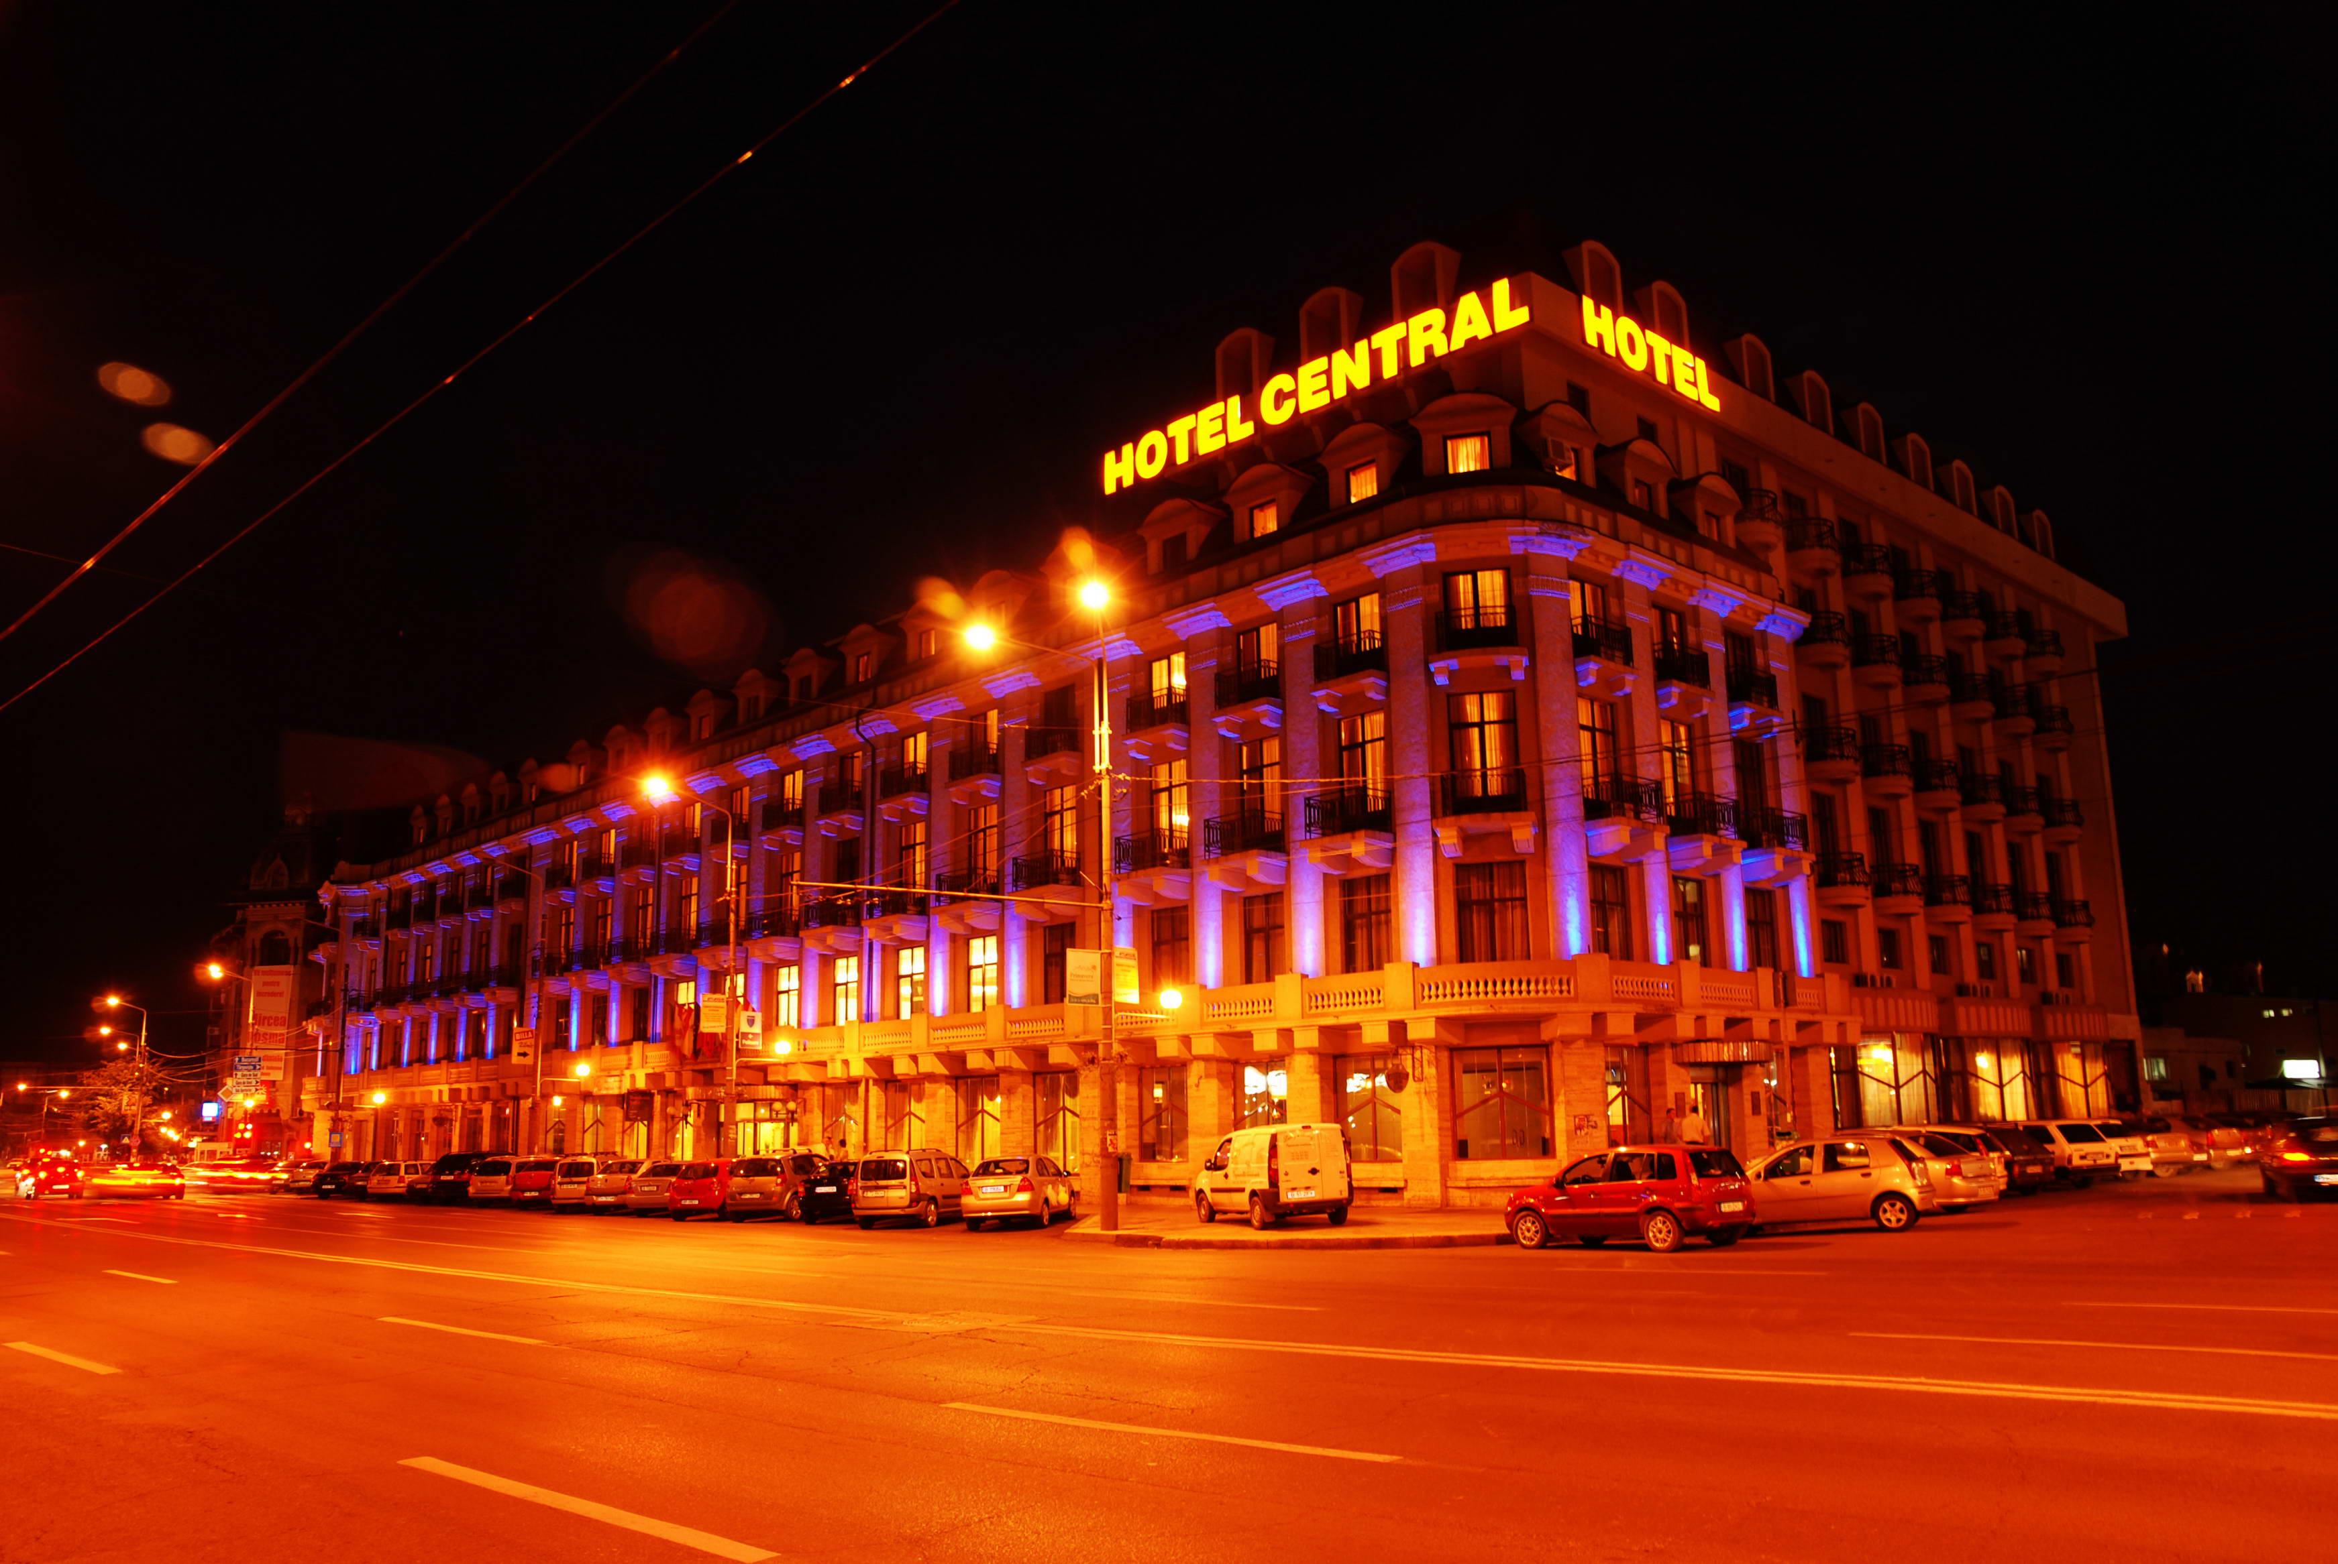
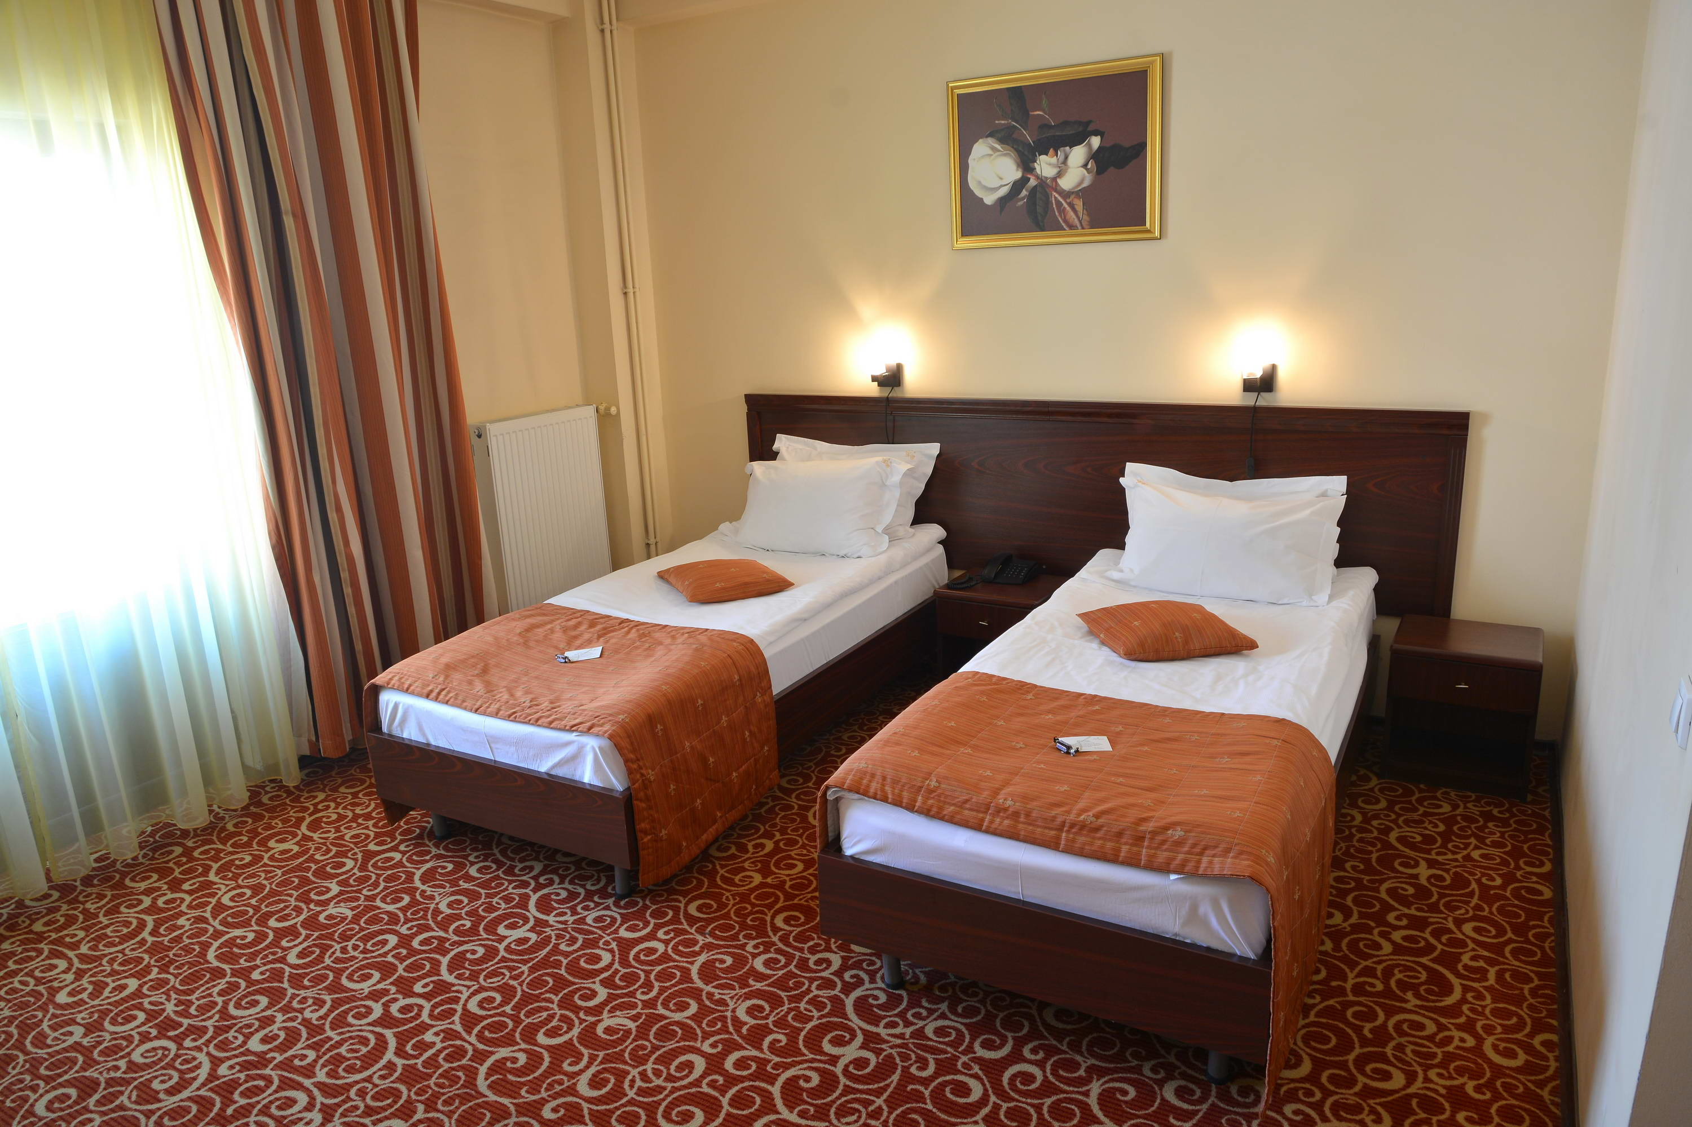
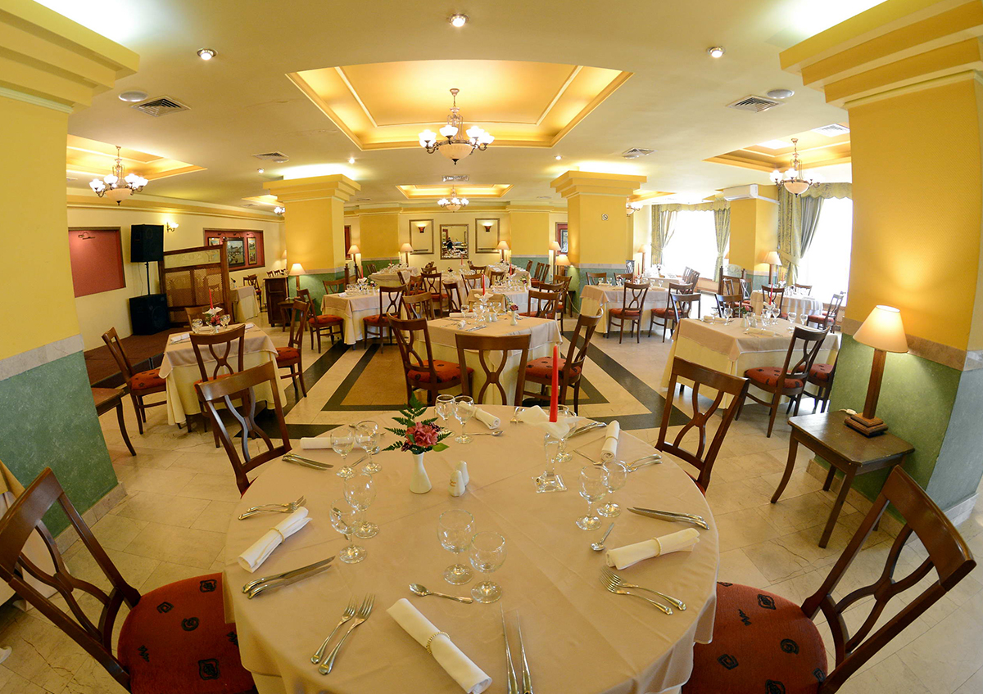
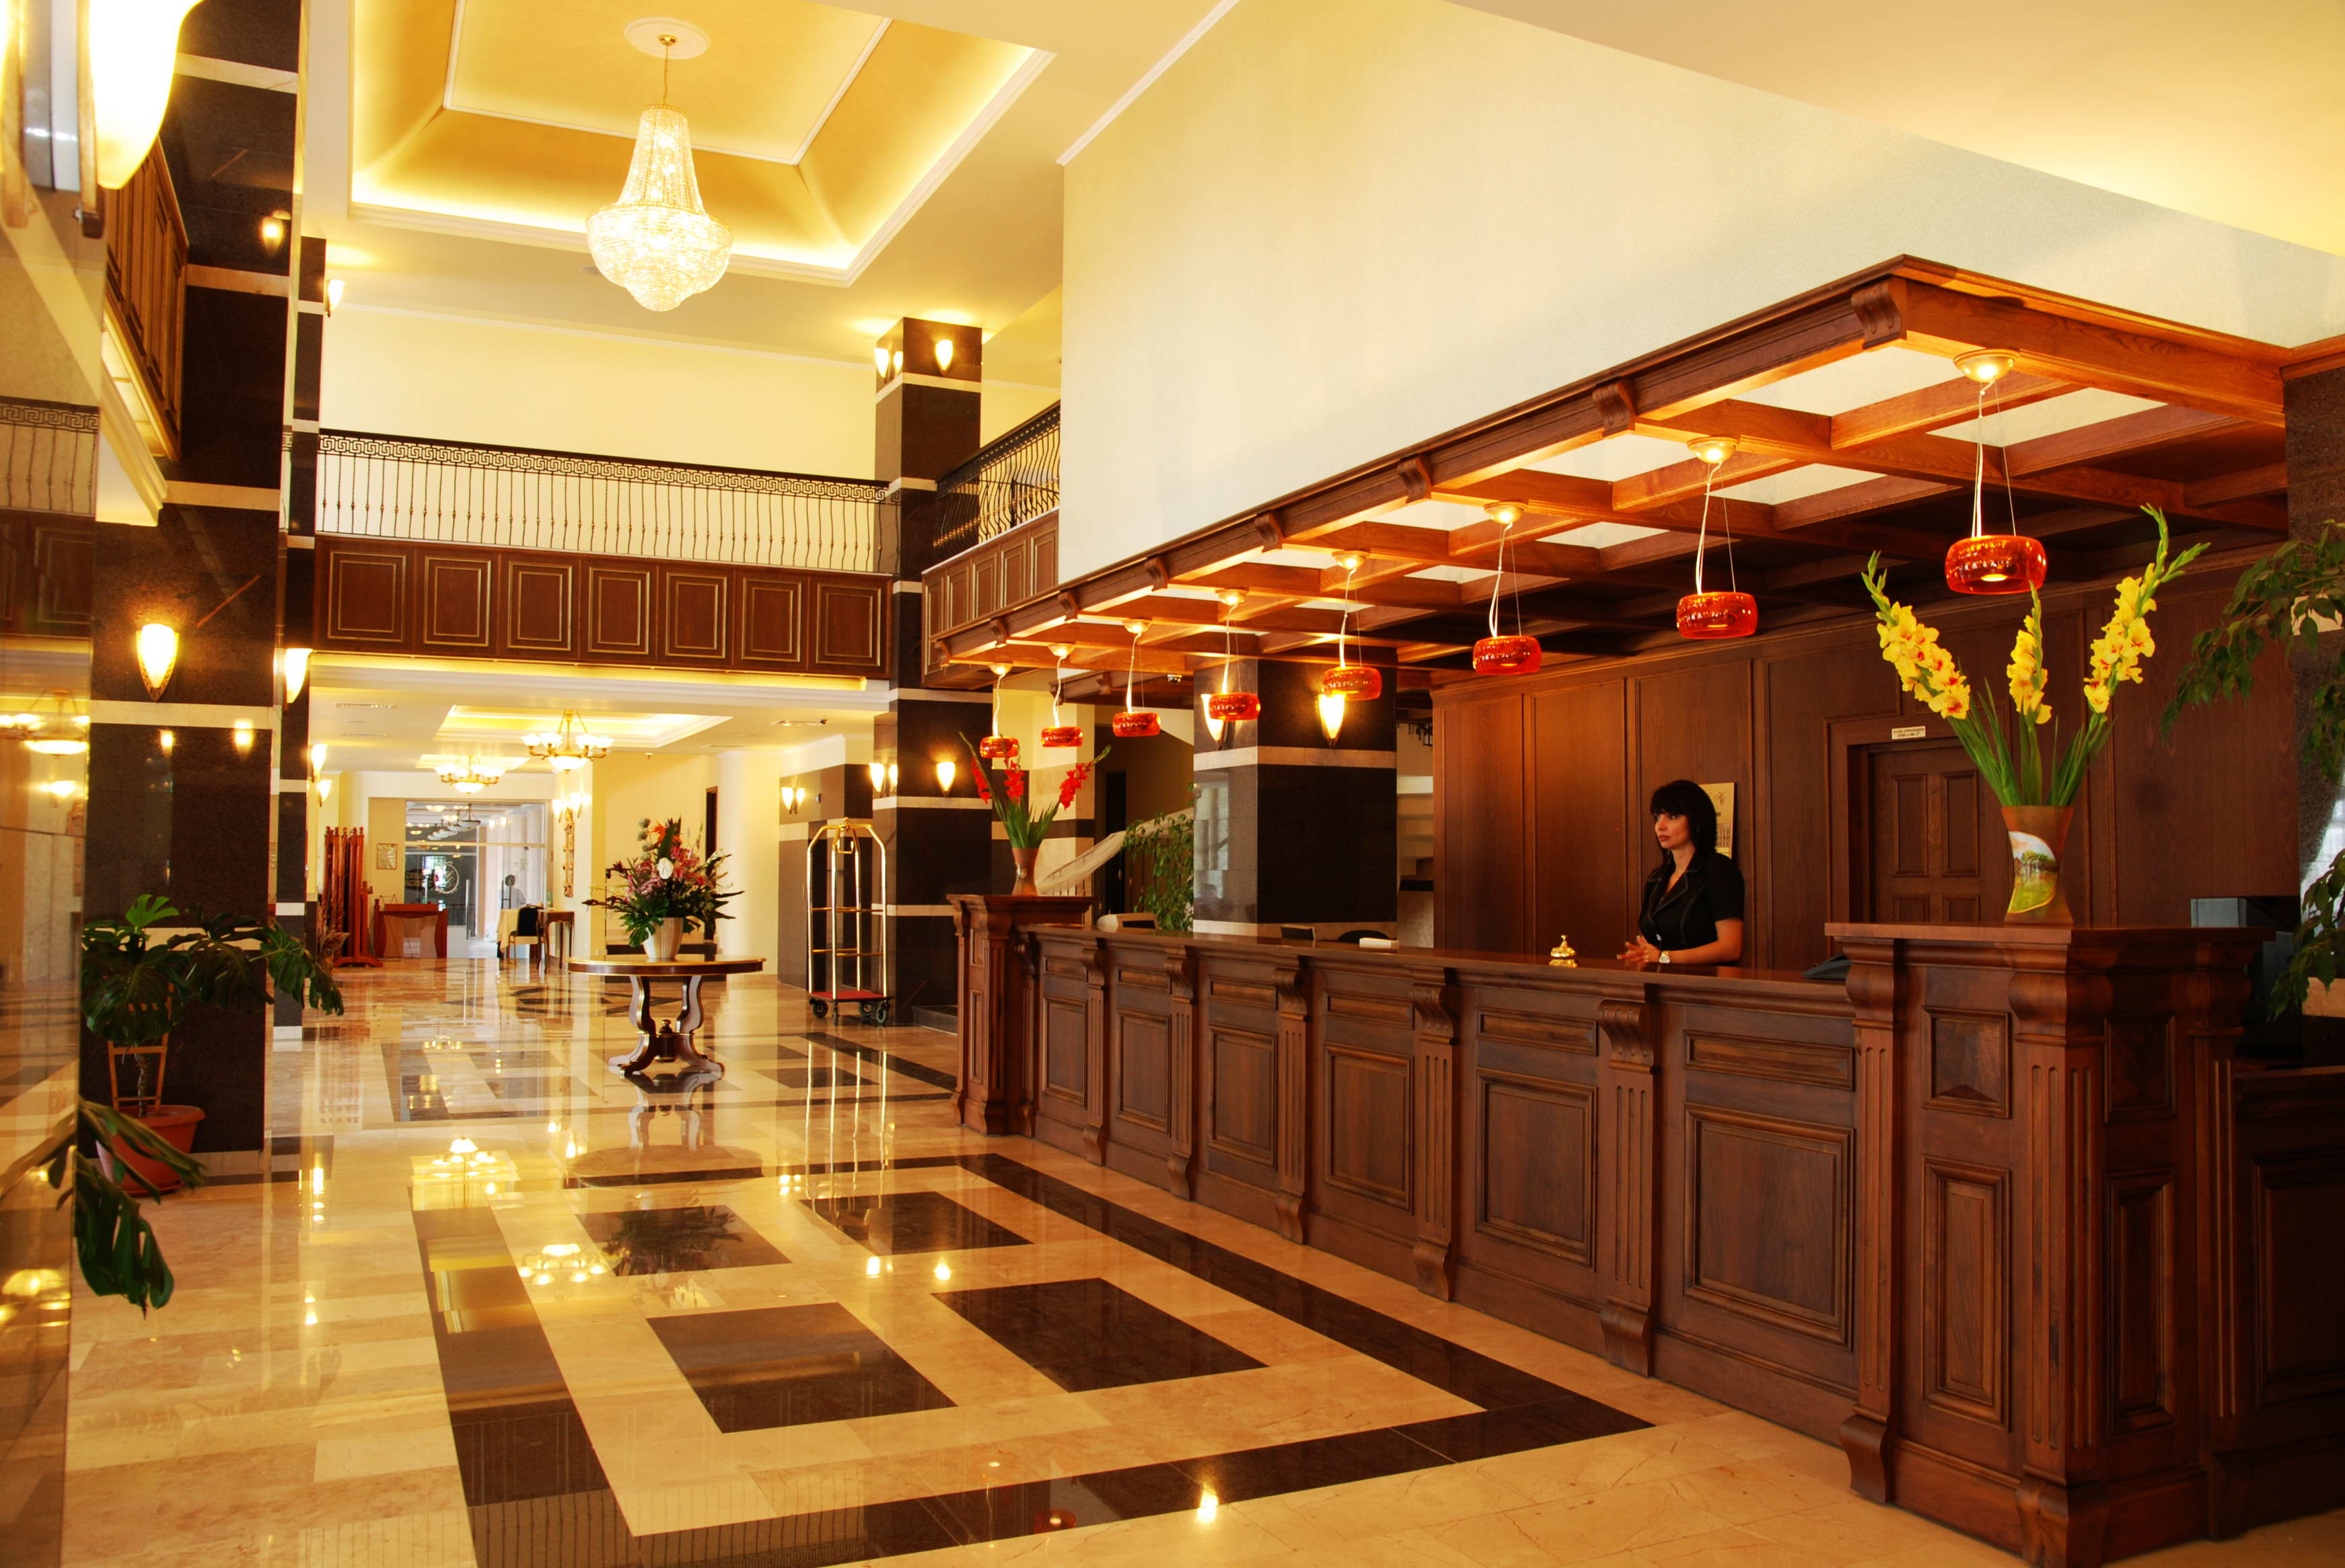
The rooms have individually controlled air conditioning. Access to the Relaxation Center is free. Guests are welcomed in the room with a complimentary welcome package consisting of: a mini chocolate tablet, a kettle with tea bags, instant coffee and sugar.
Connection to high-speed wireless internet is available at no additional cost.
The hotel’s Classic Lounge restaurant it is one of the most popular places to meet and enjoy both
Romanian and international specialties, thanks to its beauty and refinement. Inside, the lounge is adorned with crystals, chandeliers, mirrors, and artworks, creating an atmosphere of opulence and elegance. Blues Café is famous for its quality coffee and bohemian atmosphere. It also has its own confectionery laboratory.

Europa Hotel
At this hotel you can enjoy:
- Free Wi-Fi
- Free Parking
- Car Rental Services
- Transfer to Venue: 15 mins

The hotel offers individually furnished rooms, with free cable internet access and air conditioning. All rooms have wooden floors, a flat-screen TV with cable channels and a minibar. The rooms also have a balcony. The bathroom includes a hairdryer and free toiletries.
At the restaurant guests can enjoy Romanian cuisine and a buffet breakfast every morning. In the summer it can dine on the hotel's terrace.
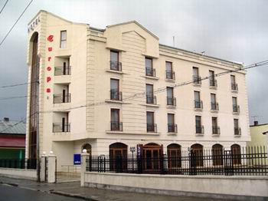
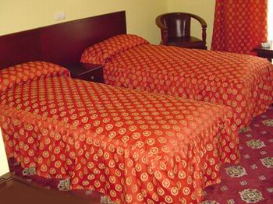
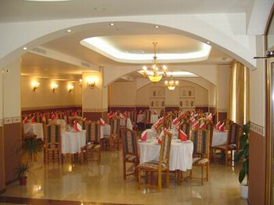
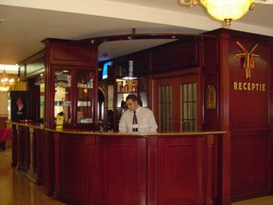
The hotel bar serves drinks. Wi-Fi internet access is available free of charge in public areas.

Albert Hotel - Restaurant
At this hotel you can enjoy:
- Free Wi-Fi
- Gym
- Transfer to Venue: 20 mins

Hotel features air-conditioned accommodation. All rooms are equipped with an LCD cable TV, a telephone and an en-suite bathroom with a shower, free toiletries and a hairdryer. Some units also have a balcony. Elegant classic design of the rooms and the tables layout create a relaxed and intimate atmosphere.
Albert Hotel offers an à la carte restaurant and free private parking, also an on-site bar, an outdoor terrace, free ironing services and free safety deposit box at the reception.

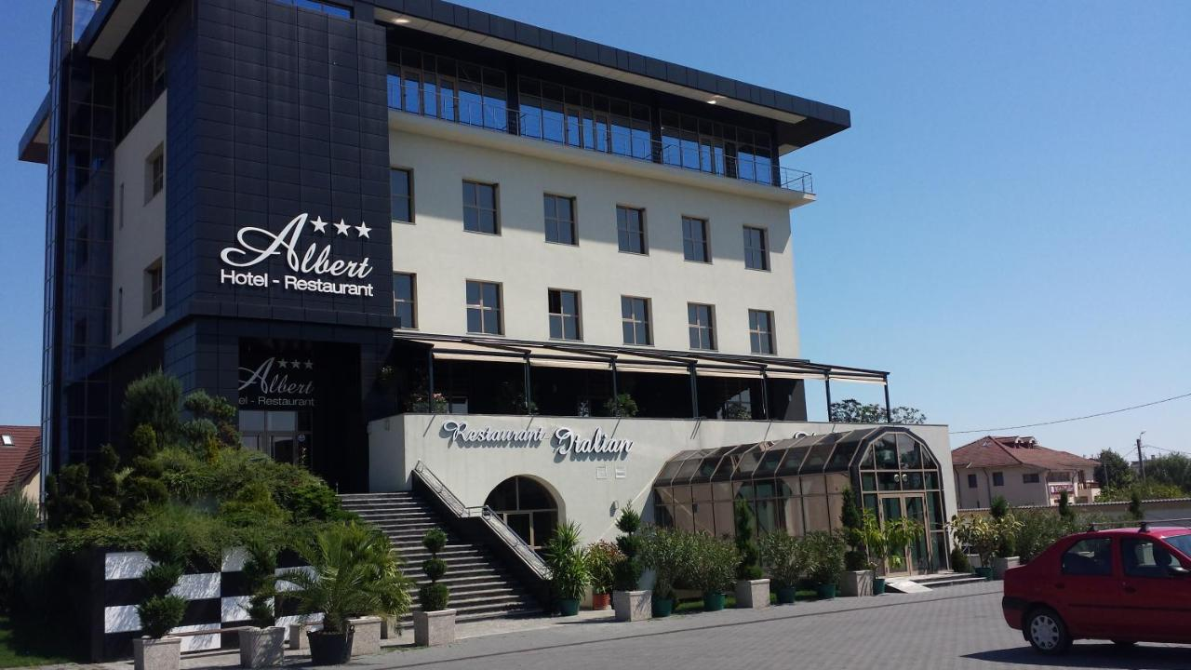
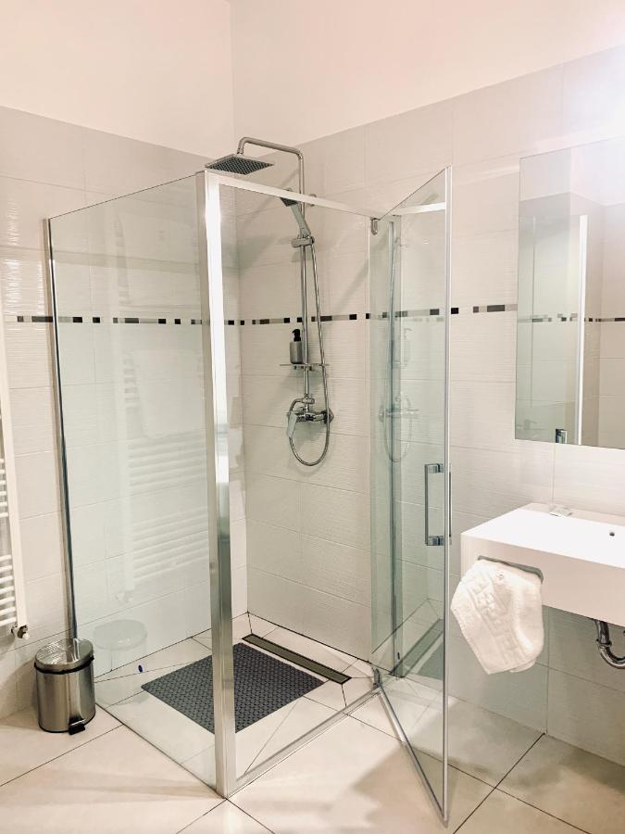
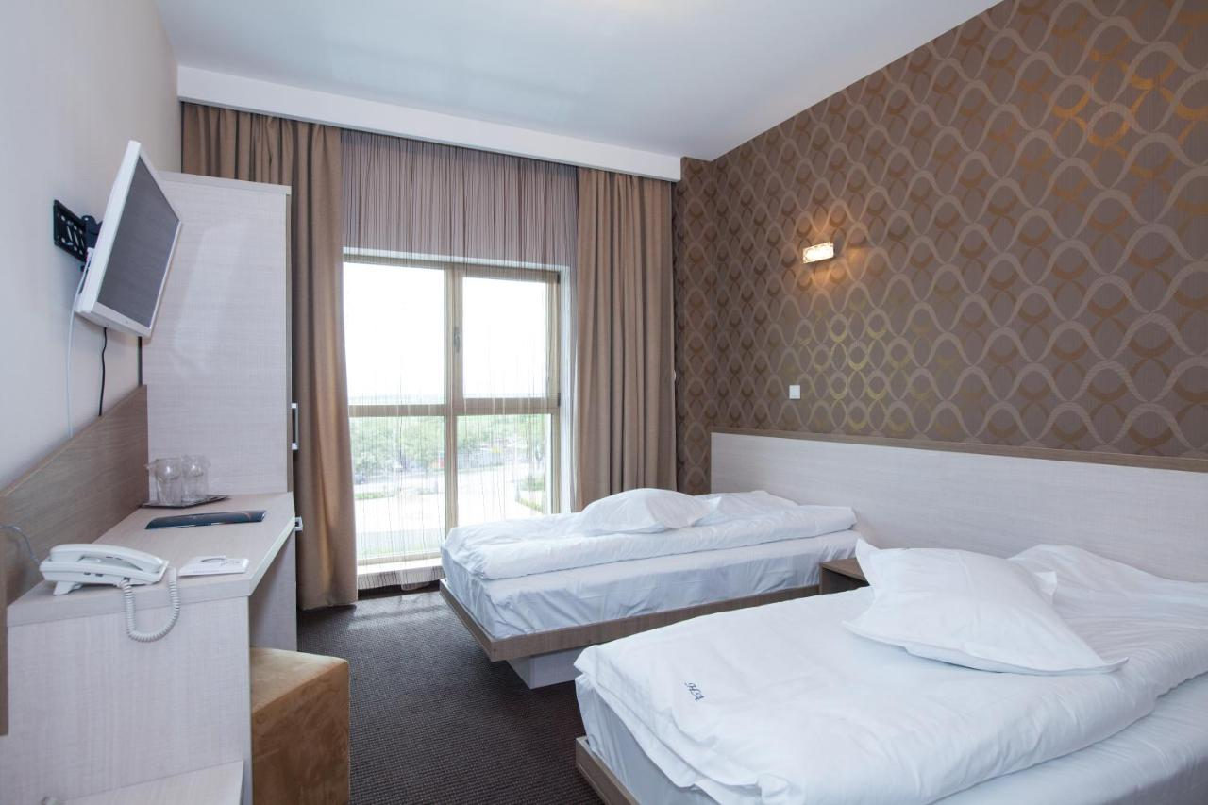
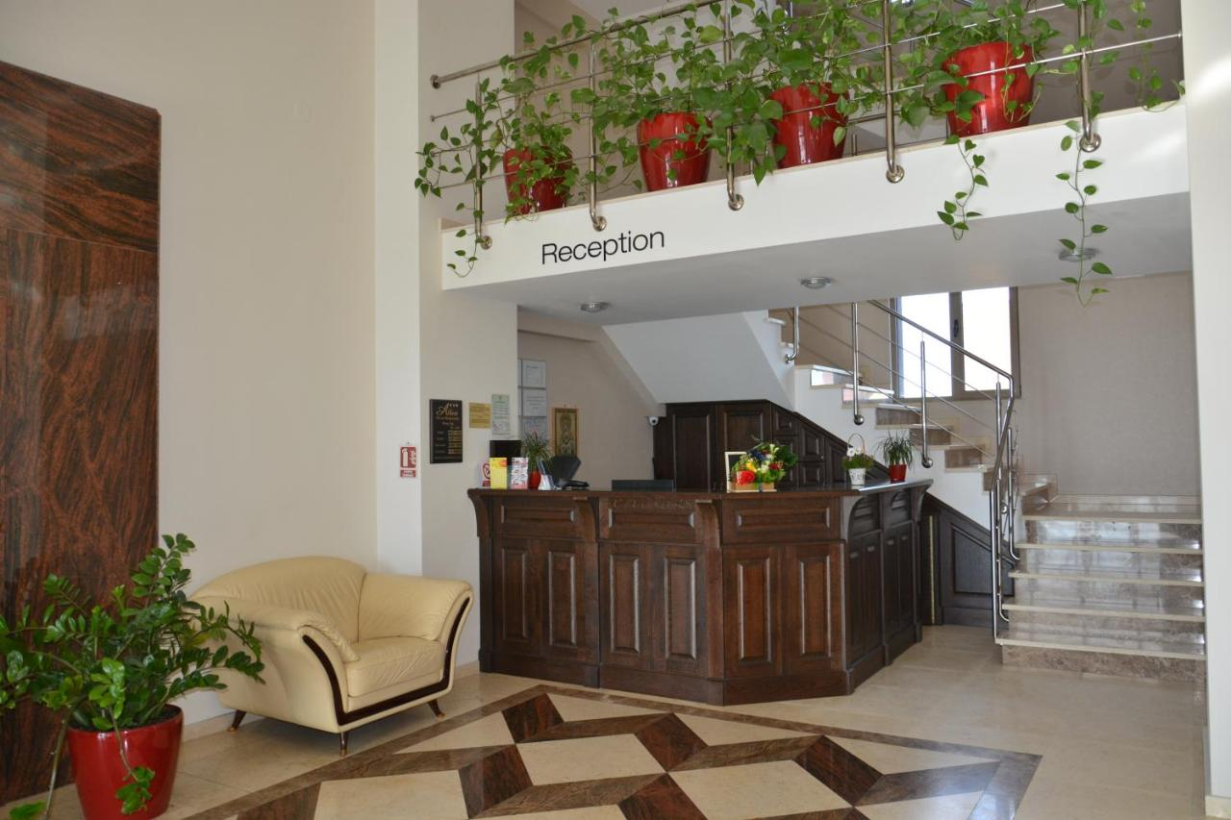
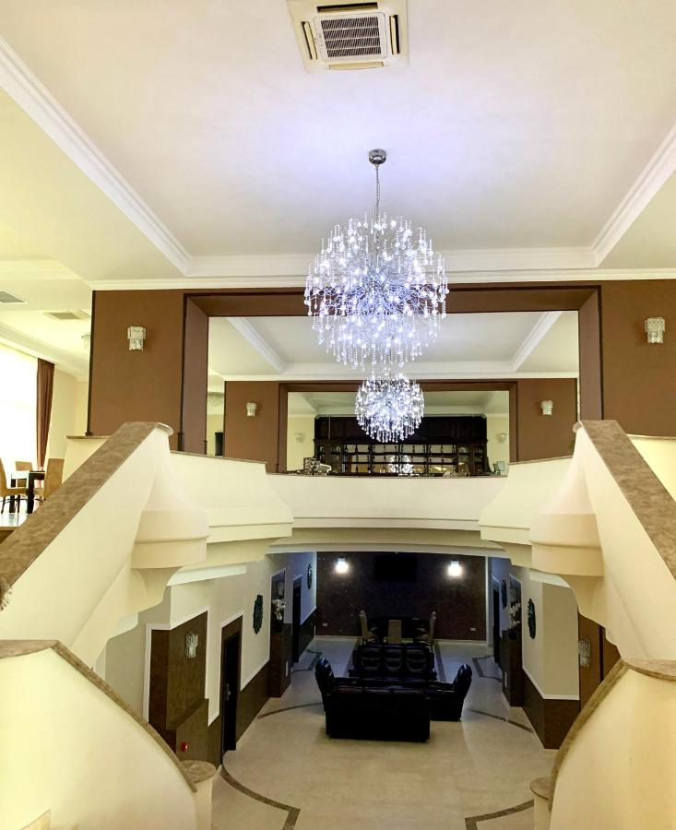

Best Hotel
At this hotel you can enjoy:
- Free Wi-Fi
- Gym
- Transfer to Venue: 15 mins

The hotel has modern, exceptionally equipped rooms (walnut wood furniture), LED lighting, AC included, LCD TV, hydromassage shower cabins and sauna in apartments, minibar.
The restaurant lounge offers a select atmosphere and a varied range of Romanian and international cuisine. A coffee break or a Swedish buffet can be provided.
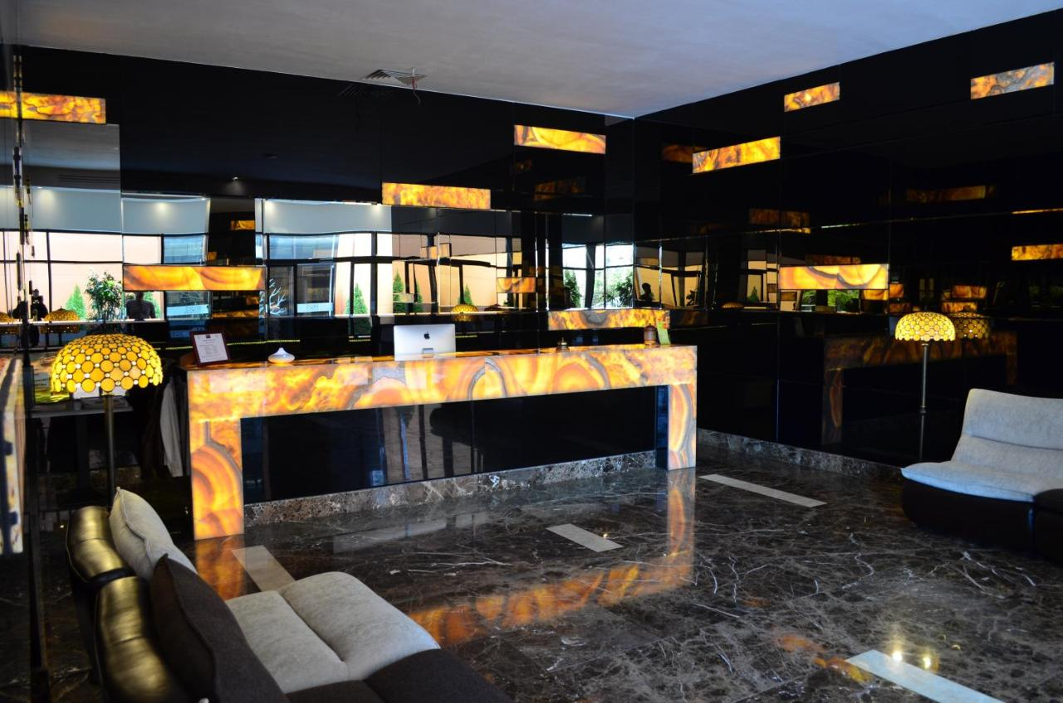
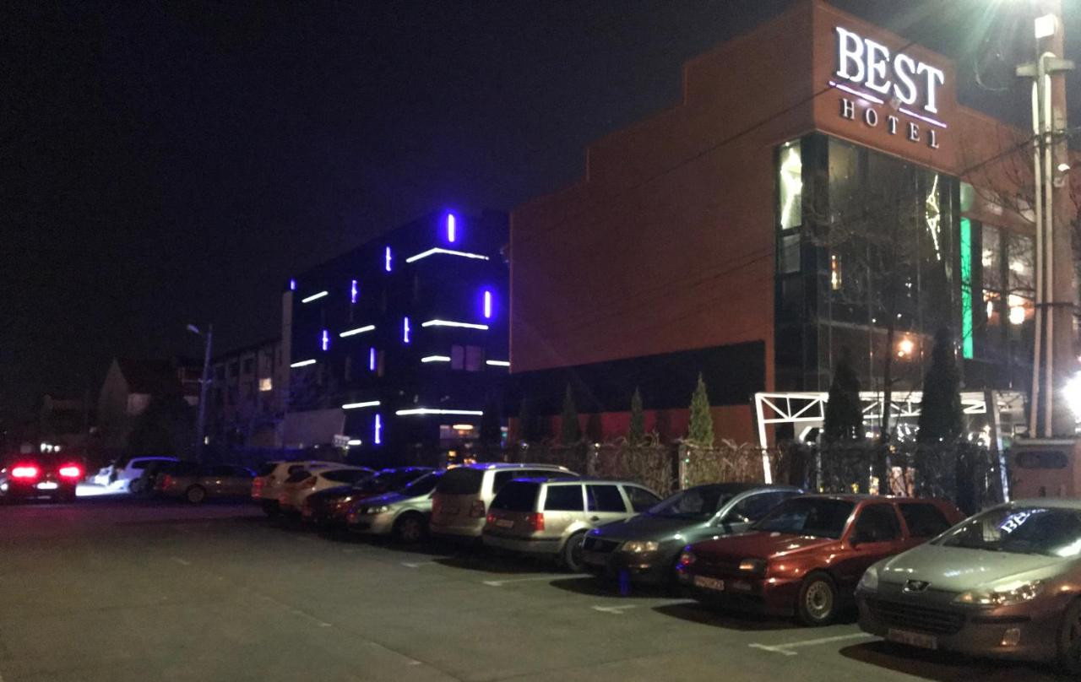

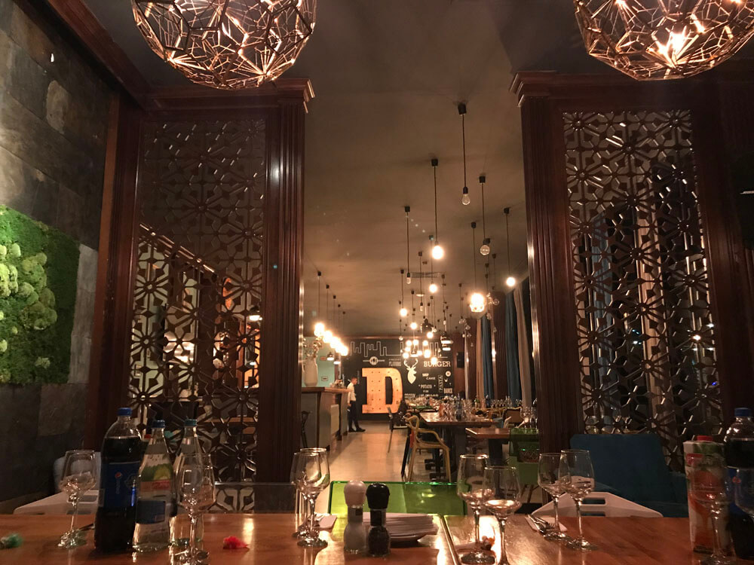
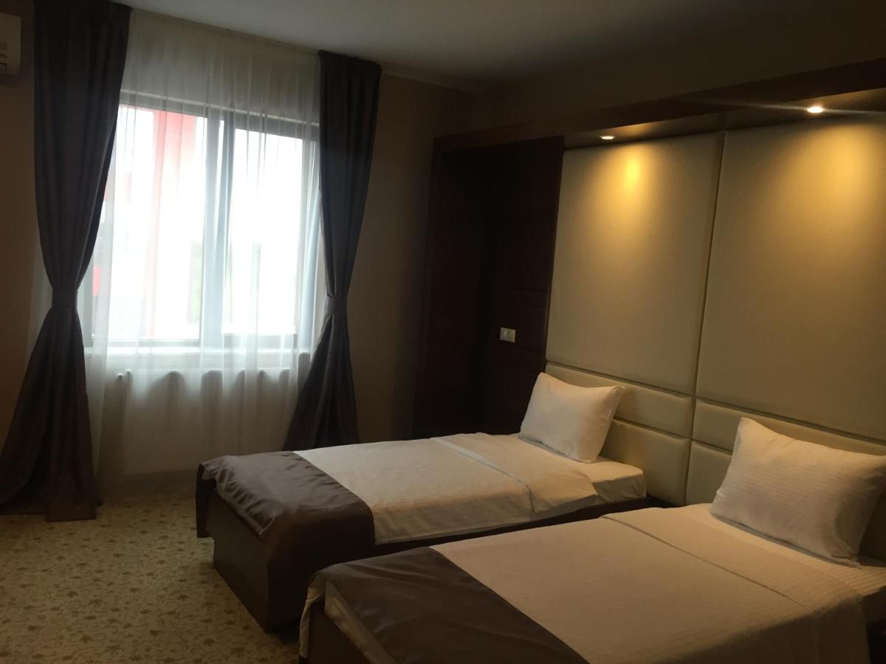

Tiara Hotel
At this hotel you can enjoy:
- Free Wi-Fi
- Room Service
- Transfer to Venue: 10 mins

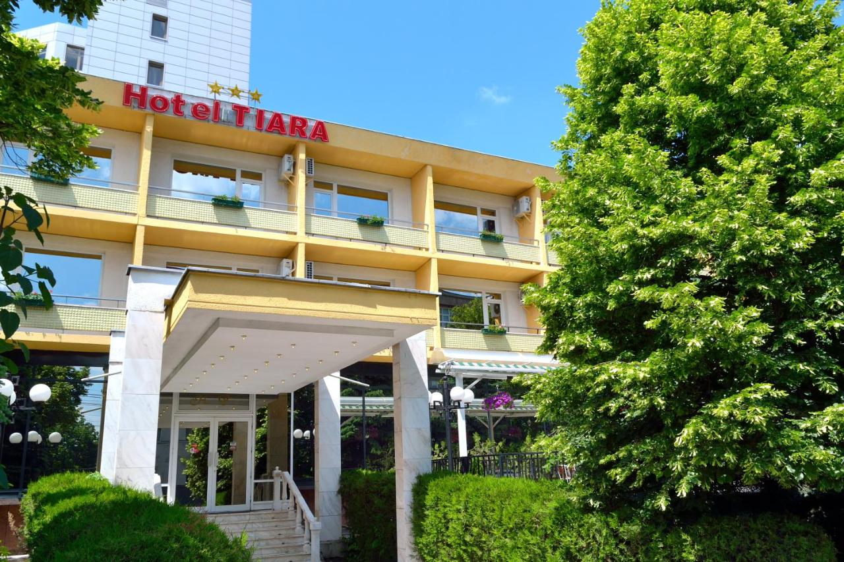
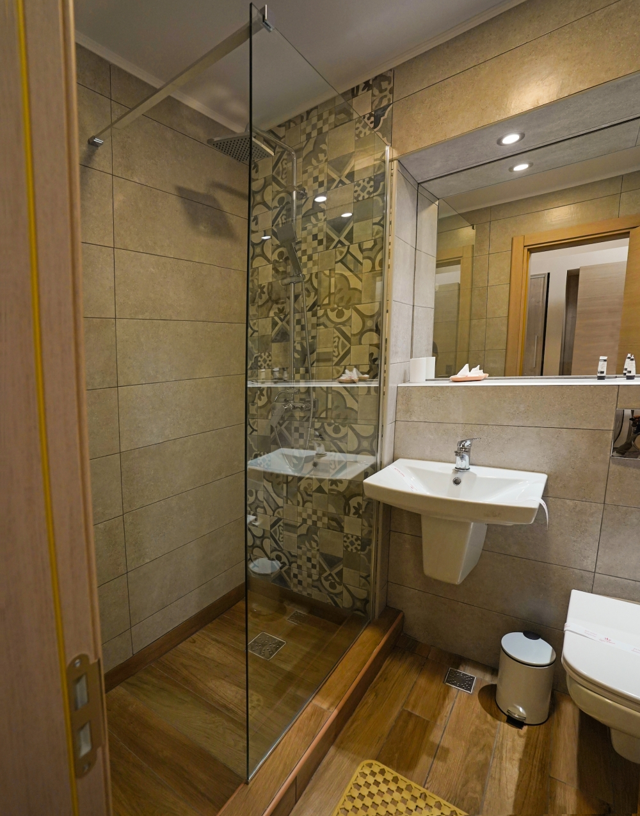
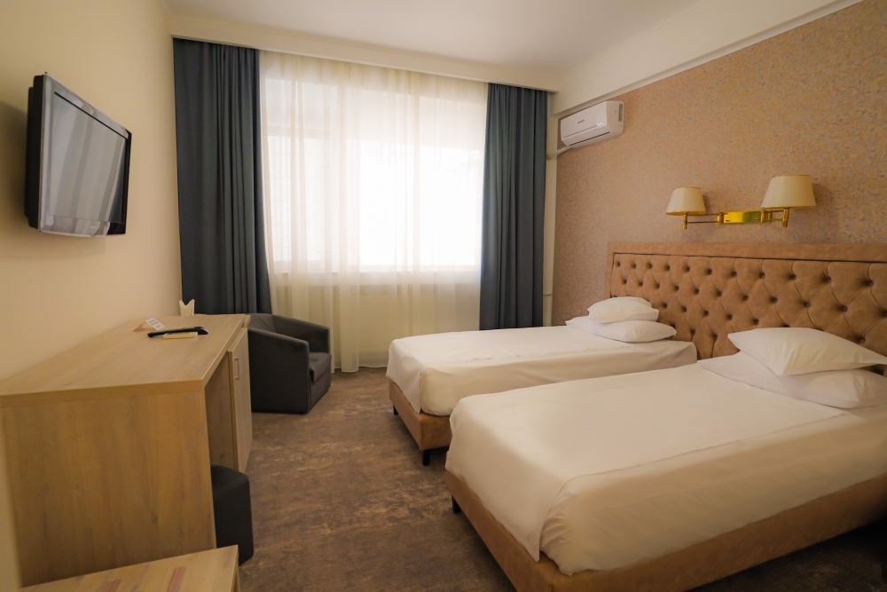
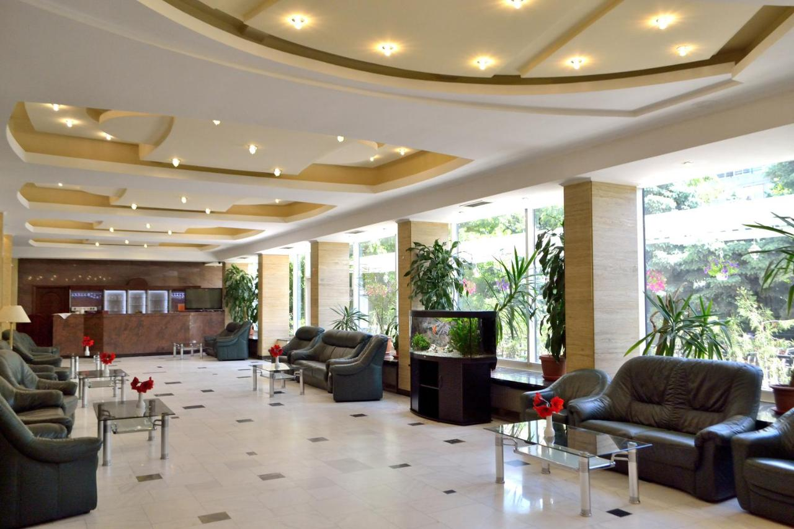
Guests are accommodated in rooms with comfort and style in a design created to meet the needs of both businessmen and travellers on vacation, with bathroom, A/C and wireless internet.

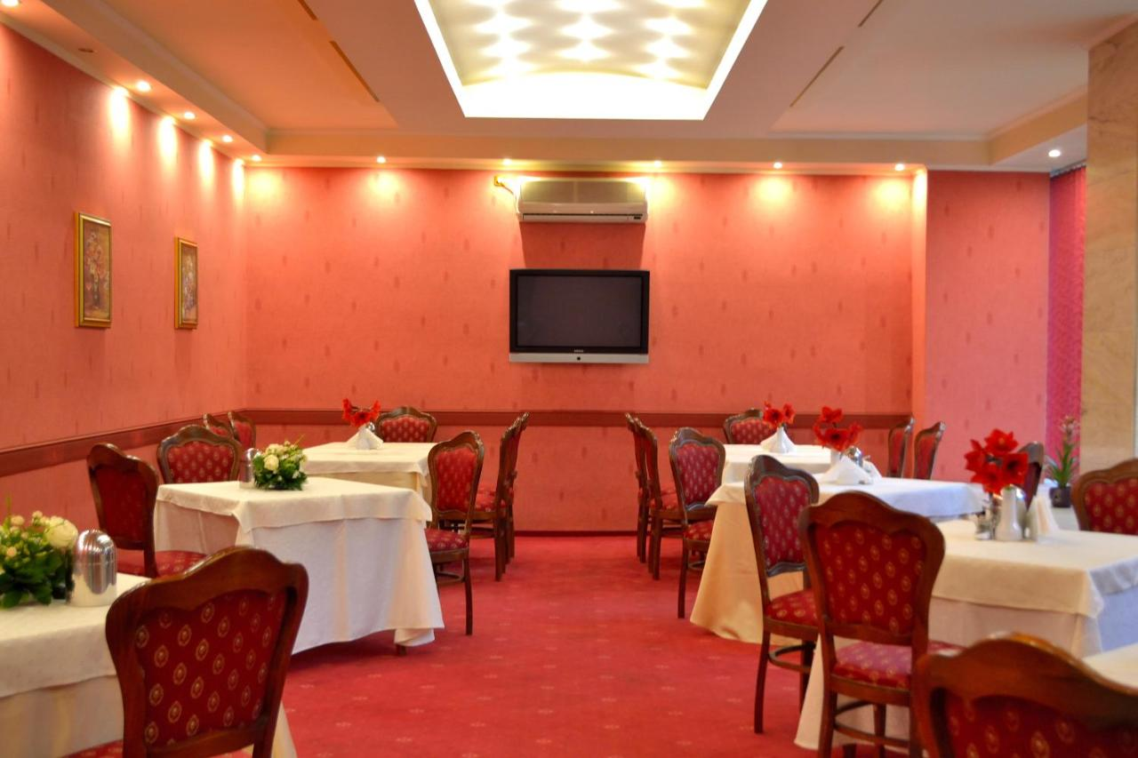
The restaurant offers a varied range of traditional and international dishes. During the summer, hotel also offer a modern terrace, which benefits from all the restaurant's services.
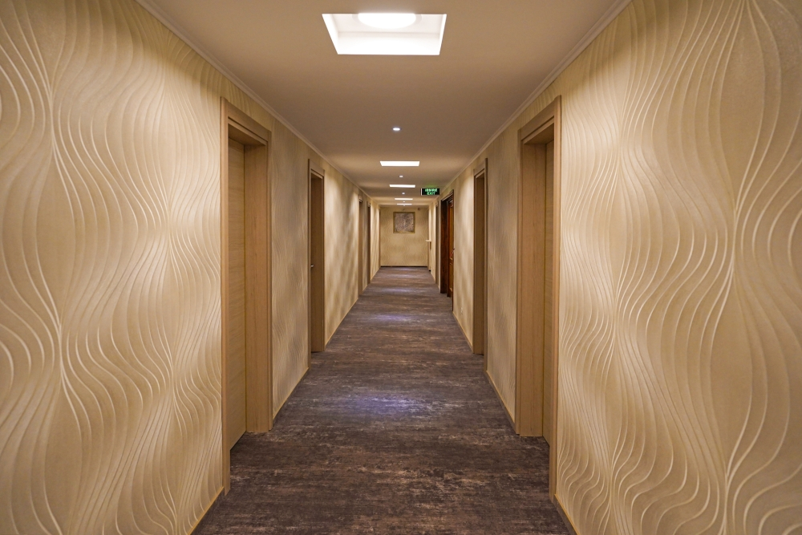

Nord Hotel
At this hotel you can enjoy:
- Free Wi-Fi
- Free Parking
- Transfer to Venue: 15 mins

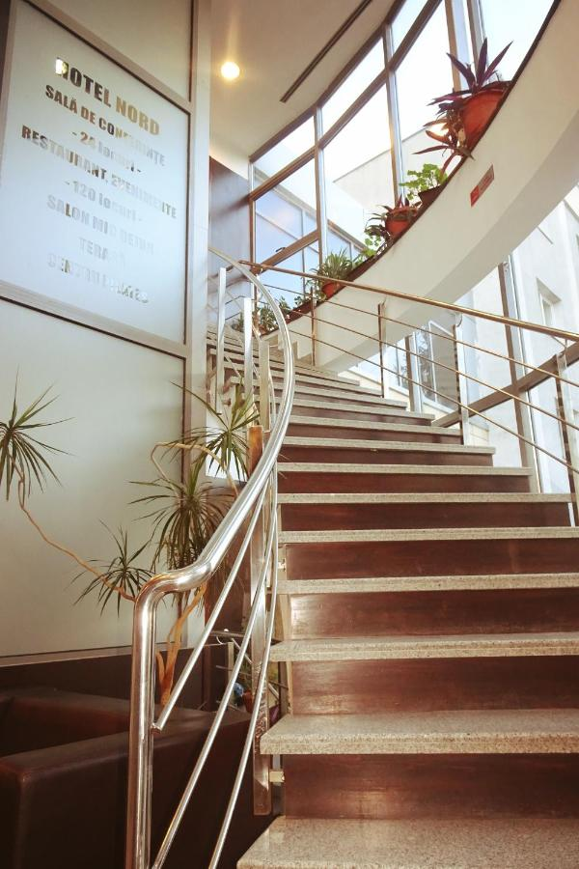
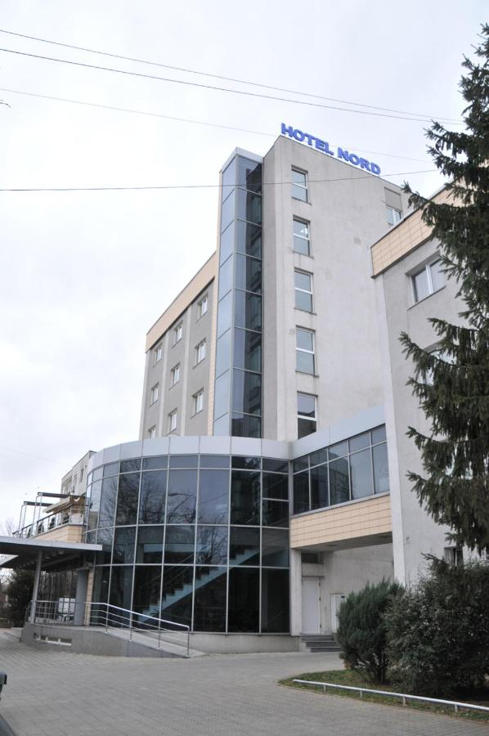
All rooms are fitted with a cable TV, a refrigerator and a private bathroom with a bathtub or a shower, a hairdryer and free toiletries. Some rooms are air-conditioned. Wi-Fi access is available in all public areas. Further facilities include a free safety deposit box at the reception. The hotel has an on-site bar with coffee place and an à la carte restaurant with international cuisine.

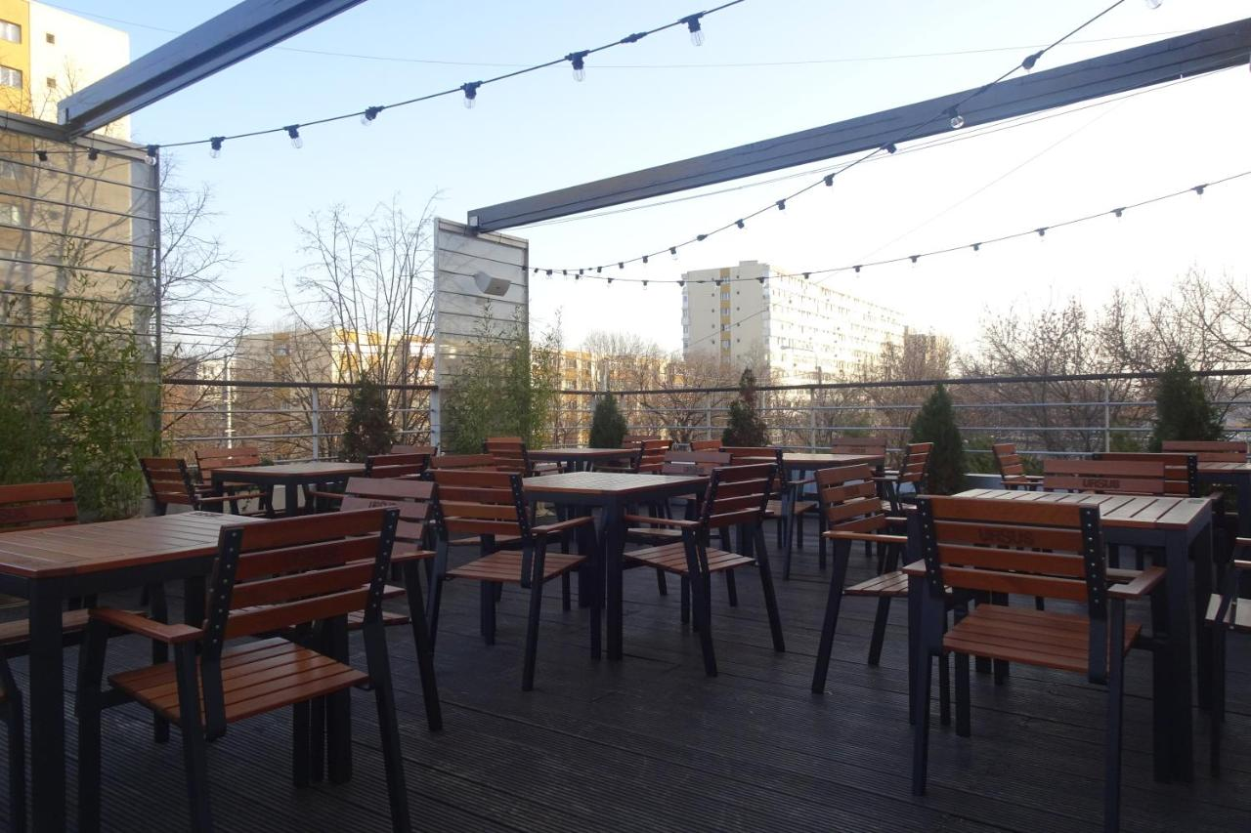
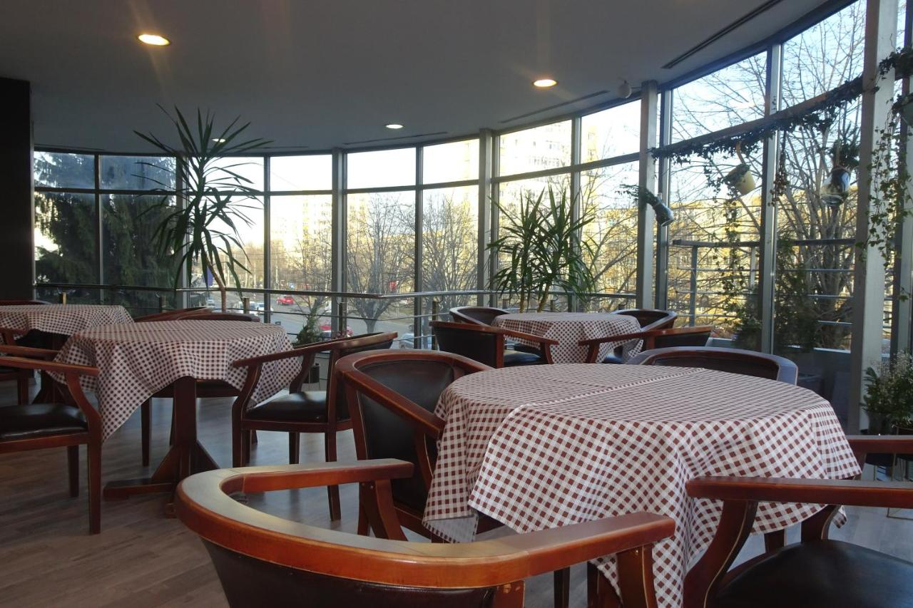
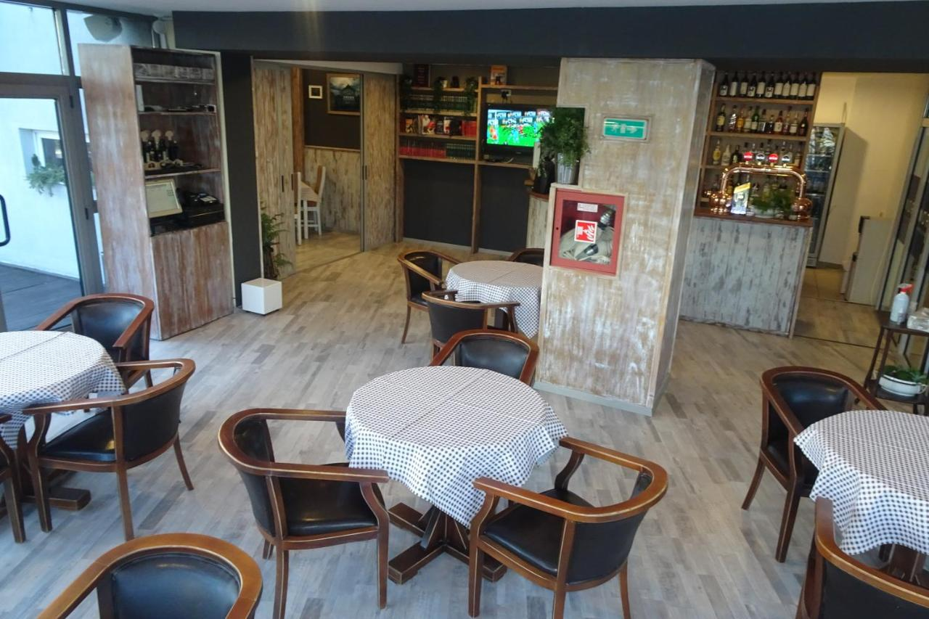
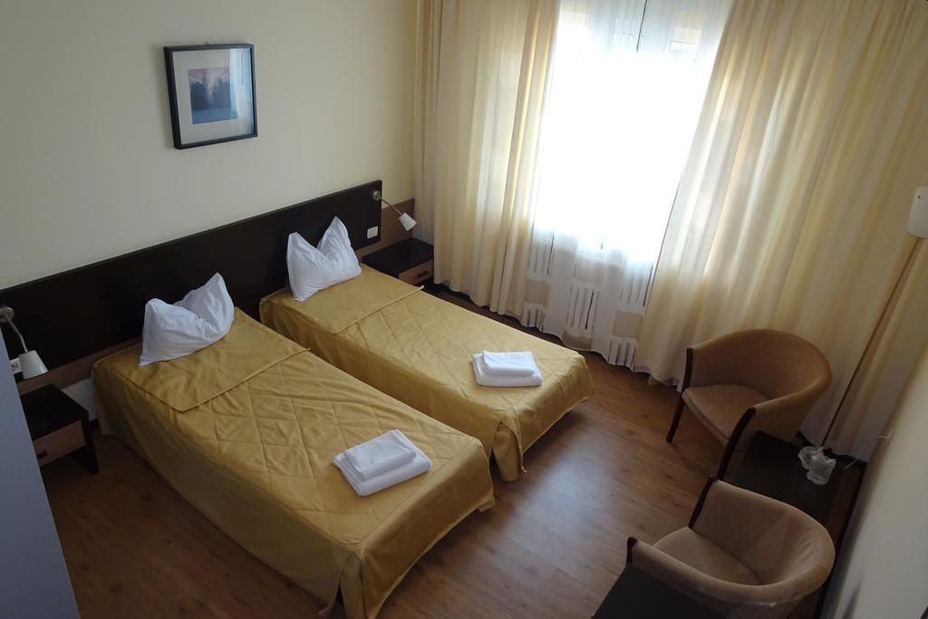
All hotels are set in close proximity within a maximum distance of 3 km to each other in central position Ploiesti, where shops and restaurants are within walking distance, while the City Mall is 1 km away.

Your reservation of room choice will only be given on receipt of deposit, selection on WAREOS is not a guarantee without deposit.

To confirm the reservation, a 60% deposit of the total amount is required to be bank transferred to the LOC before 09 April 2024. Reservations after this date will be considered only according to availability, we cannot guarantee availability and the room rate may change.

Final Hotel Reservations should be made before 17 May 2024, after this date we cannot guarantee the advertised prices.

Note: Please ensure that you complete all the necessary forms by the specified dates and make full payment for the accommodation at the time of booking. See detailed payment instructions below.

Entry fees: Individual: € 200 - Per Athlete
Officials: € 100 - Per Official
Teams: € 125 - (no fee for mixed teams)

Transportation fees from/to the airport:

The LOC will collect the teams from “Henri Coandă” - Otopeni International Airport. You have to pay the transportation fee that includes arrival and departure as follows:
Otopeni International Airport – Ploieşti City – 50 KM € 50 per person each way
(Transfers should take 50 minutes to 1 hour)

The last date for the payment of the transportation details must be with the LOC no later than 17 May. All fees must be paid no later than 17 May 2024.

From the airports to the hotel/return trip, the organizer will use buses, small buses, vans, and cars, which will depend on number of persons scheduled for transportation.

Transportation from the airports will start Sunday 07 July and will end Sunday 14 July. Arrivals and transport requests outside of these dates can be arranged by special arrangement with the LOC only.

PAYMENT CONDITIONS

- The Entry Fee should be paid in full before 18 June 2024.
- The 60% deposit of the total amount for hotel accommodation should be paid before 09 April 2024
- The full balance of payment for accommodation and total transportation should be paid before 17 May 2024
- An Invoices will be provided via WAREOS.
- All prices for payments after the stated deadlines are subject to additional charges.

Payments must be sent to the following bank account:
Account Name: Romanian Archery Federation
Account Address: No. 16, Vasile CONTA Street, 2nd District, zip code 020951, Bucharest, Romania

IBAN Number: RO46 RNCB 0090 0005 0853 0017

SWIFT / BIC code: RNCBROBU

Bank Name: BANCA COMERCIALĂ ROMĂNĂ SA
Bank Address: no. 18-20, Lipscani Street, 2nd District, Bucharest, Romania
Bank’s Phone: +40 214 074 200

NOTE:
- Please state country code as reference when making payment on transfer.
- ALL PAYMENTS MUST HAVE BEEN MADE IN FULL BEFORE ARRIVAL.
- ALL PAYMENTS SHOULD BE IN EURO (€) by Bank Transfer.
- NO CREDIT CARDS, NO TRAVELLERS CHEQUES, NO FOREIGN CURRENCIES.
- BANK TRANSFER FEES ARE THE RESPONSIBILITY OF THE SENDER.

Cancellations & Changes:
All cancellations and changes must be made through WAREOS:
- Received before 17 May 2024, for full refund of the deposit payment
- Received before 09 April 2024, for 50% refund of the deposit payment
- Received after 17 May 2024, no refunds
- Refunds, if any, will be processed after the end of the event
- Late arrivals or early departures than the originally scheduled, the room will be charged from the date of the original booking in WAREOS
- Name changes to team officials or athletes (same category and division) will be accepted up to three days before the event without any additional charge
- Should flight details change last minute, please contact the Organizing Committee
- An email will automatically notify the Organizing Committee and Member Association of any changes made in WAREOS.

Lunches at the venue:
Lunch will be served for all Athletes and Officials at each hotel’s restaurant. This will start on Sunday 07 July and end on Sunday, 14 July. There will be programmed each day same hour at the hotel reception.

Drinking water from water fountains will be available on the competition field free of charge.
Any charges made in the cafeteria at the archery venue or in the hotel are not included in the entry fee and must be paid when ordering.
Please inform us if you have special dietary requirements for food, you must inform the LOC no later than 17 May 2024.

Accreditation and Team Managers’ Meeting

Accreditation will take place at the LOC Accreditation office at Ploieşti (Conference Room of Central Hotel). From Sunday AM:

For all ceremonies, Word Archery dress code is mandatory.

More details will be provided at the Team Managers’ Meeting.

Team Managers’ Meeting will be held in the Press Conference Room at Hippodrome Complex/Conference Room of Central Hotel on Monday 08 July. Exact place and scheduled hour will be announced in time.

Practice and Competition Field

The practice field will be open from 16:00 (local time) on Sunday, 07 August, until the end of each competition day, until 17:00 on Friday 12 July. Schedule will be published.

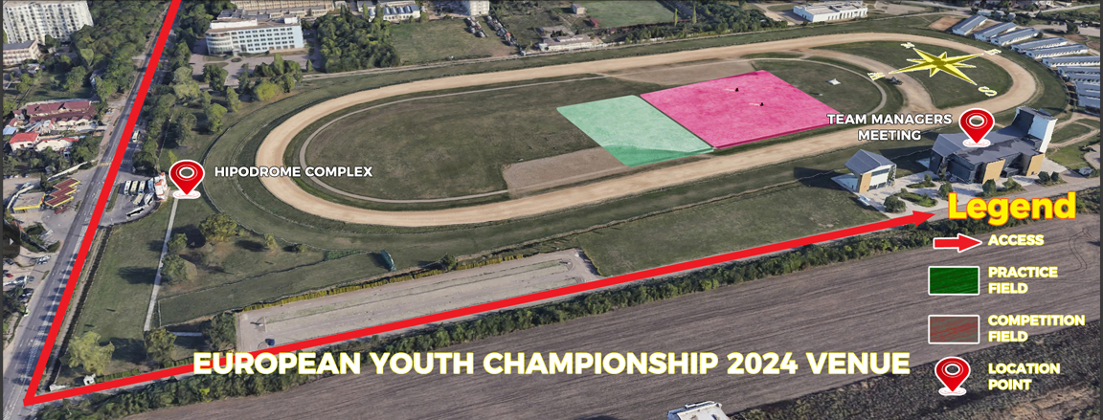
Map of Hippodrome Complex

Weather Forecast

Estimated average temperature: max. 38.3° C / min. 8.9° C
Average rainfall for the month of July: 59.2 mm
Wind speed probability: 17.43 m/s

Closing Party Night

We will inform the teams closer to the event time if we are running a closing party.

Contact the LOC

General Email: eychamp2024@frta.ro
Event Director: Cristian MOCANU
Accommodation Managers: Ştefania RUȚĂ & Răzvan ARDELEANU
Media Registrations: marketing@frta.ro
About Ploieşti: www.ploiesti.ro/legenda.php

About Ploieşti, Prahova County

Explore the attractions of "black gold" city - a phrase that follows this city from the era of the oil rush. From the surprising Ploiesti, not far from the National Petroleum Museum, The Clock Museum is located in city Centre, founded in 1963, it is one of the few museums of this kind in Europe and the only one in Romania.

Ghid turistic Ploiesti, Romania - Infotour.ro
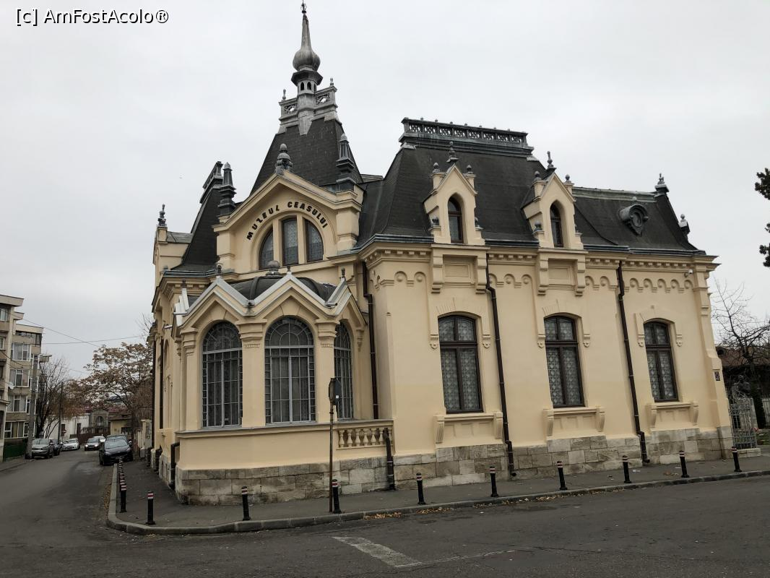
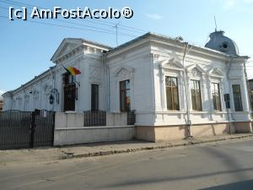
TOP OBIECTIVE TURISTICE IN PLOIESTI. - TARA DACILOR

VISAs (if applicable)

VISA
All participants who need an entry visa to Romania, will be required to complete the Visa Support sections in WAREOS by no later than 1 May 2024.

It is the applicants’ responsibility for supplying the necessary information, ensuring all details are up to date, correct and submitted by the deadlines specified.

In addition, all participants that require a visa are kindly requested to supply a copy of their latest/valid passport. Copies of each application can be uploaded on WAREOS. All passport copies and personal details entered/uploaded to WAREOS will be held securely and in the strictest of confidence and not shared with other parties.

To check if you require a Visa to enter in Romania The Romanian Visa | Ministry of Foreign Affairs (mae.ro)

Please Note: Visas are the responsibility of the individual nations and not the organizing committee.
For visa support or letters please contact eychamp2024@frta.ro.

Looking forward to welcoming you in Romania.

