EUROPEAN GRAND PRIX 2024
INVITATION PACKAGE

To all World Archery and World Archery Europe Member Associations

Dear President, Secretary General,

On behalf of the Local Organizing Committee I would like to invite your team to the European Grand Prix 2024, which will be held in Porec, Croatia, from 3-8 June 2024.

We are in the Olympic year.
All high-ranking archery events, like European Grand Prix, is very good opportunity for the final selection of teams and individuals, and pre-Olympic setup, just 47 days prior to the Olympic tournament.

According to EGP rules, each country can register 6 archers per style and category plus individual club entries, while for the next World Cup a maximum of 3 archers per style and category can be registered.

The Prize money offered to the winners is not negligible and I hope it will attract the attention of many archers and the best among them.

The participation is open to all World Archery Member Associations and club members.

We are looking forward to your arrival.
Sincerely yours,

Mr. Darko Uidl
Organizing Committee
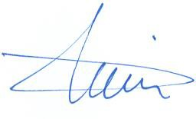
President

IMPORTANT DATES

Please find enclosed all the necessary information for registration, organization, and participation for this event. To register participation, please complete the necessary details in WAREOS within the deadlines listed below:

Summary of deadlines:

Registration Opening Date – Online WAREOS 11 February 2024
Preliminary Entries Deadline 24 March 2024
Preliminary Hotel Reservation & Payment (60%) 27 March 2024
Final Entries Deadline 14 May 2024
Final Hotel Reservation 14 May 2024
Transportation 14 May 2024
Final Payment 14 May 2024
Visa Support 17 March 2024
Full refund cancellation deadline 21 April 2024

PRELIMINARY PROGRAMME

Day |  | Date | Description
Day 0 | Sunday  2 June |  | Arrival of participants  Unofficial Practice is available
DAY 1 | Monday  3 June |  | Official Practice & Equipment Inspection  Team Managers' Meeting
DAY 2 | Tuesday  4 June |  | Qualification Round  (Practice Field open)
DAY 3 | Wednesday  5 June |  | Mixed Teams
DAY 4 | Thursday  6 June |  | Individual Eliminations up to semifinals
DAY 5 | Friday  7 June |  | Team Eliminations and Finals  Team and Mixed Team Award Ceremony
DAY 6 | Saturday  8 June |  | Individual Finals – Medal matches  Award Ceremony
DAY 7 | Sunday  9 June |  | Departure of teams

NOTE
This preliminary programme is subject to change according to participation and TV requirements. All changes will be published and distributed in good time.

PRIZE MONEY

WAE will give total amount of 12.000 € to the winners as follows:

1st place 1.500 €
2nd place 1.000 €
3rd place 500 €

PRELIMINARY & FINAL REGISTRATION

All entries, accommodation reservations, transport needs, flight arrival/departure information and visa invitation letter requests are to be completed using the World Archery Online Registration System WAREOS. These systems now handle the entire registration process for this event. No entry forms, hotel reservations or transportation forms will be accepted.

Member associations can login to WAREOS at http://extranet.worldarchery.org with the username and password assigned by World Archery. After entering WAREOS, selecting the event from the list will allow a member association to register their athletes. Select/press the “Entries” button to see the list of categories in the event. Select/press the “category” to enter the athlete and official numbers/details participating for that event. A WAREOS User Manual can be downloaded in PDF format (English) upon login.

Contact wareos@archery.sport in the World Archery Office with any questions regarding technical problems on WAREOS. For any question regarding the organisation of the event (transport, accommodation, meals etc.) please directly contact the LOC.

A maximum number of 6 men and 6 women per country can be registered into each division of the event.
The host country may enter the maximum of 8 men and 8 women per division.

EGP Rules on WAE official web site.

Member Associations should only use WAREOS to make any changes/amendments to their entries and will be able to do so at any time. Any changes made in WAREOS an email will instantly be automatically sent to the Local Organizing Committee and Member Association with the updated information.

Member Associations that have penalty fees outstanding from earlier events will need to pay these penalty fees and get good standing before being eligible to enter and compete.
Also, World Archery fee must have been paid prior the participation.

Starting date of online registration with WAREOS: | 11 February 2024
Preliminary Entries Deadline: | 24 March 2024
Final Entries Deadline: | 14 May 2024

Please respect the stated deadlines.

However, any changes that are made after the deadlines specified or if entries differ by more than 4 participants from the preliminary entries, the following penalty fees will automatically be applied:
Penalty fees to be paid to Organizing Committee: | Cost:
Penalty fee for late entries (after the final deadline) | 50 € per entry
Penalty fee for not filling Preliminary entries | 150 € per entry
Penalty fee for differences between preliminary and final entries: | 150 € per entry

Any entries received less than 3 days before the Team managers meeting will be refused if no preliminary entry and/or final entry are made prior.

ACCOMMODATION & GENERAL INFORMATION

Important Note
Non-official accommodation is not allowed. Any team or individual accommodated in non-official hotel will not be accredited and participation in the event will be refused.

To confirm your hotel reservations, 60% deposit of the total amount is to be paid by a bank transfer to the Organizing Committee before 27 March 2024. Reservations received after this date will be considered only according to availability.

o Standard Hotel *** (Plavi, Zorna, Istra, Gran Vista)

Half board (dinner at the hotel)
Single Room price 183 €
Number of rooms 20
Double/Twin 336 € per room
Number of rooms 120
Full board (lunch and dinner at the hotel)
Single Room 196 €
Double/Twin 360 € per room

Board plans half board, full board
Check-in from 1 June 2024

- Comfort Hotel ****Albatros - All inclusive

Full board (lunch and dinner at the hotel)
Single Room 232 €
Number of rooms 5
Double/Twin 423 € per room
Number of rooms 25

Board plans All Inclusive
Check-in from 1 June 2024

- Hotel **** (Molindrio)

Half board (dinner at the hotel)
Single Room 202 €
Number of rooms 10
Double/Twin 361 € per room
Number of rooms 40
Full board (lunch and dinner at the hotel)
Single Room 217 €
Double/Twin 391 € per room

Board plans half board, full board
Check-in from 1 June 2024

The hotel rates are per room, per night, including free internet. Additional purchases in the hotel bar, café and mini bar are at own expense*, excluding Hotel Albatros – All inclusive service.
*All prices are including city tax.

During the event there will be a tournament desk available in office on the FoP with all the relevant and latest information about the European Grand Prix 2024.

All information will be forwarded to the WhatsApp groups for everyone signed up for this mode of communication. Information will be shared through Instagram, and Facebook.

Important Note
Refer to the accommodation pages for detailed hotel information.
Please complete all the necessary sections in WAREOS and make full payment for entries, transport, and accommodation by the specified deadlines.
Bank transfers only, no credit cards or travel checks will be accepted.

- Standard Hotels ***

Hotel Plavi ***
Hotel Zorna ***
Hotel Gran Vista ***
Hotel Istra ***
Sitting right above a Blue Flag beach, Hotels were renovated when the new, light, and airy dining and reception area were created. Plenty of bars and restaurants along the coastline provide ample entertainment in the evening, but if you've spent your day outdoors you just might choose to stay in and relax.

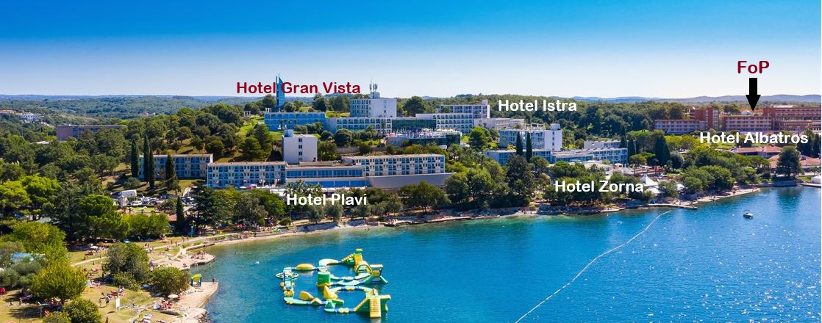

- Comfort Hotels ****
Hotel Albatros **** All Inclusive
Book an All Inclusive holiday at Hotel Albatros and leave all your worries at home. We'll wine you and dine you, entertain you and relax you, workout with you or give you so many options, you'll have to come back next year to try them all.
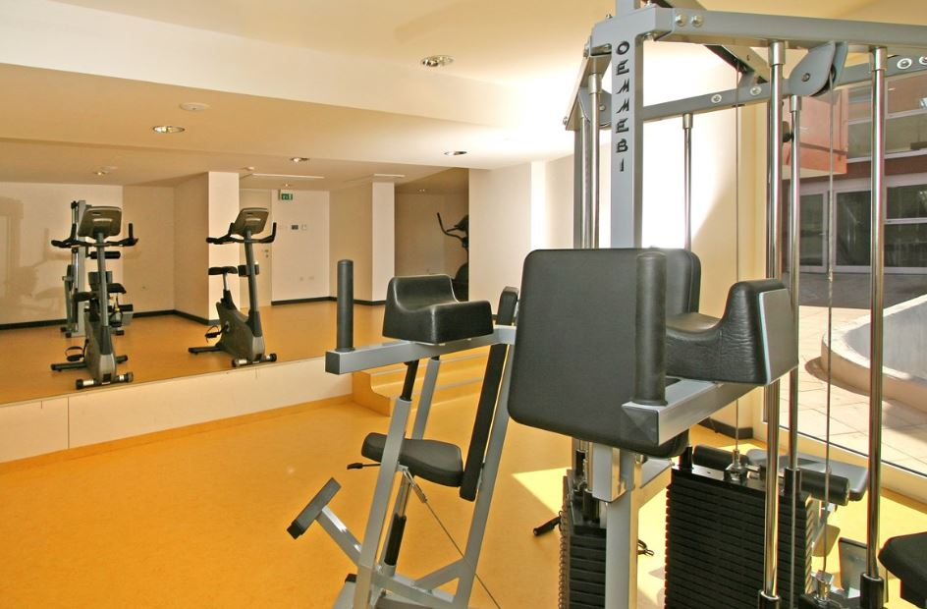
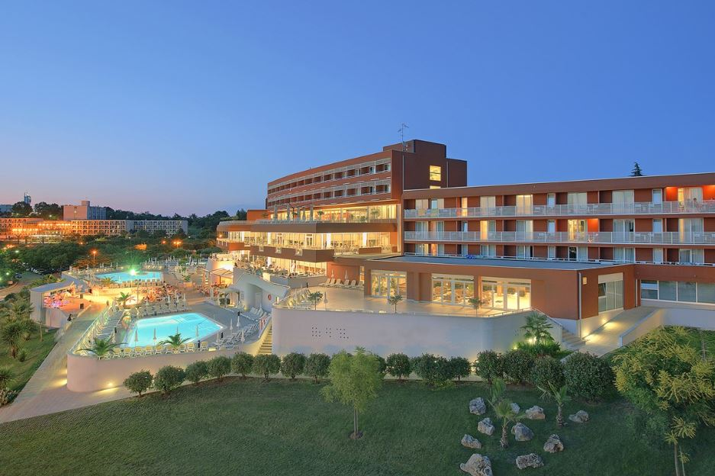

Hotel Molindrio ****

At Zelena Resort, hotel Molindrio takes the holiday experience to the next level, combining upscale amenities and elegance into one of the chicest Plava Laguna properties in Porec. The hotel grounds are all neatly trimmed grass if you want to take a barefoot walk. All rooms are appointed with sweet smelling linens, a plush robe and slippers. There's a private balcony too, so you can catch those dreamy Mediterranean views and sunsets and bask in the views of the Zelena Resort.
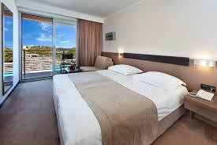
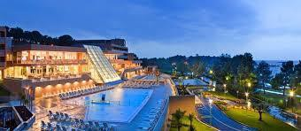

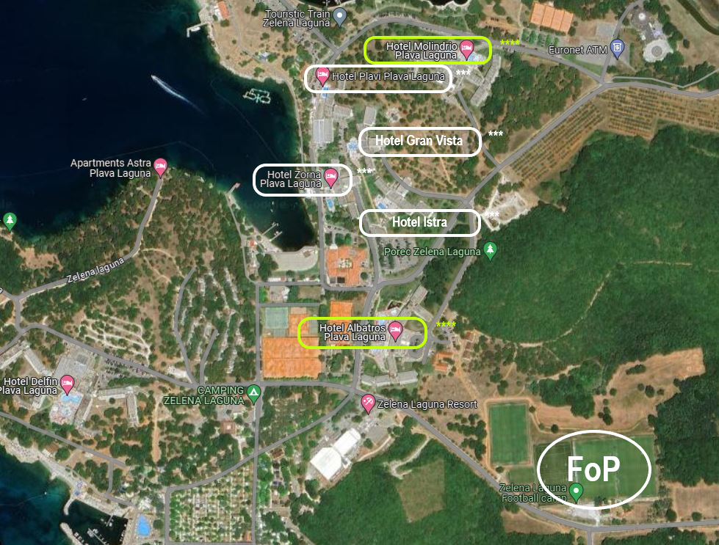

ENTRY FEE

Individual 200 € per athlete
Officials 100 € per person
Teams 125 per Team
There is no entry fee for mix teams.

Temporary Upgrade: 30 € per accreditation (for athletes - to be a coach temporarily).

Entry fees include daily local transport to and from the practice field to/from official hotels during the qualification, elimination, and finals (timetable to be confirmed on site).

PAYMENT CONDITIONS

All fees should be paid in full before arrival.

Payment of accommodation and local transportation: a minimum deposit of 60% of the total amount owed should be made when booking by 27 March 2024.
The final outstanding balance shall be transferred by 20 May 2024. Accommodation cannot be guaranteed after this deadline. A balance invoice will be provided via WAREOS.
Entry fee should be paid by 20 May 2024 separately than Accommodation & Transportation due to Croatian Tax policy.

Bank information for ACCOMMODATION &TRANSPORTATION

BANK RAIFFEISEN BANK AUSTRIA D.D. BANK ACCOUNT HOLDER NAME UNILINE D.O.O.
ADRESS BOZE GUMPCA 38, 52100 PULA
ACCOUNT No HR HR3124840081100646084
BIC/SWIFT CODE RZBHHR2X

Bank information for ENTRY FEES
BANK: PRIVREDNA BANKA ZAGREB D.D. BANK ACCOUNT HOLDER NAME: HRVATSKI STRELICARSKI SAVEZ
ADDRESS: HRVATSKOG PROLJECA 34, 10040 ZAGREB
ACCOUNT NO: HR6623400091110039202
BIC/SWIFT CODE: PBZGHR2X

NOTE: All payments shall be made in EUR only by BANK TRANSFER.

Bank transfer fees are responsible on the sender.
Credit cards and Travel checks will not be accepted.

CANCELLATIONS & CHANGES
All cancellations and changes must be made through WAREOS:
- Cancellations received before 21 April 2024 a full refund of the deposit payment will be made.
- Refunds will be processed after the event.
- Cancellations received after 21 April 2024 no refund will be given.
- Name changes to team officials or athletes (same category and division) will be accepted up to 72 hours before the event without any additional charge.
- Should flight arrival details change last minute, please contact the Organizing Committee using the details indicated in the Team Managers’ Booklet.
- If a participant’s arrival is later than the original scheduled arrival date, the room charges will start from the dates of the original booking made by the Member Association.

ADDITIONAL INFORMATION

Transport:
As the Porec city is not in the close distance of a major international airport (except for the local Pula airport), you can choose one of these for your arrival airport, whichever suits you best.

CROATIA Zagreb Airport, Pula Airport
SLOVENIA Ljubljana Airport
ITALY Trieste Airport, Venice Airport

Local transport to Porec from the above airports is very poor, so we advise you to book the private transfer options below. Price is per person per one way.

Transfers One passenger Two – Three passengers Four and more

Zagreb Airport 380 € 260 € 180 €
Ljubljana Airport 660 € 450 € 310 €
Pula Airport 120 € 60 € 40 €
Trieste Airport 260 € 140 € 70 €
Venice Airport 380 € 260 € 180 €

Group transfer with bus – fixed time departure - one way
If you choose this transfer, you will have to adapt to all other passengers and wait for the departure time.
Only one bus transfer available on arrival dates.
Minimum of 20 passengers to confirm the transfer departure. Organizer can cancel the transfer if there will not be 20 or more passengers booked per transfer.

Internet
Free WiFi will be available in the official hotel (in hotel rooms and in the lobby).

Meals
The lunch is foreseen to be served at hotels. Team managers can request a lunchbox in Hotel where they are located to dine at FoP during the official days.

Water
Water will be available at the venues free of charge.

Media Registration
Media representatives can apply for registration by emailing archery@archery.hr

Weather

https://www.meteoprog.com/weather/Porech/month/june/
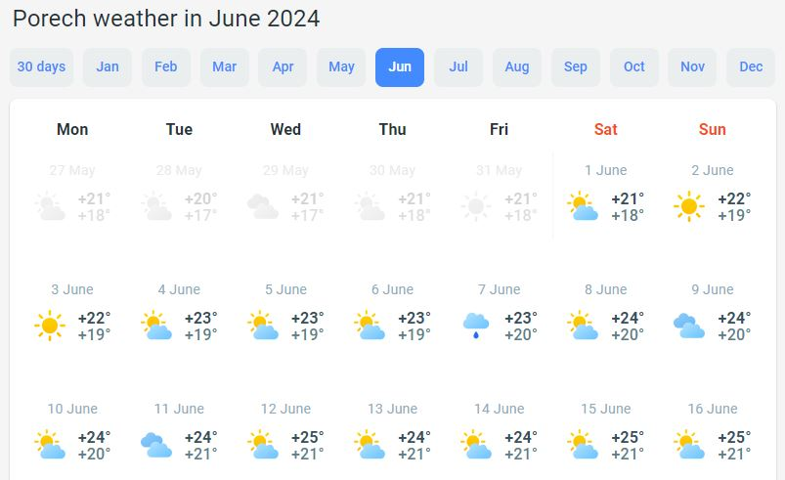

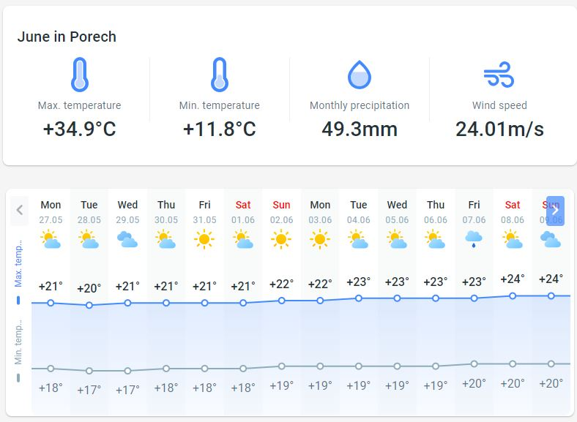

Dress regulations
WA & WAE dress regulations do apply.

Closing Party
Banquet or closing party will not be organized.

VISA SUPPORT

All participants who need an entry visa to Croatia, will be required to complete the Visa Support Form in WAREOS no later than 17 March 2024.

It is the applicants’ responsibility for supplying the necessary information, ensuring all details are up to date, correct and submitted by the deadlines specified.

In addition, all participants that require a visa are kindly requested to supply a copy of their latest/valid passport. Copies of each applications can be uploaded on WAREOS. All passport copies and personal details entered/uploaded to WAREOS will be held securely and in the strictest of confidence and will not be shared with other parties.

Please note that the Organizing Committee can provide invitation for the period of the European Grand Prix only.

LOC CONTACT

President Organizing Committee Darko Uidl
General Secretary - Entry Fee Kresimir Cadez
Email archery@archery.hr
+385 91 4343 463
English and Croatian
Transport, Accommodation
& Finances Hrvoje Mijic
Email egp2024@uniline.hr
+385 99 4696 283
Language English and Croatian
EGP Email infoegp2024@archery.hr
Official website http://egp2024.org

CLUB ARCHERS PARTICIPATION

Club archer’s participation in EGP 2024. is allowed.

Country:
Family Name:
Name: |  |  |  |  |  | WA ID #  (If any)
Date of birth: |  |  |  | DIVISION |  |  | RM
Club name: |  |  |  |  |  |  | RW
 |  |  |  |  |  |  | CM
 |  |  |  |  |  |  | CW
CLUB ARCHER REGISTRATION FORM

Event: European Grand Prix 2023
POREC CROATIA DATE 3–8 June 2024

Email address:
Address: | Street:
 | City:
 | Postal code:
 | Phone #:

All cells must be completed
Day | Month | Year

To complete ONLY by THE LOC
Date the Form was received:

Please send this form completed to the Local Organizing Committee and to your National Archery Federation/Association:

The Local Organizing Committee (LOC) will contact you to coordinate final registration, payment and any other information needed to complete your registration to the event.

Your Federation will need to register your data in WAREOS (WA Registration & Entry Online System) in order to include you into the results system and WAREOS.

Regulation for club archers participating in European Grand Prix

  - The Club Archer is responsible to send the completed form to the LOC and to his/her Federation. Sending the form does not guarantee his/her participation. The process of registration and inclusion must respect the Club Archers’ regulations and procedures in order to be able to participate to this event.

  - As soon as the Club Archer will be registered in WAREOS (by his/her Federation) and the LOC has accepted his/her registration, the Club Archer will be informed by the LOC that he/she can officially take part in the event.

  - Club Archers participating in WAE event must be members of a WA Member Association (therefore official members of the Archery Federation of his/her country).

  - The LOC will work on a “first come, first serve” basis, to take into consideration the forms they will be receiving. However, in order to participate, the Club Archer must also fulfil all the requirements requested in terms of booking, payments and other information requested by the LOC.

  - Club Archers cannot have coaches or guest accredited to access the FoP (blue area). If guest or coaches will accompany a Club Archer, he will be treated as a spectator.

  - DRESS REGULATIONS: Club Archers must respect WA rules (Book 1, point 3.22) in terms of uniform for the WA events. Club Archers cannot use any National Team uniform (neither of his country nor any other).

  - Club Archer must be present in the Official Practice Day when he will pick up his/her accreditation, confirm name and data given and pass the equipment inspection. The Club Archer is not allowed to miss the official practice and arrive directly to the qualification day. Travel plan should be arranged according to the schedule.

  - Club archers could be Junior or Senior Categories. Cadet’s archers are not allowed to participate in the event as Club Archer.

CLUB ARCHER REGISTRATION PROCEDURE

- The Club Archer interested in participating in a Grand Prix competition, has to read Invitation Package and study cost and conditions to participate.

- After the end of the Preliminary Registration, the LOC (Local Organizing Committee) will calculate the available spaces for Club Arches per Division and inform WAE, which will advertise and publish the spots available for Club Archer on WAE Website.

- Max 30% of spots of the spots available (for Division) are for Club Archers from the host country, 70% are for International Club Archers.

- The Club Archer will visit the WAE Website and as soon as she/he knows the places available, completes the 'Club Archer Registration Form' and sends it to the LOC and to her/his National Archery Federation.

- The belonging Federation, receiving the Club Archer Registration Form, has to check:
  - if she/he is a member of the Federation
  - If all is OK, the Federation will register the data of the archer in WAREOS (WA Registration & Online System) in order to include her/him into the result system and WA WAREOS data base. If Club Archer is included in WAREOS, the Federation has to inform LOC that the archer is eligible for the event.

- The LOC will prepare a list of Club Archers forms ordered by date of arrival and inform the Club Archer that her/his form has been received and she/he is included in the Club Archers list. The LOC requests to start room booking and fees-cost payment as indicated in the Invitation Package.

- The Club Archer contacts LOC to arrange room booking, arranges payments and informs about travel plan.

