2019 INDOOR EUROPEAN CHAMPIONSHIPS
SAMSUN – TURKEY

Team Managers Meeting will take place at the Samsun Sheraton Hotel, Kızılırmak Meeting Room on 19 February 2023, Sunday at 11:30hrs

All Team Managers are requested to attend this meeting.

Teams without Team Manager are advised to send one of their athletes to the meeting

Please read this document upon receipt and BRING it with you to the Team Managers Meeting

Version 1.1 – 07.02.2023

Dear Team Managers,

On behalf of the Organizing Committee, I would like to wish you a warm welcome to Samsun, 2023 European Indoor Championships.

I wish all the teams’ good luck and success.

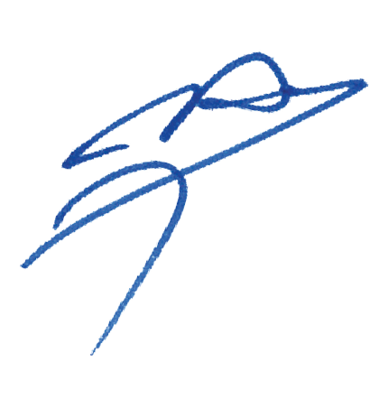

Mr. Hüsnü KOCAOĞLU
Chairman of the Organising Committee

Agenda of the Team Managers Meeting
Roll call of all attending nations (TD)

- Introduction of Officials & Opening of the Meeting (WAE TD)
  - Welcome & Introduction of the panel by WAE TD
  - Introduction of the panel, WAE TD
  - Welcome speech by the President of the Organizing Committee

- Introduction of Officials (TD)
  - Organizing Committee (OC) members, by the Chairman of the OC
  - Tournament Judges Commission, by the Chairman of Judges
  - Director of Shooting, by the Chairman of Judges
  - Jury of Appeal, by WAE TD

- Technical Aspects of the competition (WAE TD + Chairman of Judges)
3.1. Number of participants per category
3.2. Competition programme (attached)
3.3. Practice – Training – Programme attached
3.4. Equipment Inspection
3.4.1. Athletes (back) Numbers
3.5. Qualification Round & Information on scoring
3.6. Individual Elimination Round
3.6.1. Recurve
3.6.2. Compound
3.7. Team Elimination Round
3.7.1. Recurve Team
3.7.2. Compound Team
3.8. Individual Finals Round & Team Finals Round
3.9. Appeal Procedure (Form attached)

- Technical Matters (WAE TD + Chairman of Judges)
4.1. Timing Control system
4.2. Results system
4.3. Rules that apply in this event

- Logistics Aspects (OC)
5.1. Transportation: Venue, Airport etc.
5.2. Meals, during the qualification, practice, finals…

- Protocol and Ceremonies
6.1. Medal Ceremonies

- Medical Services (Medical Representative)
7.1. Medical services
7.2. Physiotherapy services
7.3. Emergencies

- Doping Control (Medical Representative)
8.1. Doping Control
8.2. Alcohol Test

- Dress Regulation

- Other Matters of Importance
10.1. Environment
10.2. Water
10.3. Non-Smoking
10.4. Mixed Zone and Press Conference
10.5. Internet Access

- Questions from Teams Managers

- Closing (WAE TD)

Important Telephone Numbers

Competition Management
Alper AYTACOGLU 00 90 533 632 35 25

Hotel and Accommodation
Sirer AYDIN 00 90 533 515 25 33
Serdar KESEN 00 90 531 992 13 53

Medical Care
Dr. Mehmet Ejder SÖZEN 00 90 505 535 15 52

Technical Requirements & Field Manager
Fatih BOZLAR 00 90 544 428 50 71

Press Officer
Cumhur YAVAŞ 00 90 532 252 25 48

World Archery Europe Technical Delegate
Hakan ÇAKIROĞLU 00 90 532 422 51 00

Tournament Judge Commission Chairman
Klaus LYKKEBEAK

Director of Shooting
Niko YLIPELKONEN

World Archery Europe Judges
Robert POTTS Mariagrazia PINNA Zascha SCHOONEWILLE
Metka VODUSEK Csaba TOTH Danielle FINSTEIN
Kryzsztof MARKIEWICZ Susan RICHARDS Per Christian STENSGAARD
Francisco Gimenez HERNANDEZ

National Judges
Orhan SENTURK Alper GULER Serdar OZDEMIR
Soner YUCEER Muharrem CAKMAK

WAE Results & Technology Team
Matteo PISANI 00 39 348 221 45 45

Accreditation & Live TV
Özal AKSU 00 90 532 522 20 20

Points to clarify

3) Technical Aspects of the competition (TD + Chairman of Judges)

3.1. Number of Participants per category

Number of Member Associations: 28

Recurve Men | Individual | 41 (1/16) | Team | 11 (1/8)
Recurve Women | Individual | 26 (1/16) | Team | 7 (1/4)
Recurve U21 Men | Individual | 28 (1/16) | Team | 6 (1/4)
Recurve U21 Women | Individual | 24 (1/16) | Team | 5 (1/4)
Compound Men | Individual | 29 (1/16) | Team | 7 (1/4)
Compound Women | Individual | 18 (1/16) | Team | 3 (No Title)
Compound U21 Men | Individual | 20 (1/16) | Team | 5 (1/4)
Compound U21 Women | Individual | 18 (1/16) | Team | 3 (No Title)
Barebow Men | Individual | 21 (1/16) | Team | 4 (1/2)
Barebow Women | Individual | 19 (1/16) | Team | 5 (1/4)
Barebow U21 Men | Individual | 12 (1/8) | Team | 3 (No Title)
Barebow U21 Women | Individual | 12 (1/8) | Team | 3 (No Title)

3.2. Competition Programme
The latest competition programme will be provided 1 week prior to official practice on the World Archer Europe website. Any official competition schedule will have indicated the version number and the date/hour it was printed. Latest version of the Competition Schedule at the moment of writing the Team Managers Booklet is V1.0

3.3. Practice
- Training range is available from 17 February 2023
  - 17 February – 22 February 09:00 – 11:30hrs and 14:00 – 17:30hrs

Official Practice
- 09:00hrs – 11:00hrs for RM + RW + CU21M + CU21W
- 14:00hrs – 16:00hrs for CM + CW + RU21M + RU21W
- 16:30hrs – 18:30hrs for All Barebow Categories

Qualification Round Practice
- 3 ends of 90 seconds practice on the Field of Play for qualification to immediate follow once the field is reset
- Non-competing athletes can use the practice field, just near the Field of Play. Practice range will be equipped by separated timing routines without sound signal.
- The transportation will be available for non-competing athletes to the practice range from official event hotels

3.4. Equipment Inspection
- Sunday 19 February, during the official practice.
- Located to the right of the field (behind the show range)
- Teams will be announced in (English) alphabetical order by the DOS
- All teams are to wear their team uniform and have their valid accreditation
- Spare equipment must also be brought for inspection
- Team Managers are to check the details of their athletes such as, name, date of birth are correct beforehand.
- Inform the Judge if details are not correct and Judge will inform World Archery Europe Results Team.
- Instructions to use the tablet scoring system will be carried out if requested.
- The passports/the id cards and the date of births will be the checked during the accreditation for U21 Categories.

3.4.1. Athlete (back) Numbers
- Athlete numbers will be issued on the day of qualification round (with the score cards) during the practice.
- Athlete numbers must be worn on the quiver or thigh, facing the waiting line while shooting

3.5. Qualification Round and Information on Scoring
Recurve - 20 February 2023, Monday
Morning Session - All Senior Categories
Afternoon Session - All U21 Categories
4 athletes per target in AB – CD Format
18m Round (60 arrows)
Compound - 20 February 2023, Monday
Morning Session – All U21 Categories
Afternoon Session – All Senior Categories
4 athletes per target In AB – CD Format
18m Round (60 arrows)
Barebow - 20 February 2023, Monday
Evening Session – All Categories
4 athletes per target In AB – CD Format
18m Round (60 arrows)
- Electronic Score Terminals (PDA) for each target will be given by volunteers when athletes will go to the target.
- Assistance will be given in the FoP if requested by the WAE Result Team on site.

3.6. Individual Elimination
- 1/16 and 1/8 Elimination Rounds for all categories will take place on 21 February 2023, Tuesday.
- 1/4 and ½ Elimination Rounds for all categories will take place on 22 February 2023, Wednesday at afternoon session
- Byes are permitted. In case of a bye, athletes might be allowed to shoot on their own target, provided the competition schedule and space on the FoP allows. If the competition schedule allows, no score will be recorded or displayed and athletes shooting their bye must respect the DOS timing and signals of the competition. Recurve athletes are permitted to shoot 3 sets of practice and compound athletes are permitted to shoot 5 ends of practice for their bye.
- Target faces will NOT be change after practice arrows. Please instruct your athletes to mark all arrow holes during practice.
- Matches will start as soon as the field is ready.
- Matches at the start of each session will begin on time. Proceeding matches will follow up on the immediate completion of prior match.
- Individual elimination rounds will start at the 1/16 elimination stage (32 athletes, in each category or less, depending on entries)
- There will be no alternate shooting for until bronze and gold final.

3.6.1. Recurve Elimination
- The set system will be used for all individual matches. Individual and Team matches will consist of the best of 5 sets, (3 arrows per set) and the winner is the athlete to reach a minimum 6 set point first. Team matches will consist of the best of 4 sets (6 arrows per team). The team that reaches minimum of 5 set points first will win match. All matches, up to and including the semi-finals, will be simultaneously on the qualification range for the individual and team events.

3.6.2. Compound Elimination
- Matches for all compound events will use the cumulative scoring, consisting of 5 ends of 3 arrows. All matches, up to and including semi-finals, will be shot simultaneously on the qualification range for the individual and team events.

3.7. Team Elimination Round
- No alternating shooting
- Byes permitted from 1/4, teams will be allowed to shoot on their allocated target, but no score will be recorded or displayed.

3.7.1. Recurve Team
- 22 February 2023, Wednesday 1/8 elimination phase
- Up to 4 sets of 6 arrows, 2 arrows per athlete (18m, set system)

3.7.2. Compound Team
- 22 February 2023, Wednesday 1/4 eliminations phase
- 4 ends of 6 arrows, 2 arrows per athlete (18m, cumulative scoring)
- There will be no championship title on CW and CU21W due to less than 4 team participation.

3.7.3. Barebow Team
- 22 February 2023, Wednesday 1/4 elimination phase
- Up to 4 sets of 6 arrows, 2 arrows per athlete (18m, set system)
- There will be no championship title on BU21M and BU21W due to less than 4 team participation.

3.8. Individual and Team Medal Matches
- All the Team and Individual Medal Matches for U21 Categories will take place on 23 February 2023, Thursday
  - 09:00hrs – 12:30hrs All U21 Team Medal Matches
  - 14:00hrs – 18:00hrs All U21 Individual Medal Matches
- All the Team and Individual Medal Matches for Senior Categories will take place on 24 February 2023, Friday
  - 09:00hrs – 13:00hrs All Senior Team Medal Matches
  - 14:00hrs – 18:00hrs All Senior Individual Medal Matches
- Finals will take place at same venue as qualification and elimination rounds
- Practice range will be open for all finalists only during the 23 February 2023, Thursday and 24 February 2023, Friday.

3.9. Appeal Procedure (Form Attached)
- In case of Appeal, the Appeal Form should be given to Chairman of Judges or his deputy.
- To proceed with an appeal, a deposit 50 Euros should be given to the WAE TD or Chairman of Judges for appeal to be valid.
- If the Appeal is upheld by the Jury of Appeal, the fee will be returned. In the case of the Appeal being rejected, the fee will not be returned.

4) Technical Matters (TD + Chairman of Judges)

4.1. Timing Control System
- The local timing system will be used for timing and scoreboards.

4.2. Results System
- Qualification Round – scoring will be completed by athletes. One athlete record, on the official paper-based score sheet, the scores of all other athletes on that target. At the same time, another athlete, on that same target, will enter all the scores of the athletes on that target into the scoring tablet. The other athletes should verify that all scores are written and entered correctly.

- Scorecards MUST be signed by both athlete and the scorer, have all the total mathematically correct with the 10s and 9s count fully completed. Any scorecards where the 10s and 9s count are not completed a “0” will be given for the total of 10s and 9s count for that athlete. Any scorecards not signed or the score total is missing will result in disqualification.
- Elimination Round – scoring will be completed by athletes. One athlete/team records the arrow values of both athletes/teams on the paper score sheet. While at the same time, the other athlete/team inputs the arrow values into the scoring tablet. Both athletes/teams should verify that all scores are written and entered correctly before returning to shooting line.
- At the end of the match, the scorecard must be fully completed and signed by the athletes (or agent/judge in the case of finals) involved in the match.
- Scoring tablets will be used during the Qualification and Elimination Rounds, but not in the Finals. Mr. Matteo PISANI (WA Results & Technology Manager) is responsible for the results of the event.
- IMPORTANT NOTE: There will be internet access on the official hotels and FoP. Because of this any information or results won’t be distributed as printed. There will be no pigeon boxes on the field. All the information’s will be shared on official result page or www.archeryeurope.org web page.

4.3. Rules that apply in this event
- Rules for Indoor and WA official interpretations.
- We will use Recurve Target Faces for all Recurve Divisions, Compound Target Faces for all Compound Divisions and Barebow Target Faces for all Barebow Divisions.

5) Logistic Aspects (OC)

5.1. Transportation
- Daily transport information and schedules will be published on official result (www.ianseo.net) page and notice boards at all the official event hotels.

5.2. Meals during the event
- Meals will be served at the hotel restaurants according to the schedule below:
  - Breakfast 07:00 – 10:00hrs
  - Lunch 12:00 – 14:00hrs
  - Dinner 19:00 – 21:00hrs

6) Protocol and Ceremonies

6.1. Medal Ceremonies
- Award ceremonies will take place after each gold final match
- All athletes involved in the ceremonies are requested to be ready at the FoP during the related gold final match for each division and categories.

7) Medical Related Issues (Medical Representative)

7.1. Medical Services
- First Aid services will be available during the training days 17 - 18 February 2023.
- Ambulance and First Aid services will be available from 19 February to 24 February 2023 in the Samsun Archery Centre.
- A doctor and a nurse are available on site for any emergency

7.2. Physiotherapy Services
- There will be Physiotherapy room on the venue and all teams are allowed to use with their physiotherapist.

7.3. Emergencies
- In case of emergencies in official hotels, please inform that contact person in each hotel or Mr. Sirer AYDIN (Mobile: 00 90 533 515 25 33) who is managing medical care operations.

8) Clean Sport

8.1. Anti-Doping Control
- Anti-Doping control will follow World Archery Europe rules.
- Athletes should bring their passports and/or accreditation cards to the anti-doping control station if selected for a test.

8.2. Alcohol Test
- Athletes and officials should also be available for random alcohol testing during the competition, following World Archery Europe Rules.

9) Dress Regulation
- Athletes, officials and staff should wear the appropriate clothing having the correct appearance when on the field during the competition. Open-toed shoes or camouflage clothing, accessories or archery equipment are not permitted.
- Athletes, team officials and technicians should wear their national team uniforms and sport shoes having the same appearance as per the division, following World Archery Europe rules.
- We would like to remind all teams that athlete names and country names or codes are mandatory on the back of their national team uniform shirts for athletes participating in World Archery Europe Championships.

10) Other Matters of Importance (WAE TD + OC)

10.1. Environment
- Team Managers, please instruct your team members to use litter bins located on the competition, practice ranges and common areas.

10.2. Water
- In an effort to aid the environment, water will be distributed using the familiar World Archery Europe bottle deposit system.
- 1 bottle of water will be given to all accredited persons at the water stations located around the FoP and Practice range.
- A new bottle of water will only be issued by the return of the empty bottle. If the empty bottle has been lost, please contact the OC at the Information desk.

10.3. Non-Smoking
- This is a non-smoking event.
- Smoking is forbidden inside public buildings and all competition and training areas. This is also included electronic cigarettes, refer to book 3, Art.12.8.

10.4. Mixed Zone and Press Conferences
- Interviews will take place at the Mixed Zone and athletes will be requested to pass through the mixed zone to speak with media.

10.5. Internet Access
- Internet access will be free of charge in the rooms and lobby of official hotels.
- All other hotels expenses including laundry and minibar, etc... will be covered by the participants themselves.
- A closed network infosystem will be available at the qualification venue for live results.

11. Questions from Team Managers

12. Closure (TD)
- Closure

Competition Venue:
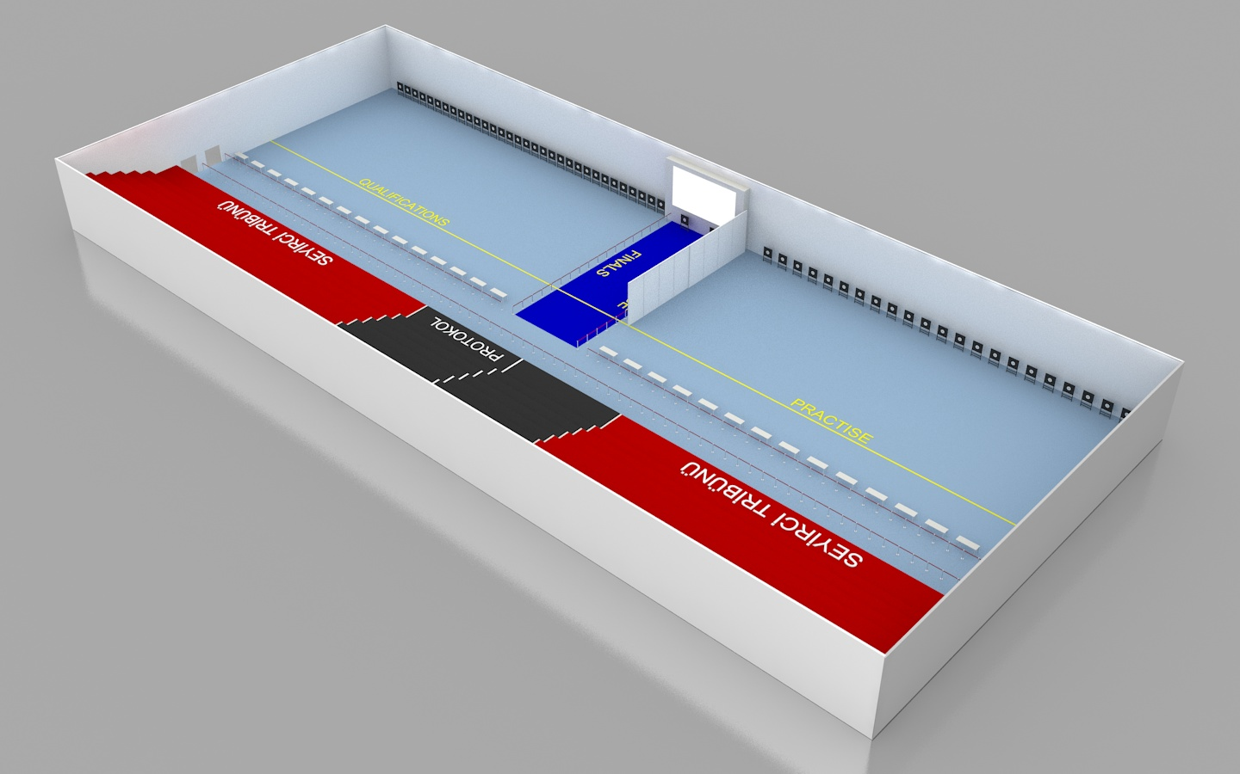
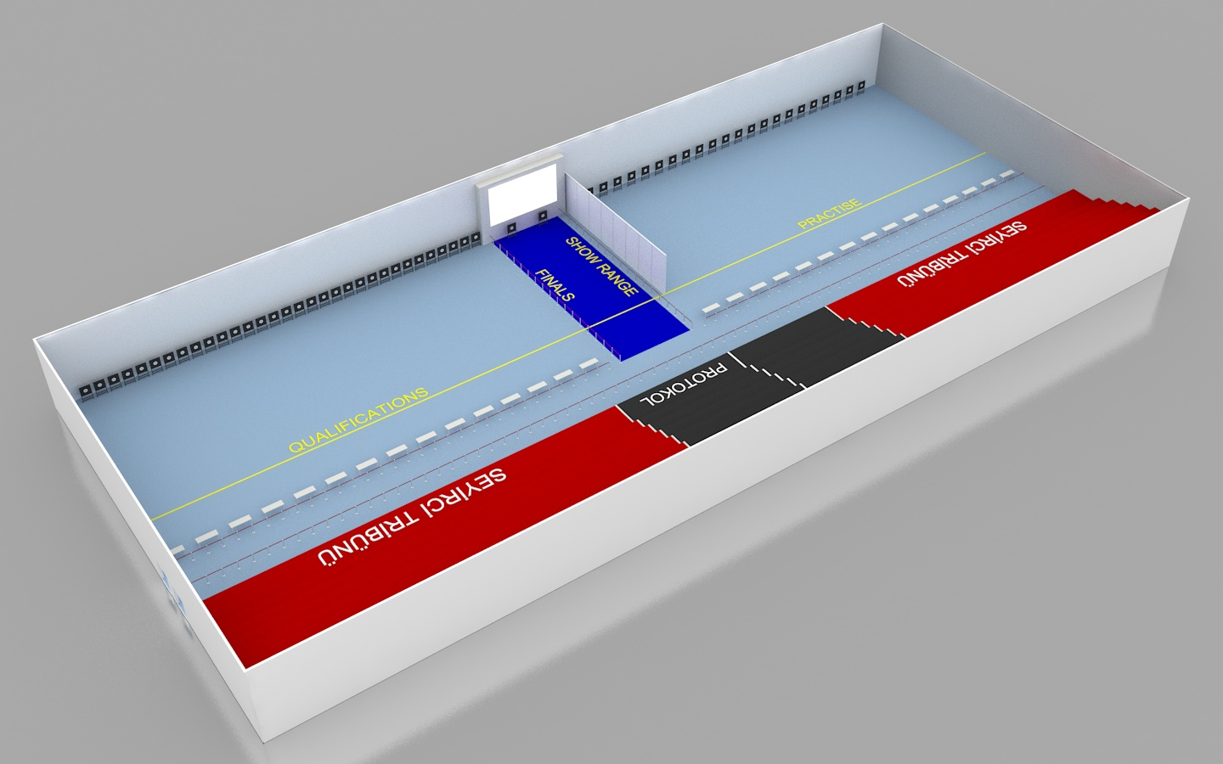

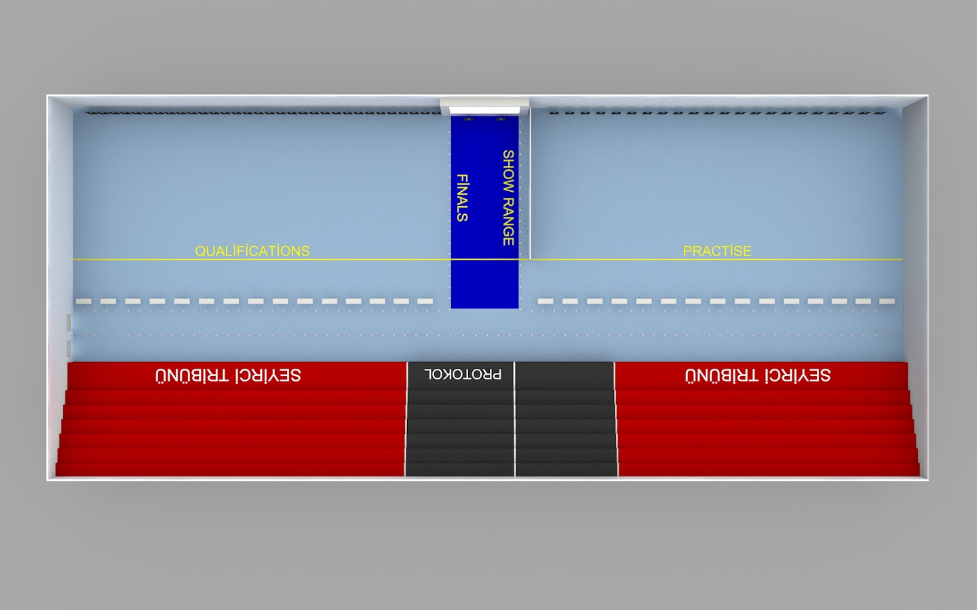

Top things to do in Samsun;

According the TripAdvisor, these are the top things to do in Samsun

