

To All World Archery Member Associations

Dear President,

As Chairman of the Local Organizing Committee (LOC) for the 2026 European Grand Prix Spring Arrows Archery Tournament which will be held on 20 - 26 April 2026 in Antalya-TURKIYE, I would like to invite and welcome your Association to participate in our event.

This competition will be organized following the WA and WAE EGP RULES, Recurve and Compound divisions in the Outdoor Target Archery discipline.

The participation is open to all World Archery Member Associations and Club Members.

Sincerely yours,

Caner SECILMIS
Chairman of LOC

Important Dates:
Please find enclosed information regarding the details of this event and how to complete registration. To register participation, please complete all the necessary sections in WAREOS within the deadlines listed below:

Summary of deadlines:

Registration Opening date on WAREOS | 25 October 2026
Preliminary Entries | 20 January 2026
Final Entries | 30 March 2026
Hotel reservation down-payment (50%) | 20 January 2026
Hotel reservation and payment | 30 March 2026
Transportation | 30 March 2026
Visa support | 20 January 2026
Full refund cancellation deadline  *After this deadline, the LOC is allowed to retain all amounts due by the Member Association. | 29 March 2026

Looking forward to welcoming you in Antalya, TURKIYE.

PRELIMINARY PROGRAMME

20 April 2026  Monday | Arrival of participants  Practice field and local transport available
21 April 2026  Tuesday | Official Practice & Equipment Inspection  Recurve & Compound
22 April 2026  Wednesday | Qualification Round  Recurve 70m Round  Compound 50m Round
23 April 2026  Thursday | Individual Eliminations  Recurve & Compound
24 April 2026  Friday | Team & Mix Team Eliminations  (Team & Mix Team Matches)
25 April 2026  Saturday | Team & Mix Team Finals  (Team & Mix Team Finals)
26 April 2026  Sunday | Individual Finals – Recurve & Compound
27 April 2026  Monday | Departure of Teams

NOTE: This preliminary program is subject to change according to participation and TV requirements. All changes will be published and distributed in good time.
PRELIMINARY & FINAL REGISTRATION

All entries, accommodation reservations, transport needs, flight arrival/departure information and visa invitation letter requests are to be completed using the World Archery Online Registration System WAREOS https://extranet.worldarchery.sport. This system handles the entire registration process for this event. No entry forms, hotel reservations or transportation forms will be accepted; all information must be entered into WAREOS.

Member associations can login to WAREOS at http://extranet.worldarchery.sport with the username and password assigned by World Archery. After entering WAREOS, selecting the event from the list will allow a member association to register their athletes. Select/press the “Entries” button to see the list of categories in the event. Select/press the “category” to enter the athlete and official numbers/details participating for that event. A WAREOS User Manual can be downloaded in PDF format (English) upon login.

Contact wareos@archery.sport with any questions regarding technical problems on WAREOS. For any question regarding the organisation of the event (transport, accommodation, meals, invoices, visa etc.) please contact directly the LOC.

A maximum number of six (6) athletes per country can be registered into each category and divisions of the event.

Member Associations can only use WAREOS to make any changes, amendments or cancellations to entries and will be able to do so at any time. An email will automatically notify the Organising Committee and Member Association of any changes made in WAREOS.

Regulations for Club Archers participating

Club archers (i.e. athletes not competing as country) can register on Open WAREOS with their
username and password if already registered in the past or register to get the log in details if it’s
the first time. After the creation of the profile, follow the instructions to register to the event.

This does not guarantee his/her participation. The process of registration and inclusion must
respect the Club Archers’ regulations and procedures to be able to participate to this event.
Club Archers participating in WRE event must be members of a WA Member Association (therefore official members of the Archery Federation of his/her country). The athlete’s national federation will be able to veto the entry if required.

DRESS REGULATIONS: Club Archers must respect WA rules (Book 1, point 3.22) in terms of uniform for the WA events. Club Archers cannot use any National Team uniform (neither of his country nor any other).

Club Archer must be present in the Official Practice Day when he will pick up his/her accreditation, confirm name and data given and pass the equipment inspection. The Club Archer is not allowed to miss the official practice and arrive directly to the qualification day. Travel plan should be arranged according to the schedule.

ENTRY FEES

Individual 200 EUR per athlete

Officials 100 EUR per person

Teams 125 EUR per team (Mixed Team free of charge)

Temporary Upgrade: 30 EUR per accreditation (for athletes – to be a coach temporarily)

Member Associations that have penalty fees outstanding from 2026 will need to have paid these penalty fees before being eligible to enter and compete.

Any entries received less than 3 days before the team managers meeting will be refused if no preliminary entry and/or final entry are made prior. This decision cannot be appealed by the teams and is fully compliant with the current World Archery rules, article 3.7.1.2.

Any changes made after the deadlines specified or if entries differ by more than 4 athletes from the preliminary entries, the following penalty fees to will automatically be applied:
Penalty fees to be paid to Organising Committee: | Cost (EURO):
Entries made after the preliminary and/or final entry deadline date. | 50 per entry
If final entries differ from the preliminary entries by more than 6 athletes/officials. | 150 per entry
Failure to have made preliminary entries before the deadline date but then have submitted final entries. | 150 per entry

ACCOMMODATION & GENERAL INFORMATION

Özkaymak Falez Hotel – Five Star Hotel
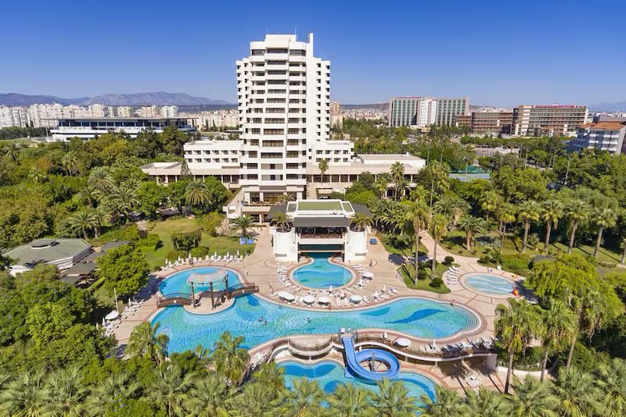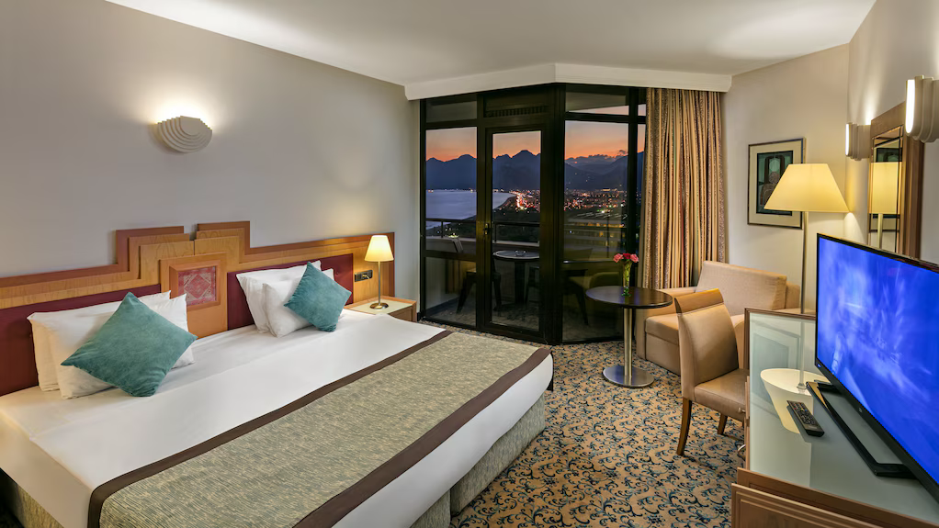
- Single Room price: EUR 275,00 per room
- Number of rooms: 10
- Double/Twin Room price: EUR 400,00 per room
- Number of rooms: 40
- Board plan: Full Board
- Check-in from 18.04.2026
- Hotel website: https://falez.ozkaymakhotels.com.tr/tr

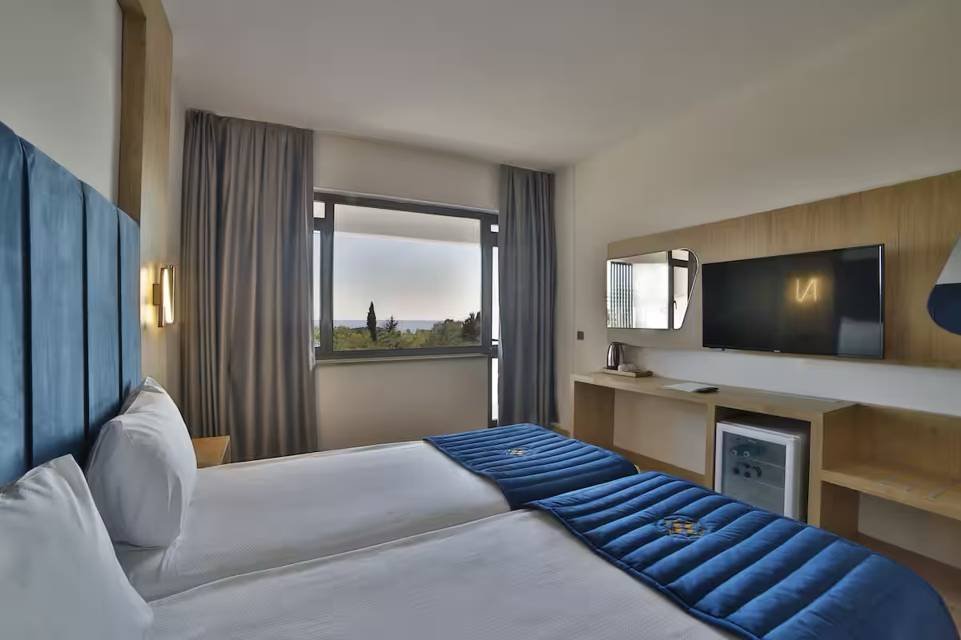

Nashira City Resort Hotel – Four Star Hotel

- Single Room price: EUR 255,00 per room
- Number of rooms: 25
- Double/Twin Room price: EUR 360,00 per room
- Number of rooms: 75
- Board plan: full board
- Check-in from 18.04.2026
- Hotel website: https://nashirahotels.com
Rooms are allocated on a first come, first serve basis. Accommodation includes breakfast, lunch, and dinner with non-alcoholic drinks.

Non-official accommodation is not allowed. Any team or individual accommodated in non-official hotel will not be accredited and participation in the event will be refused.

In addition, the LOC will be responsible to provide any event information at this hotel and provide transportation to the venues. Private vehicles can be used too.

TRANSPORTATION
Transportation will be provided from Antalya airport to the official hotel, from two days before the official practice day and until two days after the closing day at 75 EUR price (one way). Local transport will be available between the official hotel, practice, competition venues for free. Transport timetables will be confirmed.

VISA
All participants who need an entry visa to Country, will be required to complete the Visa Support sections in WAREOS by no later than 20 January 2026.

It is the applicants’ responsibility for supplying the necessary information, ensuring all details are up to date, correct and submitted by the deadlines specified.

In addition, all participants that require a visa are kindly requested to supply a copy of their latest/valid passport. Copies of each application can be uploaded on WAREOS. All passport copies and personal details entered/uploaded to WAREOS will be held securely and in the strictest of confidence and not shared with other parties.

If the applicants can obtain e-visa through www.evisa.gov.tr address, they won’t be able to receive Visa Support Letter through Turkish Foreign Ministry. They must complete their application and on online system. Please check your status through via www.mfa.gov.tr address.

PAYMENT CONDITIONS
Complete all necessary sections in WAREOS/OPEN WAREOS and make full payment by the specified deadlines. Bank transfers only, no credit cards will be accepted. All bank charges will be paid by the participants. The entry fees should be paid in full before arrival.

To confirm hotels reservations, a minimum 50% deposit of the total amount is required to be bank transferred to the OC before 20 January 2026. Reservations after this date will be considered only according to availability. The final outstanding balance shall be made via bank transfer before 30 March 2026. Accommodation cannot be guaranteed after this deadline. A balanced invoice will be provided via WAREOS.

BANK INFORMATIONS
Hotel & Transportation Fee
BANK ACCOUNT: | ANTALYA OKCULUK IHTISAS SPOR KULÜBÜ
BANK: | YAPI KREDI BANKASI
ACCOUNT NO: | 37919951
SWIFT CODE: | YAPITRIS
IBAN: | TR 36 0006 7010 0000 0037 9199 51

Entry Fee Only
BANK ACCOUNT: | TURKIYE OKCULUK FEDERASYONU
BANK: | TEB BANKASI
ACCOUNT NO: | 681169866
SWIFT CODE: | TEBUTRIS930
IBAN: | TR 65 0003 2000 0000 0068 1698 66

NOTE: ALL PAYMENTS SHALL BE MADE IN EUR BY BANK TRANSFER. CREDIT CARDS are not accepted.

Cancellations & Changes
All cancellations and changes must be made through WAREOS / Open WAREOS:
- Should flight arrival details change last minute, please contact the Organizing Committee using the details indicated in the team managers’ booklet.
- If a participant’s arrival is later than the original scheduled arrival date, the room will be charged from the date of the original booking in WAREOS.
- An email will automatically notify the Organizing Committee and Member Association of any changes made in WAREOS.

ADDITIONAL INFORMATION
Medical emergency contact and location
AKDENIZ SIFA HOSPITAL
Kuskavagi Mah. Ataturk Bulvari No 81 Konyaalti / ANTALYA – TURKEY
+ 90 444 7 606

Training
A training field will be available starting on 18 April 2026 at the Antalya 100. Yil Archery Centre.

Weather
Temperatures in April are expected to range between 20 and 25 degrees Celsius. The average in the last few years has been 23 degrees Celsius.

Media Registration
Media representatives can apply for registration by emailing info@antalyaokculuk.org

Internet
Free Wi-Fi Internet access will be available in the official hotel (in guest rooms and the lobby). Complimentary Wi-Fi will also be provided at the competition venue.

Water
Bottled water will be available at the venue.

LOC CONTACT
Name: Mr. Caner SECILMIS
Email: egp_antalya2026@antalyaokculuk.org
Language: English
Phone number with international extension: + 90 537 224 52 24

Terms and Conditions
Introduction
The Member Association acknowledges to have understood and accepted in their whole and without any restrictions the sale and purchase terms and conditions of this invitation package, and of the registration platform https://extranet.worldarchery.sport/wareos/.

Consequently, the Member Association who wishes to register to an event, and book some or all associated extras proposed by the local organizing committee acknowledges that they are fully aware present terms and conditions are accepted by entering information in WAREOS.

Any Member Association declares that it is entitled to enter a contractual relationship with the Local Organising Committee of the event, in accordance with these terms and conditions.

The Local Organising Committee commits itself to communicate, within reason, to its potential clients the greatest information available on the following topics:

Description of the main characteristics of the proposed products and of their use.
Pricing
Information on the methods of payment and reimbursement conditions.

Article 1: Entirety
The platform https://extranet.worldarchery.sport/wareos/ is the propriety of, has been designed and created and is managed by World Archery Federation at Lausanne, Switzerland, and put at the disposal of the Local Organising Committee to facilitate registration to World Archery events.
The present terms and conditions include any and all rights and obligations of the parties. No single, specific, or general term or condition that may appear on documentation sent, given, or handed over to a Member Association will alter, replace, or complete parts of or the entirety of these terms and conditions.
World Archery reserves the right to modify at any time and without any preliminary notification of any kind these terms and conditions.

Article 2: Object
The present terms and conditions define the rights and obligations of the parties in relation to the registration made through the platform https://extranet.worldarchery.sport/wareos/ of services offered by the Local Organising Committee in the scope of the event it has been set for.
Article 3: Contractual documents
The present terms and conditions and the registration process make up the contractual documents between the parties.

Article 4: Electronic signature:
The Member Association’s entering registration information is the electronic signature which is binding between the parties in the same sense as a handwritten signature would be.

Article 5: Registration Confirmation – Contract
The contract is validated as soon as the Member Association has entered its preliminary registration by entering information in WAREOS. A modification of the registration is possible until the deadline for registration set in the document. Modifications may be subject to penalty fees.

Article 6: Prices
The official prices are listed in the “Policies and Procedures Athletes, officials and team management”, the invitation package prices will be based on the official price list, converted to the currency elected by the LOC for invoicing (CHF, EUR, or USD).

The official prices valid on the date that the registration confirmation is sent to the Member Association are binding between the parties.

Article 7: Payment methods
All payments shall be made by bank transfer to the organising committee respecting the stated deadlines, with all bank charges paid by the Member Association. For any open invoices that are not settled 21 days prior the beginning of the event, the Local Organising committee will be entitled to charge a 5% surcharge on all open amounts.

Any payments received cash by World Archery on behalf of the organising committee will incur a 10% additional service fee, to be paid to World Archery.

Article 8: Payment deadlines and refunds
After the final deadlines of registration mentioned in this document, Member Association will not be entitled to any refund, and all remaining unpaid amounts shall be paid to the Local Organising Committee.
Failure to do so, will results in an immediate suspension of the Member Association, who will be set as not in good standing on the day of the official practice of the event, and so until the full amount is paid to the LOC.

Article 9: Availability of services
The availability of services is guaranteed on a first come, first serve basis, provided that the payment of such service has been paid to the local organising committee, partially or in full as mentioned in this document.
The local organising committee is not required to hold services for a Member Association that as not paid in full such service.

Article 10: Force-majeure
None of the two parties will have failed in their respective contractual obligations if their execution is delayed or prevented by a case of force-majeure. Cases considered to be a force majeure are extraordinary events or circumstances beyond the control of the parties, such as a war, strike, riot, crime, or an event described by the legal term "act of God" (e.g., flooding, earthquake, volcano eruption, etc). However, force majeure is not intended to excuse negligence or other malfeasance of a party, as where non-performance is caused by the usual and natural consequences of external forces, or where the intervening circumstances are specifically contemplated. The party experiencing a force majeure must notify in writing with 24 hours after becoming aware of the occurrence. The parties will then, within 7 business days examine, unless the force majeure prevents it, if and how the contractual obligations will be met.

Article 11: Privacy statement
All information exchanged by the Parties will be treated with the utmost confidentiality
All information requested by World Archery and the Organising Committee from the Member Association are necessary to process the event registration and can therefore be communicated only to the contractual partners of World Archery and the Local Organising Committee.
World Archery and the Local Organising committee are authorized to send informative and promotional e-mails to the Member Association, using the WAREOS e-mail address and the contact person provided by the Member Association during the registration.

October 2023 by World Archery Federation, Maison du Sport International, Avenue de Rhodanie 54 - 1007 Lausanne (Switzerland)

