
18 – 24 MAY 2026,
ANTALYA - TURKIYE
2026 EUROPEAN ARCHERY OUTDOOR CHAMPIONSHIP
INVITATION PACKAGE VERSION 1.0
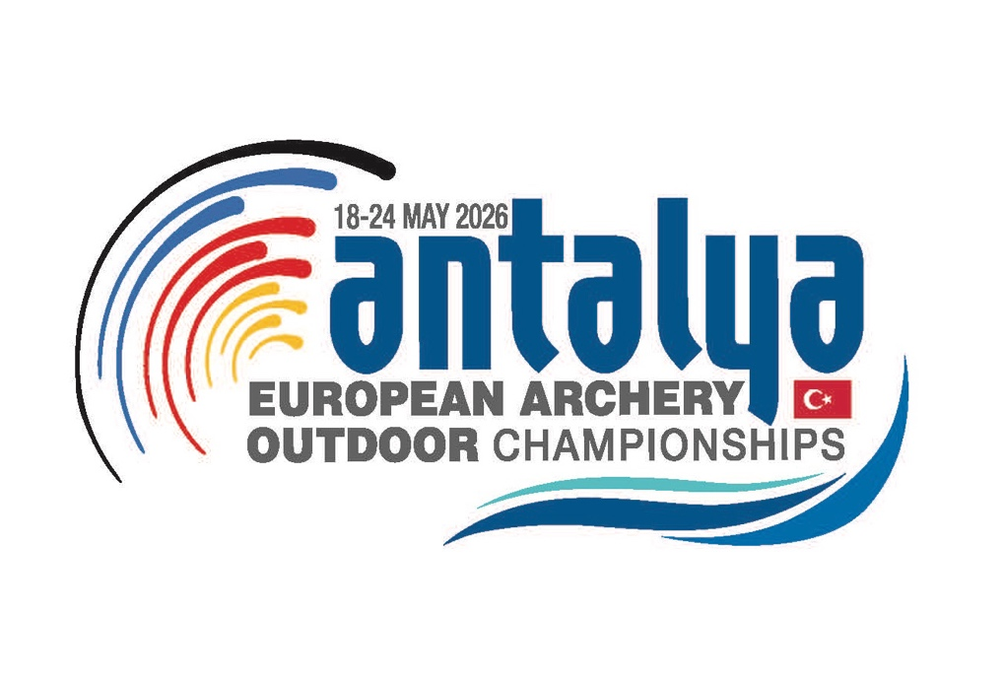

To all World Archery Europe Member Associations.

Dear President,

On behalf of the organizing committee (OC), we would like to invite your country to the 2026 European Archery Outdoor Championship which will be held from 18 – 26 May 2026 Antalya, TURKIYE

We are looking forward to welcoming you here in Antalya.

Sincerely Yours…

Caner SECİLMİS
OC Chair

Important Dates:

Please find enclosed detailed information regarding this event. To register participation, please complete all the necessary sections in WAREOS (https://extranet.worldarchery.sport) within the deadlines listed below:

Summary of deadlines:

- Registration open in WAREOS 15/12/2025

- Preliminary Entries 18/02/2026

- Preliminary Hotel Reservation 18/02/2026

- Final Hotel Reservation 29/04/2026

- 80% Deposit Hotel Payment 18/02/2026

- Final Rooming 29/04/2026

- Final Transportation 29/04/2026

- Final Entries 29/04/2026

- Visa Support 18/04/2026

- Remaining Payments (Entries/Transportation/Hotel) 29/04/2026

- Refund Cancellation Deadline* 18/02/2026

*After this deadline the LOC is allowed to retain all amounts due to the MA.

Preliminary Program

17.05.2026  Sunday | Arrival of the Team  Unofficial Practice Available
18.05.2026  Monday | Official Practice & Equipment Inspection  Team Managers’ Meeting
19.05.2026  Tuesday | Qualification Round  Recurve & Compound
20.05.2026  Wednesday | Individual & Team & Mixed Team Eliminations  Recurve & Compound
21.05.2026  Thursday | Individual & Team Eliminations  Recurve & Compound
22.05.2026  Friday | 2027 European Games Quota Tournament
23.05.2026  Saturday | Compound Finals  Teams & Individual
24.05.2026  Sunday | Recurve Finals  Teams & Individual
25.05.2026  Monday | Departure of the Teams

NOTE:
This preliminary program is subject to change according to the number of participants and special requirements. All changes will be published and distributed in good time.

PRELIMINARY & FINAL REGISTRATION

All entries, accommodation reservations, transport needs, flight arrival/departure information and visa invitation letter requests are to be completed using the World Archery Online Registration System WAREOS https://extranet.worldarchery.sport. This system handles the entire registration process for this event. No entry forms, hotel reservations or transportation forms will be accepted; all information must be entered into WAREOS.

Member Associations can login to WAREOS at https://extranet.worldarchery.sport with the username and password assigned by World Archery. After entering WAREOS, selecting the event from the list will allow a member association to register their athletes. Select/press the “Entries” button to see the list of categories in the event. Select/press the “category” to enter the athlete and official numbers/details participating for that event. A WAREOS User Manual can be downloaded in PDF format (English) upon login. Contact wareos@archery.sport with any questions regarding technical problems on WAREOS. For any question regarding the organization of the event (transport, accommodation, meals, invoices, visa etc.) please contact directly the LOC.

A maximum number of three (3) athletes per country can be registered into each category and divisions of the event. Any changes that are made after the deadlines specified or if entries differ by more than 4 athletes from the preliminary entries, the following penalty fees will automatically be applied:

Penalty fees to be paid to Organising Committee: | Cost (EURO):
Entries made after the preliminary and/or final entry deadline date. | 50 per entry
If final entries differ from the preliminary entries by more than 6 athletes/officials. | 150 per entry
Failure to have made preliminary entries before the deadline date but then have submitted final entries. | 150 per entry

Any entries received less than 3 days before the team managers’ meeting will be refused if no preliminary entry and/or final entry are made prior.

As a final note, only Member Associations in good standing will be eligible to compete. This means that World Archery fee must have been paid prior the participation.

ACCOMMODATION & GENERAL INFORMATION
Özkaymak Falez Hotel – Five Star Hotel
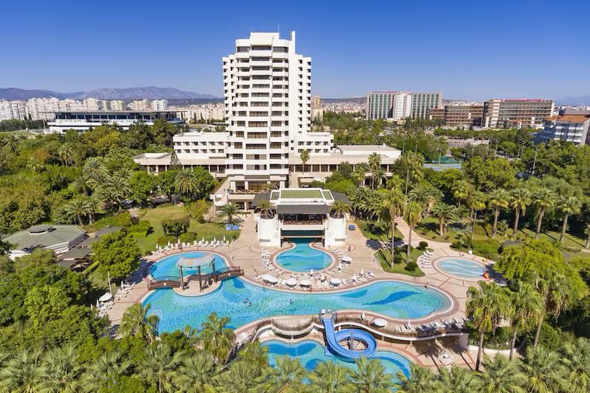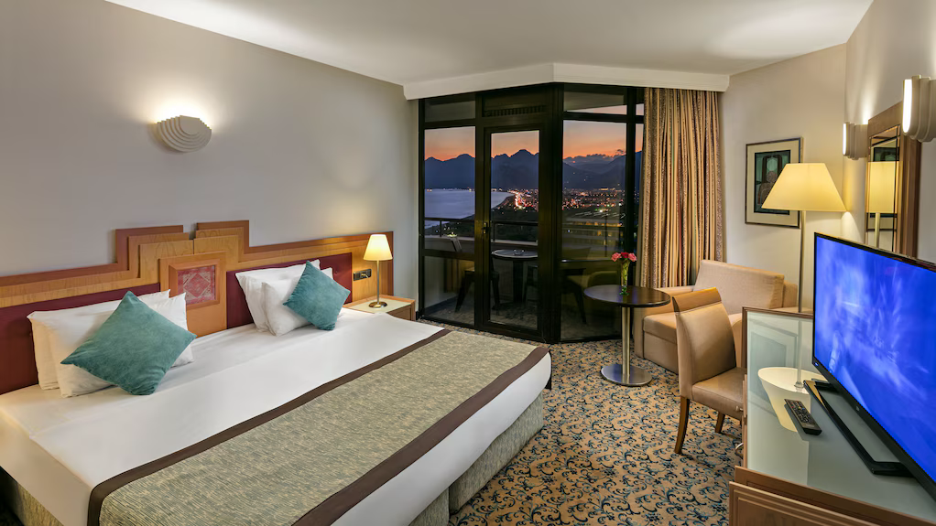
- Single Room price: EUR 290,00 per room
- Number of rooms: 25
- Double/Twin Room price: EUR 425,00 per room
- Number of rooms: 75
- Board plan: Full Board
- Check-in from 16.05.2026
- Hotel website: https://falez.ozkaymakhotels.com.tr/tr
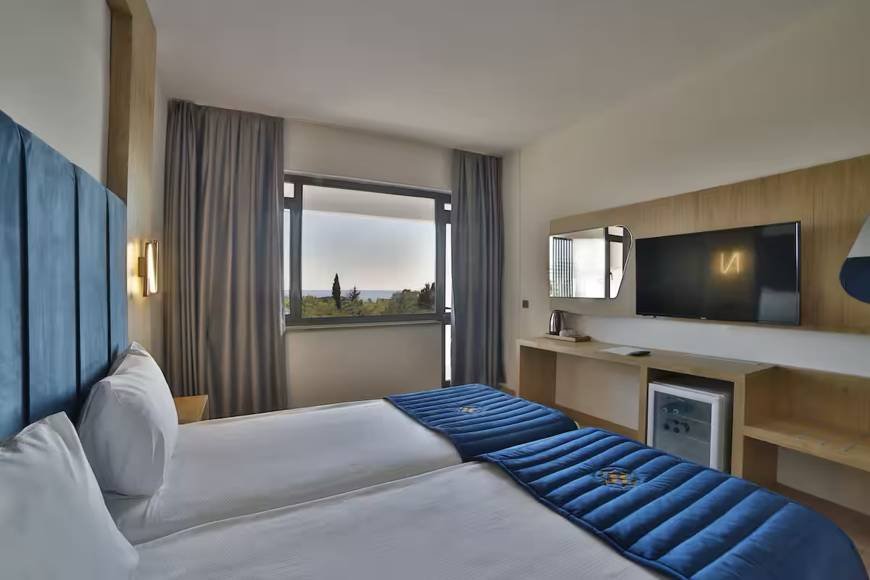

Nashira City Resort Hotel – Four Star Hotel

- Single Room price: EUR 275,00 per room
- Number of rooms: 25
- Double/Twin Room price: EUR 380,00 per room
- Number of rooms: 75
- Board plan: full board
- Check-in from 16.05.2026
- Hotel website: https://nashirahotels.com

Rooms are allocated on a first come, first serve basis. Accommodation includes breakfast, lunch, and dinner with non-alcoholic drinks.

Non-official accommodation is not allowed. Any team or individual accommodated in non-official hotel will not be accredited and participation in the event will be refused.

In addition, the LOC will be responsible to provide any event information at this hotel and provide transportation to the venues. Private vehicles can be used too.

Entry Fee

Individual: 250,00 €
Team: 150,00 €
Official: 125,00 €
Guest: 125,00 €

Entry fees include daily local transport to/from the practice field to/from the official hotels during the qualification, elimination and finals venues (timetable to be confirmed on site).

Entry fee for guest includes daily local transport between field to/from official hotels during the qualification, elimination and finals venues. They have no field of play access.

TRANSPORTATION
Transportation will be provided from Antalya airport to the official hotels, from 16 May 2026 until two days after the closing day at 75 EUR price (one way). Local transport will be available between the official hotels and venue for free. Transport timetables will be confirmed.

VISA
All participants who need an entry visa to Country, will be required to complete the Visa Support sections in WAREOS by no later than 18 April 2026.

It is the applicants’ responsibility for supplying the necessary information, ensuring all details are up to date, correct and submitted by the deadlines specified.

In addition, all participants that require a visa are kindly requested to supply a copy of their latest/valid passport. Copies of each application can be uploaded on WAREOS. All passport copies and personal details entered/uploaded to WAREOS will be held securely and in the strictest of confidence and not shared with other parties.

If the applicants can obtain e-visa through www.evisa.gov.tr address, they won’t be able to receive Visa Support Letter through Turkish Foreign Ministry. They must complete their application and on online system. Please check your status through via www.mfa.gov.tr address.

PAYMENT CONDITIONS
Complete all necessary sections in WAREOS and make full payment by the specified deadlines. Bank transfers only, no credit cards will be accepted. All bank charges will be paid by the participants. The entry fees should be paid in full before 29 April 2026.

To confirm hotels reservations, a minimum 50% deposit of the total amount is required to be bank transferred to the OC before 18 February 2026. Reservations after this date will be considered only according to availability. The final outstanding balance shall be made via bank transfer before 29 April 2026. Accommodation cannot be guaranteed after this deadline. A balanced invoice will be provided via WAREOS.

BANK INFORMATIONS
ACCOMMODATION & TRANSPORTATION
BANK ACCOUNT: | ANTALYA OKCULUK IHTISAS SPOR KULÜBÜ
BANK: | YAPI KREDI BANKASI
ACCOUNT NO: | 37919951
SWIFT CODE: | YAPITRIS
IBAN: | TR 36 0006 7010 0000 0037 9199 51

ENTRY FEE ONLY

BANK ACCOUNT: | TURKIYE OKCULUK FEDERASYONU
BANK: | TEB BANKASI
ACCOUNT NO: | 681169866
SWIFT CODE: | TEBUTRIS930
IBAN: | TR 65 0003 2000 0000 0068 1698 66

NOTE: ALL PAYMENTS SHALL BE MADE IN EUR BY BANK TRANSFER. CREDIT CARDS are not accepted.

Cancellations & Changes
All cancellations and changes must be made through WAREOS:
- Should flight arrival details change last minute, please contact the Organizing Committee using the details indicated in the team managers’ booklet.
- If a participant’s arrival is later than the original scheduled arrival date, the room will be charged from the date of the original booking in WAREOS.
- An email will automatically notify the Organizing Committee and Member Association of any changes made in WAREOS.

ADDITIONAL INFORMATION
Medical emergency contact and location
AKDENIZ SIFA HOSPITAL
Kuskavagi Mah. Ataturk Bulvari No 81 Konyaalti / ANTALYA – TURKEY
+ 90 444 7 606
Training
A training field will be available starting on 16 May 2026 at the Antalya 100. Yil Archery Centre.

Weather
Temperatures in April are expected to range between 25 and 30 degrees Celsius. The average in the last few years has been 25 degrees Celsius.

Media Registration
Media representatives can apply for registration by emailing info@antalyaokculuk.org

Internet
Free Wi-Fi Internet access will be available in the official hotel (in guest rooms and the lobby). Complimentary Wi-Fi will also be provided at the competition venue.

Water
Bottled water will be available at the venue.

LOC CONTACT
Name: Mr. Caner SECILMIS
Email: ec2026@antalyaokculuk.org
Language: English
Phone number with international extension: + 90 537 224 52 24

