to ALL World Archery MEMBER ASSOCIATIONS

INVITATION

Dear Member Associations, Dear Clubs, Dear Friends,

On behalf of the Organizing Committee, I’m pleased to invite you and welcome your Federation Club Members to participate in the 2026 European Club TeamS Cup, which will be held on 03 – 04 October 2026, in Ruse (Bulgaria).
The competition is open to female and male club teams and it is reserved only to the Recurve Division.

The competition will be organized according European Club Teams Cup rules published on WAE web site.

We are happy to welcome club teams from all countries.
You will certainly be able to sense the Bulgarian hospitality. We also hope that you and your team will enjoy your stay in Ruse and will enjoy great tournament and a wonderful weekend in the Danube city.

Looking forward to welcoming you in Ruse!

Sincerely yours,
Mr. Atanas Temelkov
Chairman of LOC

Email: ectc@abv.bg
Mobile phone: + 359 88 796 3009 – Atanas Temelkov – president (English)

Please, find enclosed the necessary documents concerning the registration, organization and participation in this event. To register participation, please complete all the necessary forms within the deadlines listed below:

Preliminary Entries | 17 August 2026
Final Entries | 14 September 2026
Preliminary Hotel Reservation | 17 August 2026
60% Hotel Reservation | 17 August 2026
Preliminary Transportation Reservation | 17 August 2026
60% Transportation Reservation  Visa Support | 17 August 2026  17 August 2026
Transportation | 14 September 2026
Final Hotel Reservation & Payment | 14 September 2026
Final Payment | 14 September 2026
Full refund cancellation deadline* | 17 August 2026
*After this deadline, the LOC is allowed to retain all amounts due by the Member Association

PRELIMINARY PROGRAM
DAY 0 | Thursday  01 October 2026 | Arrival of the Club teams
DAY 1 | Friday  02 October 2026 | Arrival of the Club teams  Team Registration  16:00 – 19:00 Practice field and local transportation available  19:30 – 20:00 Team Managers Meeting
DAY 2 | Saturday  03 October 2026 | 09:00-12:30 Qualification round 2 x 36 arrows  14:00-16:00 Pool matches Main Event  16:00-18:30 Pool matches Secondary Tournament
DAY 3 | Sunday  04 October 2026 | 09:00-10:20 Ranking rounds  10:30-13:00 4 Medal matches on a final field of play  13:00-13:15 Awards and closing  Departure of the Club teams
DAY 4 | Monday  05 October 2026 | Departure of the Club teams
NOTE:
This preliminary program is subject to change according to the number of participants and TV requirements. All changes to the program will be published and informed to all participants in good time.
ACCOMMODATION & GENERAL INFORMATION

The Official Hotels are HOTEL CRYSTAL RUSE and COMPLEX DUNAV HOTEL.
Hotel allocations will be made on a 'first come-first serve' basis. Accommodation rates will offer half board meal menu (breakfast + dinner).
Reservation should be made before 17 August 2026.

To confirm your hotel reservations, 50% deposit of the total amount is to be paid by a bank transfer to the Organizing Committee before 17 August 2026. Reservations received
after this date will be considered only according to availability and the room rate can change.

The room rates:
- are in Euro (€) per room, per night
- including bed, breakfast, dinner with non-alcoholic drinks on the spot
- including free internet in hotel lobby
- Additional purchases in the hotel bar, café and mini bar is at own expense.*
*All prices are including city tax.

Booking NON-OFFICIAL hotel:
Participants who may decide to book their accommodation at or with other hotels, i.e. non-official hotels, and not through the Local Organizing Committee (LOC), shall have to pay a TRIPLE entry fee, and the LOC will not be responsible for providing transportation from those hotels to the venue (transport for these teams will be provided only to and from airport & train station). It is not possible to distribute any information at the non-official hotels, also.

COMPLEX DUNAV HOTEL

HOTEL | CATEGORY | Single room | Double room
COMPLEX DUNAV HOTEL | 2 *** | 120 € | 200 €
Capacity |  | 8 | 25

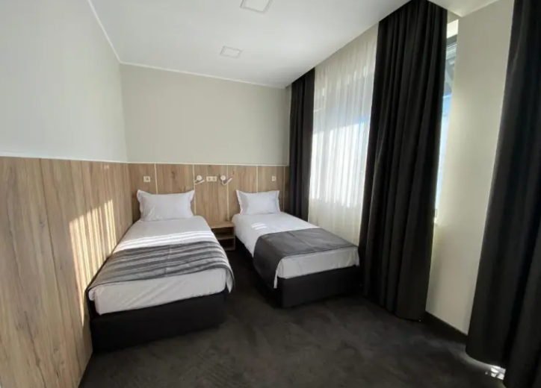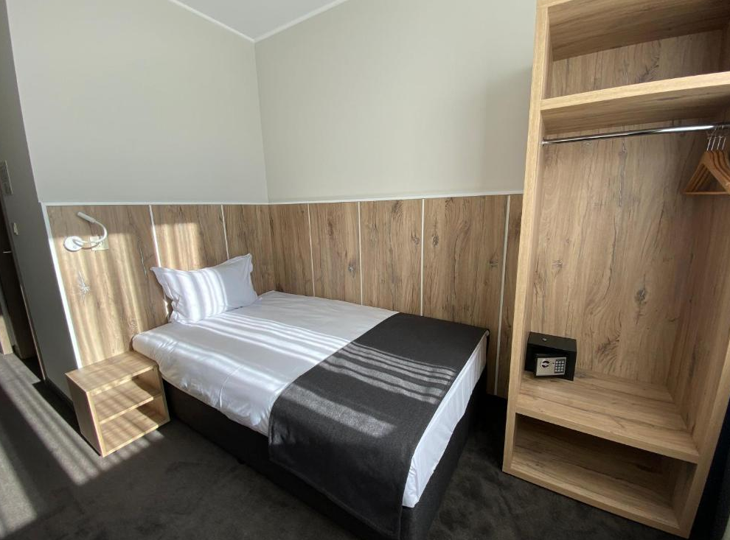
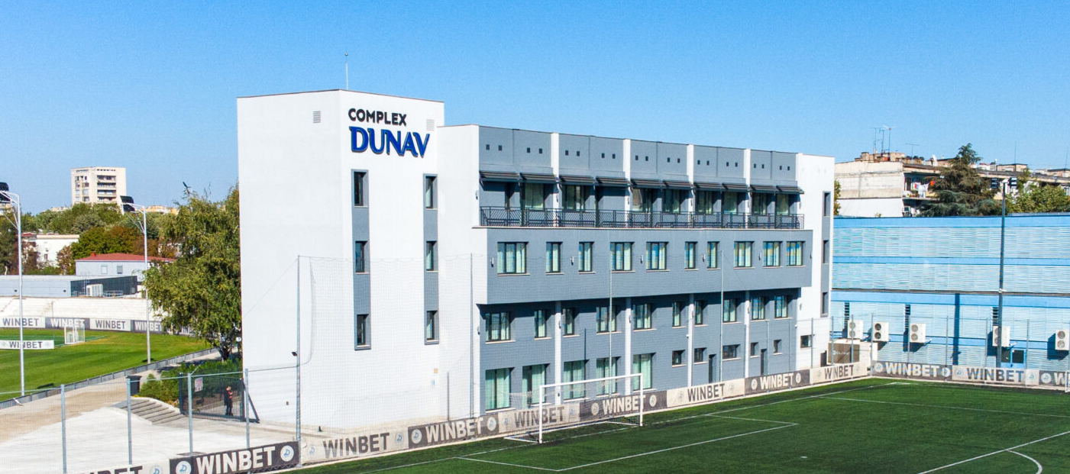

HOTEL CRYSTAL RUSE

HOTEL | CATEGORY | Single room | Twin room | 2 – Family Suit  (4 persons)
HOTEL CRYSTAL RUSE | 3 *** | 130 € | 220 € | 400 €
Capacity |  | 16 | 20 | 4

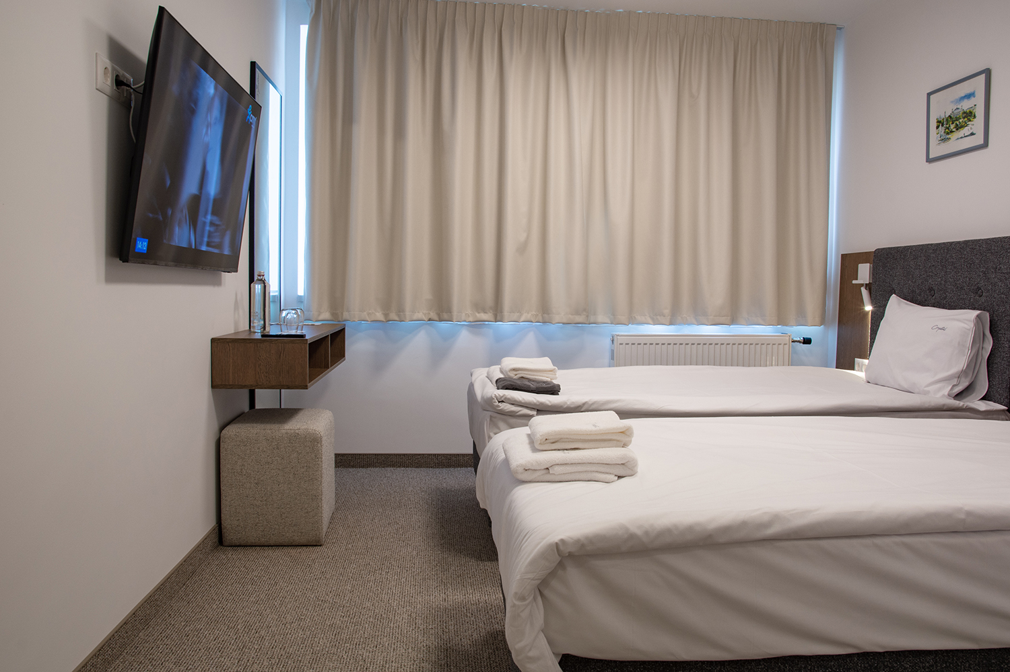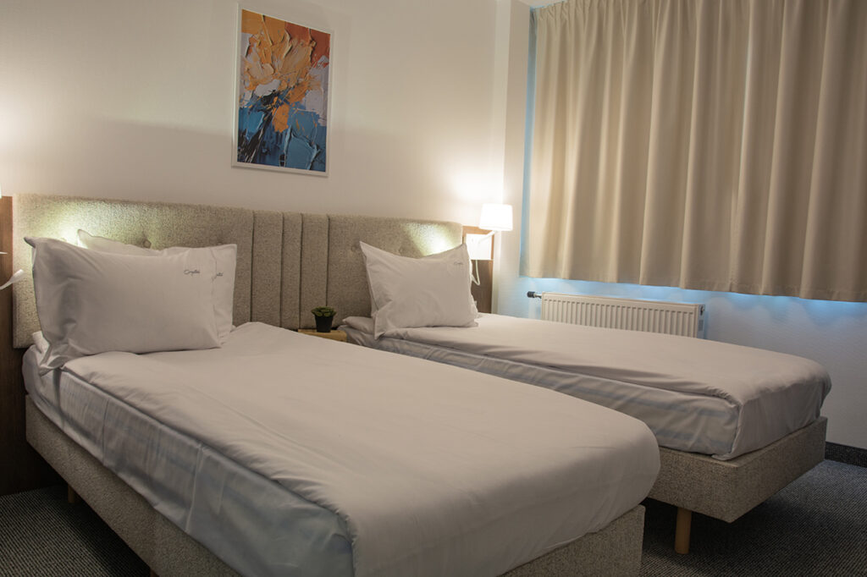
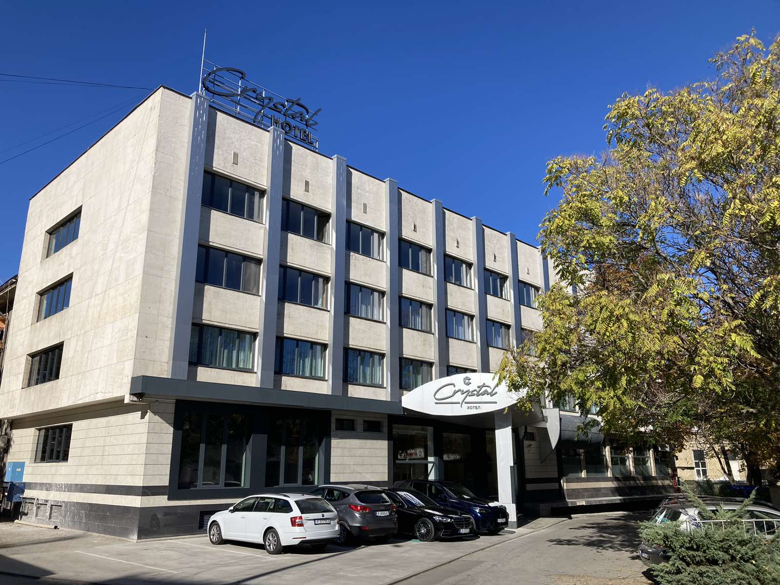

VENUE

Ruse Stadium Address: 7002 Ruse, ul. “Shtip”

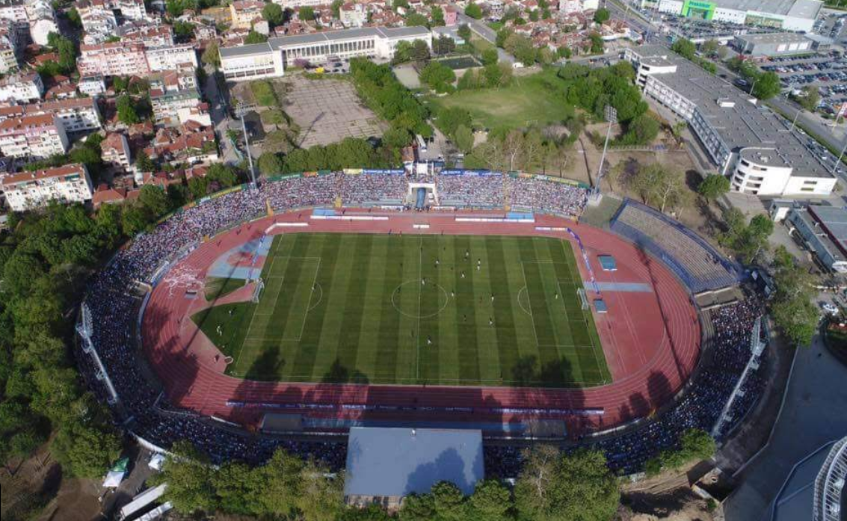
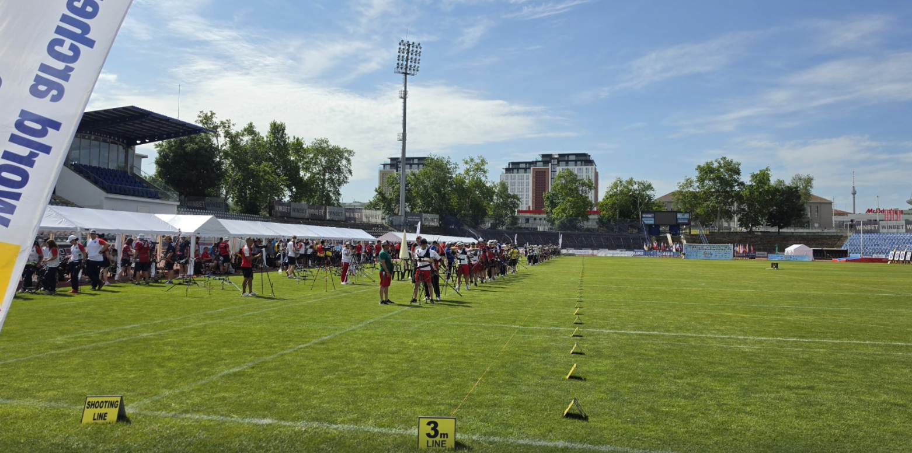

ADDITIONAL INFORMATION
ENTRY FEES
Club team: 200 € per club team

Entry fees include daily local transport to and from the practice field to/from official
hotel during the qualification, elimination and finals venues (timetable to be confirmed
on site).
*The Entry fee includes the Local transport during competition days.

TRANSPORTATION
The OC will collect the teams from the two airports. You have to pay the transportation fee as follows:

From BUCHAREST (ROM) airport to Official Hotel – (one way): 80 €/person
From VARNA (BUL) airport to Official Hotel – (one way): 80 €/person
From SOFIA (BUL) airport to Official Hotel – (one way): 80 €/person

The last date for the payment of the transportation fee is 14 September 2026.
Between airports and hotel, the organizer will use buses, small buses, vans and cars, what will depend of number of persons scheduled for transportation. Transportation from the airports will start one day before the official practice day and will end the day after the closing day

A daily shuttle service will be available for the tournament days from the Official Hotel to the competition venue and back - free of charge.

VISA
Bulgaria is a member of European Union.
It is your responsibility to establish with your respective foreign office if your team requires a visa for Bulgaria.
For participants who need a formal visa and invitation letter for entry to Bulgaria, will be required to complete the Visa Form by no later than 17 August 2026.
It is the applicants’ responsibility for supplying the necessary information, ensuring all details are up to date, correct and submitted by the deadlines specified.
In addition, all participants that require a visa are kindly requested to supply a copy of their latest/valid passport.
Please ensure your passport is valid for at least six months from the date you enter Bulgaria, or you may not be admitted.

If our help is needed you may contact us immediately.

PAYMENT CONDITIONS
All fees should be paid in full before arrival!
Payment of accommodation and local transportation: a minimum deposit of 60% of the total amount owed should be made when booking by 17 August 2026.
The final outstanding balance shall be transferred before 14 September 2026.
Accommodation cannot be guaranteed after this deadline.

NOTE:
- Please indicate in the reference/notes section the team or reservation name that corresponds to the payment.
- All payment shall be made in EURO only by BANK TRANSFER.
- Bank transfer fees are responsible on the sender.
- Credit cards and Travel checks will not be accepted.

BANK INFORMATION for ACCOMMODATION, TRANSPORTATION and ENTRY FEES:

Bulgarian Archery Federation
BANK: FIRST INVESTMENT BANK
SWIFT CODE: FINVBGSF
IBAN: BG13FINV91501203792590
ADDRESS: 37, Dragan Tsankov Blvd., 1797 Sofia, Bulgaria

NOTE: ALL PAYMENTS SHALL BE MADE IN EURO

Cancellations & Changes
Following conditions will apply:
- cancellation received before the final entry: full refund of the paid deposit
- cancellation received after the final entry: no refunds
All refunds, if any, will be processed after the event.

OC has to be informed about changes in the travel programme 72 hours prior arrival. If your arrival is later then your original schedule, the room charges are starting from the original date indicated by the Club.

Training
Training will be on official venue which will be available starting from 2 October 2026 18:00.

Weather in RUSE
In this period in Ruse is sunny. The daily temperatures in beginning of October are expected to range between 16 and 21 °C, while nighttime temperature drio to average low around 9-10°C.

Internet
Will be available at the official hotel for free.
There will also be Wi-Fi available for access to results at the venue.

Water
Water will be available at the venue free of charge.

Meals
Lunch boxes will be offered on the field on additional price of 20€ per lunch.

Dress regulations
WA & WAE dress regulations do apply.

By signing in the Club team declares that:
- Club team’s Member Association is in good standing
- All competitors and officials are covered in case of illness or accident
- Club team members have signed the WA Anti-Doping Agreement
- All archers of the Club team belong to the same club and are its members at least from 1st January 2026
- All competitors and officials allow his/her person, name, pictures or sport performance to be used for advertising purposes

HEALTH REGULATIONS
INFORMATION
- Everybody should follow the Government/public health authorities measures (national and sport-specific regulations) and be aware of the travel restrictions
- For your information, Medical infrastructure/Hospital with proper care will be
reachable within 15 minutes from the venue.

LOC CONTACT
Email: ectc@abv.bg

Mobile phone: + 359 88 796 3009 – Atanas Temelkov – president (English)
Web address: https://www.archeryeurope.org/event/european-club-team-cup-2026/

Looking forward to welcoming You in RUSE, Bulgaria!

PRELIMINARY HOTEL RESERVATION FORM
Club team and Member Association: ____________________________________________
Contact person: ________________________________________________
Mobile: _______________________________________________________
E-mail: _______________________________________________________
Number of Rooms:
HOTEL CRYSTAL RUSE /*** Complex DUNAV Hotel/**

Single € 130 Single € 120

Double: € 220 Double: € 200

Room for 4: € 400
Do you require a room for a disabled team member? Yes No

If yes, please specify: ______________________________________________
Do any of your team members have dietary requirements or allergies such as, vegetarian,
nut allergies or gluten free etc. Yes No

If yes, please specify: ______________________________________________

Accommodation Payment:
ROOM TYPE NUMBER OF ROOMS NIGHT RATE P/N TOTAL RATE

Single ______________________ x ___________ = _______________

Double/Twin ______________________ x ___________ = _______________

Triple ______________________ x ___________ = _______________

Room for 4 ______________________ x ___________ = _______________

TOTAL ACCOMMODATION AMOUNT _____________________________

DEPOSIT 60% OF TOTAL AMOUNT ______________________________

PLEASE RETURN THIS PRELIMINARY HOTEL RESERVATION FORM TO THE ORGANIZERS by e-mail to ectc@abv.bg AND PAY THE DEPOSIT BEFORE 17 August 2026

Date: ___________________ Signature of President / Secretary General: ____________________

TRANSPORTATION FORM

Club team and Member Association: __________________________

Number of passengers: ________ person/s

Arrival information

We will arrive by plane:

Airport: BUCHAREST / VARNA / SOFIA Flight Nr: _____________

Date: ______________ Arrival Time: ___________

We will arrive to RUSE by: _____________________________________

____________________________________________________________

Departure information

We will depart by plane:

Airport: BUCHAREST / VARNA / SOFIA Flight Nr: _____________

Date: ______________ Departure Time: ___________

We will depart from RUSE by: _______________________________________

____________________________________________________________

Date: _________

Signature of President / Secretary General: ______________________________

PLEASE RETURN THIS TRANSPORTATION FORM TO THE ORGANIZER BEFORE
17 August 2026 by e-mail to ectc@abv.bg
TEAM MEMBERS FORM

Club team and Member Association: ___________________________________

Contact person: _______________________________________

No | First name | Family name | Role (RM, RW, Coach)
1
2
3
4
5
6
7
8
9
10

Date: ______________________ Signature of President / Secretary General: ______________________

PLEASE RETURN THIS VISA INVITATION LETTER FORM TO THE ORGANIZER AS SOON AS POSSIBLE.
Latest 14 September 2026 by e-mail to ectc@abv.bg

VISA INVITATION LETTER FORM

Club team and Member Association: ___________________________________

Contact person: _______________________________________

No | First name | Family name | Date and place of birth |  | Citizenship /Country/
No | Address of residence |  |  |  | Passport
No |  |  |  |  | Number | Expiration
1
2
3
4
5
6
7
8
9
10

Date: ______________________ Signature of President / Secretary General: ______________________

PLEASE RETURN THIS VISA INVITATION LETTER FORM TO THE ORGANIZER AS SOON AS POSSIBLE.
Latest 17 August 2026 by e-mail to ectc@abv.bg

FINAL BUDGET FORM
Club team and Member Association: ____________________________________________
Contact person: ________________________________________________
Mobile: _______________________________________________________
E-mail: _______________________________________________________

1) Entry Fees
Posit Cost Number of Teams Total
Club team in official hotel € 200 x ________ € _______
Club team in unofficial hotel € 600 x _________ € _______
Total 1 € _______

2) Accommodation
HOTEL - Half Board
Room Cost Nr of Rooms Nr of nights Total
HOTEL CRYSTAL RUSE /*** - Single room € 130 x ___ x __ € _______
HOTEL CRYSTAL RUSE /*** - Double room € 220 x ___ x __ € _______
HOTEL CRYSTAL RUSE /*** - Room for 4 € 400 x ___ x __ € _______

Complex DUNAV Hotel/** - Single room € 120 x ___ x __ € _______
Complex DUNAV Hotel /** - Double room € 200 x ___ x __ € _______
Total 2 € _______
3) Lunch box
Cost Number of Boxes Total
Lunch box 4 October (Friday) € 20 x __________ € _______
Lunch box 5 October (Saturday) € 20 x __________ € _______
Lunch box 6 October (Sunday) € 20 x __________ € _______
Total 3 € _______

4) Transportation
Airport Cost № of Persons Arrival № of Persons Departure Total
BUCHAREST € 80 x ( + ) € _______
VARNA € 80 x ( + ) € _______
SOFIA € 80 x ( + ) € _______
Total 4 € _______

Date _______________ TOTAL /1+2+3+4/ € _______

Signature of President / Secretary General: _____________________________
PLEASE RETURN THIS BUDGET FORM TO THE ORGANIZER BEFORE
14 September 2026 by e-mail to ectc@abv.bg

