

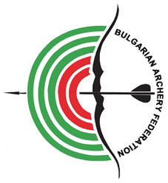

EUROPEAN INDOOR CHAMPIONSHIPS
16-21 February 2026


INVITATION PACKAGE

To all WORLD ARCHERY EUROPE Member Associations

Dear President,
Dear Friends,

On behalf of the Local Organizing Committee and Bulgarian Archery Federation I am pleased to invite you to the 2026 European Indoor Championships, which will be held in Plovdiv, Bulgaria, 16-21 February 2026.
This event will be organized following the WA and WAE rules Recurve, Compound and Barebow divisions in men/women and U21 categories in the Indoor Target Archery discipline.

THE PARTICIPATION IS OPEN TO ALL WORLD ARCHERY MEMBER ASSOCIATIONS.

Please find enclosed the necessary documents concerning the registration, organization and participation in this event. To register participation, please complete all the necessary sections in WAREOS within the deadlines listed below:

 | Registration opening deadline  Preliminary Entries | 15 September 2025  8 December 2025
 | Final Entries | 27 January 2026
 | Preliminary Hotel Reservation | 8 December 2025
 | 50% Hotel Reservation  Visa Support | 7 January 2026  7 January 2026
 | Transportation | 27 January 2026
 | Final Hotel Reservation & Payment | 27 January 2026
 | Final Payment | 27 January 2026
 | Full refund cancellation deadline | 8 December 2025
 | Hotel Cancelation 100% | 8 December 2025
! After this deadline, Member Association will be charged 50% of any cancelled hotel reservations.
 | Hotel Cancelation 50% | 7 January 2026
!! After this deadline, the LOC is allowed to retain all amounts due by the Member Association.

We are looking forward to welcoming you and your teams to Plovdiv, Bulgaria.

Website: https://www.archeryeurope.org/ Yours sincerely Atanas Temelkov
E-mail: eic2026@abv.bg President of the Organizing Committee &
Info: +359 887 963009 President of Bulgarian Archery Federation

PRELIMINARY PROGRAMME

Friday 13 February 2026 Arrival of Delegations

Saturday 14 February 2026 Arrival of Delegations
Unofficial Practice

Sunday 15 February 2026 Arrival of Delegations
Unofficial Practice
Team Registration

Monday 16 February 2026 Official practice & Equipment inspection
Team Managers' Meeting

Tuesday 17 February 2026 Qualification rounds (1,2 or 3 sessions)

Wednesday 18 February 2026 Individual Matches

Thursday 19 February 2026 Individual & Team & Mixed Team Matches

Friday 20 February 2026 Team Matches & Finals
Team Award Ceremonies

Saturday 21 February 2026 Individual Medal Matches
Individual Award Ceremonies/Closing Ceremony

Sunday 22 February 2026 Departure of Delegations

Note: This preliminary program is subject to changes according to the number of participants.
All changes and necessary information will be published and distributed in good time.

Website: https://www.archeryeurope.org/

PRELIMINARY & FINAL REGISTRATION

No entry forms will be available for registering for this event. The registration process should be done using the World Archery Online Registration System (WAREOS).

The number of athletes that may be entered by a Member Association is limited to three (3) in each recurve, compound and barebow category.

All World Archery Europe MA’s in good standing are eligible to compete in European Indoor Championships competitions, but no more than 3 athletes can be registered in each category.

In order to use WAREOS, please login on https://extranet.worldarchery.sport/ with your Username and Password assigned by World Archery. For any questions regarding the WAREOS, please contact the World Archery office wareos@archery.sport

Starting date of online registration with WAREOS is: | 15 September 2025
End of Preliminary registration: | 8 December 2025
End of Final registration: | 27 January 2026

Please respect the deadlines stated!

Member Associations should only use WAREOS to make any changes/amendments to their entries and will be able to do so at any time. Any changes made in WAREOS email will instantly be automatically sent to the Organizing Committee and Member Association with the updated information.

However, any changes that are made after the deadlines specified or if entries differ by more than
4 participants from the preliminary entries, the following penalty fees will automatically be applied:

Penalty fees to be paid to Organizing Committee: | Cost (EURO):
Penalty fee for late entries (after the final deadline) | €45 per entry
Penalty fee for not filling Preliminary entries | €140 per entry
Penalty fee for differences between preliminary and final entries *: | €140 per entry

*If the difference between final and preliminary entries number is more than 4 athletes/officials

Any entries received less than 3 days before the team managers’ meeting will be refused if no preliminary entry and/or final entry are made prior.

As a final note, only Member Associations in good standing will be eligible to compete. This means that World Archery fee must have been paid prior the participation.
ACCOMMODATION & GENERAL INFORMATION

Important Note:
Non-official accommodation is not allowed. Any team or individual accommodated in non-official hotel will not be accredited and participation in the event will be refused.

The official hotel is 4* stars category hotels – Grandhotel Plovdiv.

The room rate:
- are in Euro (€) per room, per night
- include full board accommodation, taxes and VAT
- including free internet in hotel lobby and rooms
- Check-in after 3:00 PM
- Check-out till 11:00 AM
- Late Check-out till 05:00 PM – 50% of room price per night
- Late Check-out after 05:00 PM - 100% of room price per night
- Parking €10 per car per night /€20 per bus/minibus per night
- Aqua-center €7 per person per entrance
- Additional purchases in the hotel bar, café and mini bar are at own expense. *
*All prices are including city tax.

HOTEL | Category | Single room |  | Twin room
HOTEL | Category | Price per room per night - full board | Number of rooms | Price per room per night - full board | Number of rooms
GRAND HOTEL PLOVDIV | **** | €220 | 60 | €340 | 170

*Lunch during the competition days will be served in the restaurant of the Hotel.

To confirm the reservation, a 50% deposit of the total amount is required to be bank transferred to the OC before
8 December 2025 Reservations after this date will be considered only according to availability, the room rate can change, and we cannot guarantee rooms in the official hotel.

Final Hotel Reservations and remaining payment should be made before 7 January 2026
Note: Please ensure that you complete all the necessary forms by the specified dates and make full payment for the accommodation at the time of booking. See detailed payment instructions below.

GRAND HOTEL PLOVDIV ****
Karshiaka Severen, str. „Zlatyo Boyadjiev“ 2, 4003 Plovdiv
4 km from Venue
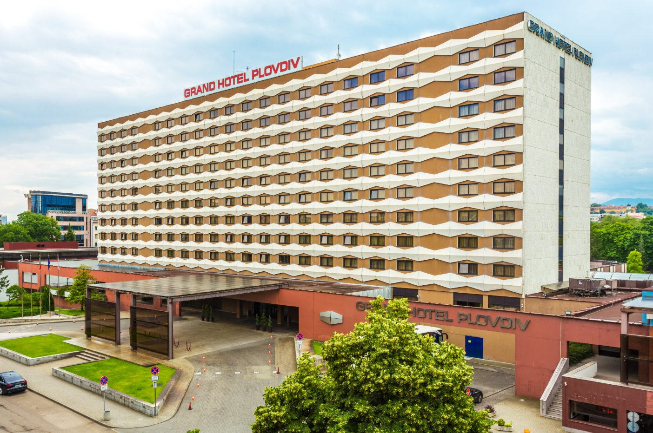
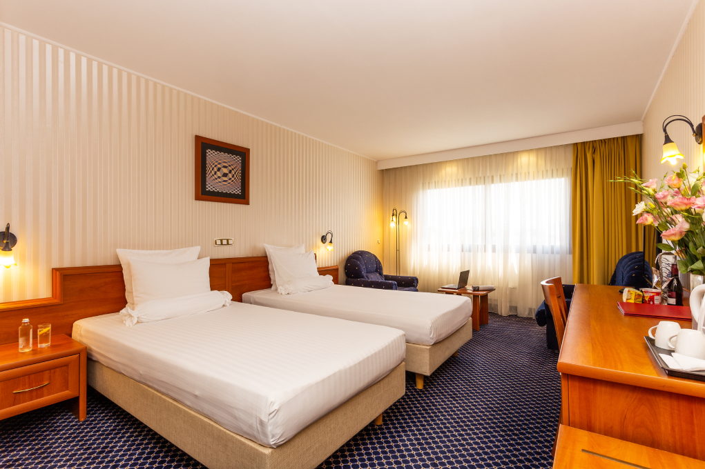

VENUE
KOLODRUM PLOVDIV
bul. „Asenovgradsko shose“ 8, 4004 Plovdiv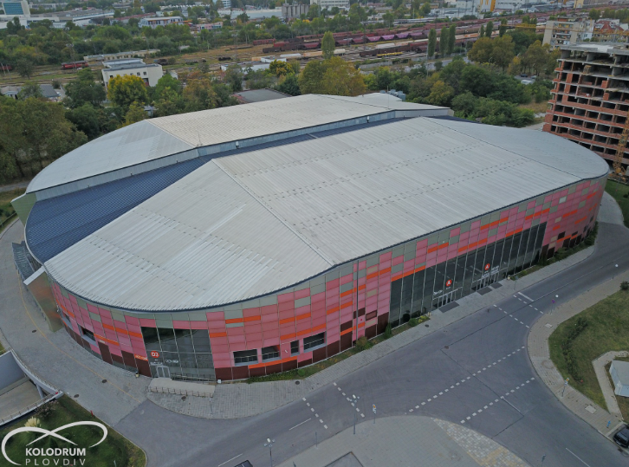 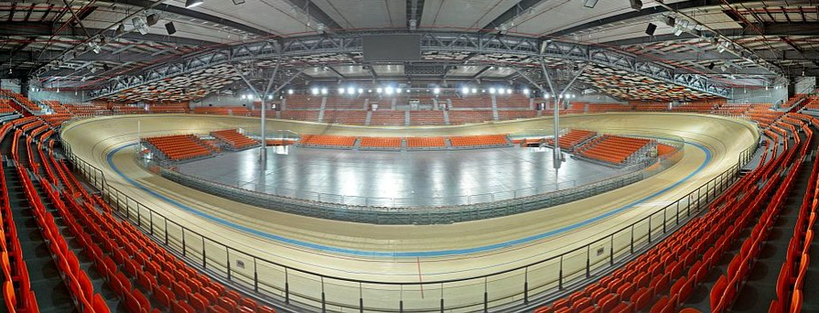

MAP
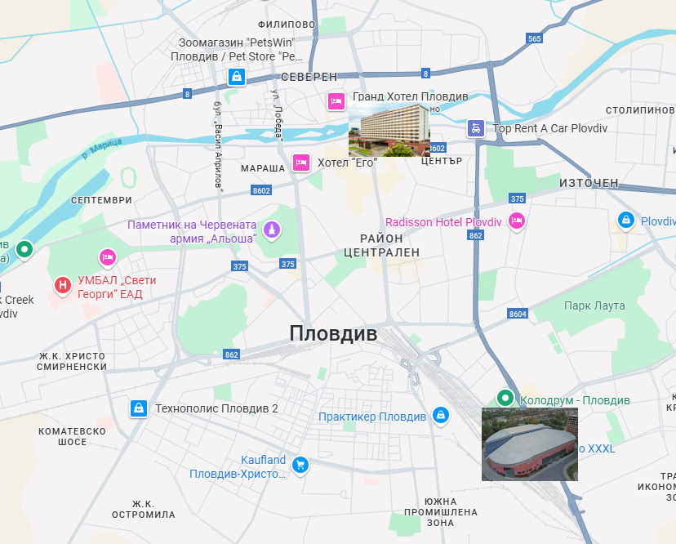

Important Note:
Refer to the accommodation pages for detailed hotel information. Please complete all the necessary sections in WAREOS and make full payment for entries, transport, and accommodation by the specified deadlines.

Reservations should be finished before 7 January 2026

ADDITIONAL INFORMATION
Entry fees
Individual: € 250 per Athlete
Officials: € 125 per Official
Teams: € 150 per Team
Mix Teams: no entry fee

Transportation fees from/to the airports
The OC will collect the teams from the Plovdiv Airport or Plovdiv Central Railway Station, or Sofia Airport or Sofia Central Railway Station. You have to pay the transportation fee as follows:

PLOVDIV airport to Official Hotels – (one way): €20 /person
PLOVDIV Central Bus/Railway Station to Official Hotels – (one way): €20 /person
Official Hotels to PLOVDIV airport – (one way): €20 /person
Official Hotels to PLOVDIV Central Bus/Railway Station – (one way): €20 /person

SOFIA airport to Official Hotels – (one way): €60 /person
SOFIA Central Bus/Railway Station to Official Hotels – (one way): €60 /person
Official Hotels to SOFIA airport – (one way): €60 /person
Official Hotels to SOFIA Central Bus/Railway Station – (one way): €60 /person

The last date for the payment of the transportation fee is 27 January 2026
Between airports and hotel, the organizer will use buses, small buses, vans and cars, what will depend of number of persons scheduled for transportation. Transportation from the airports will start two days before the official practice day and will end the day after the closing day.

A daily shuttle service will be available for the tournament days from the Official Hotels to the competition venue and back - free of charge.

Cancellations & Changes
Following conditions will apply:
- All cancellations and changes must be made through WAREOS.
- cancellations received before the preliminary entry deadline 8 December 2026: full refund of the paid deposit.
- cancellations received after the preliminary entry deadline but before 7 January 2026: 50% refund of the cancelled reservations for hotel deposit and full refund of the paid transportation and fees deposit.
- cancellation received after 7 January 2026: no refunds.

All rates for payments after deadlines are subject to additional charges without prior notice.
All refunds, if any, will be processed after the event.

OC has to be informed about changes in the travel programme 72 hours prior arrival. If your arrival is later then your original schedule, the room charges are starting from the original date indicated by the Member Association.

Meals at the venue
Lunch will be served in the restaurant of the hotel.

Drinking water will be available at lunch and at dinner and on the competition field free of charge.
All other costs made in cafeteria at the archery venue or in the hotel /snacks, drinks, small meals/ are not included in the entry fee and must be paid on consumptions.
Please inform us if you have special requirements for food and specify it.
Accreditation and Team Managers Meeting
Accreditation will take place upon arrival of teams on Sunday, 15 February 2026
Accreditation office will be open from 10:00 till 20:00.

For all Ceremonies WA dress code is obligatory.
More details will be provided at the Team Manager’s Meeting.
Team Managers Meeting will be held on Monday, 16 February 2026

Training and Competition Field
For European Indoor Championships Training venues will be available starting from Sunday, 15 February 2026 14:00
Please inform us if you would like to arrive earlier and have extra training time in Plovdiv.

VISAs
All participants who need an entry visa to Bulgaria, will be required to complete the Visa Support Form in WAREOS by no later than 7 January 2026.

It is the applicants’ responsibility to supply the necessary information, ensuring all details are up to date, correct and submitted by the deadlines specified.

In addition, all participants that require a VISA are kindly requested to supply a copy of their latest/valid passport. Copies of each applicant can be uploaded on WAREOS. All passport copies and personal details entered/uploaded to WAREOS will be held securely and in the strictest of confidence and not shared with other parties.

Please note that the Organizing Committee can provide invitation for the period of the European Indoor Championships in Plovdiv only.

As long as the Organizing Committee gets no different information, the Invitation Letter will be sent by email. If an express service should be desired, this service will be charged to the MA and must be paid to the Organizing Committee upon arrival.

Please note: the deadline for Visa Invitation Letter Form is 7 January 2026.

Internet
Will be available at the official hotels for free. There will also be Wi-Fi available for access to results at the venue.
Website
The official website of the competition is https://www.archeryeurope.org/

Weather
Expect cold, potentially snowy conditions.
Temperatures typically between -5 °C to 6 °C.

PAYMENT CONDITIONS

All fees should be paid in full before arrival!
Payment of accommodation and local transportation: a minimum deposit of 50% of the total amount owed should be made when booking by 8 December 2026.
The final outstanding balance shall be transferred before 27 January 2026.
Accommodation cannot be guaranteed after this deadline. A balance invoice will be provided via WAREOS.

NOTE:
Please indicate in the reference/notes section the team or reservation name that corresponds to the payment.
All payment shall be made in EURO only by BANK TRANSFER LATEST 27 January 2026!
Bank transfer fees are responsible on the sender.
Credit cards and Travel checks will not be accepted.

PLEASE SEND THE COPY OF THE BANK TRANSFER TO THE ORGANIZER by email to: eic2026@abv.bg

BANK INFORMATION for ACCOMMODATION, TRANSPORTATION and ENTRY FEES:

ACCOUNT HOLDER: BULGARIAN ARCHERY FEDERATION
ADDRESS: 1040 Sofia, bul. „Vasil Levski” 75
BANK: FIRST INVESTMENT BANK
SWIFT CODE: FINVBGSF
IBAN: BG13FINV91501203792590
BANK ADDRESS: 37, Dragan Tsankov Blvd., 1797 Sofia, Bulgaria

NOTE: ALL PAYMENTS SHALL BE MADE IN EURO

LOC CONTACT

Website: https://www.archeryeurope.org/

E-mail: eic2026@abv.bg

Name: Atanas Temelkov
Mobile phone: + 359 88 796 3009

Name: Alexandar Pagkou
Mobile phone: + 359 88 464 0216

Looking forward to welcoming You in PLOVDIV, Bulgaria!

