

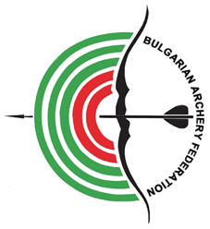

INVITATION PACKAGE
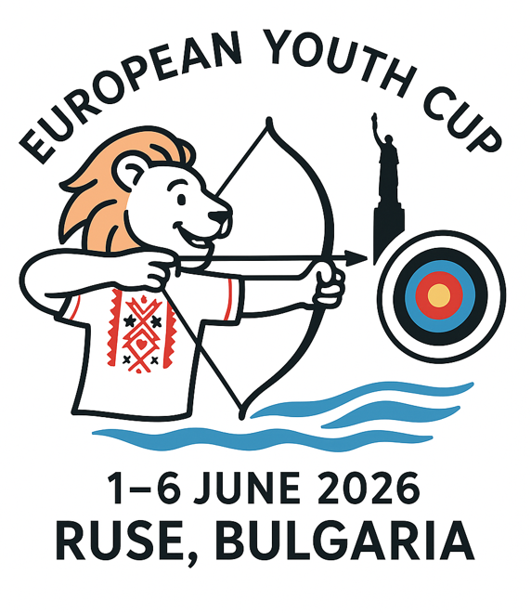

INVITATION

To all WORLD ARCHERY and WORLD ARCHERY EUROPE Member Associations

Dear President,
Dear Friends,

On behalf of the Local Organizing Committee and Bulgarian Archery Federation we are pleased to invite you to the 2026 European Youth Cup which will be held in Ruse, Bulgaria, 1-6 June 2026.
This event will be organized following the WA and WAE YOUTH CUP RULES for Under 21 Women, Under 21 Men, Under 18 Women and Under 18 Men classes, Recurve and Compound, and Under 21 Women, Under 21 Men Barebow divisions in the Outdoor Target Archery discipline.

THE PARTICIPATION IS OPEN TO ALL WORLD ARCHERY MEMBER ASSOCIATIONS.

Please find enclosed the necessary documents concerning the registration, organization and participation in this event. To register participation, please complete all the necessary sections in WAREOS within the deadlines listed below:

 | Registration opening  Preliminary Entries | 1 February 2026  1 April 2026
 | Final Entries | 11 May 2026
 | Preliminary Hotel Reservation | 1 April 2026
 | 50% Hotel Reservation payment  Visa Support request form | 1 April 2026  1 April 2026
 | Transportation | 11 May 2026
 | Final Hotel Reservation & Payment | 11 May 2026
 | Final Payment | 11 May 2026
 | Full refund cancellation deadline | 1 April 2026
 | Hotel Cancelation 100% | 1 April 2026
! After this deadline, Member Association will be charged 50% of any cancelled hotel reservations.
 | Hotel Cancelation 50% | 11 May 2026
!! After this deadline, the LOC is allowed to retain all amounts due by the Member Association.

We are looking forward to welcoming you and we are sure you will enjoy your stay in Ruse.

Website: https://www.archeryeurope.org/ Yours sincerely Atanas Temelkov
E-mail: eyc@abv.bg President of the Organizing Committee &
Info: +359 887 963009 President of Bulgarian Archery Federation

PRELIMINARY PROGRAMME

Friday 29 May 2026 Arrival of Delegations

Saturday 30 May 2026 Arrival of Delegations
Unofficial Practice

Sunday 31 May 2026 Arrival of Delegations
Unofficial Practice
Team Registration

Monday 1 June 2026 Opening
Official practice and Equipment inspection
Team Managers' Meeting

Tuesday 2 June 2026 Qualification round Under 18
Qualification round Under 21

Wednesday 3 June 2026 Mixed Teams

Thursday 4 June 2026 Individual Eliminations – up to Semifinals

Friday 5 June 2026 Team Eliminations and Finals
Team & Mixed Team Awarding

Saturday 6 June 2026 Individual Finals
Award Ceremony/Closing Ceremony
Party

Sunday 7 June 2026 Departure of Delegations

Note: This preliminary program is subject to changes according to the number of participants.
All changes and necessary information will be published and distributed in good time.

Website: https://www.archeryeurope.org/

PRELIMINARY & FINAL REGISTRATION

No entry forms will be available for registering for this event. The registration process should be done using the World Archery Online Registration System (WAREOS).

The number of athletes that may be entered by a Member Association is limited to four (4) in each recurve and compound category, and to one (1) in each barebow category.

All World Archery MA’s are eligible to compete in European Youth Cup competitions, but only the results of the athletes from WORLD ARCHERY EUROPE MA’s will be taken into consideration for the Youth Cup Circuit.

To use WAREOS, please login on https://extranet.worldarchery.sport/ with your Username and Password assigned by World Archery. For any questions regarding the WAREOS, please contact the World Archery office wareos@archery.sport
Starting date of online registration with WAREOS is: | 1 February 2026
End of Preliminary registration: | 1 April 2026
End of Final registration: | 11 May 2026

Please respect the deadlines stated!

Member Associations should only use WAREOS to make any changes/amendments to their entries and will be able to do so at any time. Any changes made in WAREOS email will instantly be automatically sent to the Organizing Committee and Member Association with the updated information.

However, any changes that are made after the deadlines specified or if entries differ by more than
4 participants from the preliminary entries, the following penalty fees will automatically be applied:

Penalty fees to be paid to Organizing Committee: | Cost (EURO):
Penalty fee for late entries (after the final deadline) | €45 per entry
Penalty fee for not filling Preliminary entries | €140 per entry
Penalty fee for differences between preliminary and final entries *: | €140 per entry
*If the difference between final and preliminary entries number is more than 4 athletes/officials

Any entries received less than 3 days before the team managers’ meeting will be refused if no preliminary entry and/or final entry are made prior.
As a final note, only Member Associations in good standing will be eligible to compete. This means that World Archery fee must have been paid prior the participation.
ACCOMMODATION & GENERAL INFORMATION

Important Note:
Non-official accommodation is not allowed. Any team or individual accommodated in non-official hotel will not be accredited and participation in the event will be refused.

The official hotels are 4 stars category hotels – DUNAV PLAZA HOTEL, COSMOPOLITAN HOTEL & WELLNESS, GRAND HOTEL RIGA in Ruse.

The room rates:
- are in Euro (€) per room, per night
- include full board accommodation, taxes and VAT
- including free internet in hotel lobby and rooms
- Check-in after 3:00 PM
- Check-out till 11:00 AM
- Additional purchases in the hotel bar, café and mini bar are at own expense. *
*All prices include city tax.

HOTEL | Single room |  | Double/Twin room |  | Triple room
HOTEL | Price per room per night - full board | Number of rooms | Price per room per night - full board | Number of rooms | Price per room per night - full board | Number of rooms
DUNAV PLAZA **** | €150 | 30 | €240 | 25 | €360 | 30
COSMOPOLITAN **** | €150 | 11 | €240 | 12 | €360 | 29
RIGA**** Standart | €150 | 5 | €240 | 15 | €360 | 2
RIGA**** Deluxe | €160 | 16 | €260 | 34 | - | -
RIGA**** Executive | €170 | 2 | €280 | 6 | - | -

*Lunch during the competition days will be served in the restaurant of the Hotel.

To confirm the reservation, a 50% deposit of the total amount is required to be bank transferred to the OC before 1 April 2026 Reservations after this date will be considered only according to availability, the room rate can change, and we cannot guarantee rooms in the official hotel.

Final Hotel Reservations and remaining payment should be made before 11 May 2026
Note: Please ensure that you complete all the necessary forms by the specified dates and make full payment for the accommodation at the time of booking. See detailed payment instructions below.

DUNAV PLAZA HOTEL

Dunav Plaza Hotel – Address: Bulgaria, 7000 Ruse, 5 Svoboda sqr

HOTEL | CATEGORY | Single room | Double room | Triple room
DUNAV PLAZA HOTEL | 4 **** | 150 € | 240 € | 360 €
Capacity |  | 30 | 25 | 30

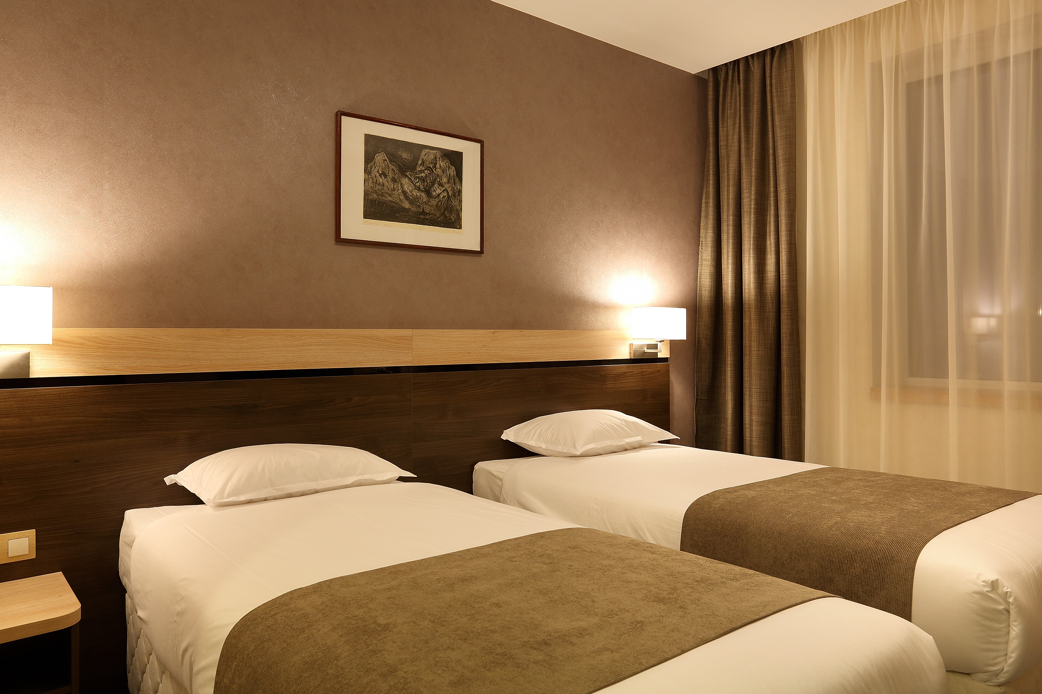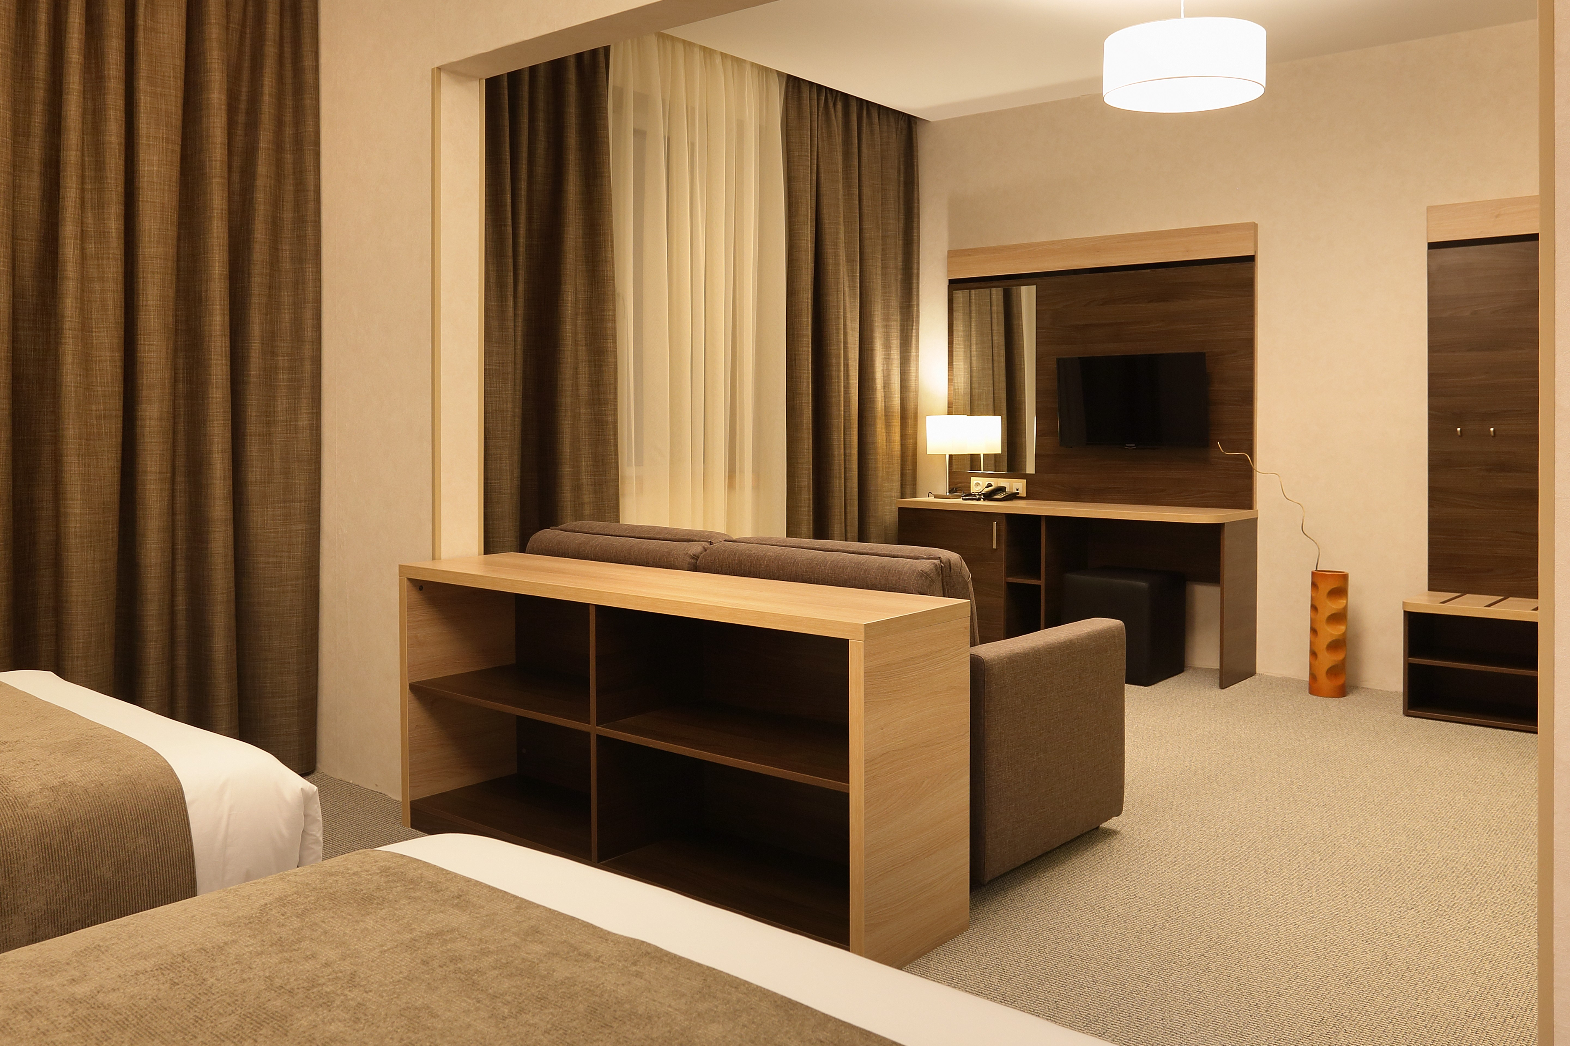
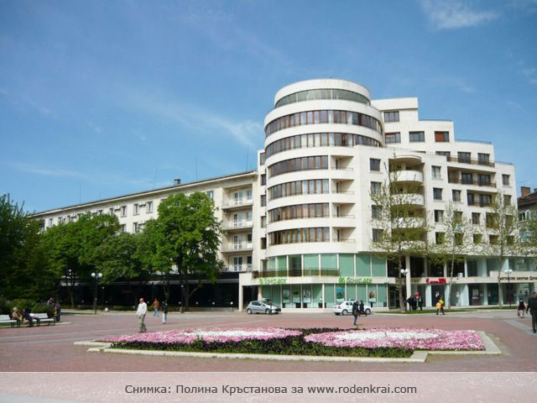

COSMOPOLITAN HOTEL & WELLNESS Address: 7000 Ruse, 1-3 "Dobri Nemirov" St

HOTEL | CATEGORY | Single room | Double room | Triple room
COSMOPOLITAN HOTEL & WELLNESS | 4 **** | 150 € | 240 € | 360 €
Capacity |  | 11 | 12 | 29

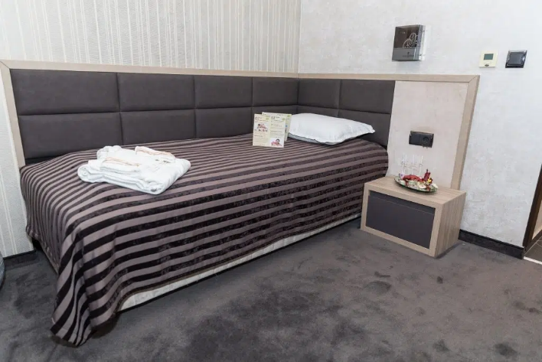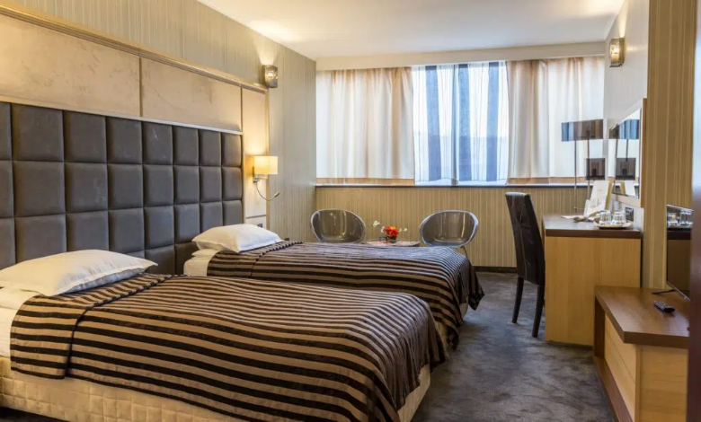
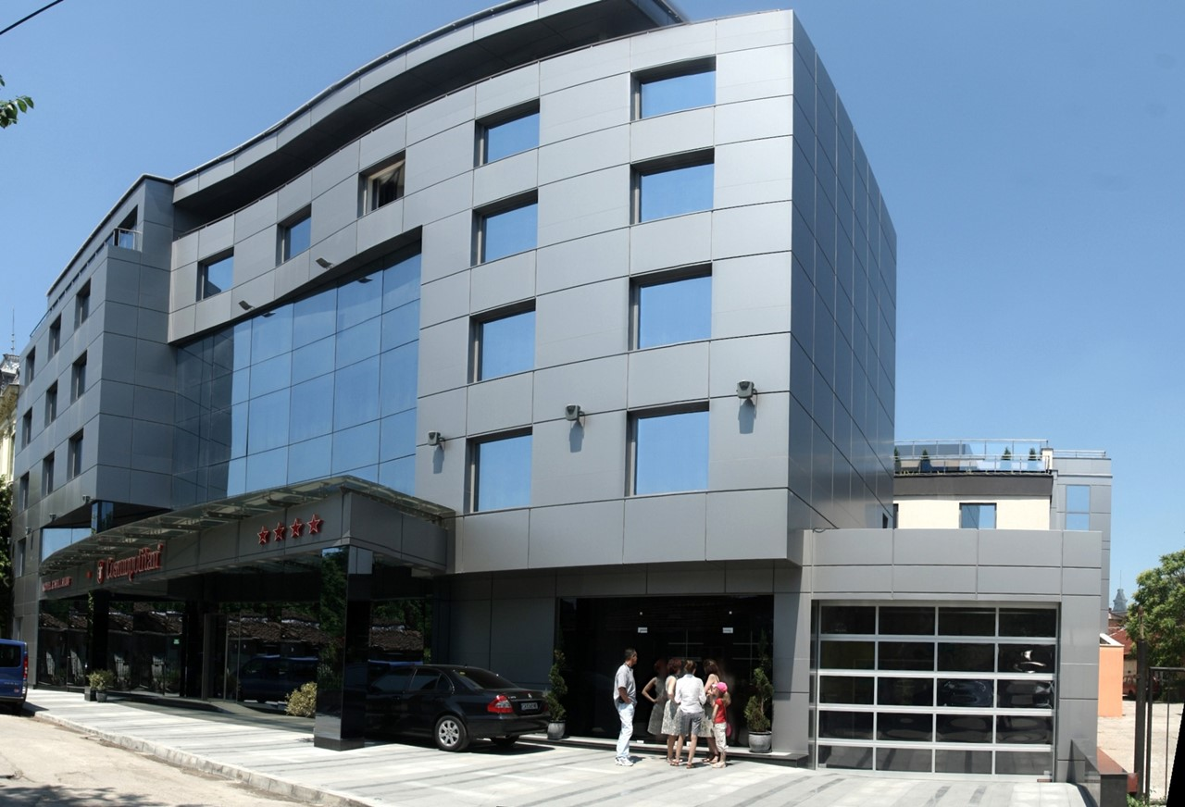

GRAND HOTEL RIGA Address: 7000 Ruse Center, bul. "Pridunavski" 22

HOTEL | CATEGORY |  | Single room | Double room | Triple room
GRAND HOTEL RIGA | 4 **** | Standart | 150 € | 240 € | 360 €
GRAND HOTEL RIGA | 4 **** | Deluxe | 160 € | 260 € | -
GRAND HOTEL RIGA | 4 **** | Executive | 170 € | 280 € | -
Capacity |  | Standart | 5 | 15 | 2
Capacity |  | Deluxe | 16 | 34 | -
Capacity |  | Executive | 2 | 6 | -

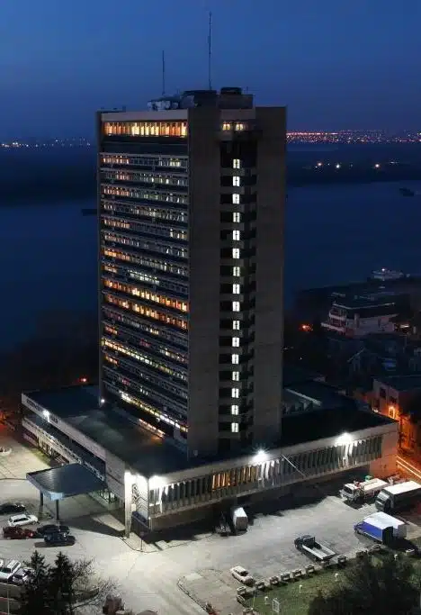
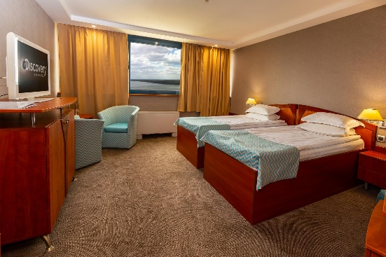
Standart

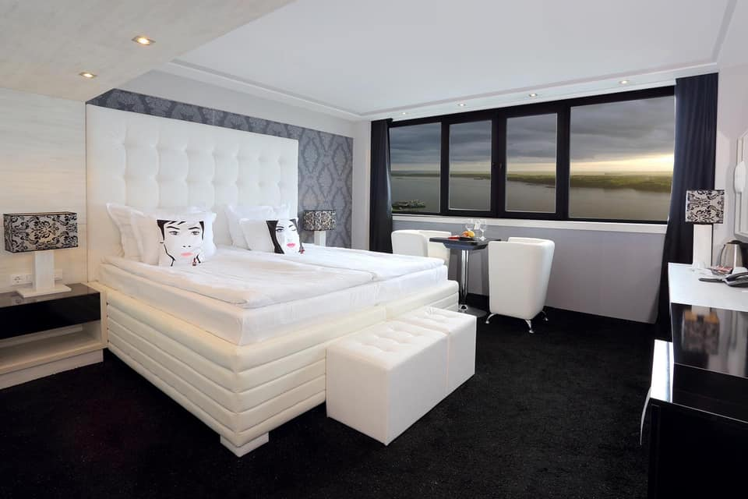
Deluxe

Executive
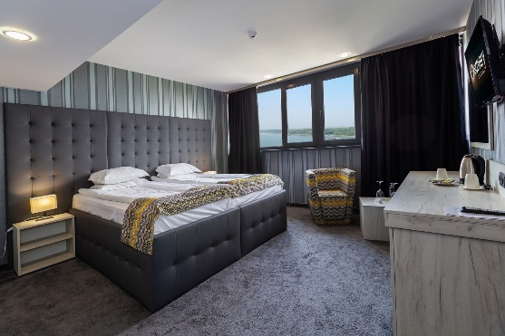

Reservations should be made before 1 April 2026

VENUE
Ruse Stadium Address: 7002 Ruse, ul. “Shtip”

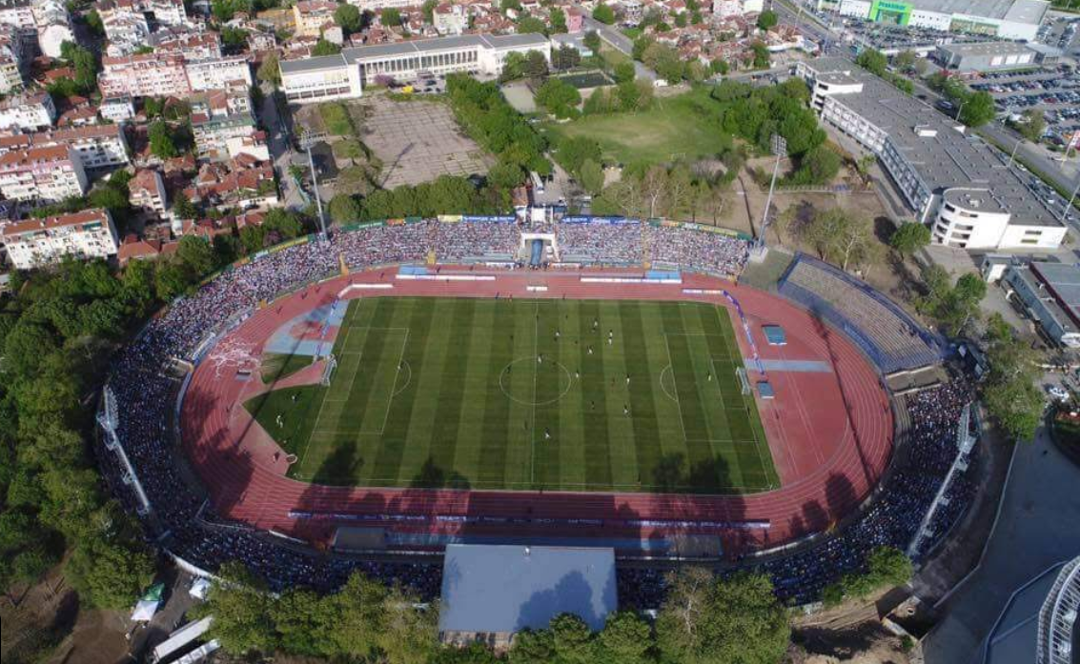

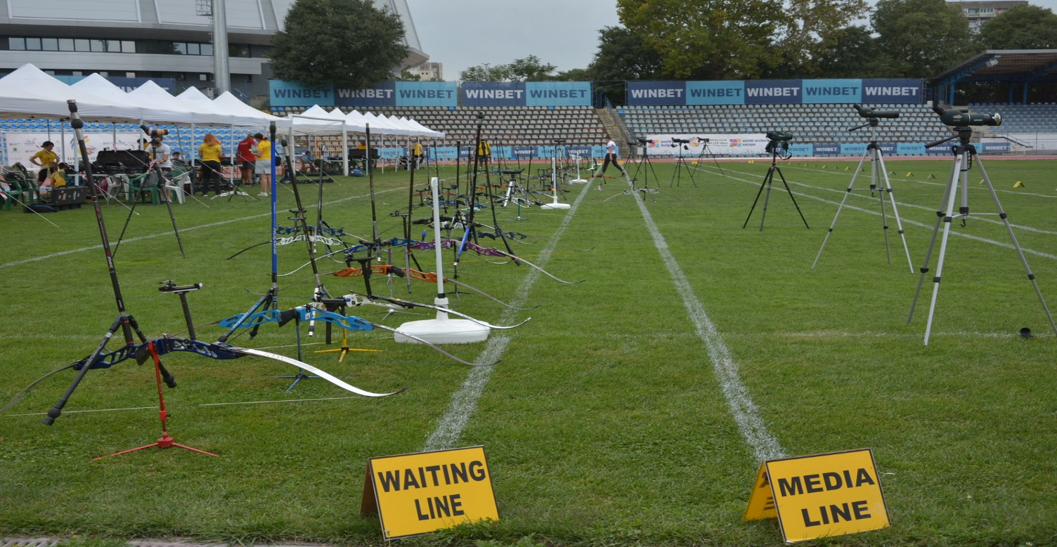

MAP
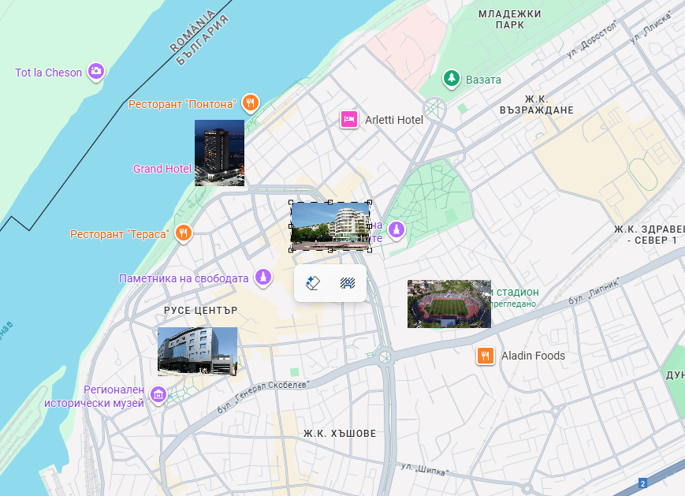

Important Note:
Refer to the accommodation pages for detailed hotel information. Please complete all the necessary sections in WAREOS and make full payment for entries, transport, and accommodation by the specified deadlines.

ADDITIONAL INFORMATION
Entry fees
Individual: €150 per athlete
Officials: Free
Teams: Free

Transportation fees from/to the airports
The OC will collect the teams from Bucharest Airport or Varna Airport. You have to pay the transportation fee as follows:

Bucharest airport to Official Hotels – (one way): €70 /person
Varna airport to Official Hotels – (one way): €70 /person
Official Hotels to Bucharest airport – (one way): €70 /person
Official Hotels to Varna airport – (one way): €70 /person

We can organize transportation from Sofia on special request. Transfer time to Ruse is 3-4 hours.

The last date for the payment of the transportation fee is 11 May 2026
Between airports and hotels, the organizer will use buses, small buses, vans and cars, which will depend on number of persons scheduled for transportation. Transportation from the airports will start two days before the official practice day and will end the day after the closing day.

A daily shuttle service will be available for the tournament days from the Official Hotels to the competition venue and back - free of charge.

Cancellations & Changes
Following conditions will apply:
- cancellation received before the preliminary entry: full refund of the paid deposit.
- cancellation received after the preliminary entry but before the final entry: 50% refund of the cancelled reservations for hotel deposit and full refund of the paid transportation and fees deposit.
- cancellation received after the final entry: no refunds.

All rates for payments after deadlines are subject to additional charges without prior notice.
All refunds, if there are any, will be processed after the event.

The OC must be informed about changes in the travel program 72 hours prior to arrival. If your arrival is later than your original schedule, the room charges will start from the original date indicated by the Member Association.

Meals at the venue
Lunch will be served in the restaurant of the hotel.

Drinking water will be available at lunch and at dinner and on the competition field free of charge.
All other costs made in cafeteria at the archery venue or in the hotel /snacks, drinks, small meals/ are not included in the entry fee and must be paid on consumptions.
Please inform us if you have special requirements for food and specify it.

Accreditation and Team Managers Meeting
Accreditation will take place upon arrival of teams on Sunday, 31 May 2026
Accreditation office will be open from 10:00 till 20:00.

For all Ceremonies WA dress code is obligatory.
More details will be provided at the Team Manager’s Meeting.
Team Managers Meeting will be held on Monday, 1 June 2026

Training and Competition Field
For European Youth Cup Training venues will be available starting from Sunday, 31 May 2026 14:00
Please inform us if you would like to arrive earlier and have extra training time in Ruse.

VISAs
All participants who need an entry visa to Bulgaria, will be required to complete the Visa Support Form in WAREOS by no later than 1 April 2026.

It is the applicants’ responsibility to supply the necessary information, ensuring all details are up to date, correct and submitted by the deadlines specified.

In addition, all participants that require a VISA are kindly requested to supply a copy of their latest/valid passport. Copies of each applicant can be uploaded on WAREOS. All passport copies and personal details entered/uploaded to WAREOS will be held securely and in the strictest of confidence and not shared with other parties.

Please note that the Organizing Committee can provide invitation for the period of the European Youth Cup in Ruse only.

If the Organizing Committee gets no different information, the Invitation Letter will be sent by email. If an express service should be desired, this service will be charged to the MA and must be paid to the Organizing Committee upon arrival.

Please note: the deadline for Visa Invitation Letter Form is 1 April 2026.

Party
On the final day, Saturday, June 6, 2026, a closing party is planned, following dinner at the hotels..
One non-alcoholic drink and small snacks will be provided at the Party.
Registration for the Party can be done via WAREOS or at accreditation desk.
Internet
Will be available at the official hotels for free.
There will also be Wi-Fi available for access to the results at the venue.
Website
The official website of the competition is https://www.archeryeurope.org/

PAYMENT CONDITIONS
All fees should be paid in full before arrival!
Payment of accommodation and local transportation: a minimum deposit of 50% of the total amount owed should be made when booking by 1 April 2026.
The final outstanding balance shall be transferred before 11 May 2026.
Accommodation cannot be guaranteed after this deadline. A balance invoice will be provided via WAREOS.

NOTE:
Please indicate in the reference/notes section the team or reservation name that corresponds to the payment.
All payment shall be made in EURO only by BANK TRANSFER LATEST 11 May 2026!
Bank transfer fees are the responsibility of the sender.Credit cards and Travel checks will not be accepted.

PLEASE SEND THE COPY OF THE BANK TRANSFER TO THE ORGANIZER by email to: eyc@abv.bg

BANK INFORMATION for ACCOMMODATION, TRANSPORTATION and ENTRY FEES:

ACCOUNT: BULGARIAN ARCHERY FEDERATION
BANK: FIRST INVESTMENT BANK
SWIFT CODE: FINVBGSF
IBAN: BG13FINV91501203792590
ADDRESS: 37, Dragan Tsankov Blvd., 1797 Sofia, Bulgaria

NOTE: ALL PAYMENTS SHALL BE MADE IN EURO

LOC CONTACT
Website: https://www.archeryeurope.org/
https://www.facebook.com/ArcheryEuropeanYouthCup

E-mail: eyc@abv.bg

Name: Atanas Temelkov
Mobile phone: + 359 88 796 3009

Name: Alexandar Pagkou
Mobile phone: + 359 88 464 0216

Looking forward to welcoming You in RUSE, Bulgaria!

