…..........................................................................................................................................................................

INVITATION

TO ALL WORLD ARCHERY MEMBER ASSOCIATIONS

Dear Presidents, dear friends, 28 February 2025

On behalf of the Organizing Committee and Archers Association of Slovenia we are pleased to invite you to the “I feel Slovenia European Youth Cup 2nd and Final Leg” that will be held in Čatež, Slovenia, 28 July–02 August 2025.
This event will be organized following the WA and WAE YOUTH CUP RULES 2025 for Under 21 Women, Under 21 Men, Under 18 Women and Under 18 Men classes, Recurve and Compound divisions and also for the first year for Under 21 Women and Under 21 Men Barebow division in the Outdoor Target Archery discipline.

THE PARTICIPATION IS OPEN TO ALL WORLD ARCHERY MEMBER ASSOCIATIONS.

Please, find enclosed the necessary documents concerning the registration, organization and participation in this event. To register participation, please complete all the necessary sections in WAREOS within the deadlines listed below:

Registration Opening Date - online WAREOS 7 March 2025
Preliminary Entries Deadline 1 June 2025
Preliminary Hotel reservation and payment 1 June 2025
Final Entries Deadline 8 July 2025
Final Hotel reservation 8 July 2025
Transportation 8 July 2025
Final Payment 8 July 2025
Visa Application 10 June 2025

We are looking forward to welcoming you and we are sure you will enjoy your stay in Čatež.

Yours sincerely

Irena Rosa Marjan Ilar
Competition Manager President of the Organizing Committee &
& Event Manager President of Archers Association of Slovenia

Website: http://www.archeryeurope.org
E-mail: oc-catez@archery-si.org
Info: +386 (0)31 633 851 Ms Irena Rosa

…..........................................................................................................................................................................
PRELIMINARY PROGRAMME

Friday 25 July 2025 Arrival of Delegations
Unofficial Practice

Saturday 26 July 2025 Arrival of Delegations
Unofficial Practice

Sunday 27 July 2025 Arrival of Delegations
Unofficial Practice
Team Registration

Monday 28 July 2025 Opening
Official practice and Equipment inspection
Team Managers' Meeting at the Čatež Hotel

Tuesday 29 July 2025 Qualification round Under 18
Qualification round Under 21

Wednesday 30 July 2025 Mixed Teams

Thursday 31 July 2025 Individual Eliminations – up to Semifinals

Friday 1 August 2025 Team Eliminations and Finals
Team & Mixed Team Awarding

Saturday 2 August 2025 Individual Finals
Award Ceremony/Closing Ceremony
Disco party

Sunday 3 August 2025 Departure of Delegations

Note: This preliminary program is subject to changes according to the number of participants.
All changes and necessary information will be published and distributed in good time.

….................................................................................................................................................................
PRELIMINARY & FINAL REGISTRATION

No entry forms will be available for registering for this event. The registration process should be done using the World Archery Online Registration System (WAREOS).

The number of athletes that may be entered by a Member Association is limited to four (4) in each Recurve and Compound category and to one (1) in each Barebow category.

All World Archery MA’s are eligible to compete in European Youth Cup competitions, but only the results of the athletes from WORLD ARCHERY EUROPE MA’s will be taken in consideration for the Youth Cup Circuit.

In order to use WAREOS, please login on https://extranet.worldarchery.sport/with your Username and Password assigned by World Archery. For any questions regarding the WAREOS, please contact the World Archery office wareos@archery.sport

Starting date of online-registration with WAREOS is: | 7 March 2025
End of Preliminary registration: | 1 June 2025
End of Final registration: | 8 July 2025

Please respect the stated deadlines.

Member Associations should only use WAREOS to make any changes/amendments to their entries and will be able to do so at any time. Any changes made in WAREOS an email will instantly be automatically sent to the Organizing Committee and Member Association with the updated information.

However, any changes that are made after the deadlines specified or if entries differ by more than
4 participants from the preliminary entries, the following penalty fees will automatically be applied:

Penalty fees to be paid to Organizing Committee: | Cost (EURO):
Penalty fee for late entries (after the final deadline) | €45 per entry
Penalty fee for not filling Preliminary entries | €140 per entry
Penalty fee for differences between preliminary and final entries *: | €140 per entry
*If the difference between final and preliminary entries number is more than 4 athletes/officials

Any entries received less than 3 days before the team managers meeting will be refused if no preliminary entry and/or final entry are made prior.

As a final note, only Member Associations in good standing will be eligible to compete. This means that World Archery fee must have been paid prior the participation.

…..........................................................................................................................................................................
ACCOMMODATION & GENERAL INFORMATION

The official hotels are 4* and 3* stars category hotels TOPLICE HOTEL and ČATEŽ HOTEL in Čatež,
standing next to each other in Čatež Spa.

The room rate:
- is per room per night,
- include full board accommodation, taxes and VAT
- include use of the swimming pool in hotel Terme and Čatež
- include use of the summer or winter thermal riviera – free entrance twice per day
- include free parking in front of the hotel for cars, minivans and busses
- internet in the hotel lobby and rooms

HOTEL | Category | Single room  Price per room per night - full board | Double room  Price per room per night - full board
TOPLICE | **** | € 150 | € 260
ČATEŽ | *** | € 140 | € 240
Lunch during the competition days will be served in the restaurant of the Hotel.
TOPLICE HOTEL Terme Čatež d.d., Topliška 35, SI - 8251 Čatež ob Savi
Coordinates: 45.89192 15.621547

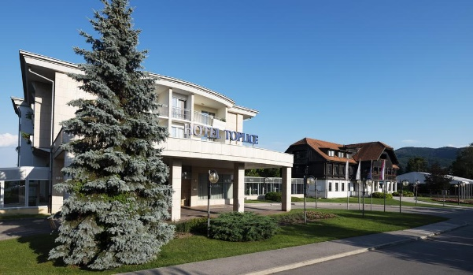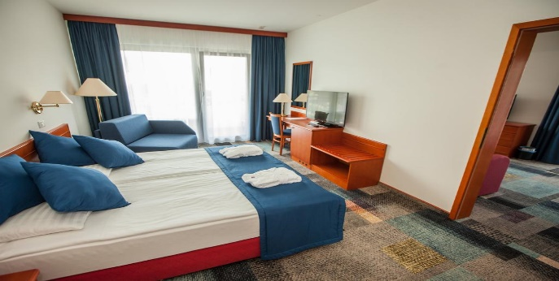

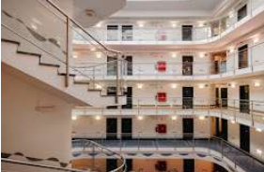
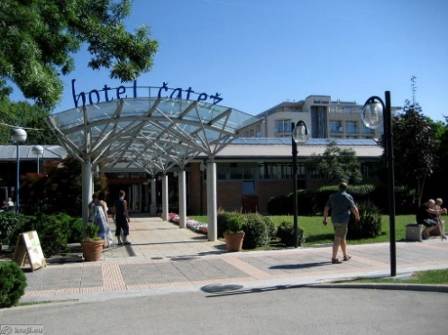
ČATEŽ HOTEL Terme Čatež d.d., Topliška 35, SI - 8251 Čatež ob Savi
Coordinates: 45.89192 15.621547

.............................................................................................................................................................................
Reservations should be made before 1 June 2025.

To confirm the reservation, a 60% deposit of the total amount is required to be bank transferred to the OC before 1 June 2025. Reservations after this date will be considered only according to availability, the room rate can change and we cannot guarantee rooms in the official hotel.

Final Hotel Reservations and remaining payment should be made before 8 July 2025.
Note: Please ensure that you complete all the necessary forms by the specified dates and make full payment for the accommodation at the time of booking. See detailed payment instructions below.

It is mandatory to choose the official hotel listed by the Local Organizing Committee. A delegation choosing a non-official hotel will not be allowed to participate in the event.

ADDITIONAL INFORMATION
Entry fees
Individual: €150 per athlete
Officials: Free
Teams: Free

Transportation fees from/to the airports
The OC will collect the teams from the two airports. You have to pay the transportation fee /including arrival and departure/ as follows:
ZAGREB International Airport – Hotel: €30 per person CRO (50km)
Hotel - ZAGREB International Airport: €30 per person CRO (50km)
LJUBLJANA International Airport - Hotel: €45 per person SLO (130km)
Hotel - LJUBLJANA International Airport: €45 per person SLO (130km)
Be aware that Zagreb is in Croatia and some countries might need visa for Croatia.

The last date for the payment of the transportation fee is 8 July 2025.

Between airports and hotels, the organiser will use buses, small buses, vans and cars, what will depend of number of persons scheduled for transportation.
Transportation from the airports will start two days before the official practice day and will end two days after the closing day.

Cancellations & Changes
Following conditions will apply:
- cancellation received before the preliminary entry: full refund of the paid deposit
- cancellation received after the preliminary entry but before the final entry: 50% refund of the hotel deposit for the cancelled reservations and full refund of the paid transportation and fees deposit
- cancellation received after the final entry: no refunds

.............................................................................................................................................................................
All rates for payments after deadlines are subject to additional charges without prior notice.
All refunds, if any, will be processed after the event.

OC has to be informed about changes in the travel programme 72 hours prior arrival. If your arrival is later then your original schedule, the room charges are starting from the original date indicated by the Member Association.

Meals at the venue
Lunch will be served in the restaurant of the hotel.

Drinking water will be available at lunch and at dinner and on the competition field free of charge.
All other costs made in cafeteria at the archery venue or in the hotel /snacks, drinks, small meals/ are not included in the entry fee and must be paid on consumptions.

Please inform us if you have special requirements for food and specify it.

Accreditation and Team Managers Meeting
Accreditation will take place upon arrival of teams in the lobby of the Hotel Čatež 27 July 2025. Accreditation office will be open from 09:00 till 21:00. Accreditation cards will be possible to issue from Monday 28 July on the competition area only with the additional payment of €30 per person.
More details will be provided at the Team Manager’s Meeting.
Team Managers Meeting will be held in the conference room in the hotel on Monday, 28 July 2028.

Dress code
On the competition field and during all ceremonies WA dress code is obligatory for participants.

Training and Competition Field
For European Youth Cup the football sport fields will be used. Fields are in walking distance from hotels.

The practice field will be available starting from 26 July 2025.

Central European Cup
For those teams who will plan to arrive earlier and those who might choose to arrive earlier for this purpose, we would like to inform you that on Saturday 26 July 2025 there will be a Central European Cup tournament (70m/50m Round with Eliminations and Finals) organized on the same competition field in Terme Čatež d.d., Topliška 35, SI - 8251 Čatež ob Savi . The tournament is open to all classes Recurve, Compound and Barebow. The Entry fee for this tournament will be €20,00. The invitation will be published on the federation web site: www.archery‐si.org.

Visas
All participants who need an entry visa to Slovenia, will be required to complete the Visa Support Form in WAREOS by no later than 10 June 2025.

It is the applicants’ responsibility to supply the necessary information, ensuring all details are up to date, correct and submitted by the deadlines specified.

.............................................................................................................................................................................
In addition, all participants that require a visa are kindly requested to supply a copy of their latest/valid passport. Copies of each applicant can be uploaded on WAREOS. All passport copies and personal details entered/uploaded to WAREOS will be held securely and in the strictest of confidence and not shared with other parties.

Please note that the Organizing Committee can provide invitation for the period of the European Youth Cup in Čatež only.

As long as the Organizing Committee gets no different information, the Invitation Letter will be sent by email. If an express service should be desired, this service will be charged to the MA and must be paid to the Organizing Committee upon arrival.

Those teams that want to land in Zagreb airport must be aware that they might need visa for Croatia.
In this case we might not be able to help you.

Please note: the deadline for Visa Invitation Letter Form is 10 June 2025.

Disco Party
On the final day - Saturday, 02 August 2025, after the dinner the Disco party will be organized free of charge. Drinks are not included and must be paid on consumptions.

Internet
Free of charge in all locations of Spa Čatež.
Website and social media
The official website of the competition is http://www.archeryeurope.org
The official Facebook page: Lokostrelska zveza Slovenije
The official instagram profile: archery_slovenia

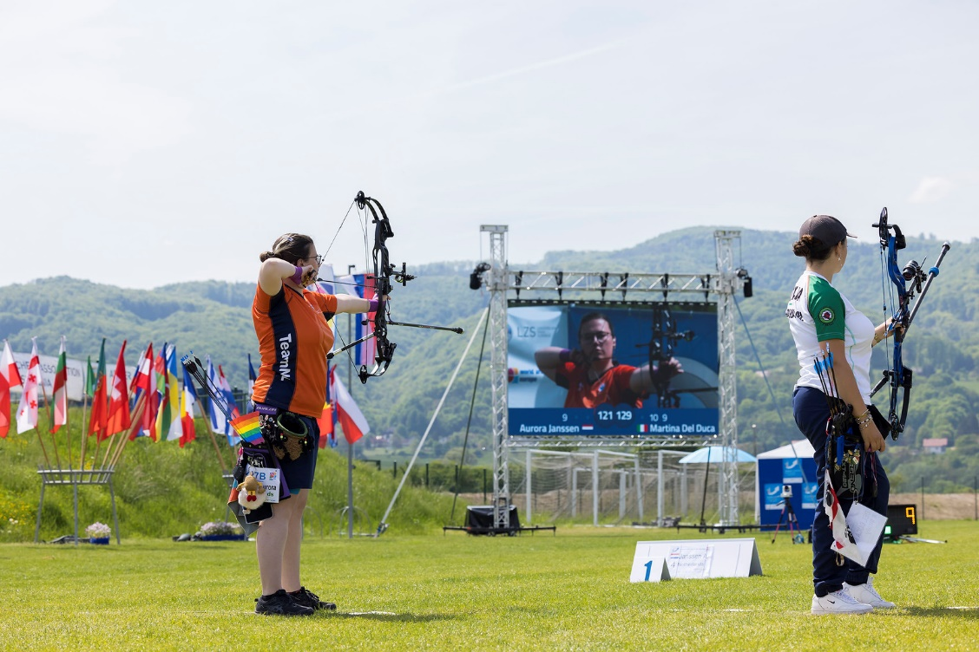

.............................................................................................................................................................................
PAYMENT INSTRUCTIONS

BANK: NOVA LJUBLJANSKA BANKA d.d.
Address: Trg republike 2
1000 Ljubljana
Slovenia
A/C NAME LOKOSTRELSKA ZVEZA SLOVENIJE
Address: Stožice 28
1000 Ljubljana
Slovenia

SWIFT CODE /BIC/: LJBASI2X
IBAN: SI56 0201 3001 7204 321

…..........................................................................................................................................................................
NOTE:
ALL PAYMENTS ARE REQUIRED TO BE DONE IN EUROS BY BANK TRANSFER LATEST 8 July 2025!
ALL BANK TRANSFER FEES HAVE TO BE PAID BY PARTICIPATING MAs, you need to state OUR option when paying.

IN CASE OF NOT PAYING THE BANK TRANSFER FEES, YOU WILL BE CHARGED FOR THE DIFFERENCE UPON ARRIVAL, AT THE ACCREDITATION.

- NO CREDIT CARDS
- NO TRAVEL CHECKS

OC contacts

For all matters
Ms Irena Rosa - 24 hours English
Mobile +386 (0)31 633 851
E-mail: oc-catez@archery-si.org

For questions about visa support
Mr Marjan Ilar - 24 hours English
Mobile +386 (0)41 788 907
E-mail: oc-catez@archery-si.org

