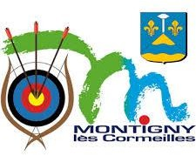

**INVITATION PACKAGE**



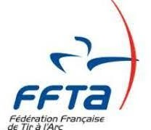

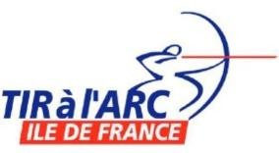 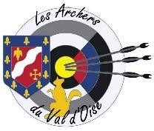 

Version 1.1

**13/07/25**

Dear athletes,



WELCOME

It is a great honor to welcome you on October 10-11-12, 2025 for the Run Archery European Cup in France in our beautiful city of Montigny lès Cormeilles. We will have the privilege of bringing together the best athletes of this exciting and demanding sport, in a spirit of conviviality, surpassing oneself and fair play.

The discipline of Run Archery is a real challenge, where skill, speed and strategy meet. We are delighted to see so many competitors from all over Europe sharing their passion and talent on this international stage.

This competition is also a special moment to celebrate the values of sport: team spirit, solidarity, and respect. We are proud to offer a platform for the practice of this emerging sport, while contributing to the development of the European sports community.

May the Run Archery European Cup be a great success and a great example of the unity and passion that drive our sporting community.

See you soon!

Guillaume ESCOTTE

Chair of the Organizing Committee

Montigny-lès-Cormeilles is 20 km in North of Paris (FRA)



LOCATION OF THE VENUE

The competition will be held in : Stade du Bois Barrais https://maps.app.goo.gl/JwCvoLUb5evKTea87

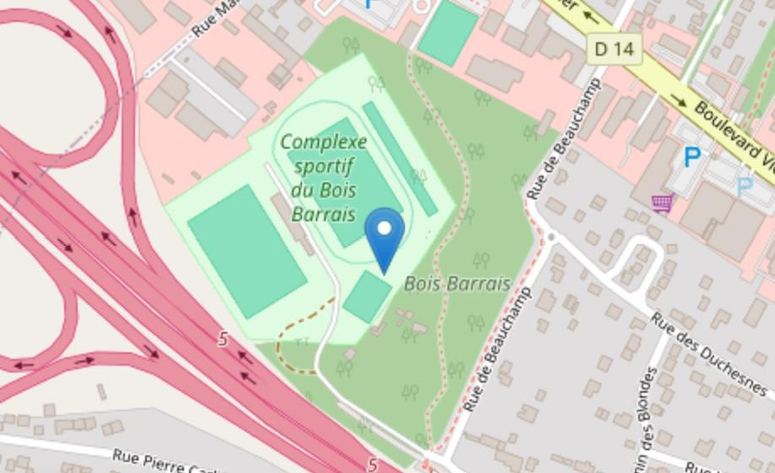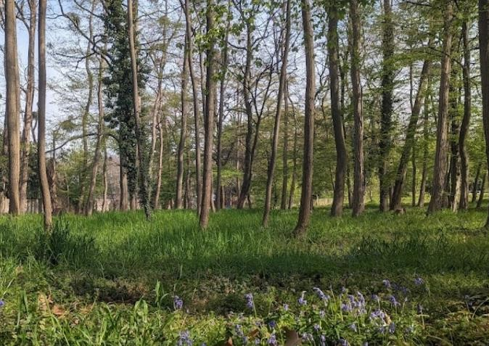

Opening of the registration on WAREOS : 10 April 2025



IMPORTANT DEADLINES

Preliminary entries (planed number by category): 12 July 2025

Final entries (detailed list of athletes and number of teams): 19 September 2025 Payment of the registration fees: 19 September 2025

General rules : WORLD ARCHERY Book 5 Chapter 34



RULES TO APPLY

Link: <https://www.worldarchery.sport/rulebook/article/3564>

European Cup : Updated for the 2025 Edition

Link: [https://www.archeryeurope.org/wp-content/uploads/2018/05/RUNARCHERY-CUP-](https://www.archeryeurope.org/wp-content/uploads/2018/05/RUNARCHERY-CUP-2025-RULES-AND-SPECIFICATION.pdf) [2025-RULES-AND-SPECIFICATION.pdf](https://www.archeryeurope.org/wp-content/uploads/2018/05/RUNARCHERY-CUP-2025-RULES-AND-SPECIFICATION.pdf)



PROVISIONAL SCHEDULE

|  |  |  |
| --- | --- | --- |
| FRI 10 Oct 2025 | During the day 15:00 - 18:00  18:00 - 18:30  18:45 - 19:15 | Arrivals, accreditation  Official practice & Equipment Inspection Team Managers meeting  Opening Ceremony |
| SAT 11 Oct 2025 | 08:30 - 09:45  10:00 - 16:00  16:45 - 17:15  17:45 | INDIVIDUAL SPRINT  Practice  Qualification Women (every 30sec) Qualification Men (every 30sec) Semi finals  Finals  SPRINT MIXED TEAMS RELAY  Final Relay Mixed Award Ceremony |
| SUN 12 Oct 2025 | 09 :10-12 :00  13 : 30-15 :00  16 : 00 | INDIVIDUAL 4K  Individual Race SPRINT TEAMS RELAY  Final Relay Award Ceremony |

Schedule will be confirmed in the Team Managers booklet (publication 1 week before the event).

# 2025 EUROPEAN CUP RULES



REGISTRATION

Only World Archery Member Associations can register athletes and officials. The number of registrations is limited to 9 males and 9 females.

The number of athletes in the U21 category is unlimited. U15 are not allowed. Participation in both individual race formats Sprint and 4K is mandatory.

# Argent avec un remplissage uniFEES

|  |  |  |  |  |
| --- | --- | --- | --- | --- |
| INDIVIDUAL | W, M, 50+ W, 50+ M | 65,00 € | MIXED TEAM RELAY | 40,00 € |
| INDIVIDUAL | U21 W, U21 M | 55,00 € | WOMEN TEAM RELAY | 60,00 € |
| OFFICIAL |  | 35,00 € | MEN TEAM RELAY | 60,00 € |

Ordinateur portable avec un remplissage uniONLINE REGISTRATION

Archery Online Registration System WAREOS must be used.

Member associations can login to WAREOS at [http://extranet.worldarchery.org](http://extranet.worldarchery.org/)

The registration for this competition doesn’t include the international license and the related services and rights. The registration of the teams (number by kind of team) is done through the “extra” section.

The wished additional teams must be registered. The maximum number will be defined based on this pre- registration, after the deadline for final entries.

# Banque en ligne avec un remplissage uniPAYMENT

Bank Account Owner: LES ARCHERS DE MONTIGNY LES CORMEILLES

Bank Account Number: 00020190701

# IBAN: FR76 3006 6102 2600 02019070 164

SWIFT Code: CMCIFRPP

Currency : EUR

Specific Symbol: RAEC/ country code (specify your international country code)

Organizing Committee [concoursamlc@yahoo.com](mailto:concoursamlc@yahoo.com) Chair of the OC: Guillaume ESCOTTE



CONTACT

Technical Delegate : Dominique OHLMANN [ohlmann.dominique@gmail.com](mailto:ohlmann.dominique@gmail.com)

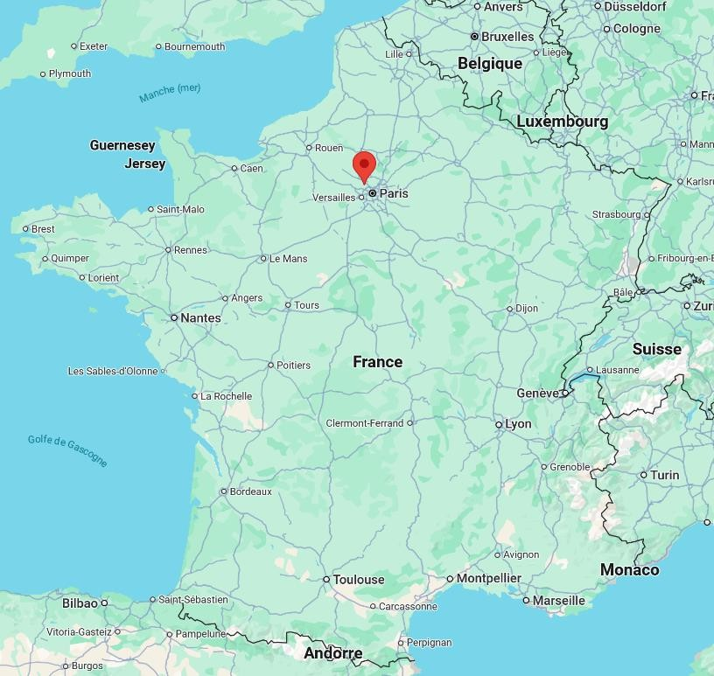The Organizing Committee doesn’t provide any local transport.



NEAREST DESTINATIONS

|  |
| --- |
| AIRPORT |
| CDG – Roissy Charles de Gaulle  45 km by car to Montigny-Lès-Cormeilles Possible use of public transport |
| Train avec un remplissage uni RAIL STATION |
| PARIS- Gare du Nord  22 km by car to Montigny-Lès-Cormeilles Possible use of public transport  For any question, feel free to contact us. |
| ACCOMMODATION |

The organizing committee is not in charge of the accommodation for the participants. The hotels close to the venue are:

|  |  |  |  |
| --- | --- | --- | --- |
| 1. HOTEL PREMIERE CLASSE – Herblay sur Seine |  1,6 km - | 4’ | 1,5 km - 22’ |
| 2. HOTEL B&B – Herblay sur Seine |  1,8 km - | 5’ | 1,7 km - 23’ |
| 3. HOTEL CAMPANILE – Taverny |  4,3 km - | 10’ |  |

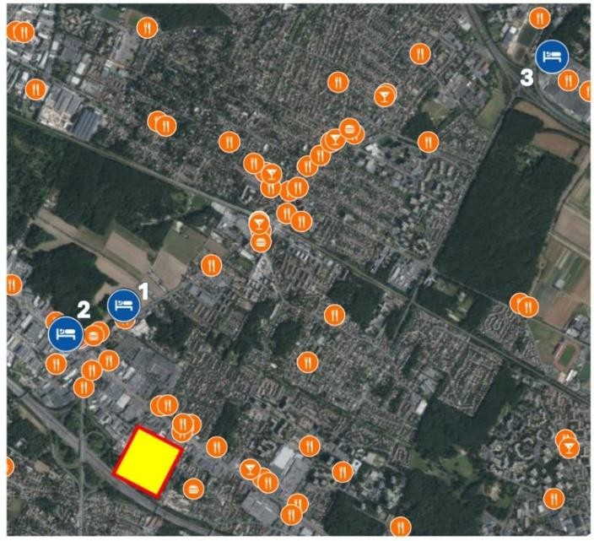There are many various restaurants around the venue and on the way to the hotels.