



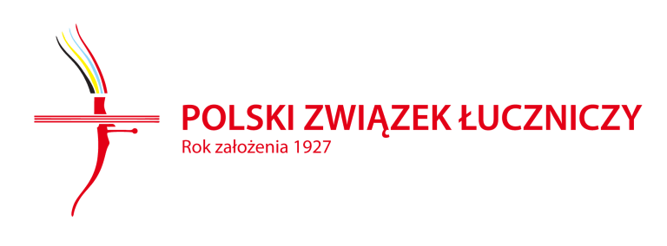 | 
 | 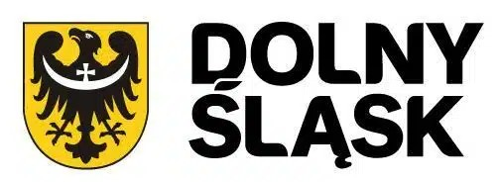
 | 

INVITATION PACKAGE
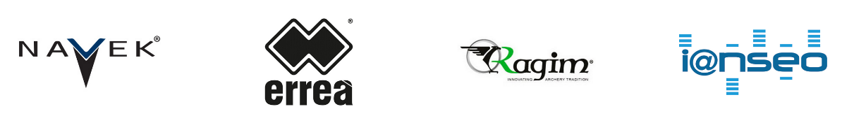
Draft
Version 1.0
13/05/26
 |  | WELCOME

Dear athletes,

UKS Luks Smolec club feels honored to be entrusted with hosting of the European Cup hoping we will be able to provide the participants with good condition for their sports performance and while helping internationally with promoting of this event.
UKS Luks Smolec club has much experience with run & ski archery events. We have hosted the historical 1. Polish Run Archery Tournament (2024, Kąty Wrocławskie), 2 rounds of Three Nations' Cup (2025, Smolec & Kąty Wrocławskie) and final round of Polish Run Archery Sprint Cup (2025, Smolec). This year, we have also actively participated in organizing international events promoting run archery and enabling athletes to compete throughout the spring & summer season and prepare well for the European Cup, which concludes the season. Together with our friends from Germany, the Czech Republic, Hungary, and Estonia, we are organizing a series of run archery competitions in long runs (4K and relays – Three Nations' Cup) and sprints (as well as a mixed team sprint – Run Archery Sprint Cup). We kicked off the season with the first ski archery competition in our region (and only the second in Poland)!
The Lower Silesia region, hosting this year's Run Archery European Cup, has a long and complex history, shaped by the combined efforts of Poles, Czechs, Germans, Austrians, and Jews. As custodians of this centuries-old heritage, we encourage all athletes to visit us for more than just the three days of competition, to explore Wrocław and the region's historical sites.
LOC hopes that at least a dozen national teams, as well as many guests from other continents, will come to Kąty Wrocławskie this year, giving the competition a global dimension. LOC is also convinced that we all will have a great time with the 2026 edition of the 3. Kąty Wrocławskie Run Archery Open and WAE Run Archery European Cup! See you soon!

Przemysław JASTRZĄB
Chair of the Organizing Committee
President of UKS Luks Smolec club
Member of The Non-Olympic Archery Commission of the Polish Archery Association

 |  | LOCATION OF THE VENUE
Kąty Wrocławskie is 27 km in West of Wrocław (POL)
The competition will be held in : City Stadium and Park https://maps.app.goo.gl/e42igVKHBLKZBx9H7
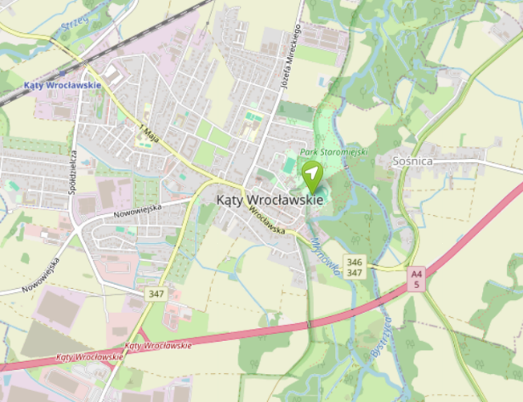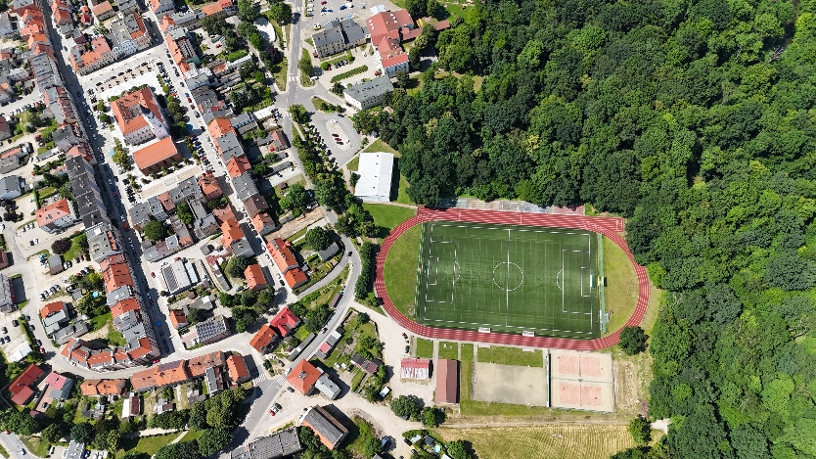

 |  | IMPORTANT DEADLINES
Opening of the registration on WAREOS : 01 June 2026
Preliminary entries (planed number by category): 10 July 2026
Final entries (detailed list of athletes and number of teams): 18 September 2026
Payment of the registration fees: 18 September 2026

 |  | RULES TO APPLY

General rules : WORLD ARCHERY Book 6 Chapter 49
Link: https://www.worldarchery.sport/rulebook
European Cup : Updated for the 2026 Edition
Link: https://www.archeryeurope.org/wp-content/uploads/2018/05/RUNARCHERY-CUP-2026-RULES.pdf
 |  | PROVISIONAL SCHEDULE

FRI 9 Oct 2026 | During the day  15:00 - 18:00  18:00 - 18:30  18:45 - 19:15 | Arrivals, accreditation  Official practice & Equipment Inspection  Team Managers meeting  Opening Ceremony
SAT 10 Oct 2026 | 08:30 - 09:45  10:00 - 16:00  16:45 - 17:15  17:45 | INDIVIDUAL SPRINT  Practice  Qualification Women (every 30sec)  Qualification Men (every 30sec)  Semi finals  Finals  SPRINT MIXED TEAMS RELAY  Final Relay Mixed  Award Ceremony
SUN 11 Oct 2026 | 09 :10-12 :00  13 : 30-15 :00  16 : 00 | INDIVIDUAL 4K  Individual Race  SPRINT TEAMS RELAY  Final Relay  Award Ceremony

Schedule will be confirmed in the Team Managers booklet (publication 1 week before the event).

 |  | REGISTRATION

 | 2026 EUROPEAN CUP RULES

Only World Archery Member Associations can register athletes and officials.
The number of registrations is limited to 9 males and 9 females.
The number of athletes in the U21 category is unlimited. U15 are not allowed.
Participation in both individual race formats Sprint and 4K is mandatory.

 | FEES

INDIVIDUAL W, M, 50+ W, 50+ M 65,00 € MIXED TEAM RELAY 40,00 €
INDIVIDUAL U21 W, U21 M 55,00 € WOMEN TEAM RELAY 60,00 €
OFFICIAL 35,00 € MEN TEAM RELAY 60,00 €

 | ONLINE REGISTRATION

Archery Online Registration System WAREOS must be used.
Member associations can login to WAREOS at http://extranet.worldarchery.org
The registration for this competition doesn’t include the international license and the related services and rights.
The registration of the teams (number by kind of team) is done through the “extra” section.
The wished additional teams must be registered. The maximum number will be defined based on this pre-registration, after the deadline for final entries.

 | PAYMENT

Bank Account Owner: UKS LUKS SMOLEC
Bank Account Number: 73253000082041107146630001
IBAN: PL73 2530 0008 2041 1071 4663 0001
SWIFT Code: NESBPLPW
Currency : PLN
Specific Symbol: RAEC/ country code (specify your international country code)

 |  | CONTACT

Organizing Committee smolec@uksluks.pl
Chair of the OC: Przemysław JASTRZĄB
Technical Delegate : Dominique OHLMANN ohlmann.dominique@gmail.com

 |  | NEAREST DESTINATIONS

The Organizing Committee can provide local transport for groups by minivan (up to 7 persons with luggage):
- from Wrocław (Airport / Rail Station / hotel) to Kąty Wrocławskie (venue or hotel) – 50 EUR / 1 transfer
- in Kąty Wrocławskie or Krobielowice (venue / hotel) – 10 EUR / 1 transfer

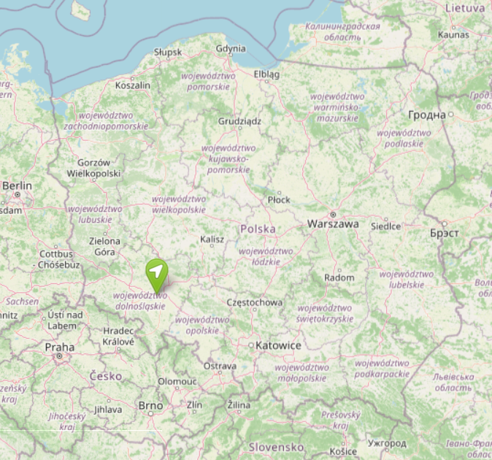 |  |  |  |  | AIRPORT
WRO – Nicolaus Copernicus

27 km by car to Kąty Wrocławskie
Possible use of public transport

 |  |  |  |  | RAIL STATIONS
WROCŁAW GŁÓWNY – Main Station

27 km by car to Kąty Wrocławskie
Possible use of public transport

KĄTY WROCŁAWSKIE – Local Station
2,2 km - 5’ 2 km - 28’

For any question, feel free to contact us.

 |  | ACCOMMODATION

The organizing committee is not in charge of the accommodation for the participants.
The hotels close to the venue are:
- HOTEL AZYL – Kąty Wrocławskie
1,8 km - 4’ 1,6 km - 23’
- HOTEL PAŁAC KROBIELOWICE – Krobielowice
3,6 km - 6’
- HOTEL TERMINAL – Wrocław
18 km - 20’
Wrocław offers many options for accommodation in hotels of various standards.
There are a few various restaurants & bars around the venue.

