TO ALL World Archery Europe Member Associations, Dear President,

As Chair of the Local Organizing Committee (LOC) of the European Para Archery Championships to be held in Rome, Italy starting from 27 April 2026, I would like to invite you all to be part of one of the most important archery events to take place in the Europe in 2026.

Sincerely yours, Sante Spigarelli Rome OC Chairman

IMPORTANT DATES

Please find enclosed detailed information regarding this event. To register participation, please complete all the necessary sections in WAREOS (https://extranet.worldarchery.sport) within the deadlines listed below.

Summary of deadlines:

Registration Opening date on WAREOS | 6th February 2026
Preliminary Entries | 27th February 2026
Classification request submission  Final Entries | 26th February 2026  27th March 2026
Hotel reservation  Payment | will be done by LOC after the final entries based on capacity of accommodation and size and male/ fe- male/ wheelchair user’s ratio of the teams. Deadline 27th March 2026  27th March 2026
Transportation | 27th March 2026
Visa support | 27th March 2026
Full refund cancellation deadline | 27th March 2026

*After this deadline, the LOC is allowed to retain all amounts due by the Member Association.

Please adhere to the provided deadlines. It is imperative for Member Associations to update WAREOS with any changes, including cancellations or modifications, even after submitting a preliminary entry. Non-compliance may result in additional penalties.

VENUE LOCATION

Practice venue | Police sport center Via del Risaro, 192/198, 00128 Roma RM
Qualifications venue | Police sport center Via del Risaro, 192/198, 00128 Roma RM
Finals venue | Nando Martellini Stadium - Largo delle Vittime del Terrorismo, 1, 00153 Roma RM

PRELIMINARY PROGRAMME

25th April Saturday | Arrival of participants
26th April Sunday | Arrival of participants Free Practice  International Classification
27th April Monday | Official Practice (Equipment Inspection) Team managers meeting
28th April Tuesday | Qualification Round (2 or 3 sessions)
29th April Wednesday | Team elimination  (Double and mixed teams)
30th April Thursday | Individual Eliminations (up to 1/2) (Para Compound, Recurve, W1)  VI official practice followed by qualification round
1st May  Friday | Team Finals (Para Compound, Para Recurve, W1)  VI individual elimination (sport class VI 1 and VI 2)
2nd May Saturday | Individual Finals  (all categories)  Award ceremonies (Para Compound, Para Recurve, W1, VI)
3rd May Sunday | Departure of teams

NOTE: This preliminary programme is subject to change according to participation and TV requirements. All changes will be published and distributed in good time.

*As per World Ranking requirements it is mandatory to schedule at least gold medal matches for each individual category in a separate 1-hour session for broadcast.

VISUALLY IMPAIRED CATEGORIES
Based on the number of participants registered at preliminary entries, WA Rule Book 5 Chap 35.1 will apply : “If there are insufficient final entries in either or both divisions, a single competition combining all VI athletes will proceed with all VI athletes wearing a blindfold regardless of their respective classification.”

PRELIMINARY & FINAL REGISTRATION
All entries, accommodation reservations, transport needs, flight arrival/departure information and visa invitation letter requests are to be completed using the World Archery Online Registration System WAREOS https://extranet.worldarchery.sport. This system handles the entire registration process for this event. No entry forms, hotel reservations or transportation forms will be accepted; all information must be entered into WAREOS.

Member associations can login to WAREOS at http://extranet.worldarchery.sport with the username and password assigned by World Archery. After entering WAREOS, selecting the event from the list will allow a member association to register their athletes. Select/press the “Entries” button to see the list of categories in the event. Select/press the “category” to enter the athlete and official numbers/details participating for that event. A WAREOS User Manual can be downloaded in PDF format (English) upon login.

Contact wareos@archery.sport with any questions regarding technical problems on WAREOS. For any question regarding the organisation of the event (transport, accommodation, meals, invoices, visa etc.) please contact directly the LOC.

A maximum number of three (3) athletes per country can be registered into each category and divisions of the event.

Member Associations can only use WAREOS to make any changes, amendments or cancellations to entries and will be able to do so at any time. An email will automatically notify the Organising Committee and Member Association of any changes made in WAREOS.

Please, be aware that only WAE Mas can take part to European Championships, so no extra WAE federations will be allowed to register.

ENTRY FEES

Individual 230 € per person
Team Manager 130 € per person
Coach 130 € per person
Medical 130 € per person
Teams 75 € per team
International License 100 CHF per participant per calendar year to be paid to World
Archery

All other fees applicable to the event can be found in the Policies and Procedures Athletes, Officials and Team Management.

Member Associations that have penalty fees outstanding from 2025 will need to have paid these penalty fees before being eligible to enter and compete.

Any entries received after the final registration deadline will be refused. Only substitution will be allowed.

Entries and substitutions received after the deadlines are subject to penalties as clearly stated in the rule book and the world ranking event invitation documents. A Member Association that has made final entries in WAREOS and does not participate will be invoiced for the number of entries entered in the system as well as any other booking they made through the platform (including but not limited to accommodation, transportation, and any other extras the Member Association has booked through the platform).

CLASSIFICATION
International classification will be conducted only for athletes registered by their Federation as part of the national team.
All relevant information regarding classification procedures is available on the World Archery website:
https://www.worldarchery.sport/sport/disciplines/para-archery/classification
The Evaluation Agreement Form and the Medical Diagnostic Form, required to apply for classification, can be downloaded from WAREOS under:

Home → Para → Forms

It is the full responsibility of the teams to ensure that athletes arrive on time for their scheduled classification. No postponement of the classification session, official practice, or equipment inspection will be possible under any circumstances. Athletes registered for classification are strongly advised to arrive at least one (1) day prior to their scheduled classification appointment.
Member Associations (MAs) are requested to regularly verify the classification status of their already classified athletes in the official Master List.

ACCOMMODATION

Hotel assignment and reservation will be done by the LOC after the final entries based on capacity of accommodation and size and male/ female/ wheelchair users ratio of the teams

MERCURE ROMA WEST https://all.accor.com/hotel/8516/index.it.shtml

Mercure Roma WEST l Mercure Roma West is a 4 stars hotel, modern and elegant, placed at 20 mins from city Center, close to EUR (Rome Universal Exposition district) and Roma Fiumicino airport. The hotel offers 215 rooms with TV and minibar, free Wi-Fi and free of charge internal parking.
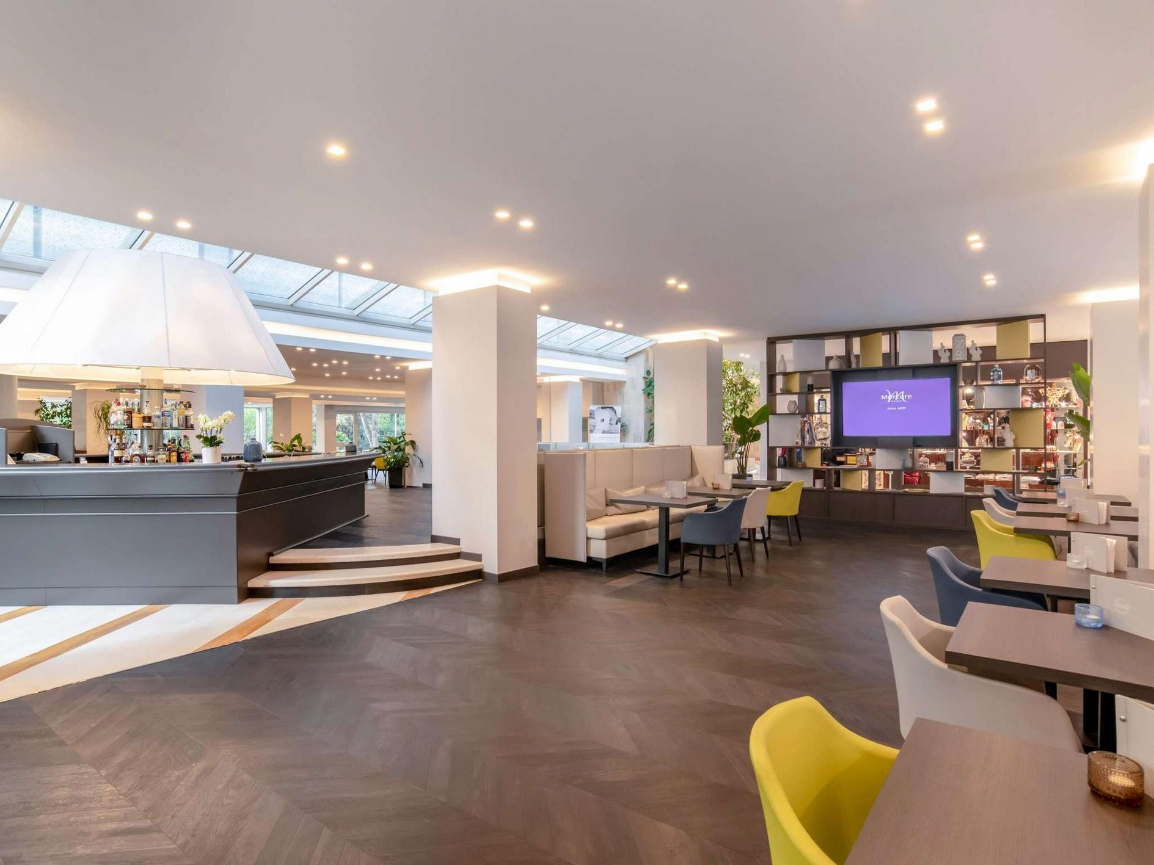

PRECISE HOUSE HOTEL MANTEGNA.
https://www.precisehotels.com/precise-house-mantegna-roma

Precise House Mantegna Rome is a large design hotel boasting a quiet location in the Tor Marancia district. The property offers free WiFi throughout and a spacious business center.
Precise House Mantegna Rome is located 600 meters from Via Cristoforo Colombo. Basilica San Paolo Metro Station can be reached in a 20-minute walk.
All rooms are equipped with air conditioning, a flat-screen satellite TV, and a private bathroom with a hairdryer.
The hotel features private parking, a 24-hour front desk, and two on-site restaurants serving traditional local and Mediterranean cuisine. Breakfast is served as a buffet.
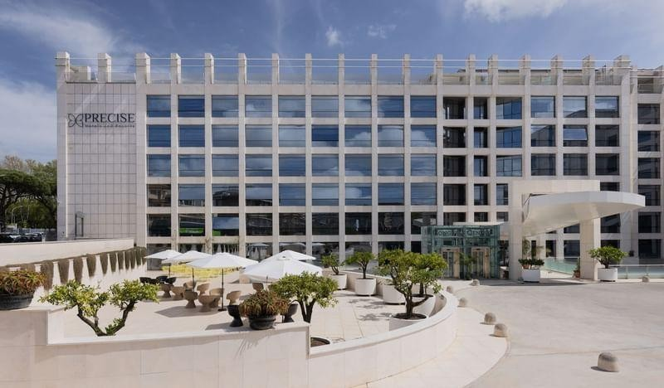

OCCIDENTAL ARAN PARK
https://www.barcelo.com/en-ie/occidental-aran-park/

is located in a quiet residential area in the EUR district of Rome. It is surrounded by green, gardened areas, which create the perfect environment for relaxation.
The hotel has 325 bright, spacious rooms, refurbished in 2020 and decorated in a
modern, innovative style. All rooms are fully equipped and feature 40" LCD TVs and free Wi-Fi connection.
One of the highlights of the hotel are its 6 meeting rooms, which are fitted with the
latest technology and have seating capacity for up to 280 people, making them ideal for a wide range of events.
All of the meeting rooms receive plenty of natural light and benefit from free Wi-Fi. The hotel also offers free covered parking and a fully equipped fitness studio.
There is also a range of dining options on offer at the hotel. There are 2 restaurants and
a bar where you can enjoy both Italian and international cuisine. Il Giardino Delle Rose, located on the 7th floor, offers fantasticpanoramic views from the terrace. Batik
Restaurant specialises in customised events, subject to prior booking. And the Lobby Bar is the perfect place to enjoy an Italian aperitif, watch the TV or surf the Internet.
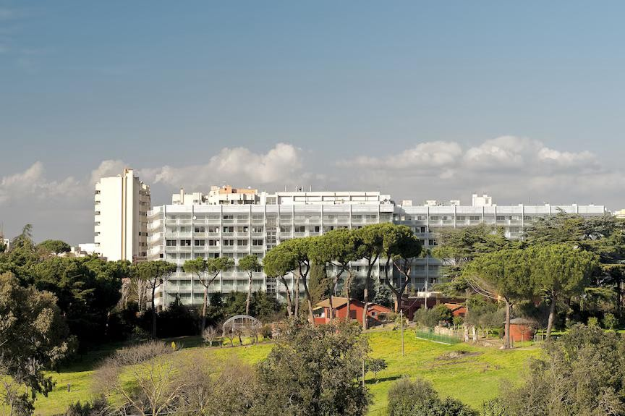

According to WAE rules the accommodation in the LOC official hotels is mandatory to participate.

In addition, the LOC will be responsible to provide any event information at this hotel and provide transportation to the venues. Private vehicles can be used too.

For all hotels

- Single Room price: 180 € per night / person
- Number of rooms: 30
- Double/Twin Room price: 140 € per night / person TOT 280 € per day
- Number of rooms: 70
- Triple Room price: 110 € per night / person TOT 330 € per day
- Number of rooms: 30
- Board plan: full board.
- Check-in from 23/04/2026
- Late check-out full day fee

TRANSPORTATION
Transportation will be provided from Fiumicino (FCO) airport to the official hotels, from two days before the official practice day and until two days after the closing day. Local transport will be available between the official hotel, practice and competition venues. Transport timetables will be confirmed. The single all-inclusive fee for all transportations is 250 € per person.

VISA
All participants who need an entry visa to Country, will be required to complete the Visa Support sections in WAREOS by no later than 1st April 2026.

It is the applicants’ responsibility for supplying the necessary information, ensuring all details are up to date, correct and submitted by the deadlines specified.

In addition, all participants that require a visa are kindly requested to supply a copy of their latest/valid passport. Copies of each application can be uploaded on WAREOS. All passport copies and personal details entered/uploaded to WAREOS will be held securely and in the strictest of confidence and not shared with other parties.

BANK INFORMATION FOR ACCOMMODATION, TRANSPORTATION AND ENTRY FEES

A/C Name: Roma European Para Archery

City and Country: Via Vitorchiano 113/115 Rome, Italy

Bank: PER BANCA S.P.A.

Account Number: IT93B0538773920000004059103

Swift: BPMOIT22XXX

NOTE: ALL PAYMENTS SHALL BE MADE IN EURO.

CANCELLATIONS & CHANGES
All cancellations and changes must be made through WAREOS / Open WAREOS:

- Should flight arrival details change last minute, please contact the Organising Committee using the details indicated in the team managers’ booklet.
- If a participant’s arrival is later than the original scheduled arrival date, the room will be charged from the date of the original booking in WAREOS.
- An email will automatically notify the Organising Committee and Member Association of any changes made in WAREOS.

HEALTH REGULATIONS

Closest Hospital Ospedale Regina Elena Via Elio Chianesi, 53, 00128 Roma RM

An Ambulance will be present on the venue during all the Event

ADDITIONAL INFORMATION

TRAINING
A training field will be available starting on 25th April at the competition Venue. All transports required for training are included in “Transport Fee”

WEATHER
The last month of the spring May, is a temperate month in Rome, Italy, with average temperature fluctuating between 19°C and 30°C. In April and May, the rain falls for 3.3 days and regularly aggregates up to 36.8mm (1.45") of precipitation.

MEDIA REGISTRATION
Media representatives can apply for registration by emailing stampa@fitarco-italia.org specifying the competition name “Rome European Para Archery Championships “

INTERNET
Will be available in the official hotels according specific hotel regulations. A specific internet connection point will be available on the venue.

WATER
Each participant will unlimited number of fresh water bottles

LOC CONTACT

By email
Name: Mrs Isabella Meattini
Email: info@repac22.com Language: English and French

By phone
Name: Mr Ardingo Scarzella Language: English and French
Phone number with international extension: +39 3347836370

Technical Delegate
Name: Mr Arnoud Strijbis
Email: arnoudstrijbis@gmail.com
Language: English
Phone number with international extension: +31 6 46133286

Looking forward to welcoming you in Roma, Italy.

Terms and Conditions Introduction
The Member Association acknowledges to have understood and accepted in their whole and without any restrictions the sale and purchase terms and conditions of this invitation package, and of the registration platform https://extranet.worldarchery. sport/wareos/.

Consequently, the Member Association who wishes to register to an event, and book some or all associated extras proposed by the local organizing committee acknowledges that they are fully aware present terms and conditions are accepted by entering information in WAREOS.

Any Member Association declares that it is entitled to enter a contractual relationship with the Local Organising Committee of the event, in accordance with these terms and conditions.

The Local Organising Committee commits itself to communicate, within reason, to its potential clients the greatest information available on the following topics: Description of the main characteristics of the
proposed products and of their use.
Pricing
Information on the methods of payment and reimbursement conditions.

Article 1: Entirety
The platform
https://extranet.worldarchery. sport/wareos/ is the propriety of, has been designed and created and is managed by World Archery Federation at Lausanne, Switzerland, and put at the disposal of the Local Organising Committee to facilitate registration to World Archery events.
The present terms and conditions include any and all rights and obligations of the parties. No single, specific, or general term or condition that may appear on documentation sent, given, or handed over to a Member Association will alter, replace, or complete parts of or the entirety of these terms and conditions
World Archery reserves the right to modify at any time and without any preliminary notification of any kind these terms and conditions.

Article 2: Object
The present terms and conditions define the rights and obligations of the parties in relation to the registration
made through the platform https://extranet.worldarchery. sport/wareos/ of services offered by the Local Organising Committee in the scope of the event it has been set for.

Article 3: Contractual documents
The present terms and conditions and the registration process make up the contractual documents between the parties.

Article 4: Electronic signature:
The Member Association’s entering registration information is the electronic signature which is binding between the parties in the same sense as a handwritten signature would be.

Article 5: Registration Confirmation – Contract
The contract is validated as soon as the Member Association has entered its preliminary registration by entering information in WAREOS. A modification of the registration is possible until the deadline for registration set in the document. Modifications may be subject to penalty fees.

Article 6: Prices
The official prices are listed in

the “Policies and Procedures Athletes, officials and team management”, the invitation package prices will be based on the official price list, converted to the currency elected by the LOC for invoicing (CHF, EUR, or USD). The official prices valid on the date that the registration confirmation is sent to the Member Association are binding between the parties. Article 7: Payment methods All payments shall be made by bank transfer to the organising committee respecting the stated deadlines, with all bank charges paid by the Member Association. For any open invoices that are not settled 21 days prior the beginning of the event, the Local Organising committee will be entitled to charge a 5% surcharge on all open amounts.
Any payments received cash by World Archery on behalf of the organising committee will incur a 10% additional service fee, to be paid to World Archery.

Article 8: Payment deadlines and refunds
After the preliminary’s entry deadline, the downpayment of 50% shall not be reimbursable. After the final deadlines of registration
mentioned in this document, Member Association will not be entitled to any refund, and all remaining unpaid amounts shall be paid to the Local Organising Committee.
Failure to do so, will results in an immediate suspension of the Member Association, who will be set as not in good standing on the day of the official practice of the event, and so until the full amount is paid to the LOC.

Article 9: Availability of services
The availability of services is guaranteed on a first come, first serve basis, provided that the payment of such service has been paid to the local organising committee, partially or in full as mentioned in this document. The local organising committee is not required to hold services for a Member Association that as not paid in full such service.

Article 10: Force-majeure None of the two parties will have failed in their respective contractual obligations if their execution is delayed or prevented by a case of force- majeure. Cases considered to be a force majeure are extraordinary events or circumstances beyond the control of the parties, such as
a war, strike, riot, crime, or an event described by the legal term "act of God" (e.g., flooding, earthquake, volcano eruption, etc). However, force majeure is not intended to excuse negligence or other malfeasance of a party, as where non-performance is caused by the usual and natural consequences of external forces, or where the intervening circumstances are specifically contemplated. The party experiencing a force majeure must notify in writing with 24 hours after becoming aware of the occurrence. The parties will then, within 7 business days examine, unless the force majeure prevents it, if and how the contractual obligations will be met.

Article 11: Privacy statement
All information exchanged by the Parties will be treated with the utmost confidentiality All information requested by World Archery and the Organising Committee from the Member Association are necessary to process the event registration and can therefore be communicated only to the contractual partners of World Archery and the Local Organising Committee.

World Archery and the Local Organising committee are authorized to send informative and promotional e-mails to the Member Association, using the
WAREOS e-mail address and the contact person provided by the Member Association during the registration.

November 2024 by World
Archery Federation, Maison du Sport International, Avenue de Rhodanie 54 - 1007 Lausanne (Switzerland)

